**1** [Biblioteca - Pontificia Università Urbaniana](http://www.urbaniana.edu/Urbaniana/biblioteca/Default.aspx)

**Angelicum** - Catalogo della Biblioteca dell' Università

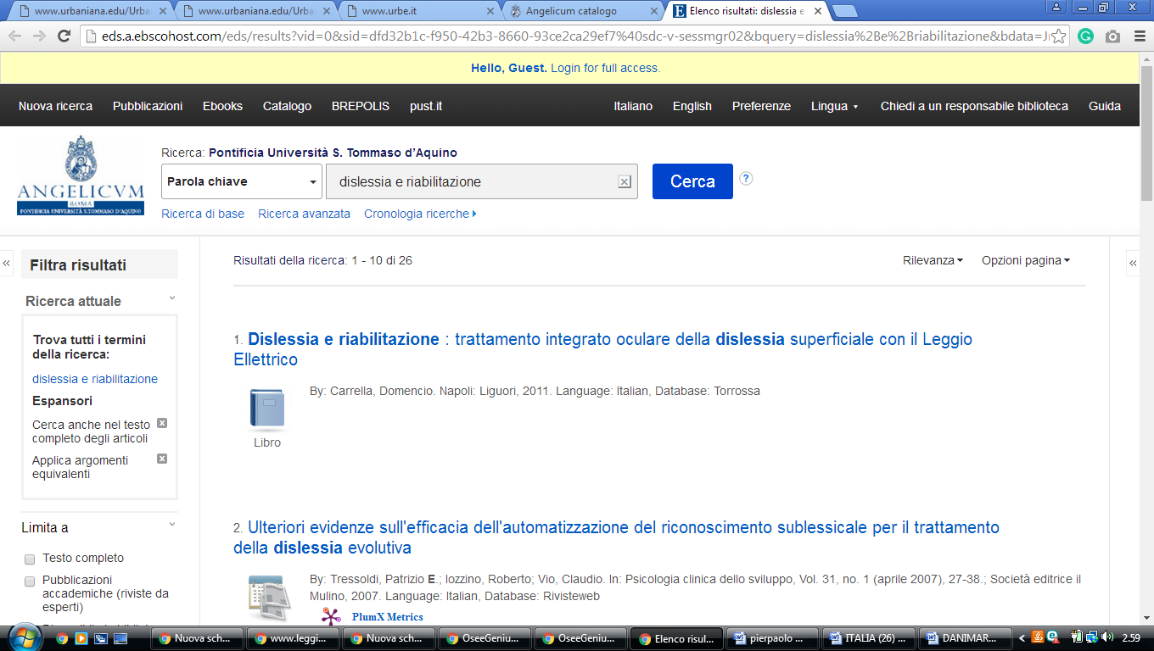http://eds.a.ebscohost.com/eds/results?vid=0&sid=dfd32b1c-f950-42b3-8660-93ce2ca29ef7%40sdc-v-sessmgr02&bquery=dislessia%2Be%2Briabilitazione&bdata=Jmxhbmc9aXQmdHlwZT0wJnNlYXJjaE1vZGU9QW5kJnNpdGU9ZWRzLWxpdmUmc2NvcGU9c2l0ZQ%3d%3d