**WISCONSIN = 21**

**1** [**BELOIT COLLEGE LIBRARY**](http://www.beloit.edu/library/) – (Beloit, Wisconsin, Usa)

<https://beloit.on.worldcat.org/search?sortKey=LIBRARY&databaseList=&queryString=dislessia+e+riabilitazione&changedFacet=author&scope=&format=all&database=all&author=Carrella%2C+Domenico&year=all&yearFrom=&yearTo=&language=all&topic=all>

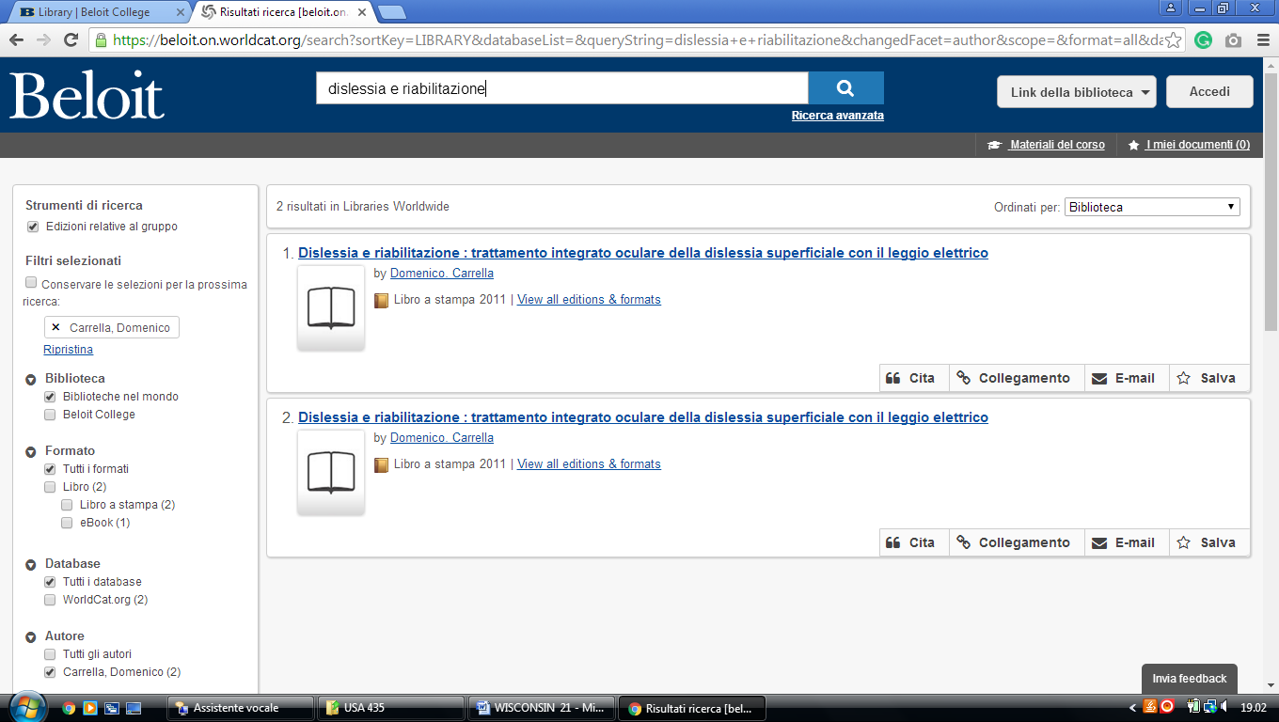

**2** [**CARROLL COLLEGE LIBRARY**](http://www.carroll.edu/library/) - (Waukesha, Wisconsin, Usa)

<https://carroll-primo.hosted.exlibrisgroup.com/primo-explore/search?vid=01TRAILS_CARROLL&query=any,contains,dislessia%20e%20riabilitazione&tab=everything&search_scope=EVERYTHING&facet=rtype,exclude,newspaper_articles&facet=rtype,exclude,reviews&sortby=rank&lang=en_US&pcAvailability=true>

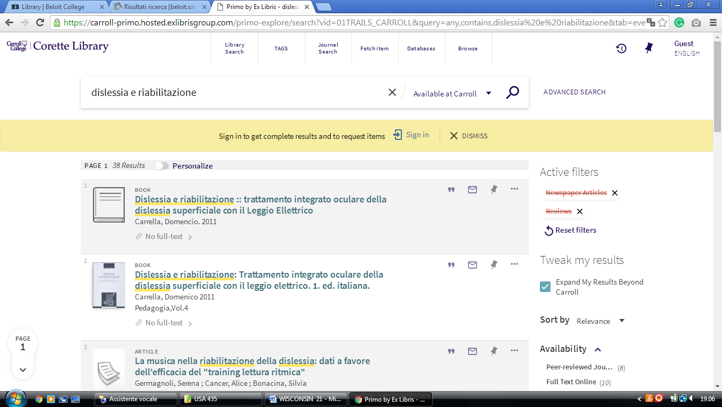

**3** [**CHALMER DAVEE UNIVERSITY LIBRARY**](http://www.uwrf.edu/library/) **-** (River Falls, Wisconsin, Usa)

<https://uw-primo.hosted.exlibrisgroup.com/primo-explore/search?institution=RF&vid=RF&search_scope=Everything&mode=Basic&displayMode=full&bulkSize=10&highlight=true&dum=true&query=any,contains,dislessia%20e%20riabilitazione&displayField=all&pcAvailabiltyMode=true&sortby=rank&lang=en_US>

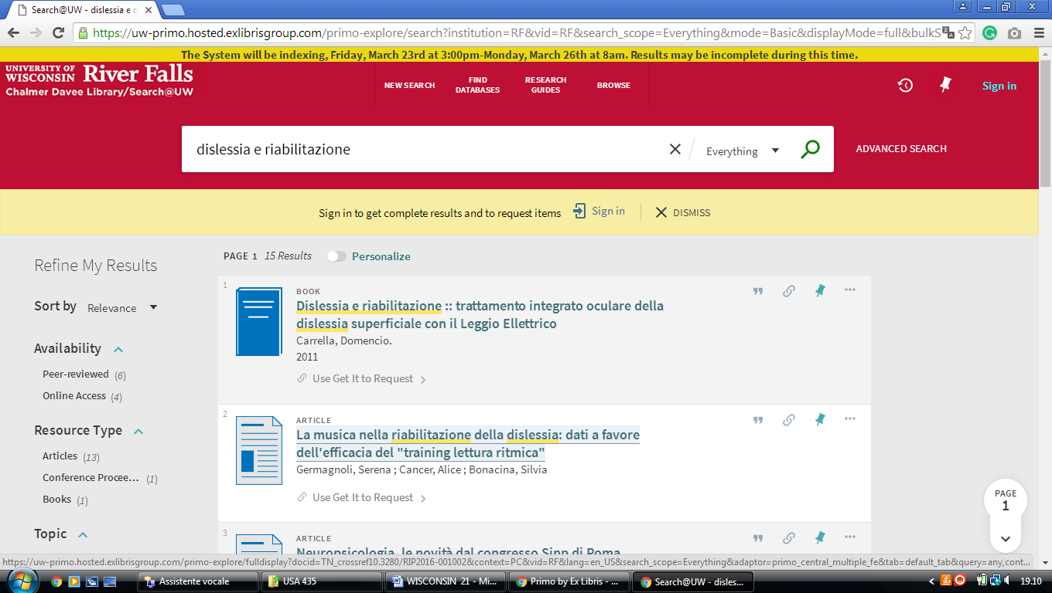

**4** [**MCINTYRE LIBRARY**](http://www.uwec.edu/library/) - (University Wisconsin, Usa)

<https://uwi-primoalma-prod.hosted.exlibrisgroup.com/primo-explore/search?query=any,contains,dislessia%20e%20riabilitazione&tab=default_tab&sortby=rank&vid=EC&lang=en_US&search_scope=Everything>

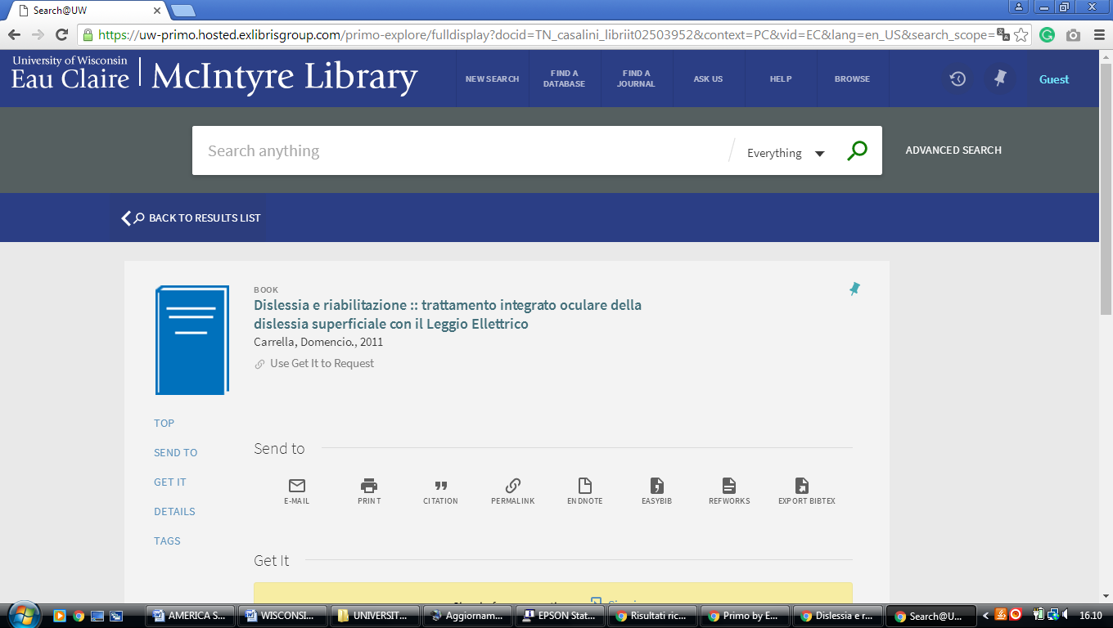

**5** [**POLK LIBRARY**](http://www.uwosh.edu/library/) – (Oshkosh, Wisconsin, Usa)

<https://uw-primo.hosted.exlibrisgroup.com/primo-explore/search?search_scope=OSH_ALL&institution=OSH&vid=OSH&query=any,contains,DISLESSIA%20E%20RIABILITAZIONE&sortby=rank&lang=en_US>

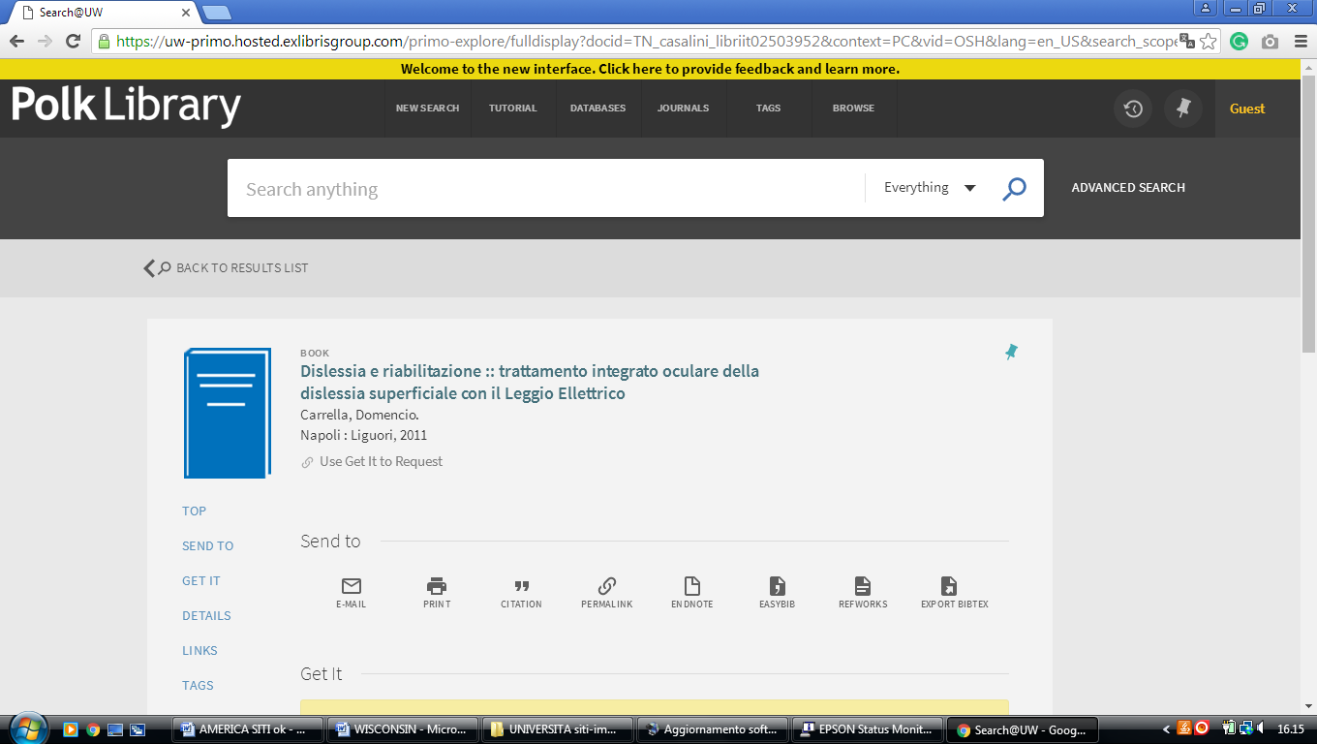

**6** [**STEVENS POINT UNIVERSITY LIBRARY**](http://library.uwsp.edu/) – (Stevens Point, Wisconsin,Usa)

<https://uwi-primoalma-prod.hosted.exlibrisgroup.com/primo-explore/search?query=any,contains,dislessia%20e%20riabilitazione&tab=default_tab&search_scope=SP_ALL&vid=SP&lang=en_US&offset=0&sortby=rank&pcAvailability=true>

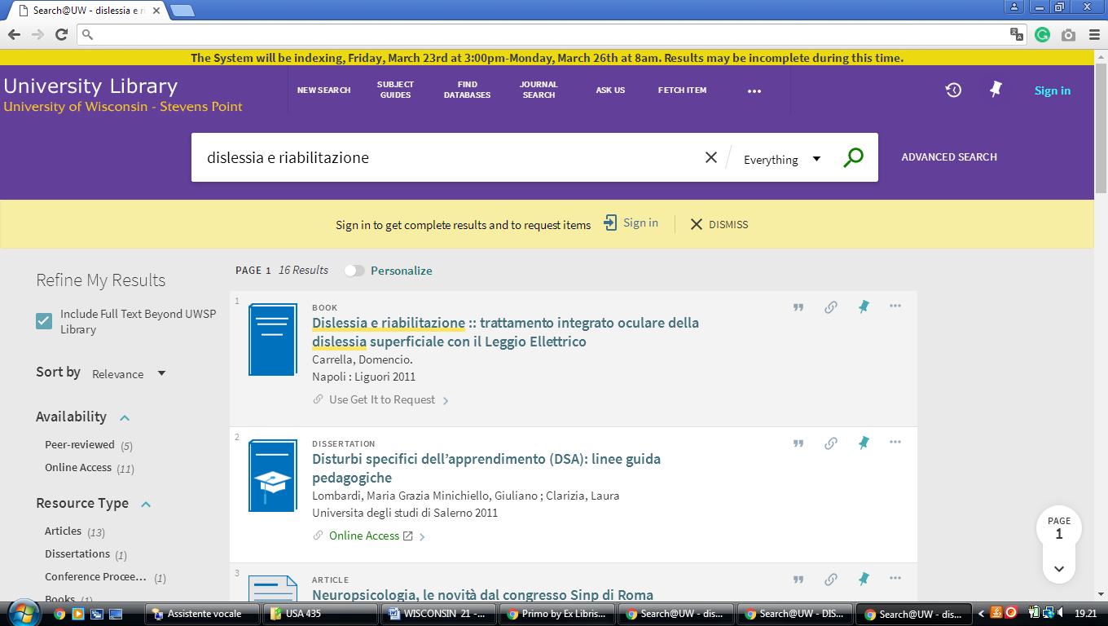

# 7 <HTTPS://UWBSC.ON.WORLDCAT.ORG> - (University of Wisconsin - Baraboo/Sauk County, Usa)

<https://uwbsc.on.worldcat.org/search?sortKey=LIBRARY&databaseList=&queryString=dislessia+e+riabilitazione&changedFacet=author&scope=&format=all&database=all&author=Carrella%2C+Domenico&year=all&yearFrom=&yearTo=&language=all&topic=all>

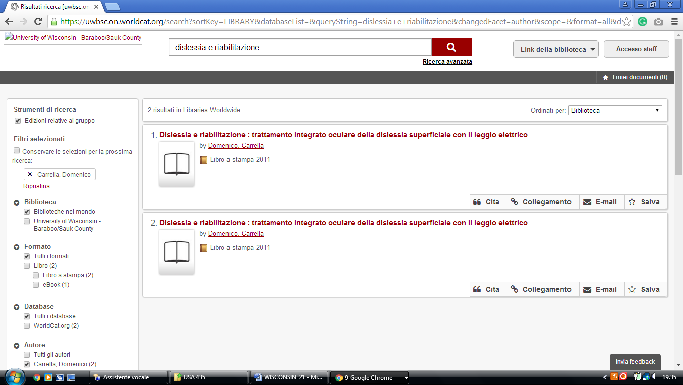

**8** [**HTTP://UNIVERSITYOFWISCONSIN-BARRONCOUNTY.ON.WORLDCAT.ORG**](http://universityofwisconsin-barroncounty.on.worldcat.org/)

(University of Wisconsin - Uw-Barron County Library, Usa)

<https://universityofwisconsin-barroncounty.on.worldcat.org/search?sortKey=LIBRARY&databaseList=&queryString=dislessia+e+riabilitazione&changedFacet=author&scope=&format=all&database=all&author=Carrella%2C+Domenico&year=all&yearFrom=&yearTo=&language=all&topic=all>

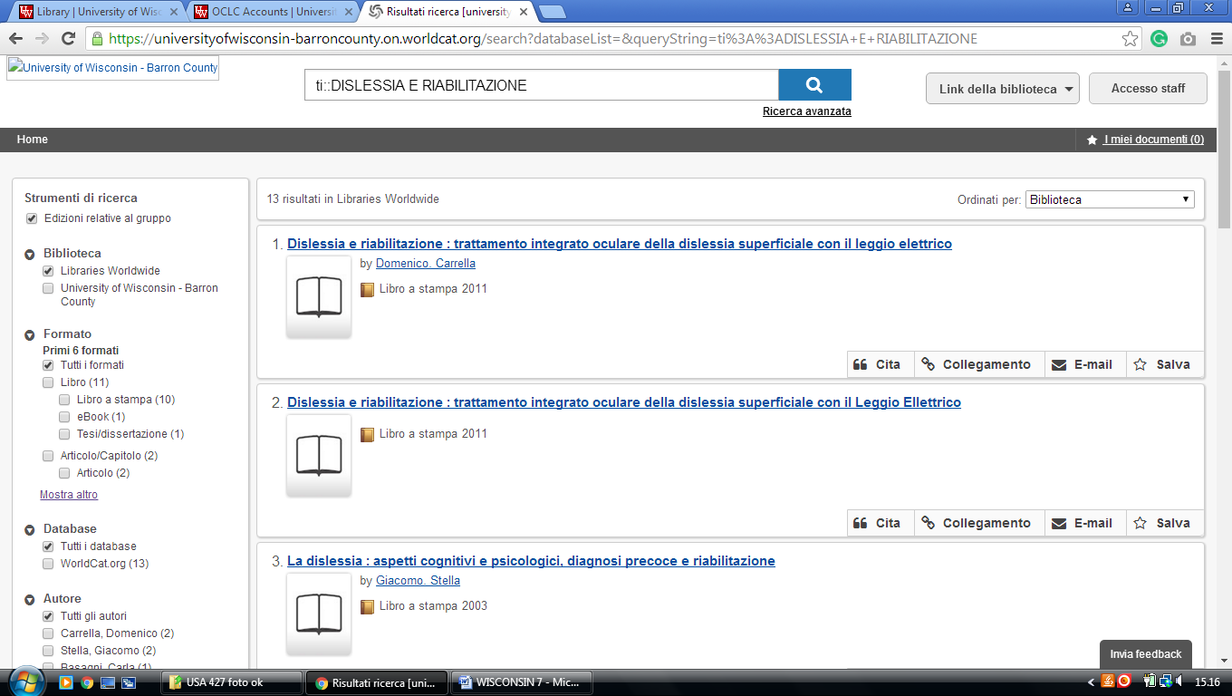

# 9 [HTTP://UNIVERSITYOFWISCONSIN-FONDDULAC.ON.WORLDCAT.ORG](http://universityofwisconsin-fonddulac.on.worldcat.org  ) (University of Wisconsin - Fond Du Lac  Library, Usa)

<https://universityofwisconsin-fonddulac.on.worldcat.org/search?sortKey=LIBRARY&databaseList=&queryString=dislessia+e+riabilitazione&changedFacet=author&scope=&format=all&database=all&author=Carrella%2C+Domenico&year=all&yearFrom=&yearTo=&language=all&topic=all>

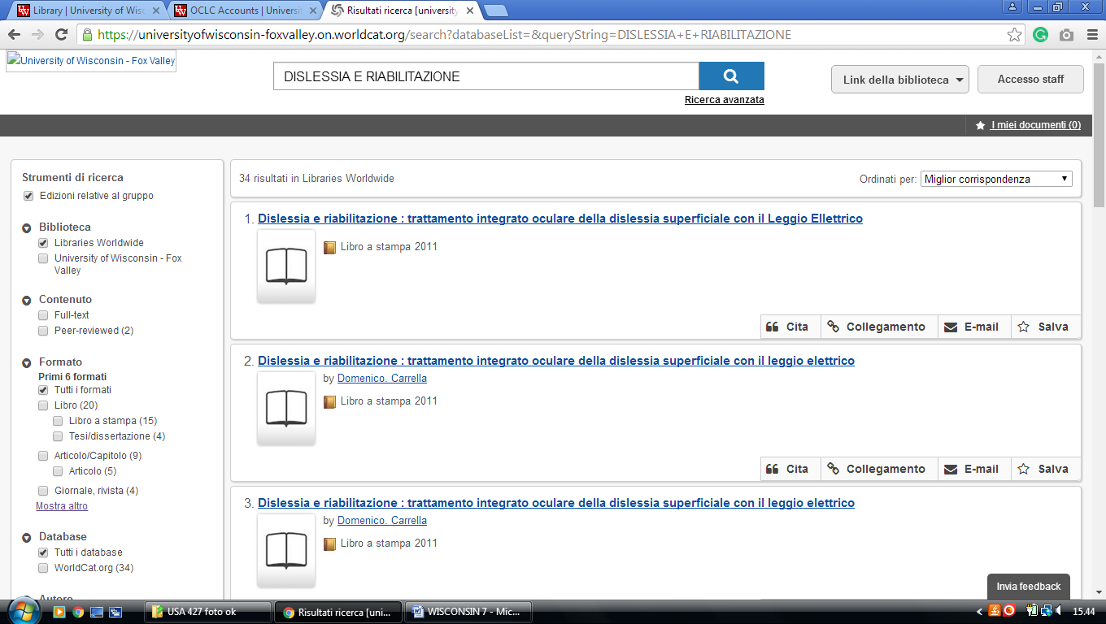

# 10 HTTPS://UNIVERSITYOFWISCONSIN FOXVALLEY.ON.WORLDCAT.ORG. (University of Wisconsin - Fox Valley Library,Usa)

<https://universityofwisconsin-foxvalley.on.worldcat.org/search?databaseList=&queryString=dislessia+e+riabilitazione>

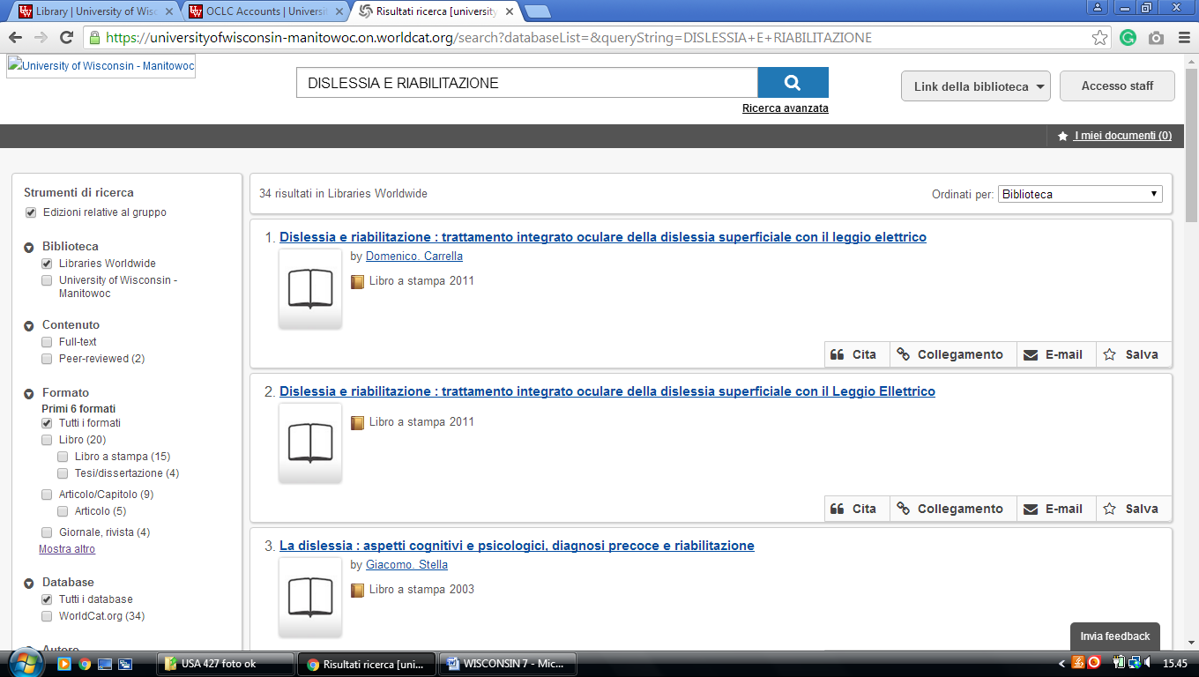

**11 HTTP://UNIVERSITYOFWISCONSIN MANITOWOC.ON.WORLDCAT.ORG**,

(Uw-Manitowoc Library, Wisconsin,Usa)

<https://universityofwisconsin-manitowoc.on.worldcat.org/search?sortKey=LIBRARY&databaseList=&queryString=dislessia+e+riabilitazione&changedFacet=author&scope=&format=all&database=all&author=Carrella%2C+Domenico&year=all&yearFrom=&yearTo=&language=all&topic=all>

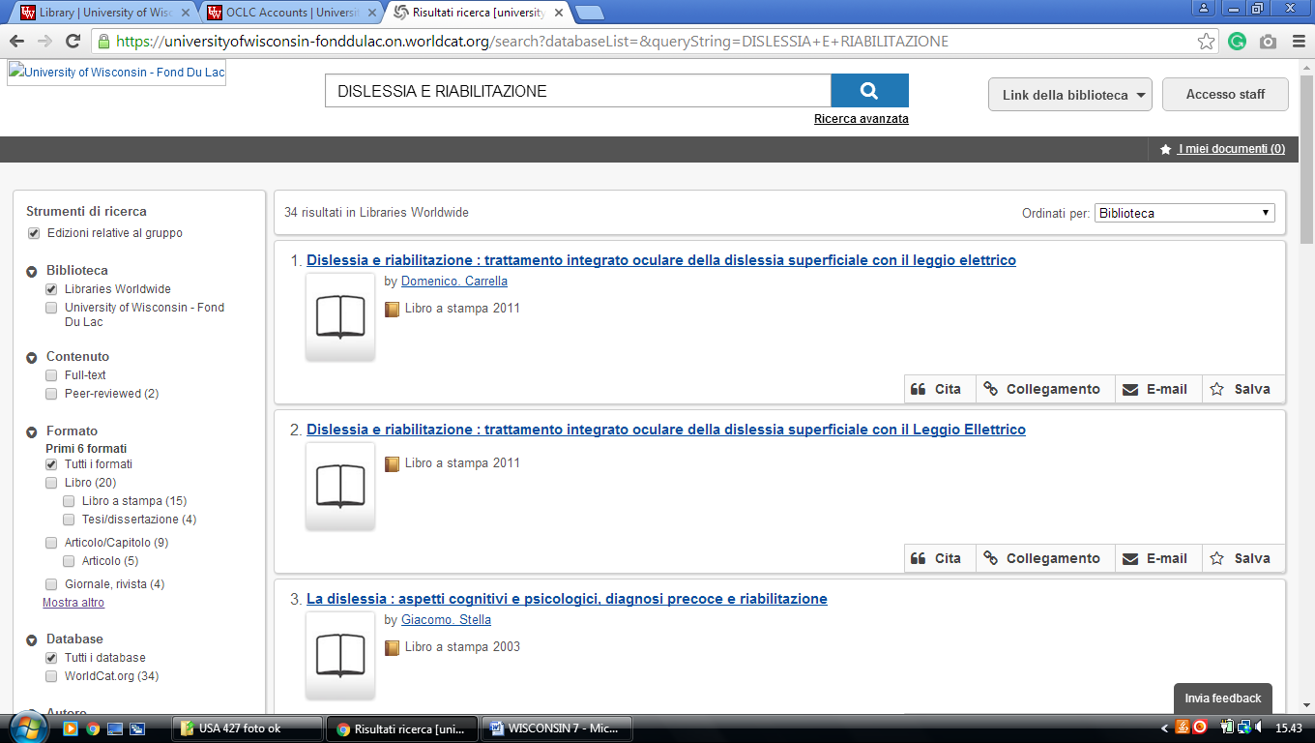

**12** [**HTTP://UNIVERSITYOFWISCONSIN-MARINETTE.ON.WORLDCAT.ORG.**](http://universityofwisconsin-marinette.on.worldcat.org. )(Uw-Marinette Library, Wisconsin,Usa)

<https://universityofwisconsin-marinette.on.worldcat.org/search?databaseList=&queryString=dislessia+e+riabilitazione>

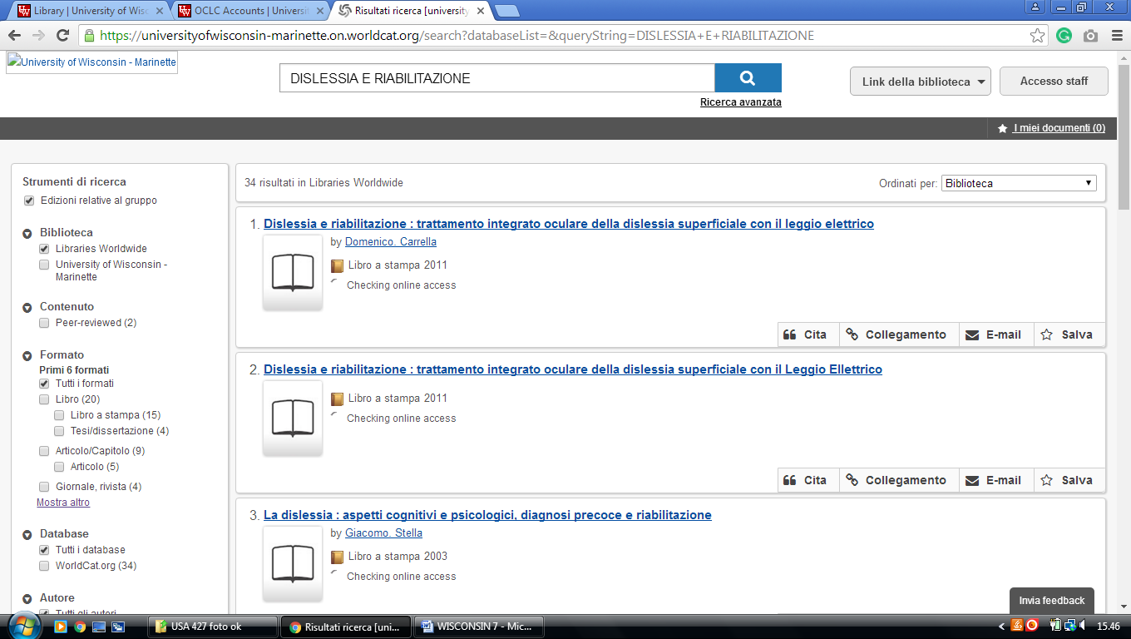

UW-Marathon County: [http://universityofwisconsin-marathoncounty.on.worldcat.org](http://universityofwisconsin-marathoncounty.on.worldcat.org/)

**13 HTTP://UNIVERSITYOFWISCONSIN.** **MARATHONCOUNTY ON.WORLDCAT.ORG.** (Uw-Marathon Countylibrary, Wisconsin,Usa)

<https://universityofwisconsin-marathoncounty.on.worldcat.org/search?sortKey=LIBRARY&databaseList=&queryString=dislessia+e+riabilitazione&changedFacet=author&scope=&format=all&database=all&author=Carrella%2C+Domenico&year=all&yearFrom=&yearTo=&language=all&topic=all>

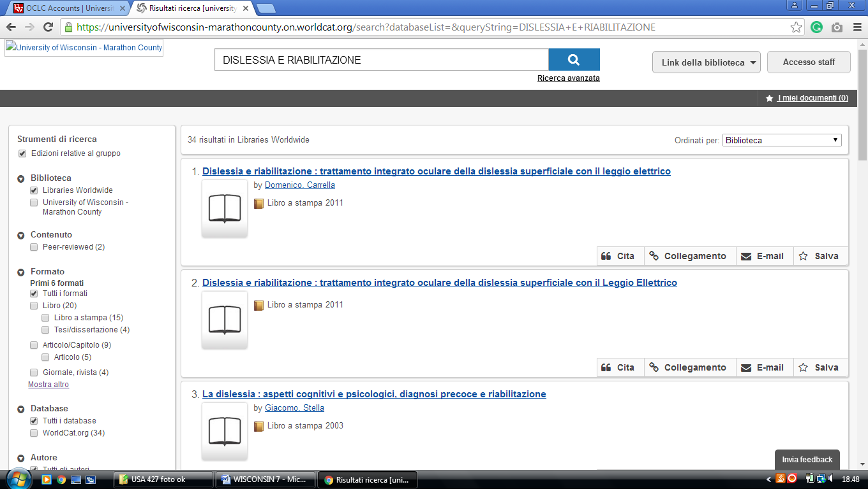

**14  HTTP://UNIVERSITYOFWISCONSIN73804.ON.WORLDCAT.ORG** – (Uw-Marshfield/Wood County Library, Wisconsin,Usa)

<https://universityofwisconsin-marathoncounty.on.worldcat.org/search?databaseList=&queryString=dislessia+e+riabilitazione>

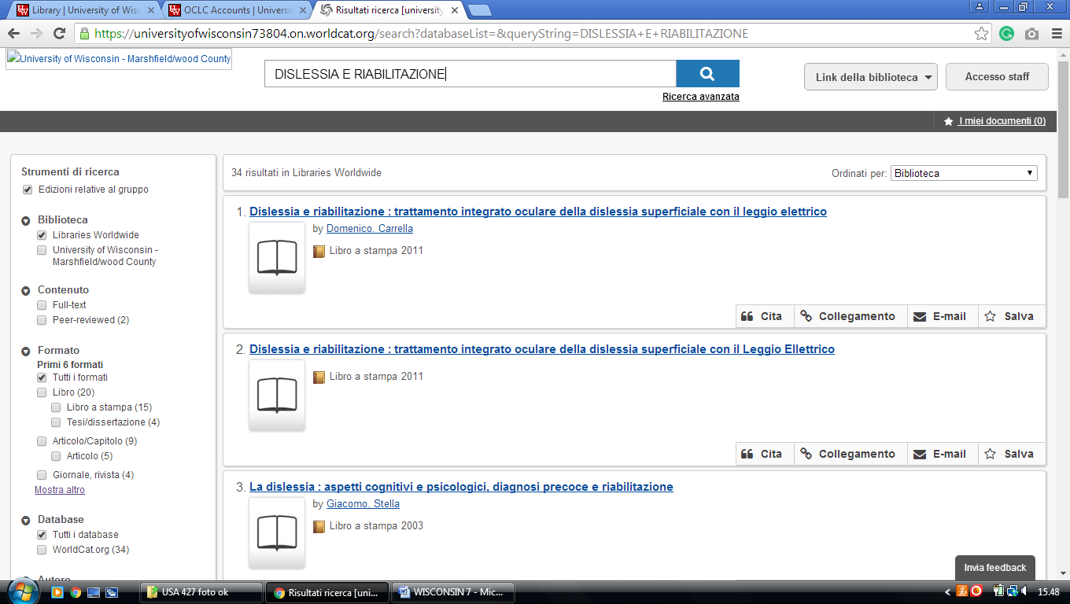

UW-Richland: [http://universityofwisconsin-richland.on.worldcat.org](http://universityofwisconsin-richland.on.worldcat.org/)

UW-Rock County: [http://universityofwisconsin-rockcounty.on.worldcat.org](http://universityofwisconsin-rockcounty.on.worldcat.org/)

**15** [**HTTP://UNIVERSITYOFWISCONSIN-RICHLAND.ON.WORLDCAT.ORG**](http://universityofwisconsin-richland.on.worldcat.org/)**, - (**Uw-Richland Library,Wisconsin, Usa)

<https://universityofwisconsin-richland.on.worldcat.org/search?databaseList=&queryString=dislessia+e+riabilitazione>

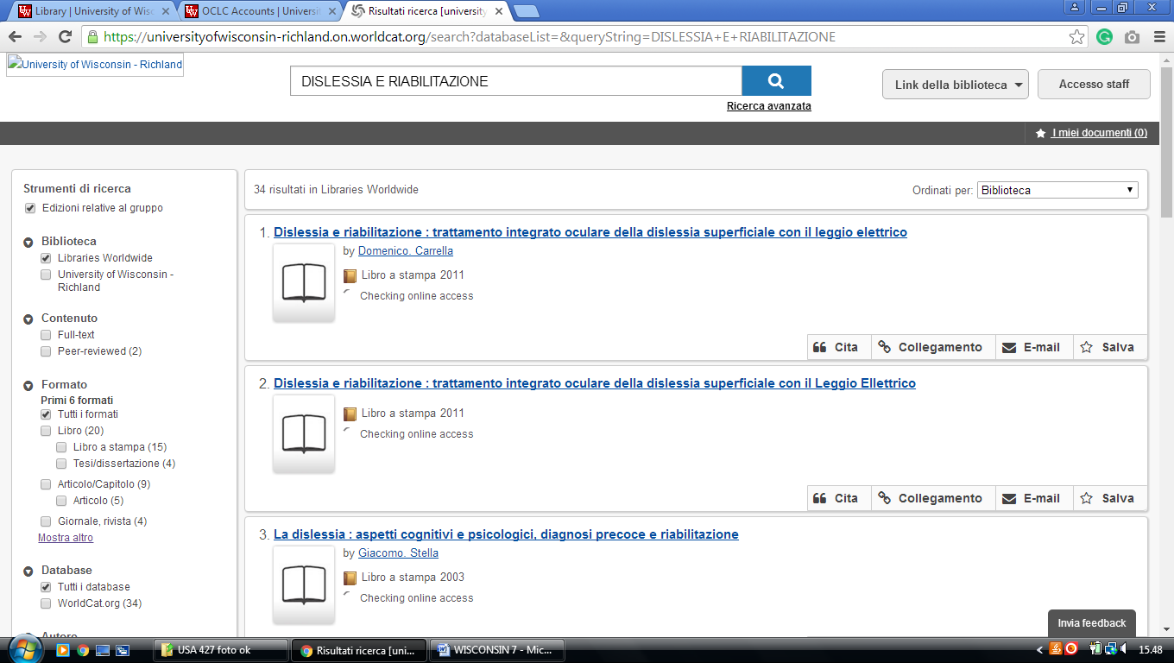

**16 HTTPS://UNIVERSITYOFWISCONSIN-ROCKCOUNTY.ON.**

**WORLDCAT.ORG/discovery -** (Uw-Rock County Library, Wisconsin, Usa)

<https://universityofwisconsin-rockcounty.on.worldcat.org/search?databaseList=&queryString=dislessia+e+riabilitazione>

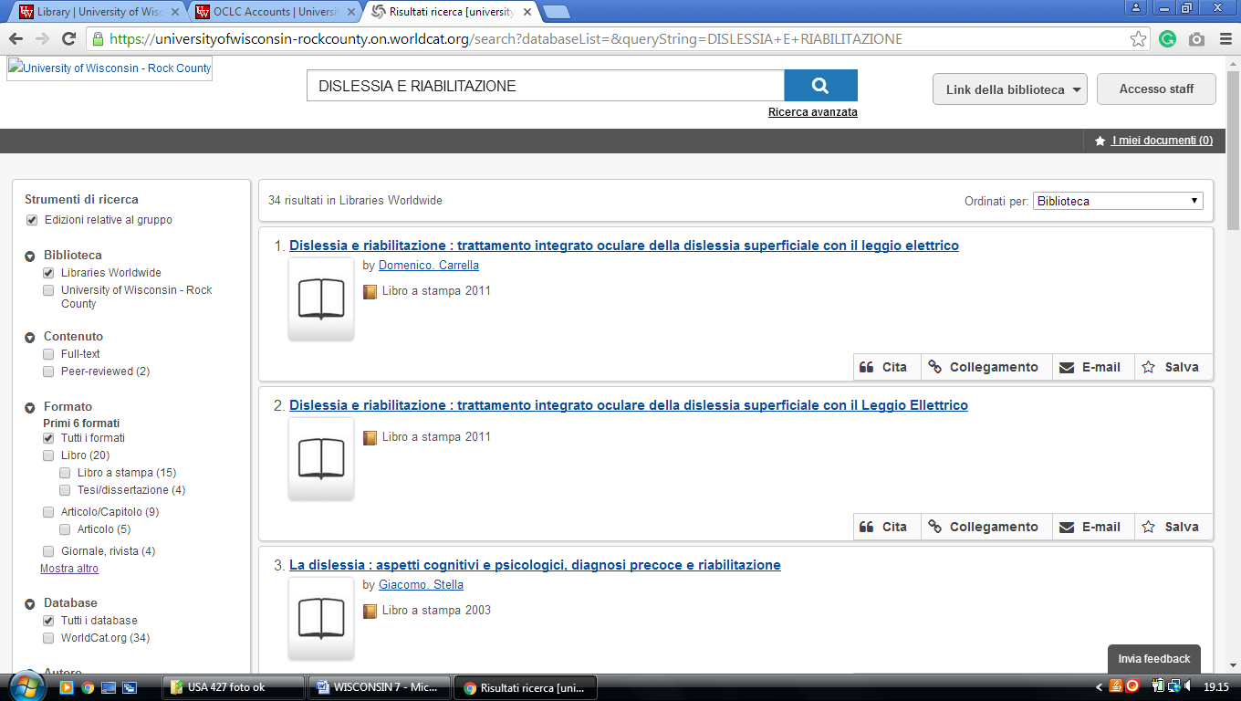

**17** [**HTTPS://UNIVERSITYOFWISCONSIN-**](HTTPS://UNIVERSITYOFWISCONSIN-)**SHEBOYGAN.ON.**

**WORLDCAT.ORG/discovery**- (Uw-Sheboygan**,** Wisconsin, Usa)

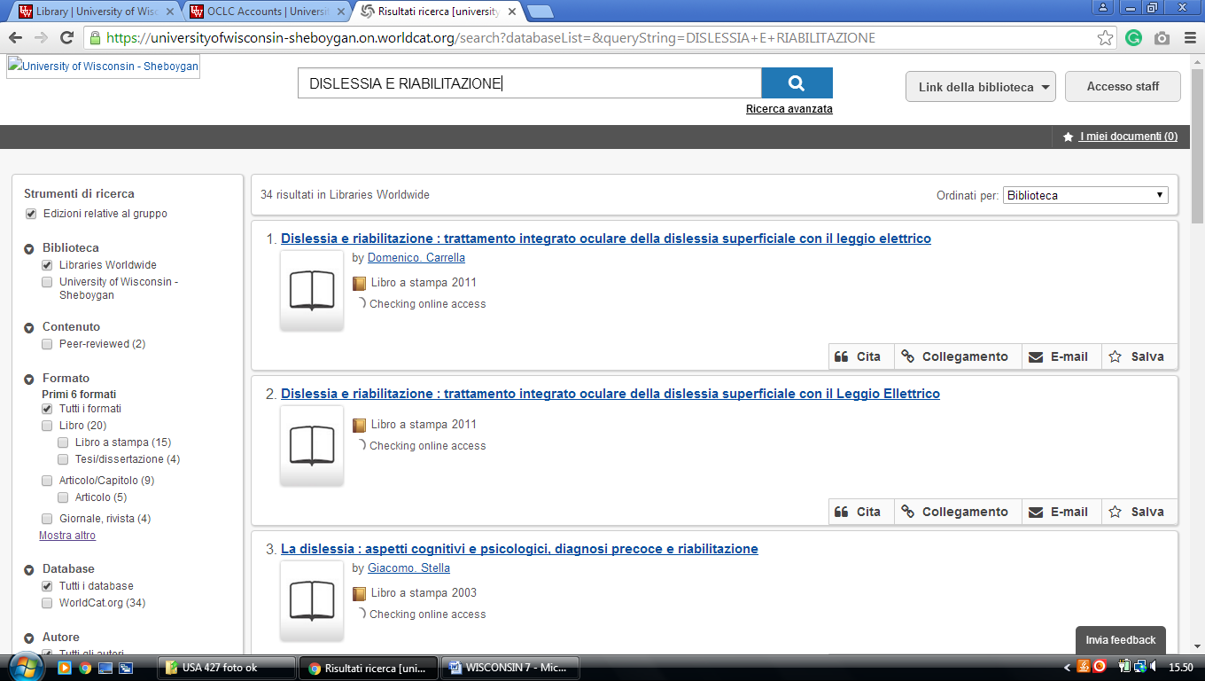<https://universityofwisconsin-sheboygan.on.worldcat.org/search?sortKey=LIBRARY&databaseList=&queryString=dislessia+e+riabilitazione&changedFacet=author&scope=&format=all&database=all&author=Carrella%2C+Domenico&year=all&yearFrom=&yearTo=&language=all&topic=all>

**18** [**HTTP://UNIVERSITYOFWISCONSIN73808.ON.WORLDCAT.ORG**](http://universityofwisconsin73808.on.worldcat.org/)

(Uw-Washington County Library, Wisconsin, Usa)

<https://universityofwisconsin73808.on.worldcat.org/search?databaseList=&queryString=dislessia+e+riabilitazione>

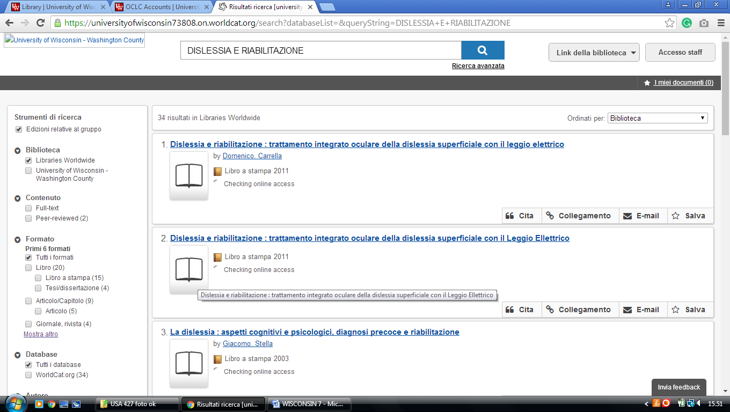

UW-Waukesha: [http://universityofwisconsin-waukesha.on.worldcat.org](http://universityofwisconsin-waukesha.on.worldcat.org/)

**19** [**HTTP://UNIVERSITYOFWISCONSIN-WAUKESHA.ON.WORLDCAT.ORG**](http://universityofwisconsin-waukesha.on.worldcat.org/)(Uw-Waukesha Library, Wisconsin, Usa)

<https://universityofwisconsin-waukesha.on.worldcat.org/search?databaseList=&queryString=dislessia+e+riabilitazione>

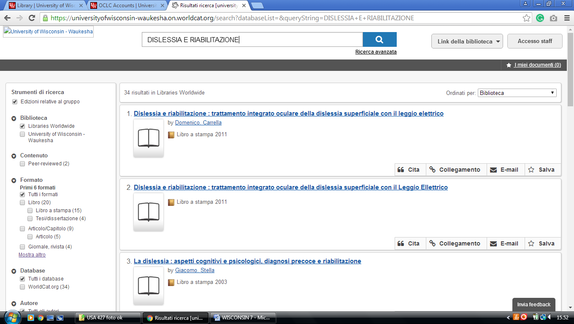

### 20 HTTPS://MCW.ON.WORLDCAT.ORG/ - (Medical College of Wisconsin, Usa)

### <https://mcw.on.worldcat.org/search?sortKey=LIBRARY&databaseList=&queryString=dislessia+e+riabilitazione&changedFacet=author&scope=&format=all&data>

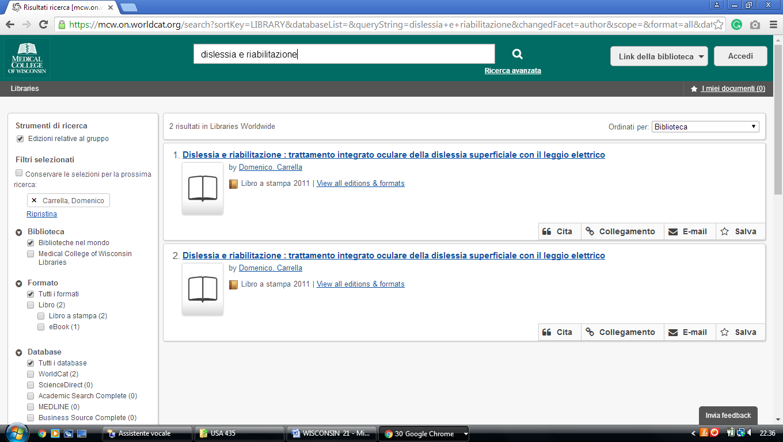

### 21 [HTTP://UWBSC.ON.WORLDCAT.ORG](http://uwbsc.on.worldcat.org/)  - (UW-Baraboo/Sau County, Wisconsin, Usa)

<https://uwbsc.on.worldcat.org/search?databaseList=&queryString=dislessia+e+riabilitazione>

