**SOUTH CAROLINA 3**

### 1 [LIBRARY, MULTIMEDIA CENTER AND ARCHIVES | BENEDICT COLLEGE](http://www.benedict.edu/cms/?q=library) -

(Columbia, South Carolina, Usa)

<http://eds.b.ebscohost.com/eds/resultsadvanced?vid=4&sid=a787204a-56a6-4e89-8e8d-1c0e4025f0a6%40sessionmgr101&bquery=(dislessia+AND+e+AND+riabilitazione)&bdata=JnR5cGU9MSZzaXRlPWVkcy1saXZlJnNjb3BlPXNpdGU%3d>

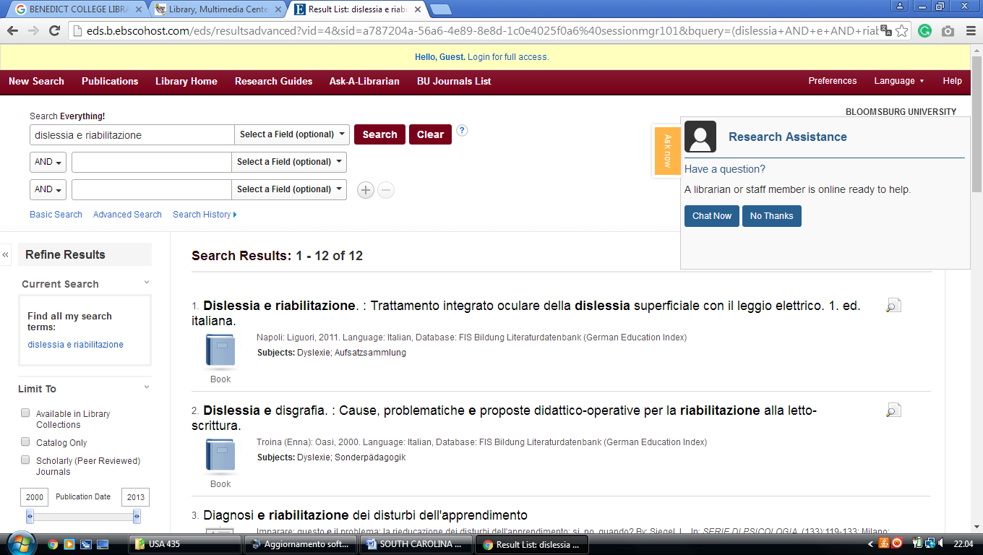

**2** [**DANIEL LIBRARY**](http://library.citadel.edu/home) – (Charleston, South Carolina, Usa)

<http://eds.a.ebscohost.com/eds/resultsadvanced?vid=2&sid=f3877440-4112-49cd-a28f-cbf0f8699707%40sessionmgr4009&bquery=(dislessia+AND+e+AND+riabilitazione)&bdata=JnR5cGU9MSZzaXRlPWVkcy1saXZl>

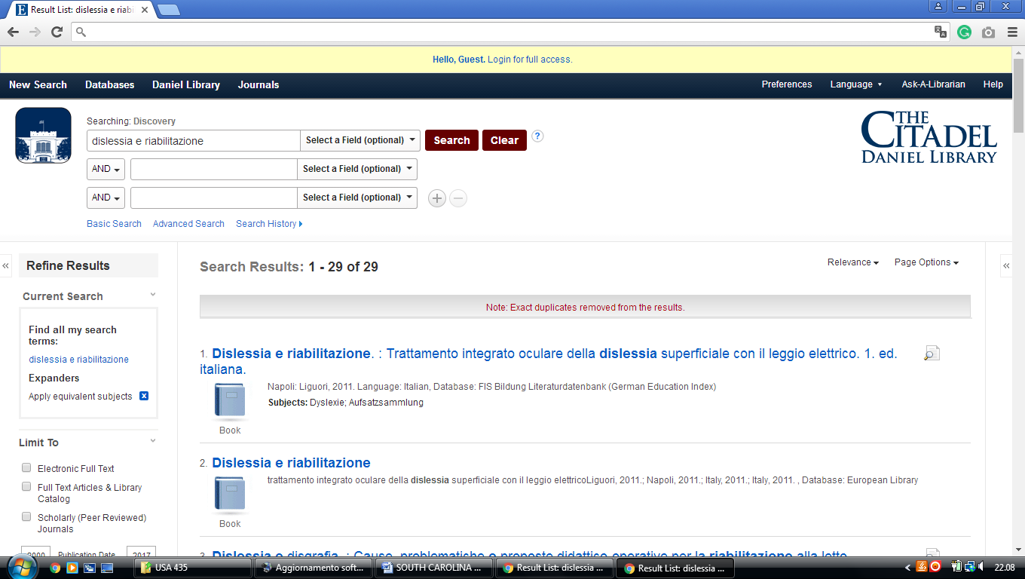

**3** [**MEDICAL UNIVERSITY OF SOUTH**](http://www.library.musc.edu/) **CAROLINA LIBRARY-** (Charleston, Usa)

<https://musc.on.worldcat.org/search?sortKey=BEST_MATCH&databaseList=&queryString=dislessia+e+riabilitazione&changedFacet=author&clusterResults=on&scope=&format=all&database=all&author=Carrella%2C+Domenico&year=all&yearFrom=&yearTo=&language=all&topic=all>

