**RHODE ISLAND = 7**

**1** [**RHODE ISLAND COLLEGE LIBRARY**](http://www.ric.edu/adamslibrary) **(RI) – (**[Providence, Rhode Island](https://en.wikipedia.org/wiki/Providence,_Rhode_Island), Usa) <https://ric.on.worldcat.org/search?sortKey=LIBRARY&databaseList=&queryString=dislessia+e+riabilitazione&changedFacet=author&scope=&format=all&database=all&author=Carrella%2C+Domenico&year=all&yearFrom=&yearTo=&language=all&topic=all>

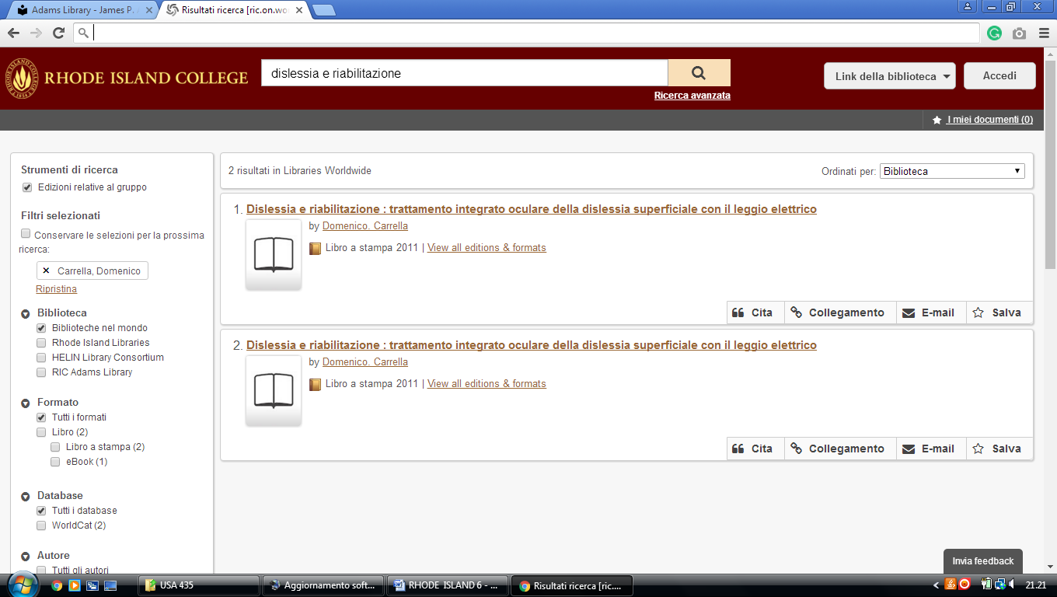

**2** [**COMMUNITY COLLEGE OF RHODE**](http://www.ccri.edu/library/)  **ISLAND LIBRARY** – (Warwick, R.I., Usa)

<https://ccri.on.worldcat.org/search?sortKey=BEST_MATCH&databaseList=283&queryString=dislessia+e+riabilitazione&changedFacet=scope&clusterResults=off&stickyFacetsChecked=on&scope>=

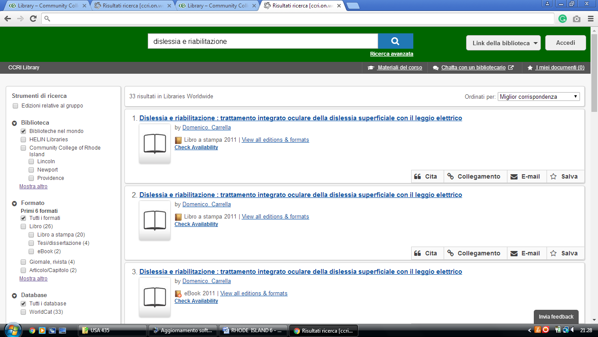

### 3 [DOUGLAS AND JUDITH KRUPP LIBRARY](http://library.bryant.edu/) – (Smithfield, R. I., Usa)

<https://bryant.on.worldcat.org/search?sortKey=BEST_MATCH&databaseList=&queryString=kw%3A%2Cdislessia+e+riabilitazione&changedFacet=author&scope=&format=all&database=all&author=Carrella%2C+Domenico&year=all&yearFrom=&yearTo=&language=all&topic=all>

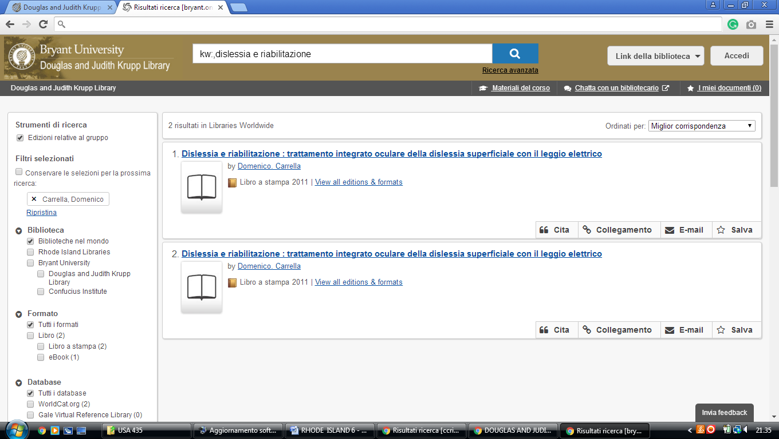

**4** [**MCKILLOP LIBRARY LOGO MCKILLOP**](http://library.salve.edu/) **LIBRARY – (**Newport, R.I., Usa)

<https://salve.on.worldcat.org/search?sortKey=LIBRARY&databaseList=&queryString=dislessia+e+riabilitazione&changedFacet=author&scope=&format=all&database=all&author=Carrella%2C+Domenico&year=all&yearFrom=&yearTo=&language=all&topic=all>

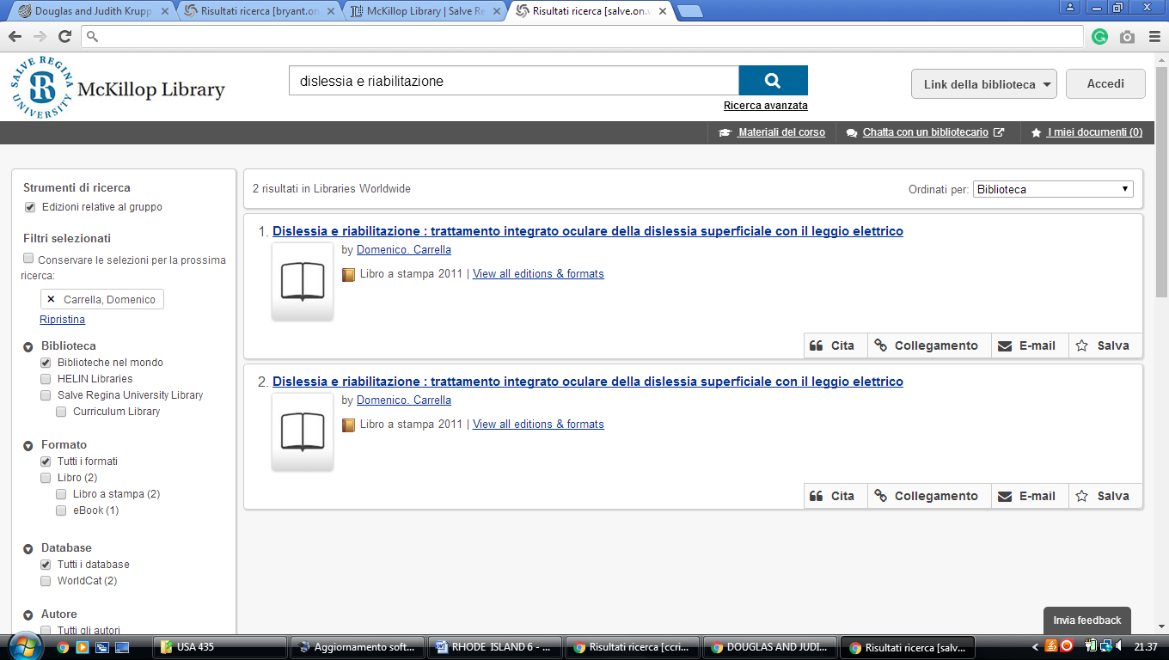

**5**  [**PHILLIPS MEMORIAL LIBRARY**](http://www.providence.edu/library/Pages/default.aspx) – (Providence, Rhode Island, Usa)

<https://providencecollege.on.worldcat.org/search?sortKey=LIBRARY&databaseList=283%2C1708%2C638&queryString=dislessia+e+riabilitazione&changedFacet=author&clusterResults=off&scope=&format=all&database=all&author=Carrella%2C+Domenico&year=all&yearFrom=&yearTo=&language=all&topic=all>

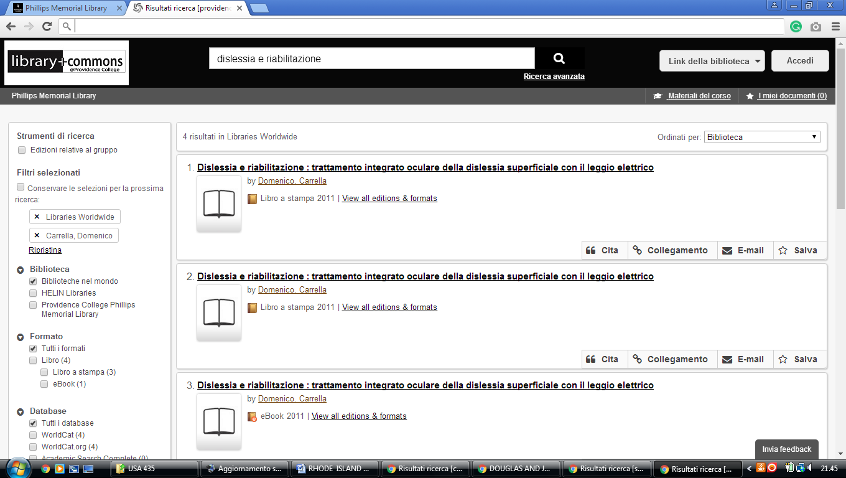

### 6 [LIBRARIES | ROGER WILLIAMS UNIVERSITY](https://www.rwu.edu/academics/libraries) - (Bristol, Rhode Island, Usa)

https://rwulibrary.on.worldcat.org/search?sortKey=BEST_MATCH&databaseList=&queryString=dislessia+e+riabilitazione&changedFacet=author&scope=&format=all&database=all&author=Carrella%2C+Domenico&year=all&yearFrom=&yearTo=&language=all&topic=all

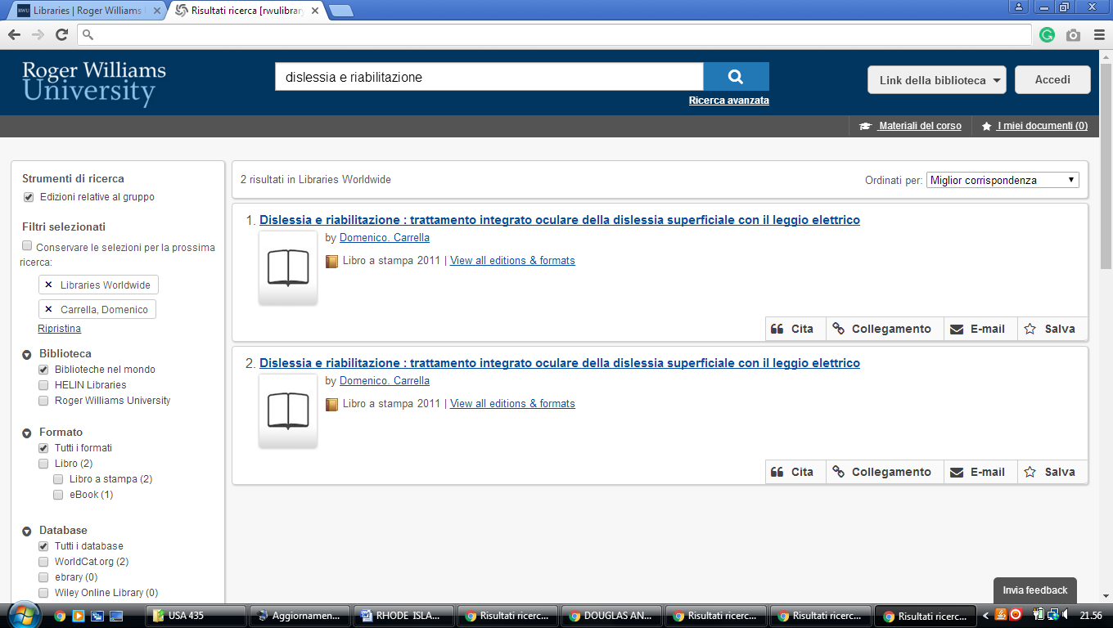

**New Providence university John Hay Library**

https://omni-primo.hosted.exlibrisgroup.com/primo-explore/search?query=any,contains,dislessia%20e%20riabilitazione&tab=articles&search_scope=PRIMO_CENTRAL&vid=01TRAILS_UGF&lang=en_US&offset=0&pcAvailability=true

