**PENNSYLVANIA = 16**

### 1 [QUICK START - LEHMAN - LIBRARY AT SHIPPENSBURG UNIVERSITY](http://library.ship.edu/) -

(Shippensburg, Pennsylvania, Usa)

<http://shiplibrary.worldcat.org/search?q=dislessia+e+riabilitazione&dblist=638&se=%24d&sd=desc&fq=ap%3A%22carrella%2C+domenico%22&qt=facet_ap%3A>

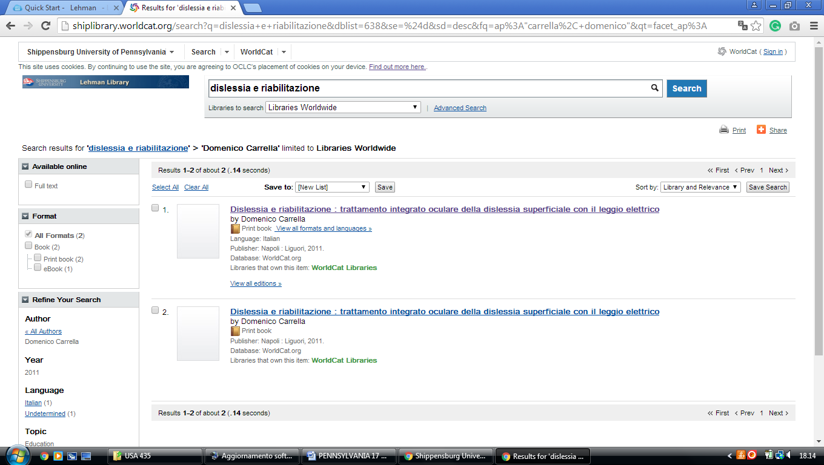

**2** [**FALVEY MEMORIAL LIBRARY**](http://library.villanova.edu/) – (Villanova, Pennsylvania, Usa)

<https://library.villanova.edu/Find/WorldcatRecord/745970355>

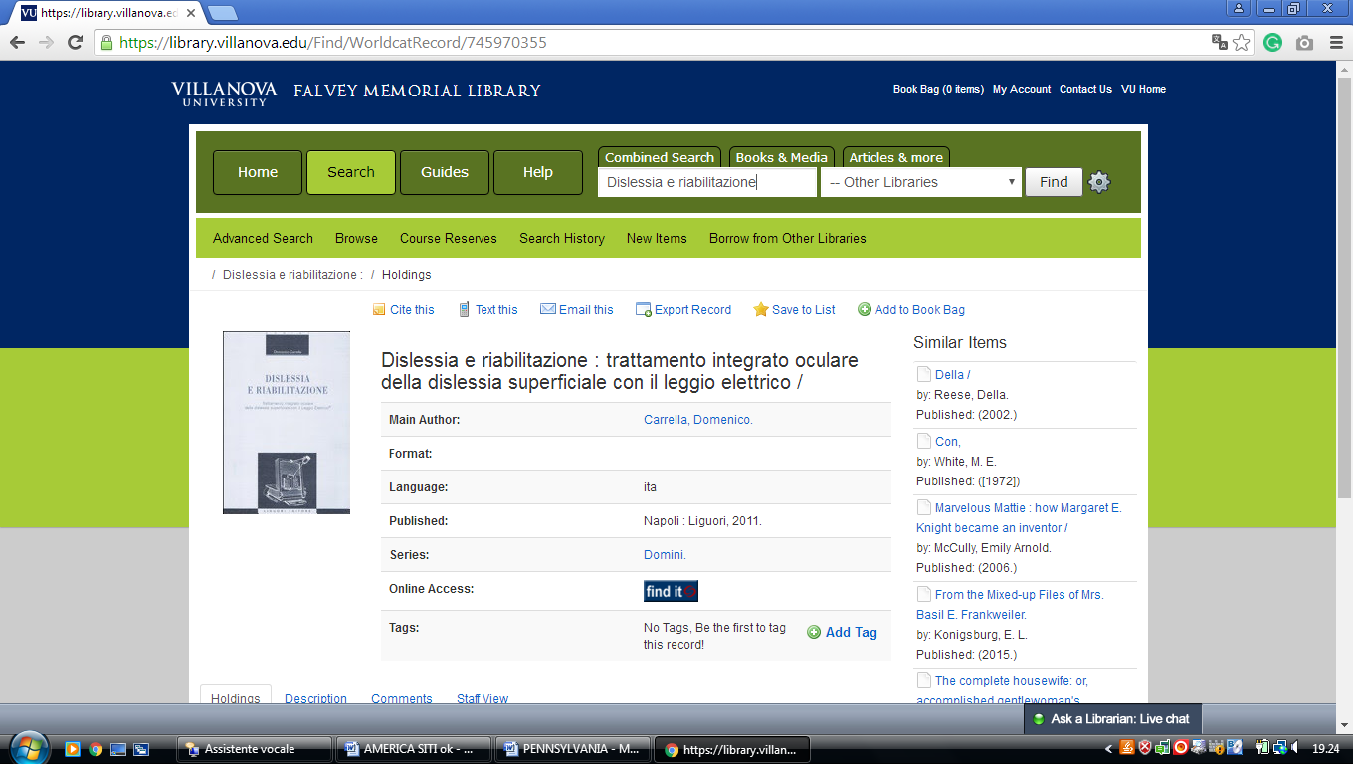

**3** [**LA SALLE UNIVERSITY - CONNELLY LIBRARY**](http://www.lasalle.edu/library/) – (Philadelphia, Penn., Usa)

<http://lasalle.summon.serialssolutions.com/?q=dislessia+e+riabilitazione#!/search?ho=f&l=en&q=dislessia%20e%20riabilitazione>

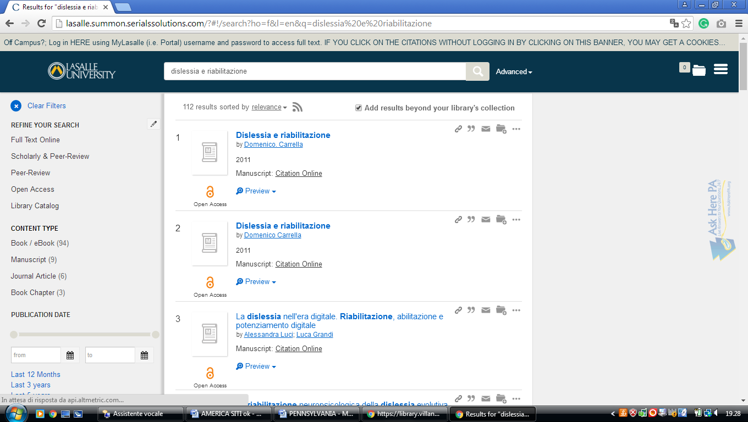

**4** [**PENN LIBRARIES**](http://www.library.upenn.edu/) – (Philadelphia, Pennsylvania, Usa)

<https://franklin.library.upenn.edu/bento?q=dislessia+e+riabilitazione&meta=t>

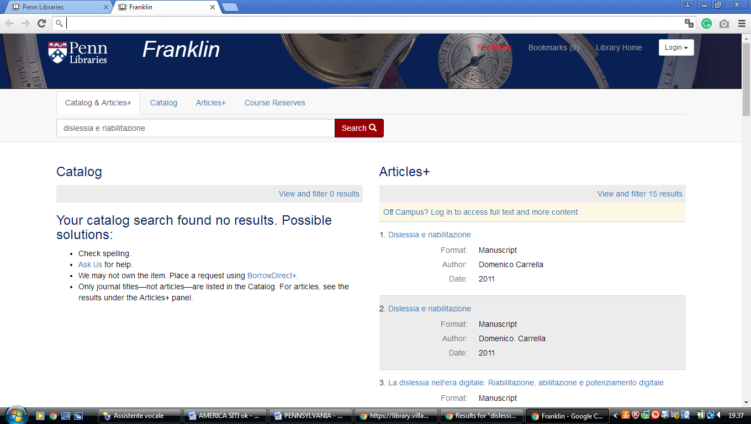

### 5 [PENN STATE UNIVERSITY LIBRARIES](https://libraries.psu.edu/) – (State College, Penn., Usa)

<https://psu.summon.serialssolutions.com/search/results?s.q=dislessia+e+riabilitazione#!/search?ho=f&l=en&q=dislessia%20e%20riabilitazione>

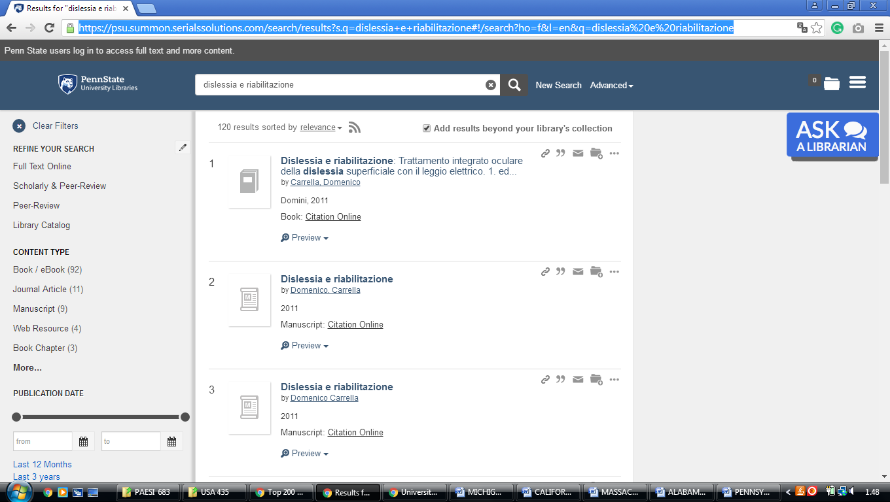

**6** [**SAINT FRANCIS UNIVERSITY LIBRARY**](http://library.francis.edu/) – (Loretto, Pennsylvania, Usa)

<https://stfrancisuniversity.on.worldcat.org/search?sortKey=LIBRARY&databaseList=&queryString=dislessia+e+riabilitazione&changedFacet=author&scope=&format=all&database=all&author=Carrella%2C+Domenico&year=all&yearFrom=&yearTo=&language=all&topic=all>

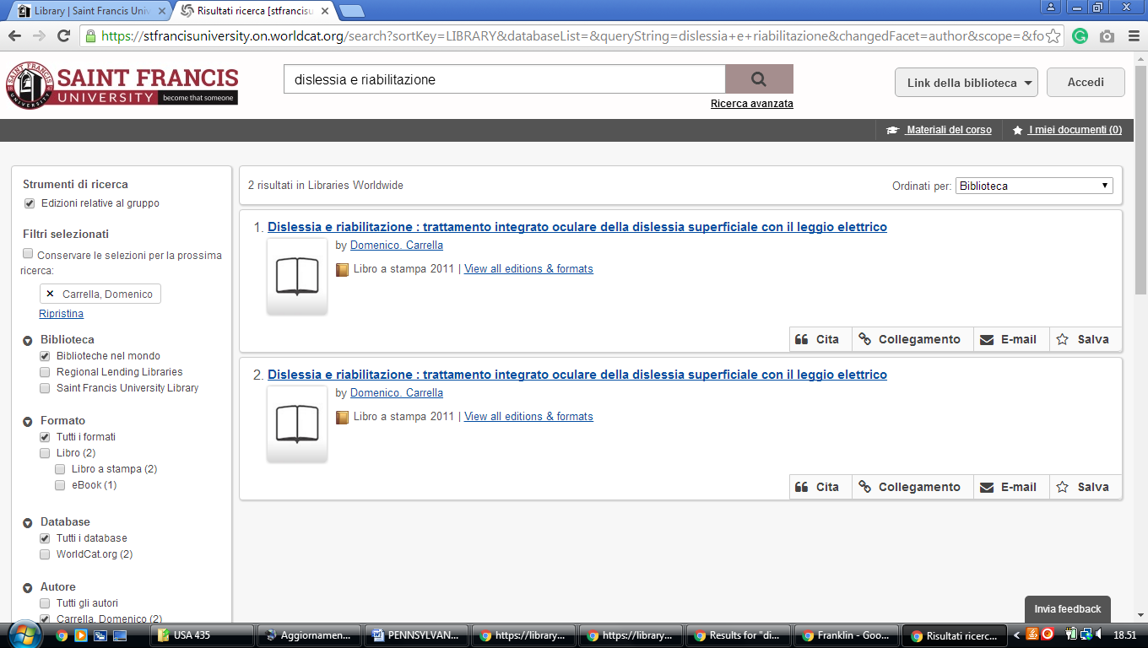

**7** [**SCHMIDT LIBRARY**](http://library.ycp.edu/home) – (York, Pennsylvania, Usa)

<https://stfrancisuniversity.on.worldcat.org/search?sortKey=LIBRARY&databaseList=&queryString=dislessia+e+riabilitazione&changedFacet=author&scope=&format=all&database=all&author=Carrella%2C+Domenico&year=all&yearFrom=&yearTo=&language=all&topic=all>

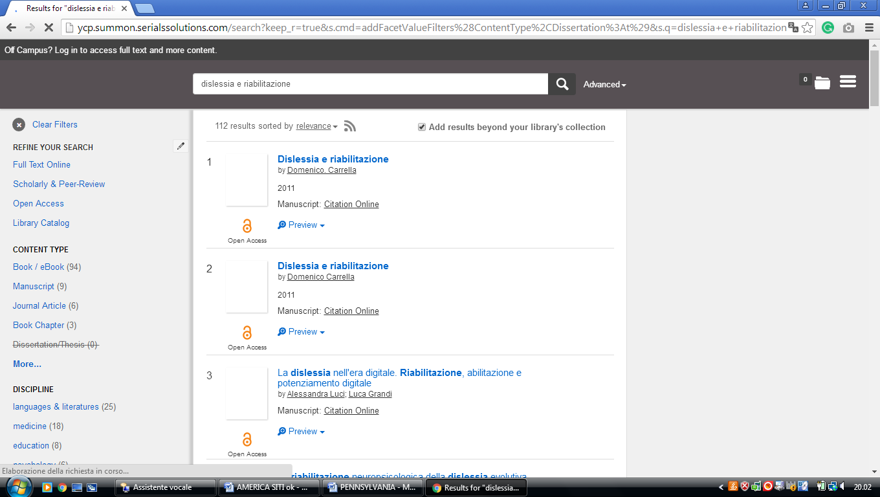

**8** [**TEMPLE UNIVERSITY LIBRARIES**](http://library.temple.edu/) – (Philadelphia, Pennsylvania, Usa)

<https://temple-primo.hosted.exlibrisgroup.com/primo-explore/search?query=any,contains,&query=dislessia%20e%20riabilitazione&query=&vid=TULI&tab=default_tab&search_scope=default_scope&sortby=rank&pcAvailabilityMode=true&mode=Basic&displayMode=full&bulkSize=10&highlight=true&dum=true&displayField=all&pcAvailabiltyMode=true&pcAvailability=true>

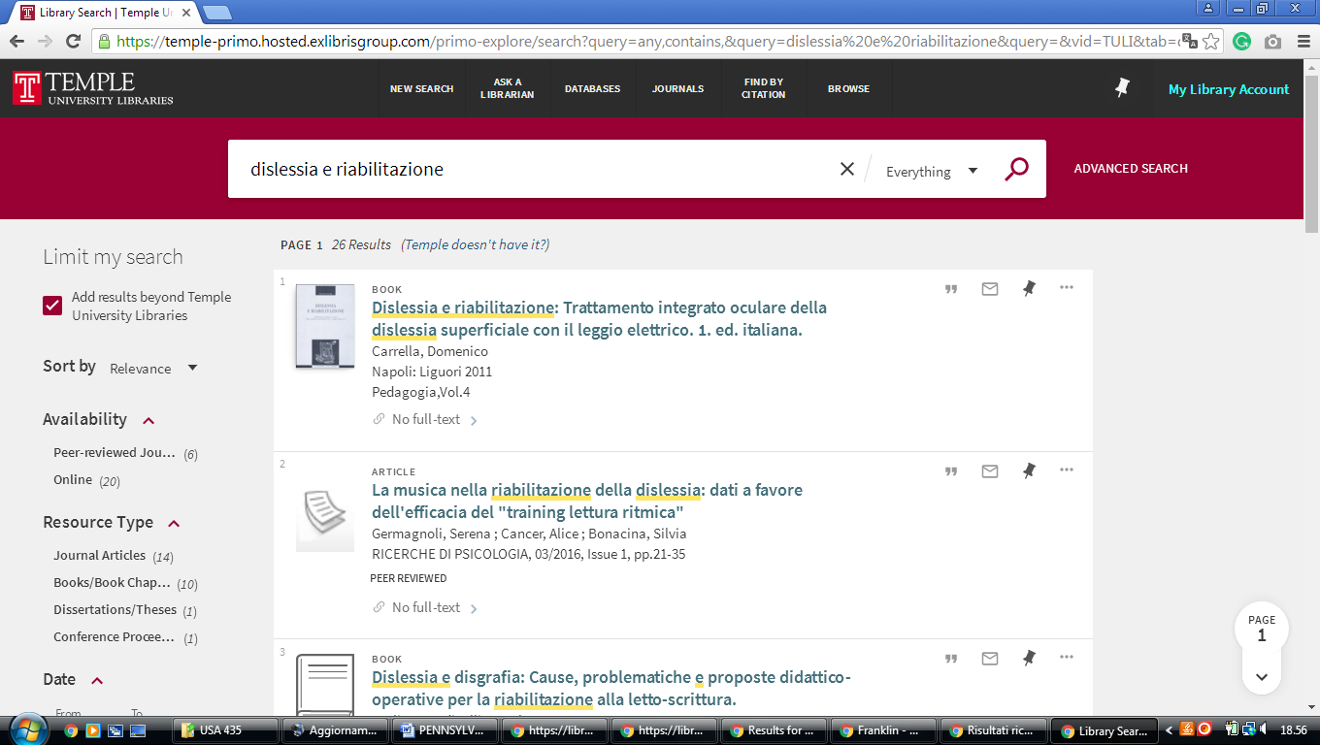

### 9 [LIBRARY | EASTERN UNIVERSITY](https://www.eastern.edu/library) -  (Wayne, Pennsylvania, Usa)

<https://eastern.summon.serialssolutions.com/?q=dislessia%20riabilitazione#!/search?ho=f&l=en&q=dislessia%20riabilitazione>

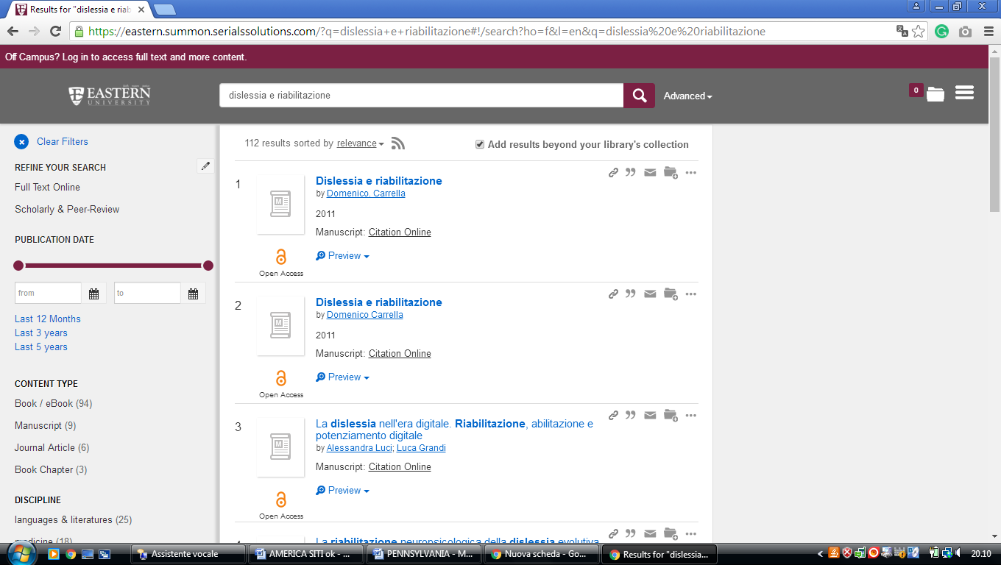

**10** [**WASHINGTON AND JEFFERSON COLLEGE LIBRARY**](http://www.washjeff.edu/library/) – (WA., Penn., Usa)

<http://washjeff.summon.serialssolutions.com/search/results?q=dislessia+e+riabilitazione&submit=Unleash+Summon%21#!/search?ho=f&l=en&q=dislessia%20e%20riabilitazione&submit=Unleash%20Summon>!

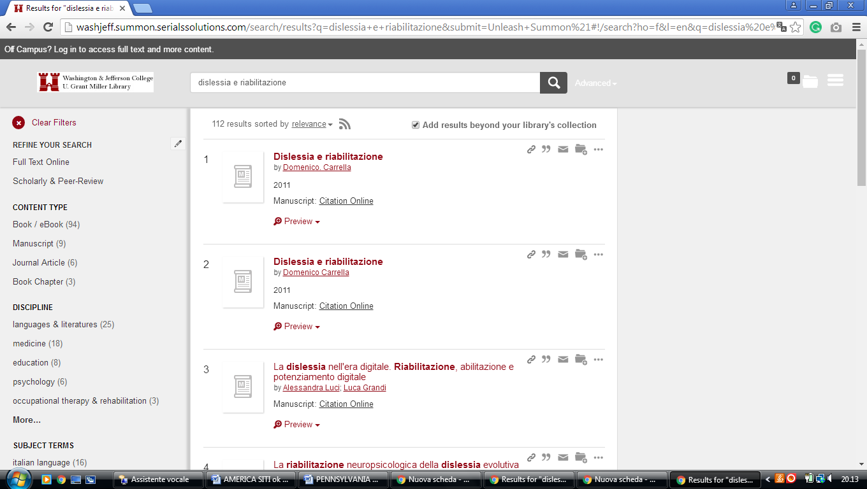

**11** [**WESTMINSTER COLLEGE LIBRARY**](http://www.westminster.edu/library/library_overview.cfm) – (New Wilmington, Pennsylvania, Usa)

<https://westminster.on.worldcat.org/search?sortKey=LIBRARY&databaseList=&queryString=dislessia+e+riabilitazione&changedFacet=author&scope=&format=all&database=all&author=Carrella%2C+Domenico&year=all&yearFrom=&yearTo=&language=all&topic=all>

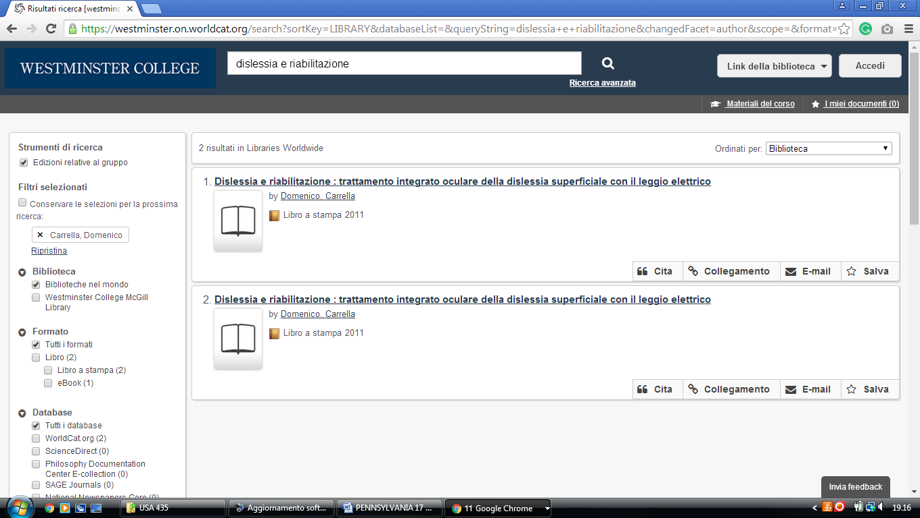

### 12 [DIGITIZED COLLECTIONS « LIBRARY AND INFORMATION ... - ALLEGHENY COLLEGE](https://sites.allegheny.edu/lits/digitizedcollections/) LIBRARY - (Meadville, Pennsylvania, Usa)

<https://allegheny.summon.serialssolutions.com/#!/search?ho=f&l=en&q=dislessia%20e%20riabilitazione>

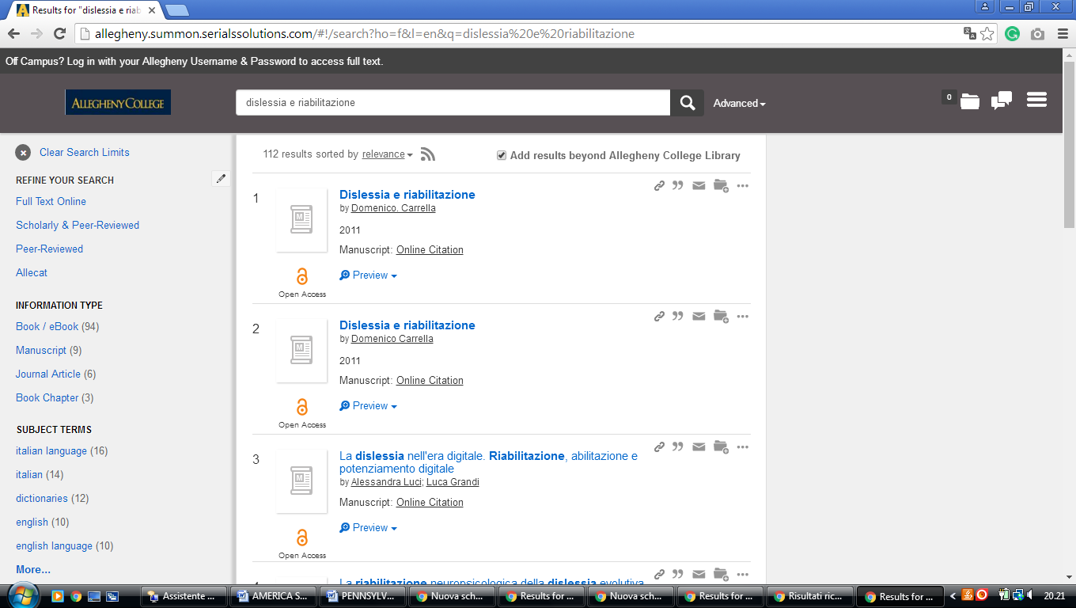

**13**  **BLOOMSBURG UNIVERSITY OF PENN. LIBRARY** – (Harvey A. Penn. Usa)

<http://eds.a.ebscohost.com/eds/resultsadvanced?vid=7&sid=4b9f0aca-d28b-4eb9-8c66-daa180efade3%40sessionmgr4007&bquery=(dislessia+AND+e+AND+riabilitazione)&bdata=JnR5cGU9MSZzaXRlPWVkcy1saXZlJnNjb3BlPXNpdGU%3d>

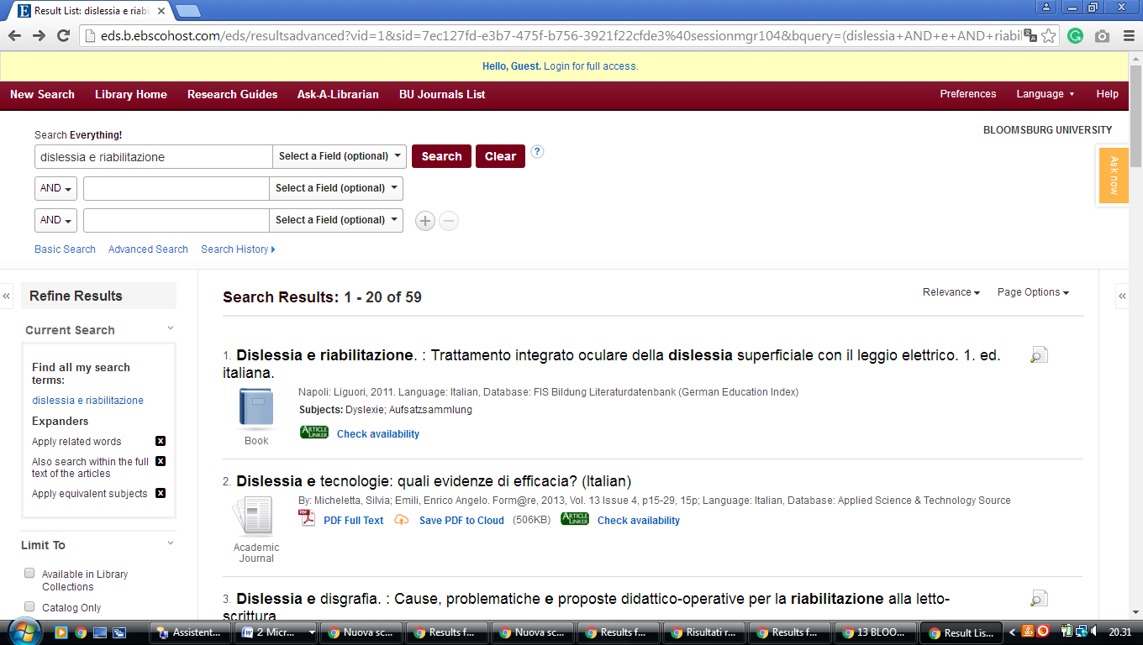

### 14 [BUCKNELL UNIVERSITY](https://www.google.it/search?rlz=1C1CHIK_itIT460IT464&q=Bucknell+University&ludocid=17540622480588794361&sa=X&ved=0ahUKEwjwobDzpK7VAhXIchQKHacdCAIQ8G0IjwEoADAX), [BERTRAND LIBRARY](https://www.google.it/url?sa=t&rct=j&q=&esrc=s&source=web&cd=1&cad=rja&uact=8&ved=0ahUKEwjwobDzpK7VAhXIchQKHacdCAIQFggnMAA&url=https%3A%2F%2Fwww.bucknell.edu%2Flibrary&usg=AFQjCNHckpamfqsJFmdLCcdLDjkIuCavyw) – (Lewisburg, PA, Usa)

<https://bucknell.on.worldcat.org/search?sortKey=LIBRARY&databaseList=&queryString=dislessia+e+riabilitazione&changedFacet=author&scope=&format=all&database=all&author=Carrella%2C+Domenico&year=all&yearFrom=&yearTo=&language=all&topic=all>

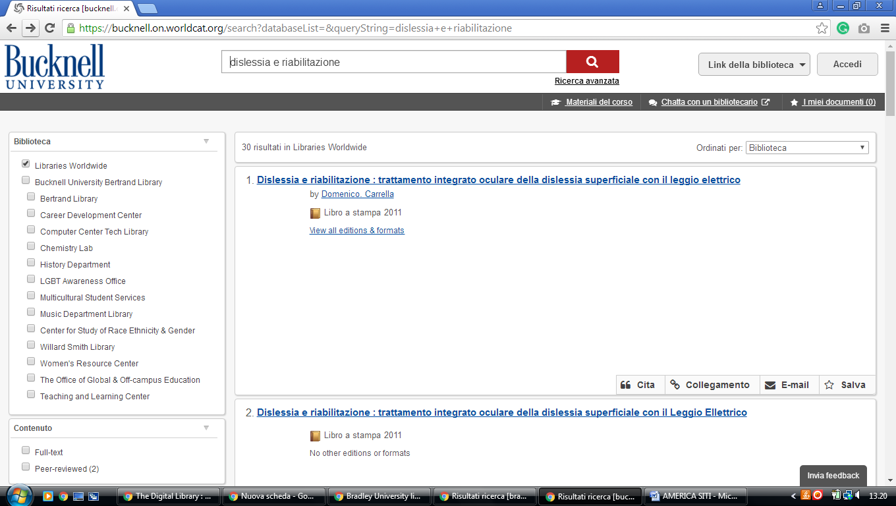

### 15 [LIBRARY | HOLY FAMILY UNIVERSITY](https://www.holyfamily.edu/current-students/student-resources/library)

### <https://holyfamily.on.worldcat.org/search?sortKey=LIBRARY_PLUS_RELEVANCE&databaseList=&queryString=dislessia+e+riabilitazione&changedFacet=author&stickyFacetsChecked=on&scope=&subformat=Book%3A%3Abook_printbook&subformat=Book%3A%3Abook_thsis&subformat=Book%3A%3Abook_digital&subformat=Book%3A%3Abook_mic&subformat=Book%3A%3Abook_largeprint&subformat=Book%3A%3Abook_braille&subformat=Book%3A%3Abook_continuing&database=all&author=Carrella%2C+Domenico&year=all&yearFrom=&yearTo=&language=all&topic=all>

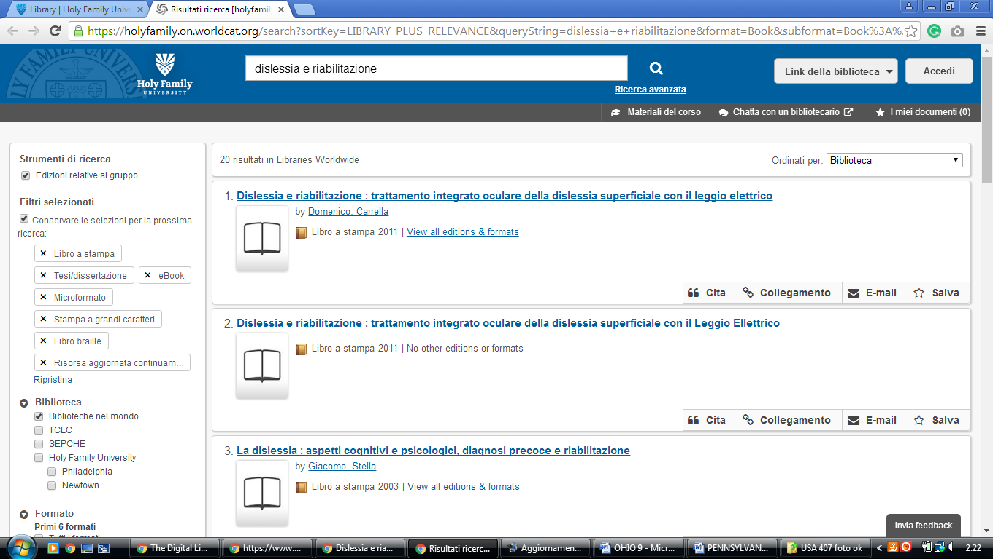

### 16 [NORTH HALL LIBRARY - MANSFIELD UNIVERSITY](http://lib.mansfield.edu/) [- (Pennsylvania](https://www.google.it/search?rlz=1C1CHIK_itIT460IT464&q=Mansfield+University+of+Pennsylvania&ludocid=8486819058821085449&sa=X&ved=0ahUKEwjMk52HvNHZAhVCKuwKHd5cBIgQ8G0IkgEoADAQ), Usa)

<http://mansfieldpa.worldcat.org/search?q=dislessia+e+riabilitazione&dblist=638&se=%24d&sd=desc&fq=ap%3A%22carrella%2C+domenico%22&qt=facet_ap%3A>

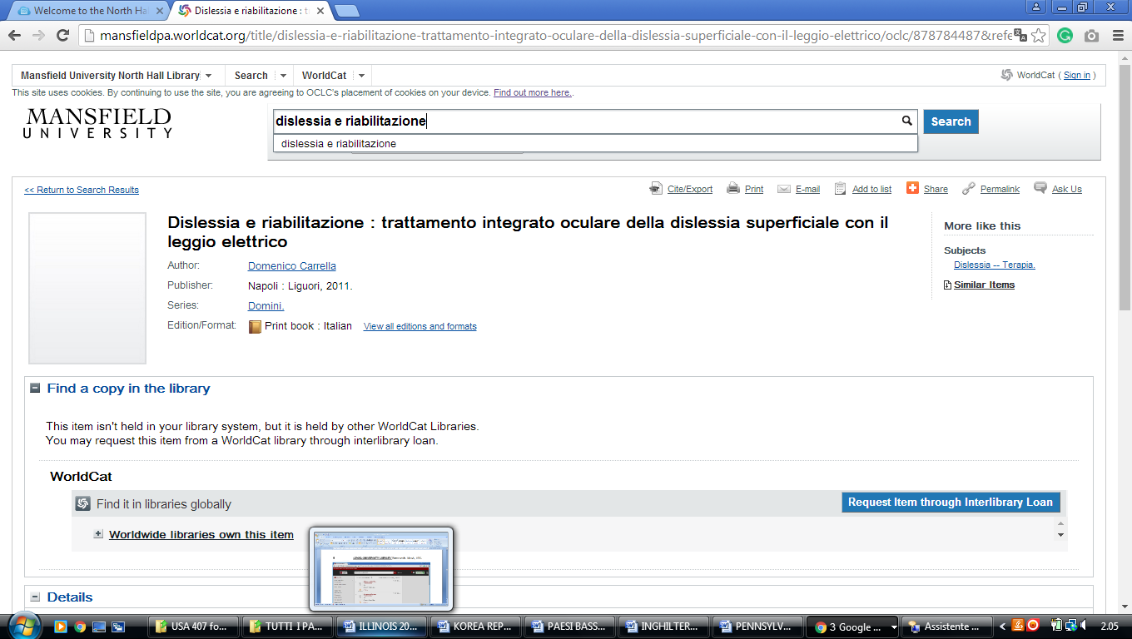

[Drexel University Library](https://www.google.com/search?rlz=1C1CHIK_itIT460IT464&q=Drexel+University+Library&spell=1&sa=X&ved=2ahUKEwiypd7y2qvnAhWCGewKHbpbDPMQkeECKAB6BAgPECk)

<https://drexel.summon.serialssolutions.com/#!/search?ho=f&l=en&q=dislessia%20e%20riabilitazione>

