**OHIO = 9**

**1** [**UNIVERSITY OF CINCINNATI LIBRARIES**](http://libraries.uc.edu/) – (Cincinnati, Ohio, Usa)

<https://uc.summon.serialssolutions.com/search?q=dislessia+e+riabilitazione&x=18&y=13#!/search?ho=f&l=en&q=dislessia%20e%20riabilitazione&x=18&y=13>

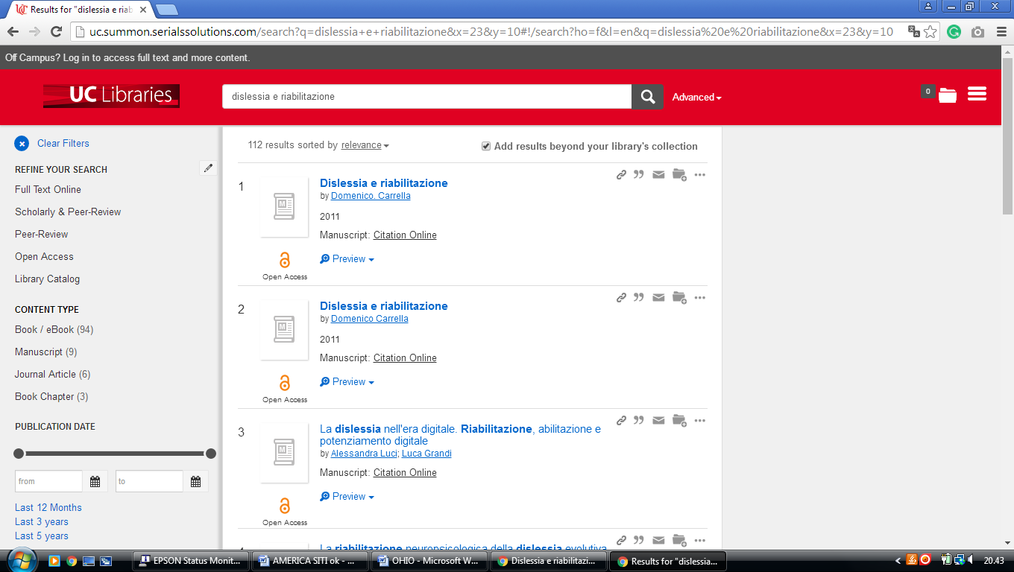

**2** [**BOWLING GREEN STATE UNIVERSITY**](http://www.bgsu.edu/colleges/library/) **LIBRARY** – (Ohio, Usa)

<https://bgsu.summon.serialssolutions.com/search?s.q=dislessia+e+riabilitazione&spellcheck=true#!/search?ho=f&l=en&q=dislessia%20e%20riabilitazione>

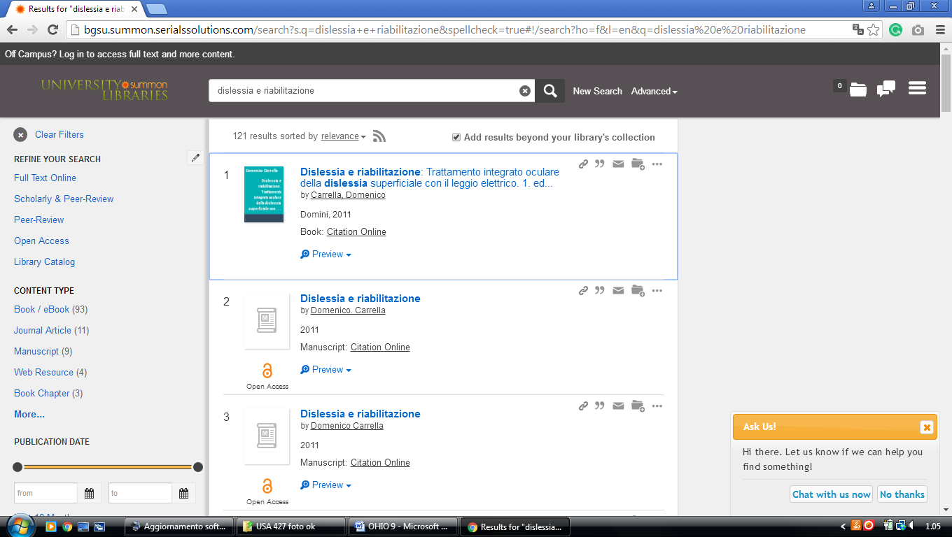

**3** [**KELVIN SMITH LIBRARY**](http://library.case.edu/loc/libraries.html) – (Cleveland, Ohio, Usa)

<http://case.summon.serialssolutions.com/search?s.q=dislessia+e+riabilitazione#!/search?ho=f&l=it-IT&q=dislessia%20e%20riabilitazione>

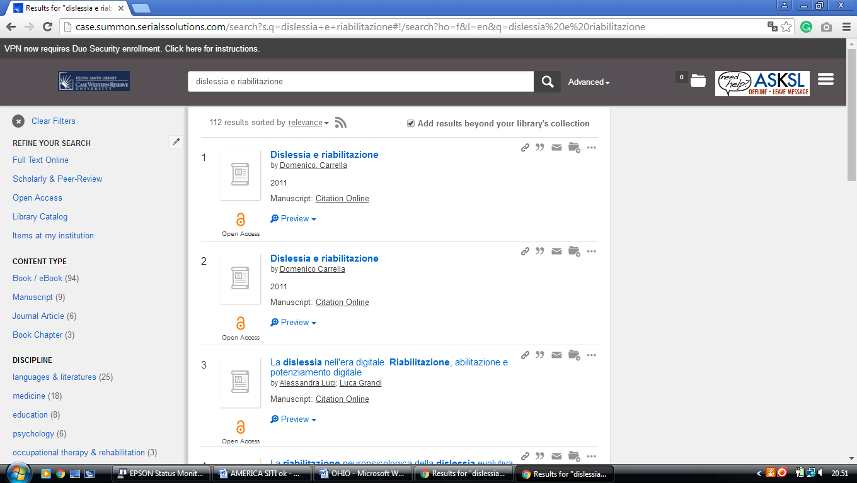

**4** [**KENT STATE UNIVERSITY LIBRARY**](http://www.kent.edu/library/index.cfm) – (Kent, Ohio, Usa)

<http://eds.a.ebscohost.com/eds/results?vid=0&sid=b9928991-70ca-4c01-a1ba-e4d0bbe780b0%40sessionmgr4010&bquery=dislessia+e+riabilitazione&bdata=JkF1dGhUeXBlPWlwJnR5cGU9MSZzaXRlPWVkcy1saXZlJnNjb3BlPXNpdGU%3d>

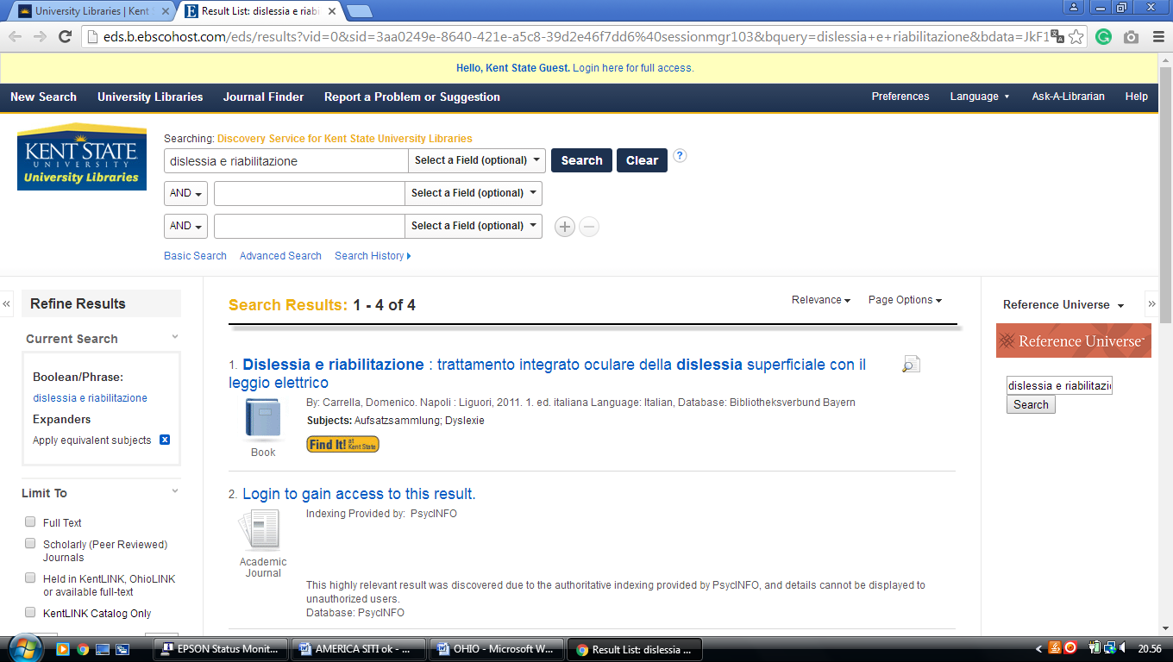

**5** [**OBERLIN COLLEGE LIBRARY**](http://www.oberlin.edu/library/) – (Oberlin, Ohio, Usa)

<http://oberlin.summon.serialssolutions.com/search?s.q=dislessia+e+riabilitazione+#!/search?ho=f&l=en&q=dislessia%20e%20riabilitazione%20>

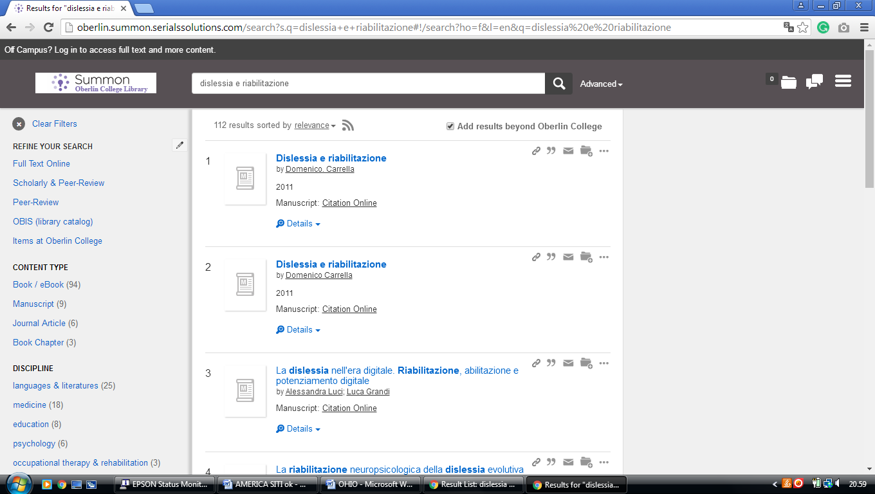

**6** [**OHIO STATE UNIVERSITY LIBRARIES**](http://library.osu.edu/) – (Columbus, Ohio, Usa)

<http://osu.worldcat.org/search?q=kf%3Adislessia+e+riabilitazione&dblist=1461%2C1708%2C3909%2C1723%2C1725%2C239%2C638&se=%24d&sd=desc&fq=ap%3A%22carrella%2C+domenico%22&qt=facet_ap%3A>

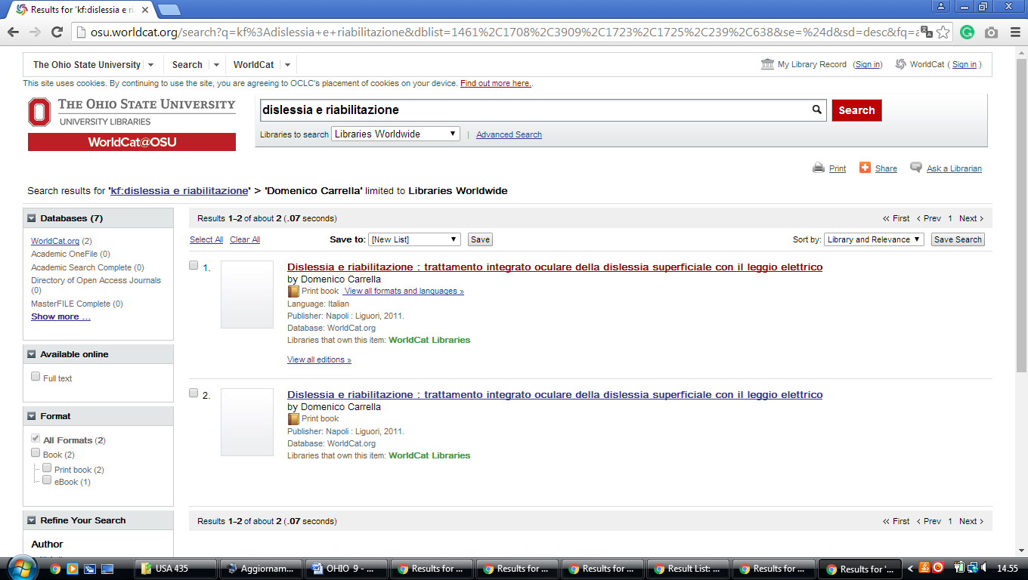

**7** [**OHIO WESLEYAN UNIVERSITY LIBRARY**](http://library.owu.edu/) – (Wesleyan, Ohio, Usa)

https://owu.summon.serialssolutions.com/search?ho=t&fvf=ContentType%2CNewspaper+Article%2Ct&fvf=ContentType%2CBook+Review%2Ct&q=dislessia+e+riabilitazione#!/search?ho=f&fvf=ContentType,Newspaper%20Article,t%7CContentType,Book%20Review,t&l=en&q=dislessia%20e%20riabilitazione

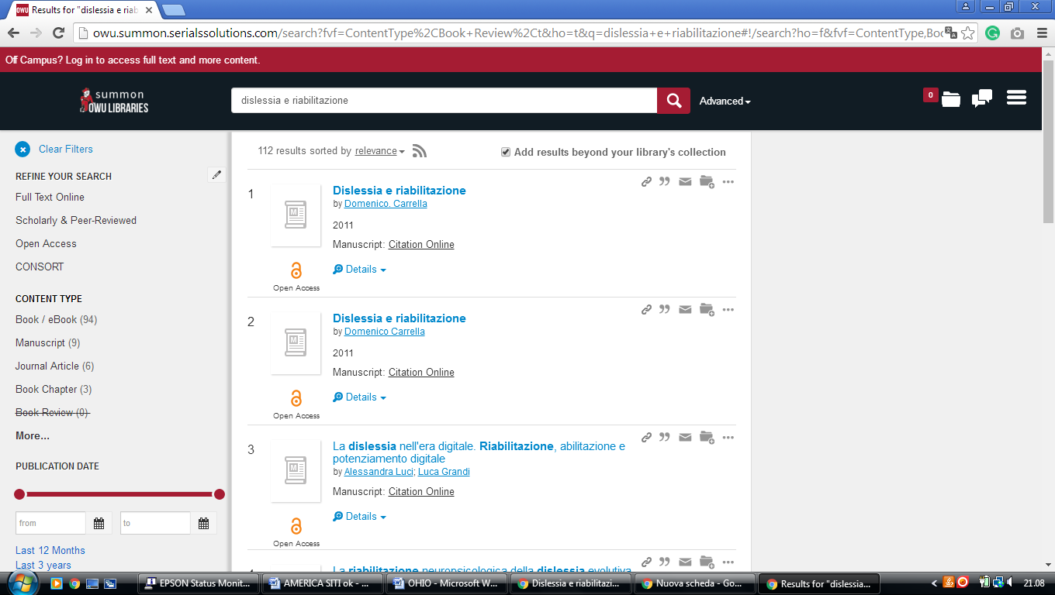

**8** [**UC BLUE ASH COLLEGE LIBRARY**](http://www.libraries.uc.edu/ucba/) – (Blue Ash, Ohio, Usa)

<http://uc.summon.serialssolutions.com/search?q=dislessia+e+riabilitazione&search3.x=14&search3.y=19#!/search?ho=f&l=en&q=dislessia%20e%20riabilitazione&x=14&y=19>

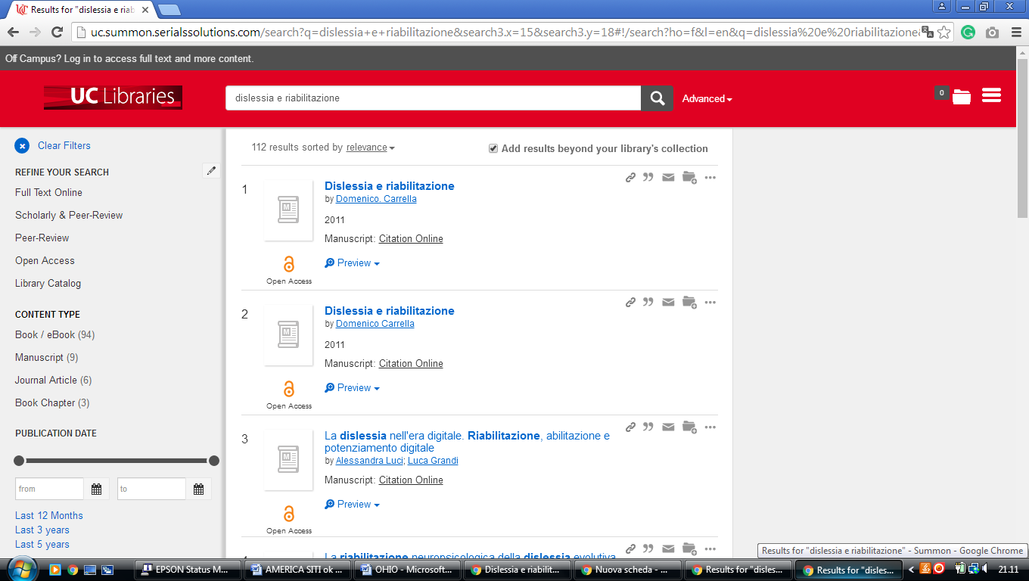

### 9 [HEALTH SCIENCES LIBRARY MCMASTER UNIVERSITY](https://hsl.mcmaster.ca/) – (Columbus, Ohio, Usa)

<http://mcmasteruniversity.worldcat.org/search?q=dislessia+e+riabilitazione&dblist=638&se=%24d&sd=desc&fq=ap%3A%22carrella%2C+domenico%22&qt=facet_ap%3A>

