**Mayville, UNIVERSITY OF NORD DAKOTA, US**

[Library : Mayville State University: Mayville, ND](https://www.google.com/url?sa=t&rct=j&q=&esrc=s&source=web&cd=1&cad=rja&uact=8&ved=2ahUKEwjzoPfbndnoAhUQYcAKHXRmC1oQFjAAegQIAhAC&url=https%3A%2F%2Fmayvillestate.edu%2Fstudent-resources%2Flibrary%2F&usg=AOvVaw3qWg91Abr4KbNGTJJAtVQy)

[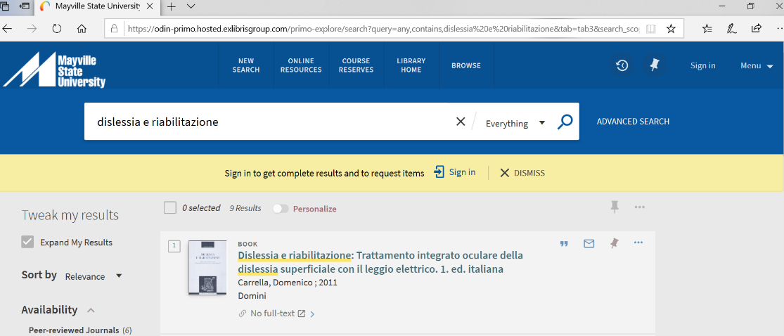](https://www.google.com/url?sa=t&rct=j&q=&esrc=s&source=web&cd=1&cad=rja&uact=8&ved=2ahUKEwjzoPfbndnoAhUQYcAKHXRmC1oQFjAAegQIAhAC&url=https%3A%2F%2Fmayvillestate.edu%2Fstudent-resources%2Flibrary%2F&usg=AOvVaw3qWg91Abr4KbNGTJJAtVQy)