**NORTH CAROLINA = 13**

### 1 [CLEVELAND COMMUNITY COLLEGE, SHELBY, NC](http://www.clevelandcc.edu/) - ([Rose Library](http://library.clevelandcc.edu/home) – Shelby, North Carolina, Usa)

<http://clevelandcc.summon.serialssolutions.com/?custid=s5071755&direct=true&scope=site&site=eds-live&profid=eds&groupid=main&authtype=ip%2Cguest&cli0=FT1&clv0=Y&bquery=dislessia+e+riabilitazione&cli1=RV#!/search?ho=f&l=en&custid=s5071755&direct=true&scope=site&site=eds-live&profid=eds&groupid=main&authtype=ip,guest&cli0=FT1&clv0=Y&bquery=dislessia%20e%20riabilitazione&cli1=RV&q=dislessia%20e%20riabilitazione>

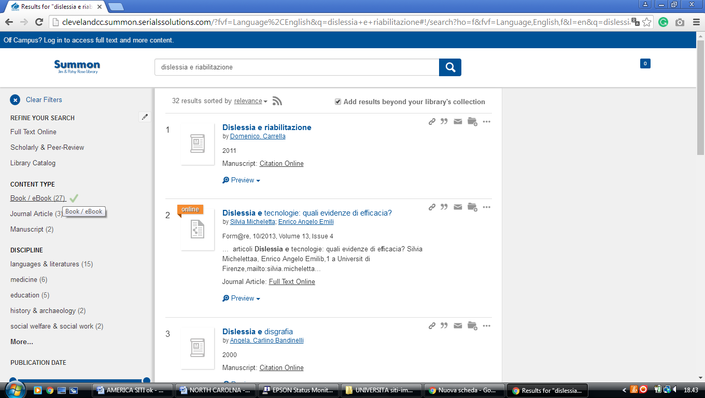

**2** [**CARLYLE CAMPBELL LIBRARY**](http://www.meredith.edu/library/) – (Raleigh, North Carolina, Usa)

<https://meredith.summon.serialssolutions.com/?fvf=ContentType%2CBook+Review%2Ct&q=dislessia+e+riabilitazione#!/search?ho=f&fvf=ContentType,Book%20Review,t&l=en&q=dislessia%20e%20riabilitazione>

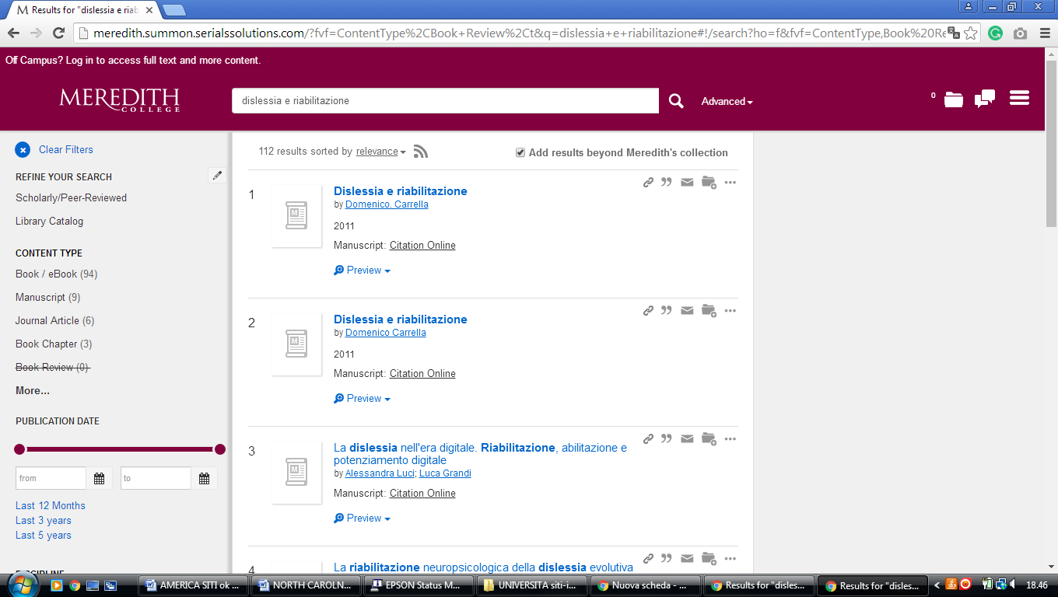

**3** [**CATAWBA COLLEGE LIBRARY**](http://www.lib.catawba.edu/) – (Salisbury, North Carolina, Usa)

<https://catawba.worldcat.org/title/dislessia-e-riabilitazione-trattamento-integrato-oculare-della-dislessia-superficiale-con-il-leggio-elettrico/oclc/878784487&referer=brief_results>

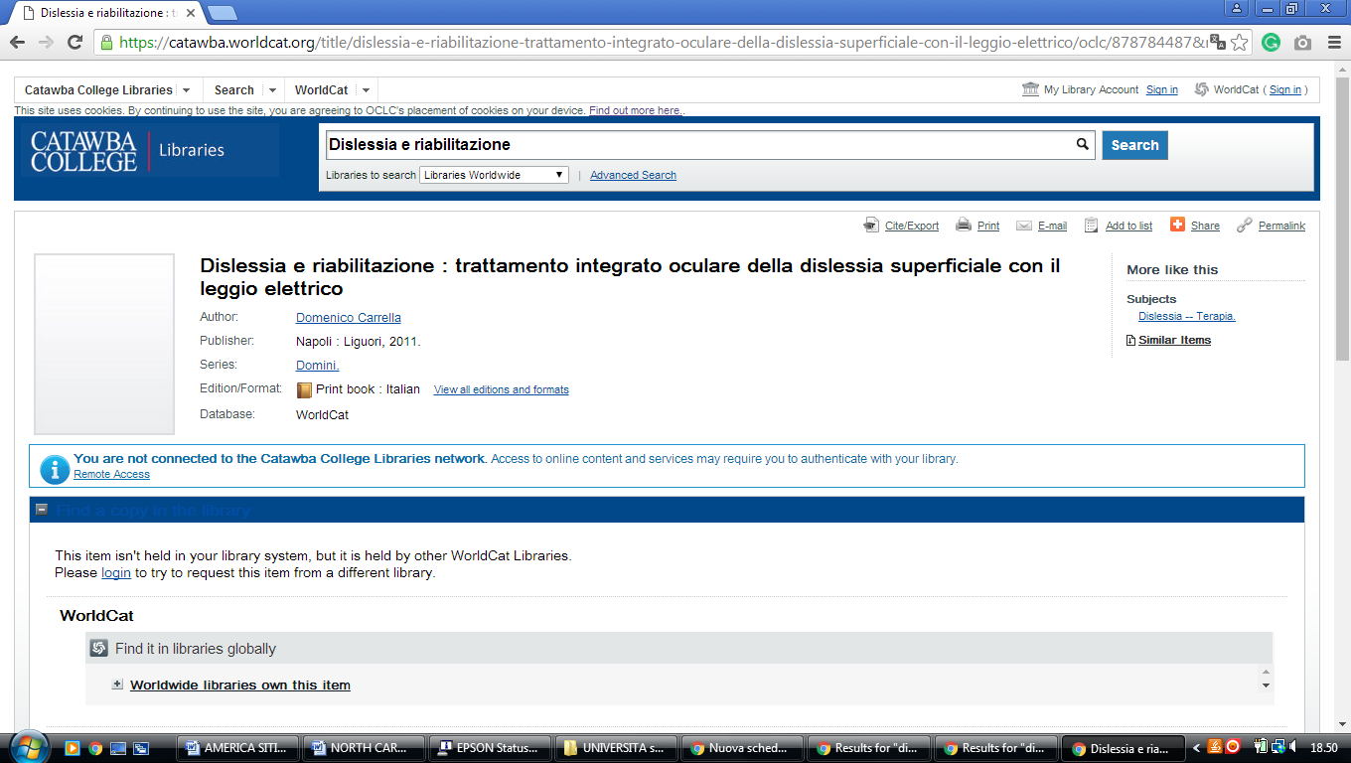

**4** [**DAVIDSON COLLEGE LIBRARY**](http://www3.davidson.edu/cms/x14938.xml) – (Davidson, North Carolina, Usa)

<https://davidson.on.worldcat.org/search?sortKey=LIBRARY&databaseList=&queryString=dislessia+e+riabilitazione&changedFacet=&clusterResults=off&scope=&format=&database=all&author=all&year=all&yearFrom=&yearTo=&language=all&topic=all>

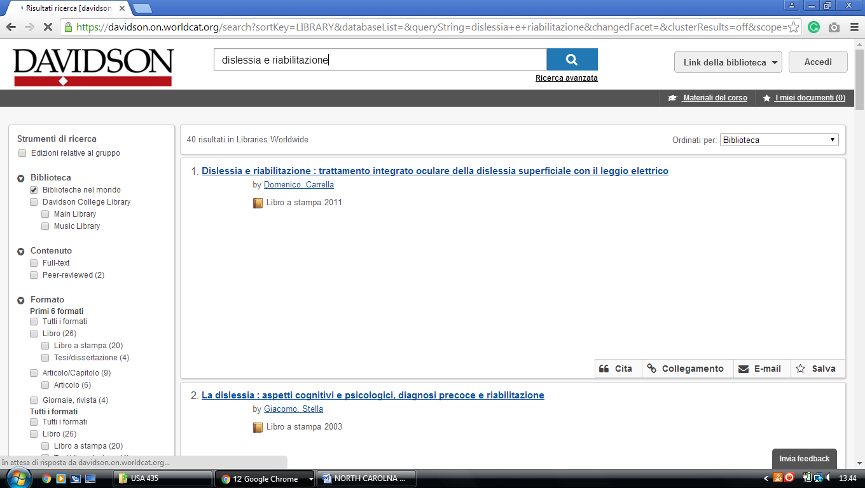

**5** [**GUILFORD TECHNICAL COMMUNITY**](http://www.gtcc.edu/library.aspx) **COLLEGE LIBRARY - (**Jamestown, N.C., Usa)

<https://gtcc.on.worldcat.org/search?sortKey=LIBRARY&databaseList=&queryString=dislessia+e+riabilitazione&changedFacet=&clusterResults=off&scope=&format=all&database=all&author=all&year=all&yearFrom=&yearTo=&language=all&topic=all>

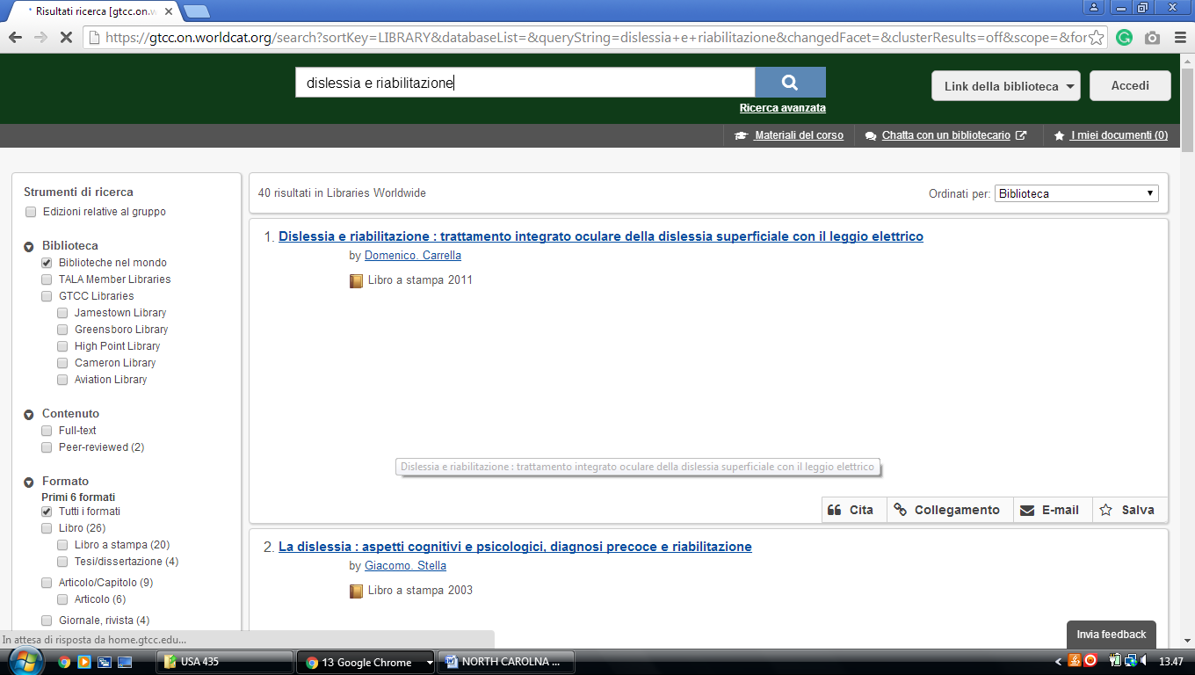

**6** [**HIGH POINT UNIVERSITY LIBRARIES**](http://library.highpoint.edu/) – (High Point, North Carolina, Usa)

<https://hpulibraries.on.worldcat.org/search?sortKey=BEST_MATCH&databaseList=&queryString=dislessia+e+riabilitazione&changedFacet=scope&scope=&format=all&database=all&author=all&year=all&yearFrom=&yearTo>=

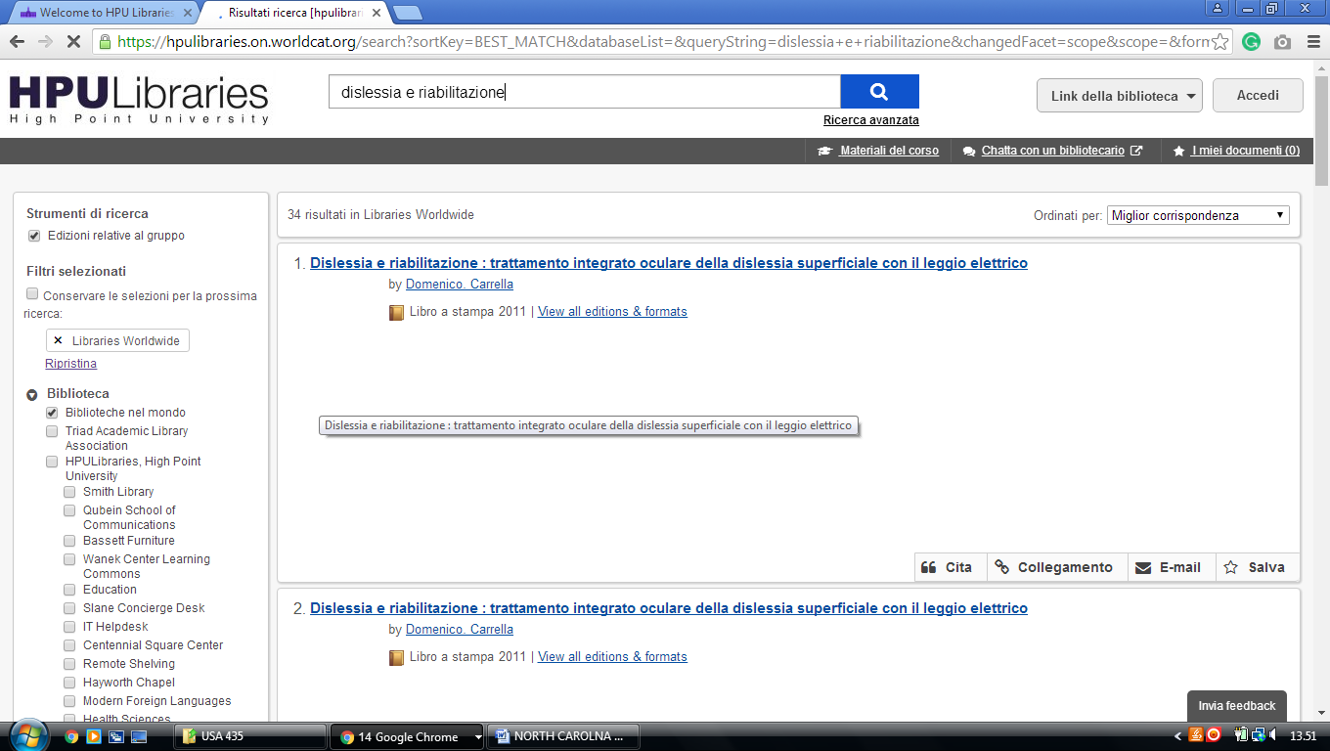

**7** [**HOME | J. MURREY ATKINS LIBRARY | UNC CHARLOTTE**](https://library.uncc.edu/) [– (Charlotte](https://en.wikipedia.org/wiki/Charlotte,_North_Carolina), [North Carolina](https://en.wikipedia.org/wiki/North_Carolina), Usa)

<https://uncc.primo.exlibrisgroup.com/discovery/search?query=any,contains,dislessia%20e%20riabilitazione&vid=01UNCC_INST:01UNCC_INST&tab=Everything&search_scope=MyInst_and_CI&sortby=rank&pcAvailability=true>

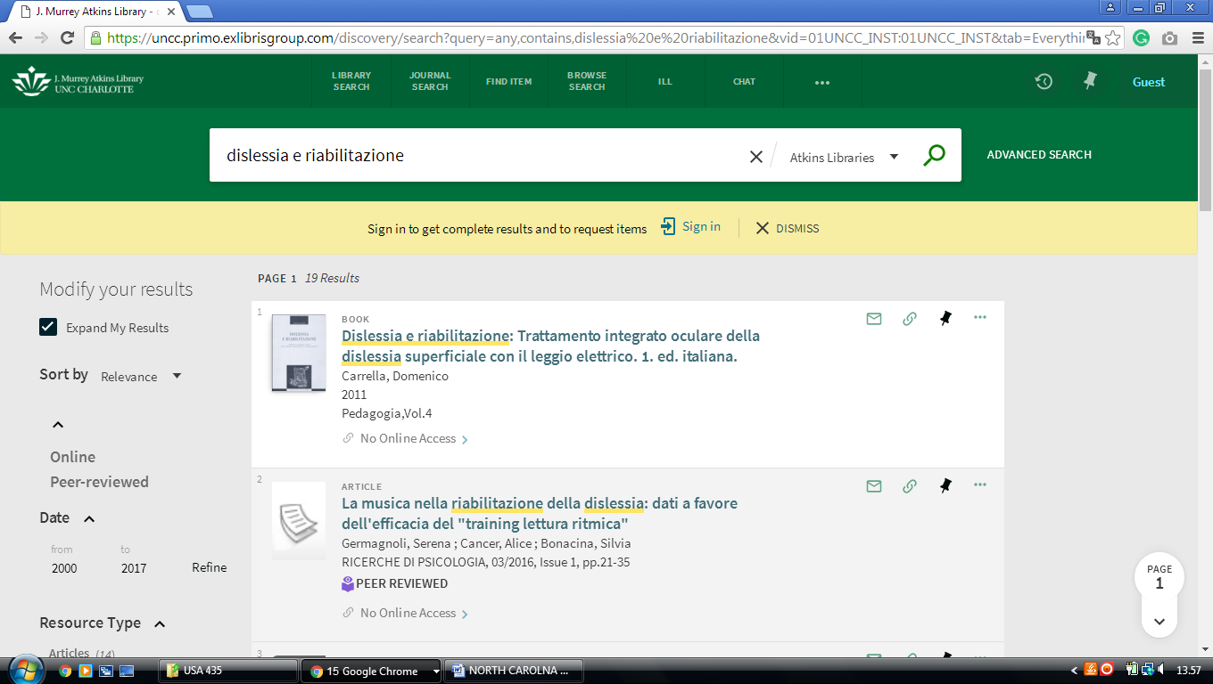

**8** [**JOYNER LIBRARY**](http://www.ecu.edu/lib/) – (Greenville, North Carolina,Usa)

<https://eastcarolina.summon.serialssolutions.com/search?q=+++dislessia+e+riabilitazione++&submit=#!/search?ho=f&l=it-IT&q=%20%20%20dislessia%20e%20riabilitazione%20%20>

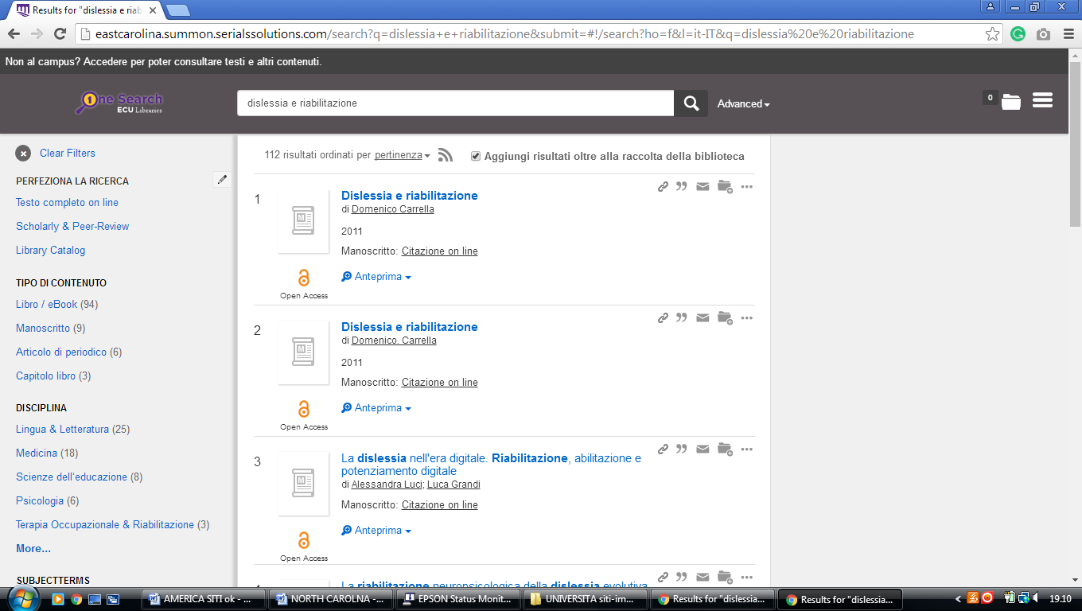

**9** [**WAKE TECH LIBRARIES**](http://www.waketech.edu/student-services/libraries) – (Raleigh, North Carolina, Usa)

<http://waketech.summon.serialssolutions.com/?fvf=Language%2CEnglish&q=dislessia+e+riabilitazione#!/search?ho=f&fvf=Language,English,f&l=en&q=dislessia%20e%20riabilitazione>

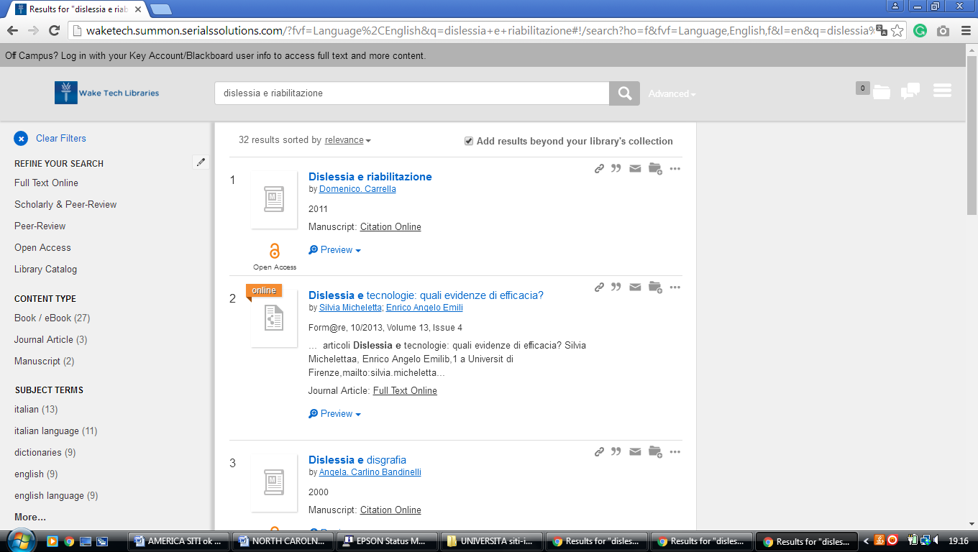

**10** [**WALTER CLINTON JACKSON LIBRARY**](http://library.uncg.edu/) – (Greensboro, North Carolina, Usa)

<http://uncg.worldcat.org/title/dislessia-e-riabilitazione-trattamento-integrato-oculare-della-dislessia-superficiale-con-il-leggio-elettrico/oclc/878784487&referer=brief_results>

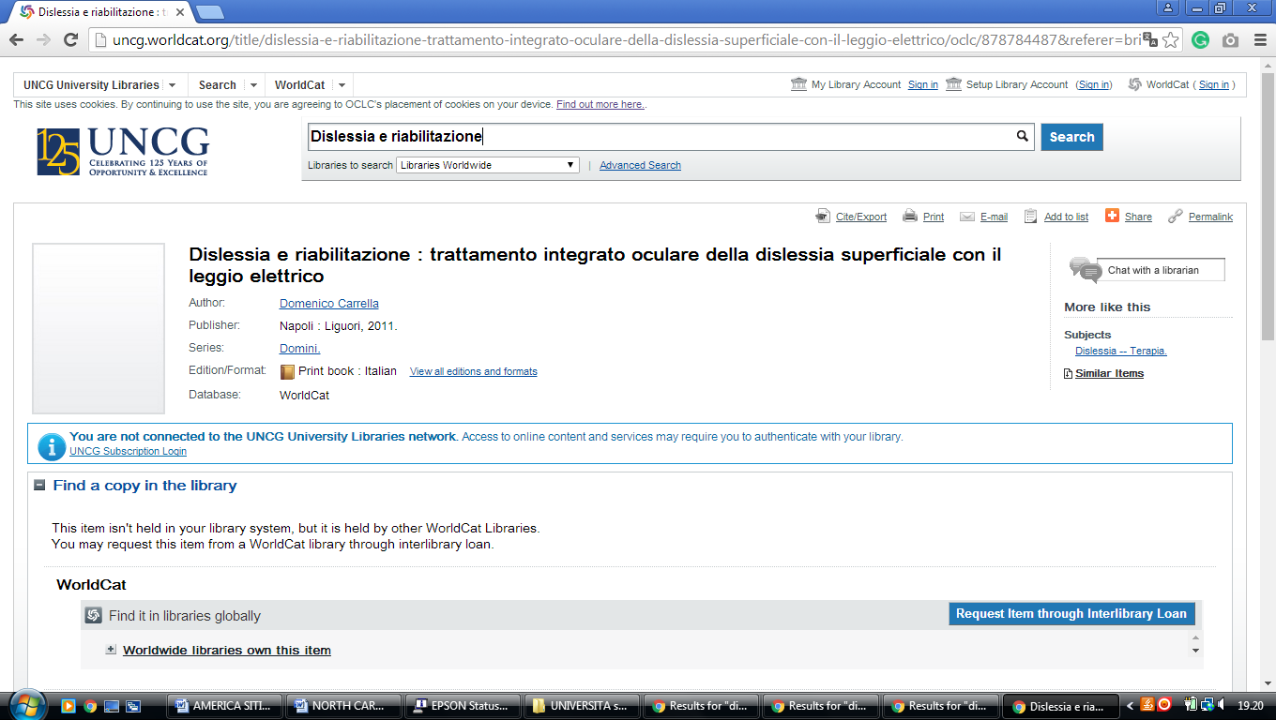

**11** [**WARREN WILSON COLLEGE LIBRARY**](http://www.warren-wilson.edu/~library/) – (Asheville, North Carolina, Usa)

<http://warrenwilson.summon.serialssolutions.com/#!/search?ho=f&l=en&q=dislessia%20e%20riabilitazione>

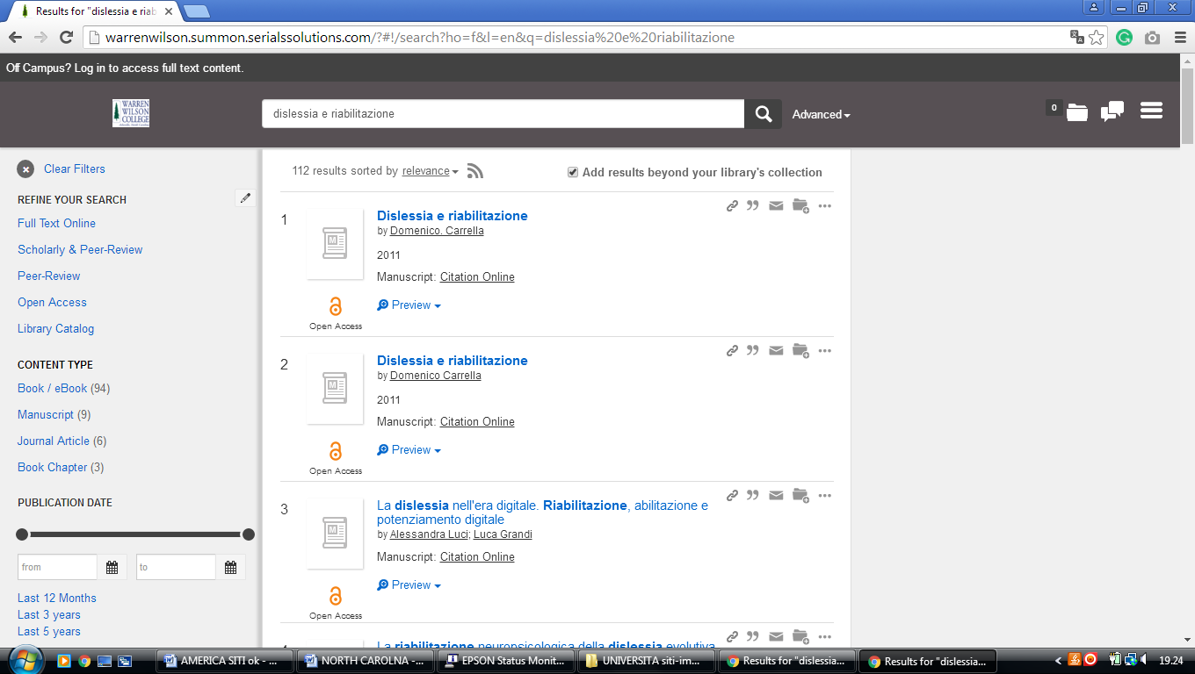

**12** [**Z. SMITH REYNOLDS LIBRARY**](http://zsr.wfu.edu/) – (Winston-Salem, North Carolina, Usa)

<https://wfu.summon.serialssolutions.com/#!/search?ho=f&fvf=ContentType,Newspaper%20Article,t%7CContentType,Book%20Review,t&l=en&q=dislessia%20e%20riabilitazione&_ga=2.53804008.1158008487.1521638958-1218349051.1521638958>

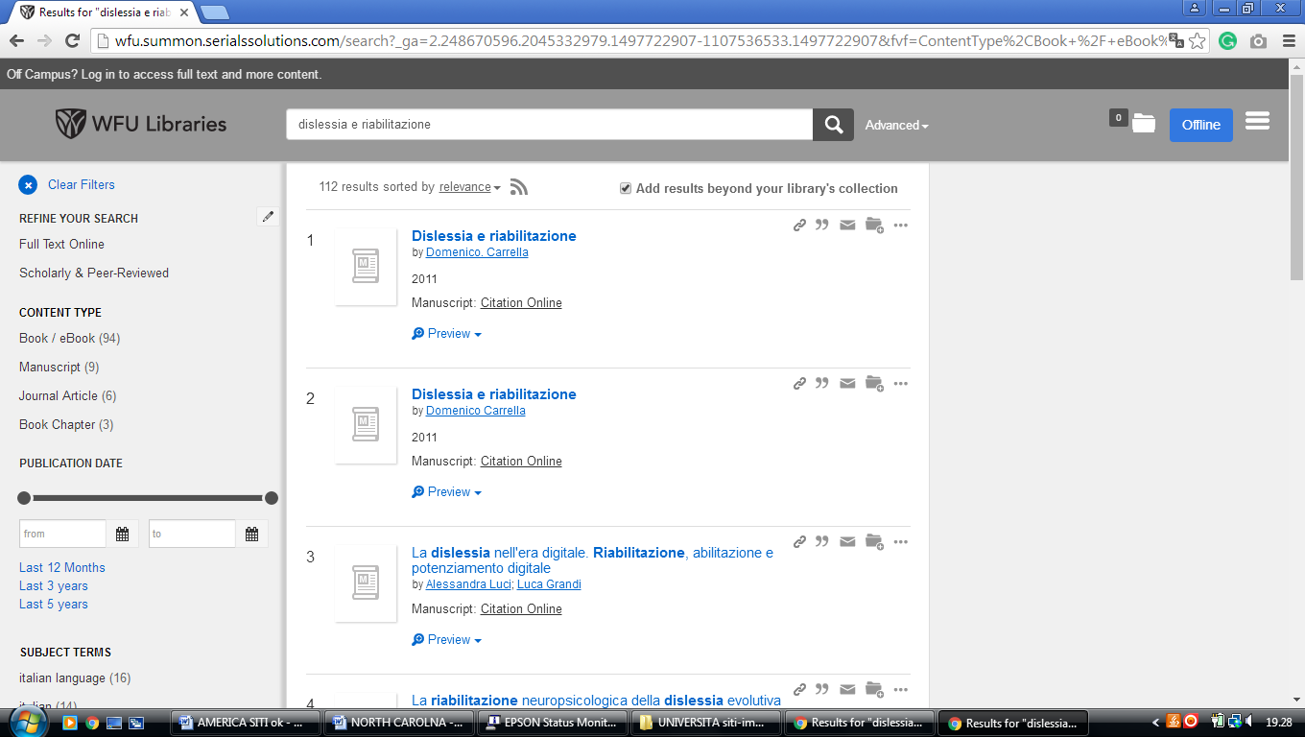

**13 ELON UNIVERSITY, LIBRARY – (**[Elon](https://en.wikipedia.org/wiki/Elon,_North_Carolina" \o "Elon, North Carolina), [North Carolina](https://en.wikipedia.org/wiki/North_Carolina), Usa)

<https://elonuniversity.on.worldcat.org/search?queryString=dislessia+e+riabilitazione>

