**NEBRASKA = 4**

**1** [**CONCORDIA UNIVERSITY NEBRASKA**](http://www.cune.edu/academics/library/) **LIBRARY** – (Seward, Nebraska, Usa)

<https://cune.on.worldcat.org/search?sortKey=LIBRARY&databaseList=&queryString=dislessia+e+riabilitazione&changedFacet=scope&clusterResults=on&scope=&scope=wz%3A1022>

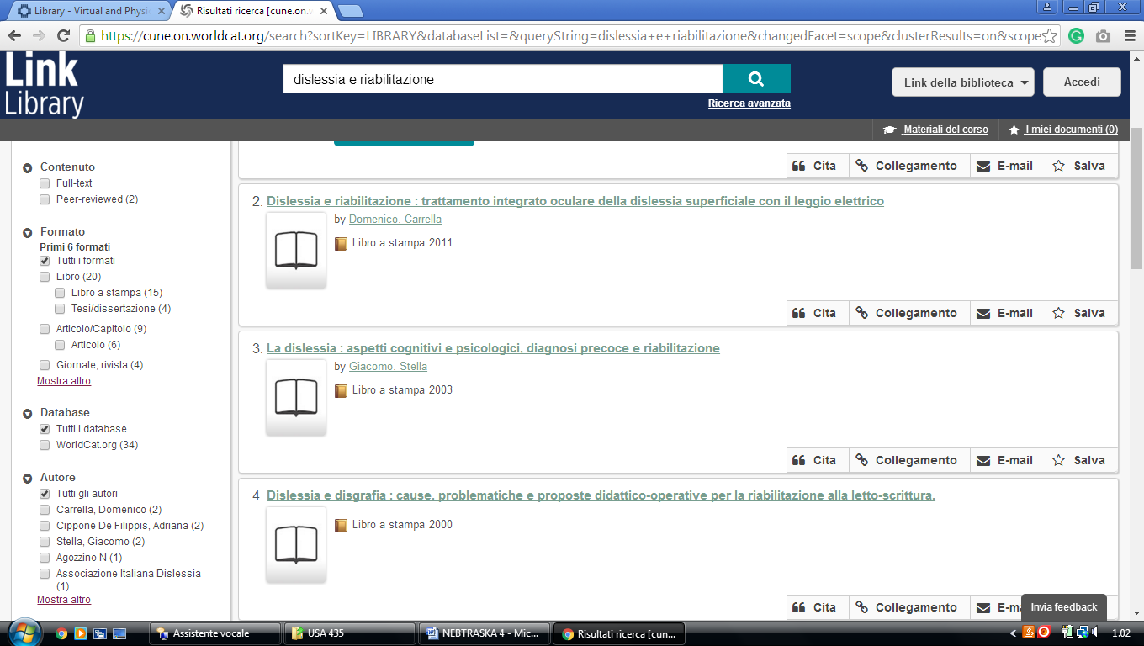

**2 [FREEMAN/LOZIER LIBRARY](http://www.bellevue.edu/services/library.aspx" \t "_blank" \o "Freeman/Lozier library)** – (Bellevue, Nebraska, Usa)

<http://eds.b.ebscohost.com/eds/results?vid=2&sid=fede2645-d9c1-4d97-9c09-e23d3af4fb56%40sessionmgr101&bquery=(dislessia+AND+e+AND+riabilitazione)&bdata=JnR5cGU9MCZzaXRlPWVkcy1saXZl>

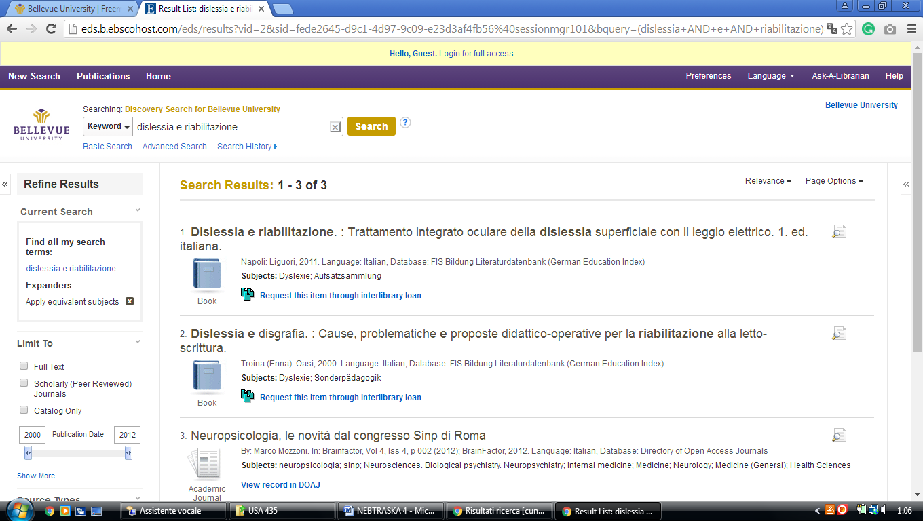

**3** [**UNO CRISS LIBRARY**](http://revelation.unomaha.edu/) – ([Omaha](https://en.wikipedia.org/wiki/University_of_Nebraska_at_Omaha" \o "University of Nebraska at Omaha), Nebraska, Usa)

<https://unomaha.on.worldcat.org/search?sortKey=LIBRARY&databaseList=&queryString=dislessia+e+riabilitazione&changedFacet=scope&scope=&scope=wz%3A1908&format=all&database=all&author=all&year=all&yearFrom=&yearTo>=

**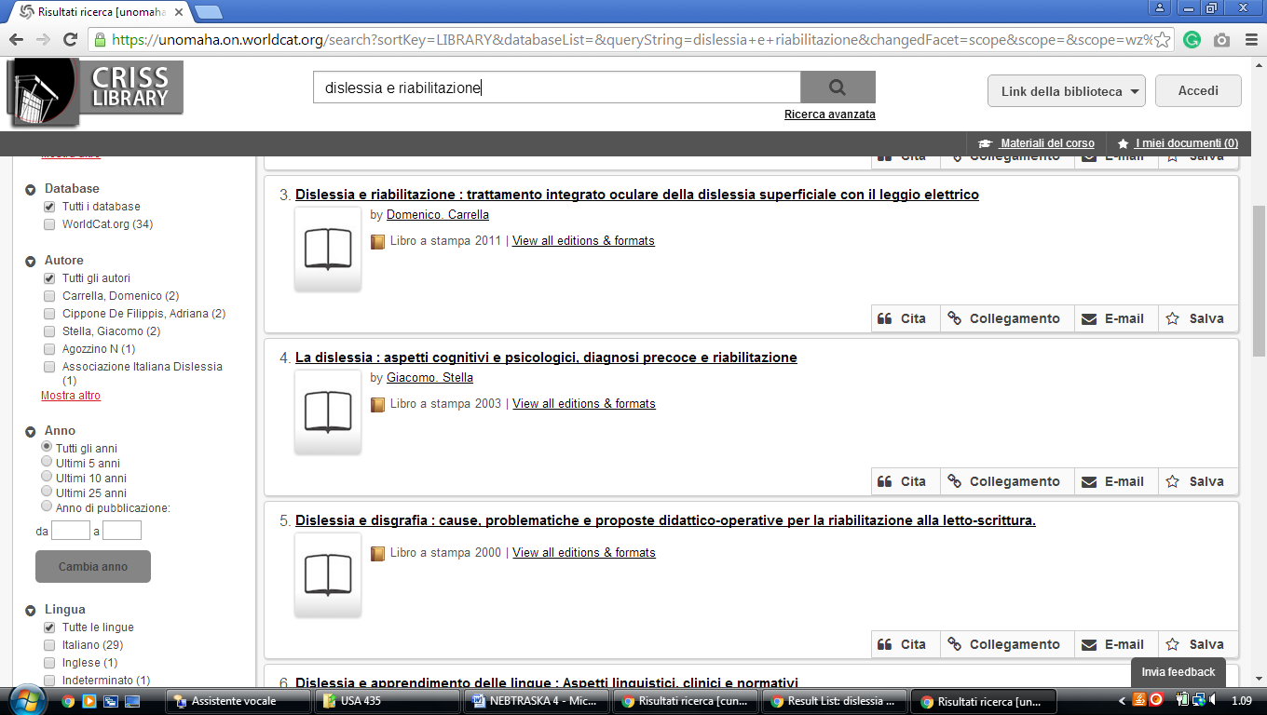**

**4 BELLEVUE UNIVERSITY, FREEMAN/LOZIER LIBRARY** – (Bellevue, NE, Usa)

<http://eds.b.ebscohost.com/eds/results?vid=5&sid=58dd56ac-9cdf-43c1-9100-02d3ff74aa22%40sessionmgr103&bquery=(dislessia+AND+e+AND+riabilitazione)&bdata=JnR5cGU9MCZzaXRlPWVkcy1saXZl>

