**MARYLAND = 9**

**1** [**BLACKWELL LIBRARY**](http://www.salisbury.edu/library/) – (Salisbury, Maryland, Usa)

<http://salisbury.worldcat.org/search?ai=wclocal_salisbury&qt=affiliate_wcl_all&fq=&search_category=journals&search_type=journals&search_field=title&search_relation=starts_with&func=find-db-1-title&mode=title&search_type=contains&q=dislessia+e+riabilitazione&quick-search-submit=Search%21&scope=0>

**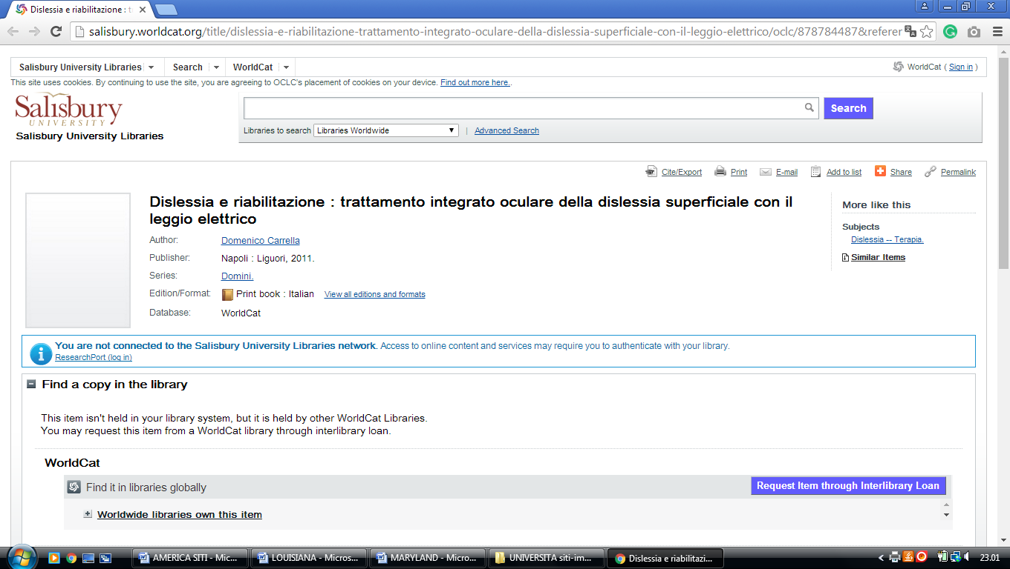**

**2** [**FREDERICK DOUGLASS LIBRARY**](http://www.umes.edu/fdl/Default.aspx?id=1538) **– (**Princess Anne, Maryland, Usa)

<http://eds.b.ebscohost.com/eds/results?vid=3&sid=8c3e7e0d-c7b5-4394-8dbb-8a3d2ab23709%40sessionmgr101&bquery=(dislessia+AND+e+AND+riabilitazione)&bdata=JnR5cGU9MCZzaXRlPWVkcy1saXZl>

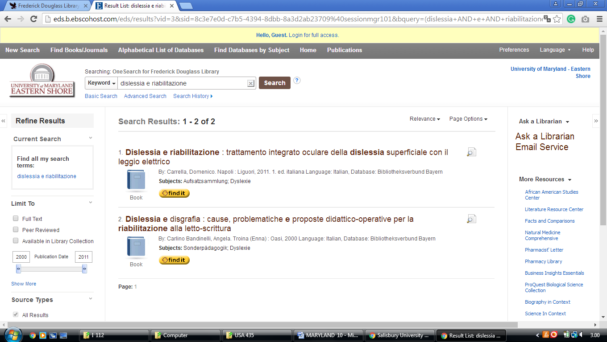

**3**  [**LANGSDALE LIBRARY**](http://langsdale.ubalt.edu/) – (Baltimore, Maryland, Usa)

<http://ubalt.worldcat.org/search?qt=afiliate&ai=wclocal_ubalt&q=dislessia+e+riabilitazione&wcsbtn2w=Go>

**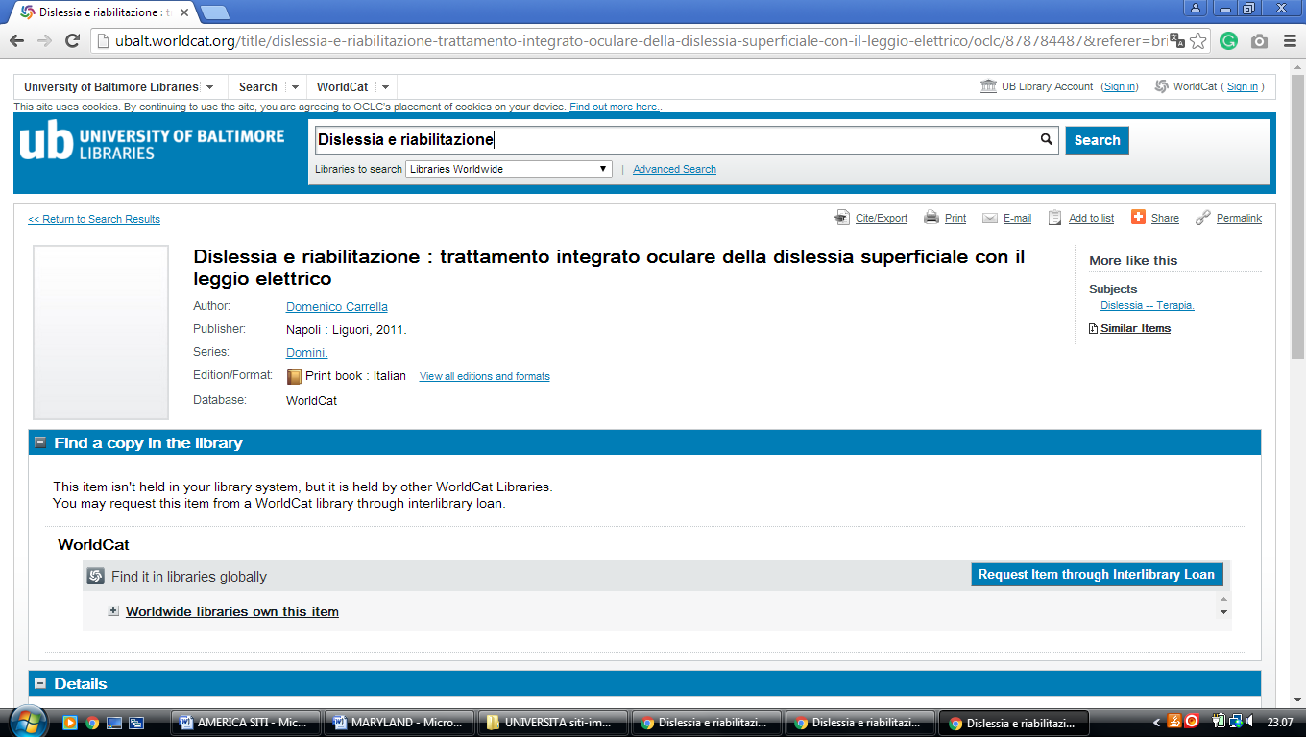**

**4** [**LEWIS J. ORT LIBRARY**](http://www.frostburg.edu/lewis-ort-library/) – (Frostburg, Maryland, Usa)

<http://eds.a.ebscohost.com/eds/results?vid=0&sid=8f6fca4a-e989-4492-b96a-79f1a391a2fa%40sessionmgr4008&bquery=dislessia+e+riabilitazione&bdata=JnR5cGU9MCZzaXRlPWVkcy1saXZlJnNjb3BlPXNpdGU%3d>

**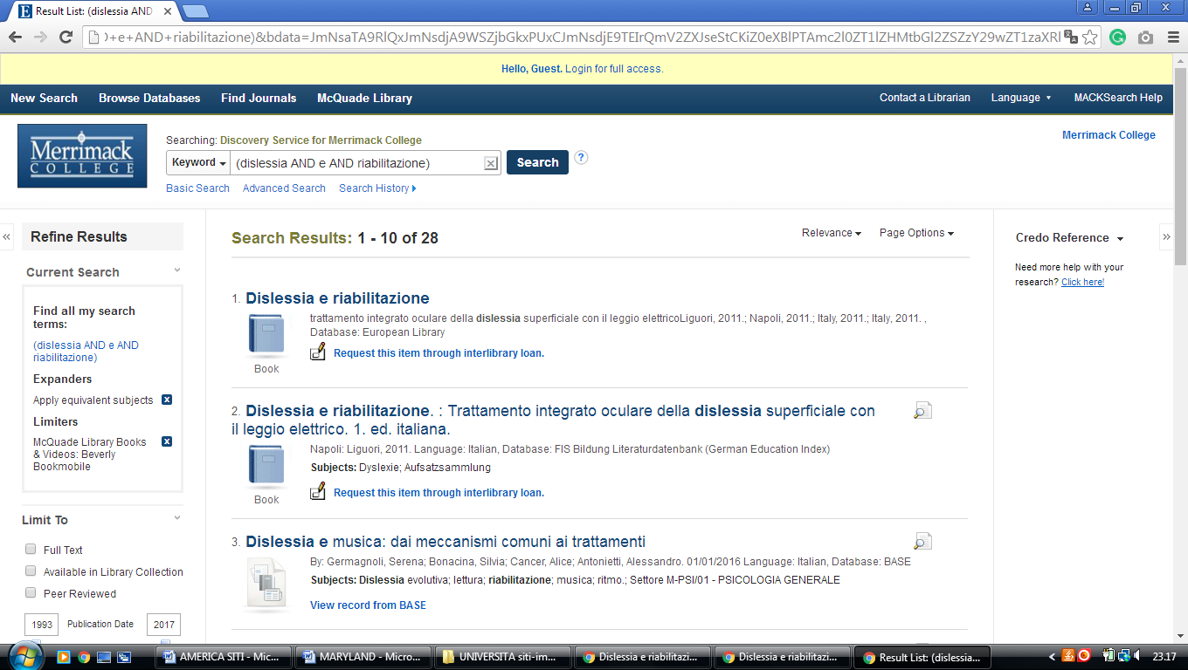**

### 5 [MOUNT ST. MARY'S SEMINARY AND COLLEGE: HUGH J. PHILLIPS LIBRARY ...](https://www.loc.gov/rr/main/religion/msm.html)– (Emmitsburg, MD, Usa)

<https://msm.on.worldcat.org/search?sortKey=LIBRARY&databaseList=&queryString=dislessia+e+riabilitazione&changedFacet=author&scope=&format=all&database=all&author=Carrella%2C+Domenico&year=all&yearFrom=&yearTo=&language=all&topic=all>

**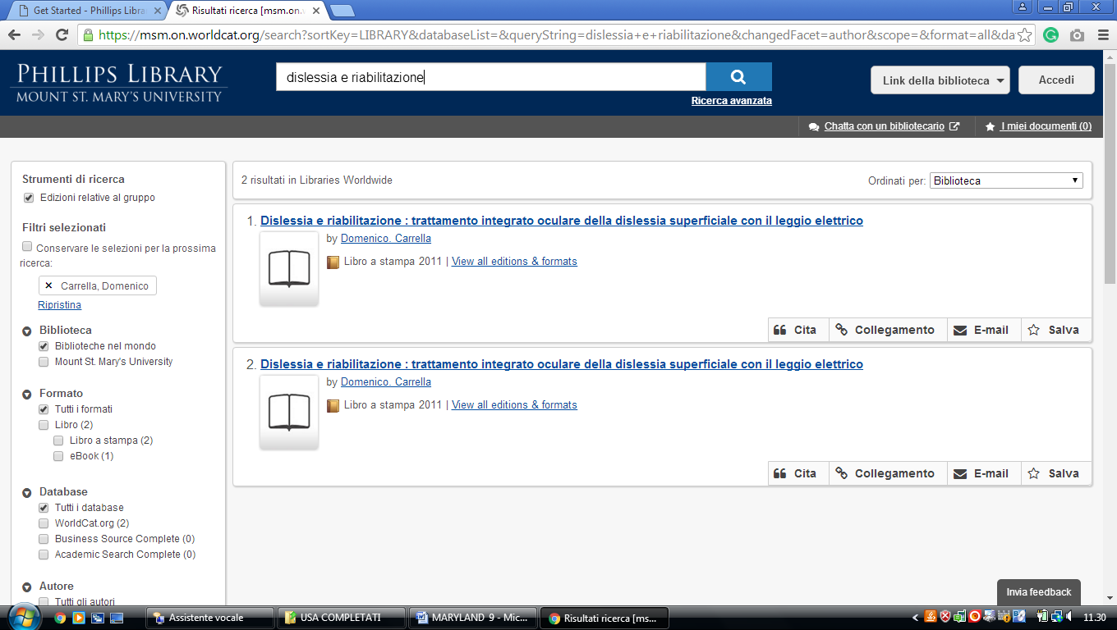**

**6** [**NIMITZ LIBRARY**](http://www.usna.edu/Library/) – (Annapolis, Maryland, Usa)

<https://usna.summon.serialssolutions.com/?#!/search?ho=f&fvf=ContentType,Book%20Review,t&l=en&q=dislessia%20e%20riabilitazione>

**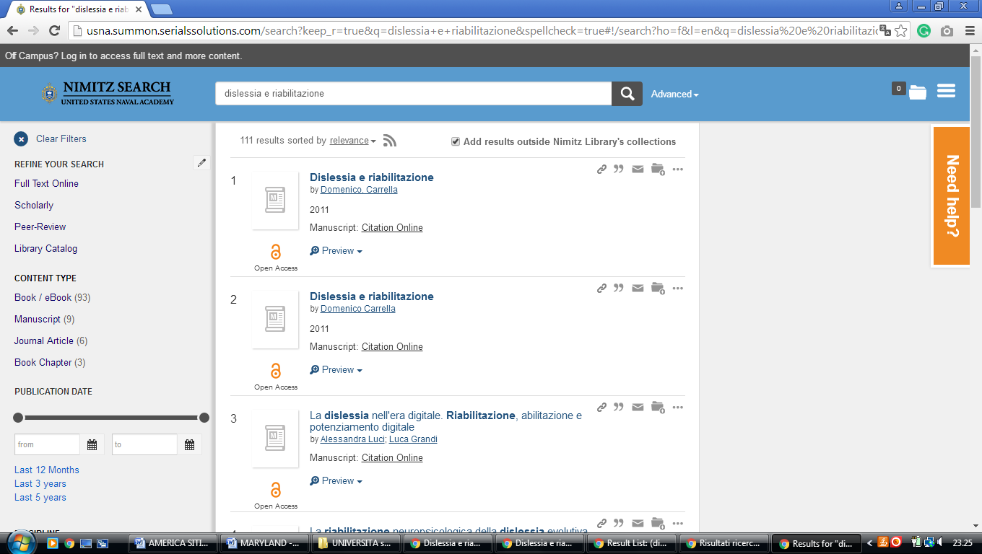**

**7**  [**PRINCE GEORGE’S COMMUNITY**](http://www.pgcc.edu/Library/Library.aspx) **COLLEGE LIBRARY – (**Largo, Maryland, Usa)

<http://pgcc.summon.serialssolutions.com/search?s.q=dislessia+e+riabilitazione&spellcheck=true&keep_r=true#!/search?ho=f&l=en&q=dislessia%20e%20riabilitazione>

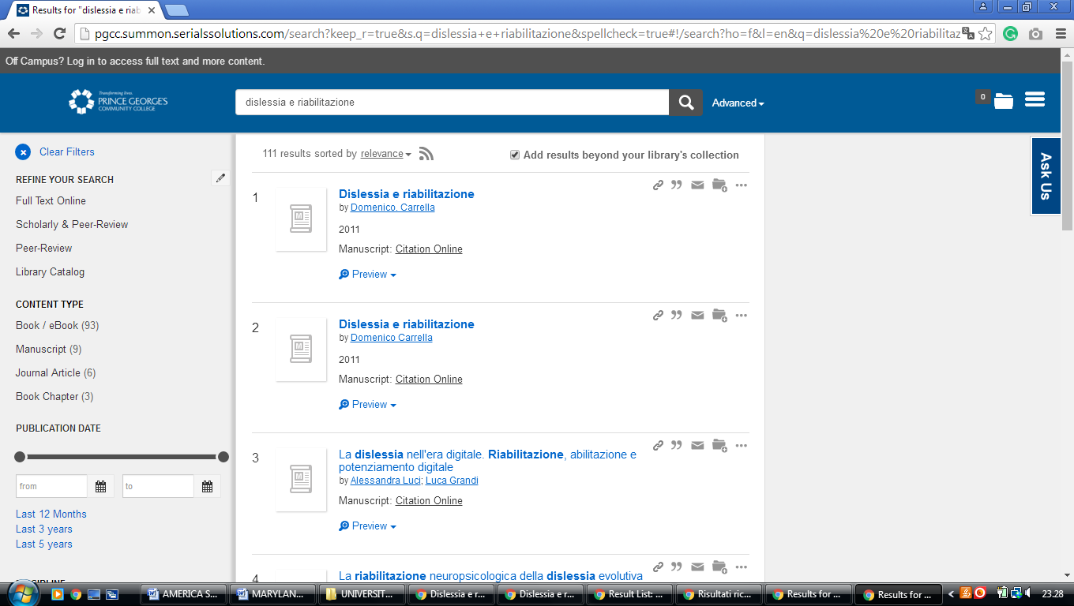

**8** **[UNIVERSITY OF MARYLAND](http://www.lib.umd.edu/" \t "_blank" \o "University of Maryland Libraries) LIBRARIES – (**College Park, Maryland, Usa)

<https://umaryland.on.worldcat.org/search?sortKey=LIBRARY&databaseList=&queryString=dislessia+e+riabilitazione&changedFacet=author&scope=&format=all&database=all&author=Carrella%2C+Domenico&year=all&yearFrom=&yearTo=&language=all&topic=all>

**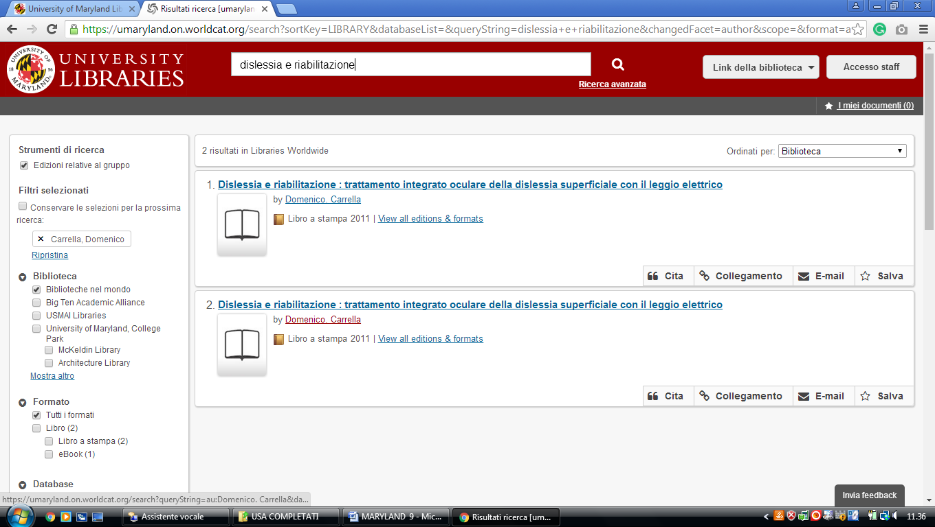**

### 9 [LANGSDALE LIBRARY - UNIVERSITY OF BALTIMORE](http://langsdale.ubalt.edu/) - (Maryland, Usa)

<http://ubalt.worldcat.org/title/dislessia-e-riabilitazione-trattamento-integrato-oculare-della-dislessia-superficiale-con-il-leggio-elettrico/oclc/878784487&referer=brief_results>

