**MAINE = 7**

**1**  **[BATES COLLEGE](http://abacus.bates.edu/library/" \t "_blank" \o "Bates College) LIBRARY** – (Lewiston, Maine, Usa)

[https://bates.summon.serialssolutions.com/search?s.fvf%5B%5D=ContentType%2CNewspaper+Article%2Ct&s.fvf%5B%5D=ContentType%2CBook+Review%2Ct&s.q=dislessia+e+riabilitazione#!/search?ho=f&fvf=ContentType,Newspaper%20Article,t%7CContentType,Book%20Review,t&l=en&q=dislessia%20e%20riabilitazione](https://bates.summon.serialssolutions.com/search?s.fvf%5B%5D=ContentType%2CNewspaper+Article%2Ct&s.fvf%5B%5D=ContentType%2CBook+Review%2Ct&s.q=dislessia+e+riabilitazione" \l "!/search?ho=f&fvf=ContentType,Newspaper%20Article,t%7CContentType,Book%20Review,t&l=en&q=dislessia%20e%20riabilitazione)

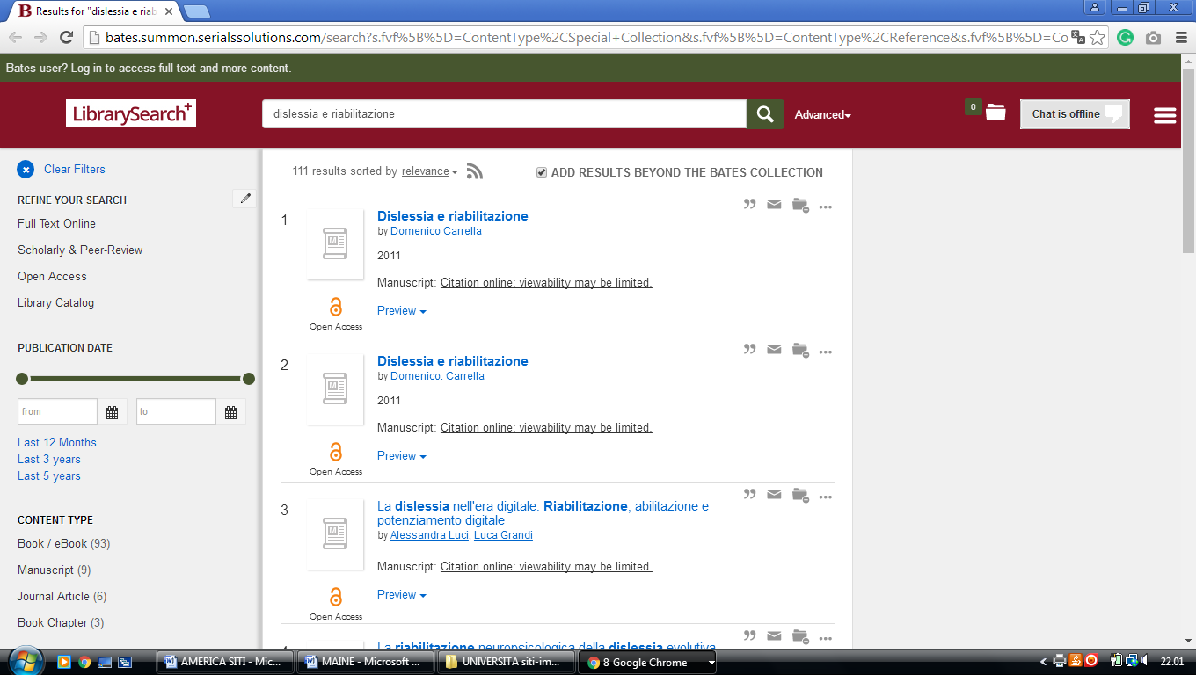

**2**  **[BLAKE LIBRARY](http://www.umfk.edu/library/" \t "_blank" \o "Blake Library)** (Fort Kent , Maine, Usa)

[https://umfk.summon.serialssolutions.com/?#!/search?ho=f&l=en&q=dislessia%20e%20riabilitazione](https://umfk.summon.serialssolutions.com/?" \l "!/search?ho=f&l=en&q=dislessia%20e%20riabilitazione)

**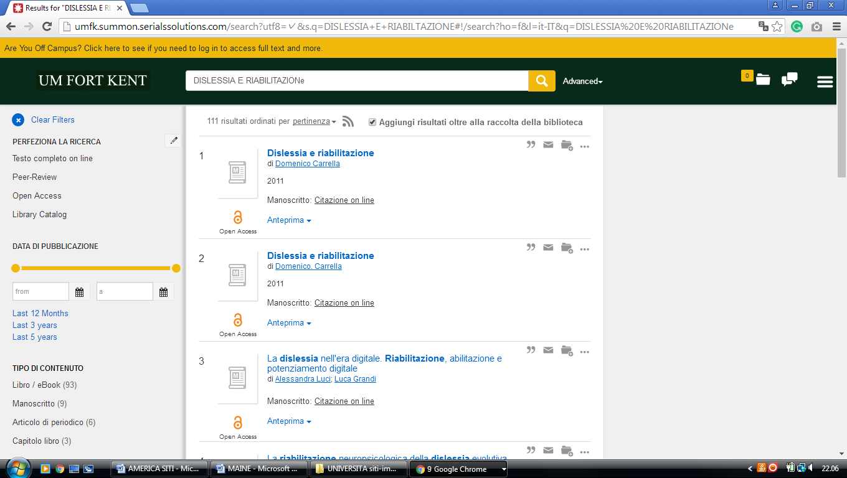**

**3** **[BOWDOIN COLLEGE LIBRARY](http://library.bowdoin.edu/" \t "_blank" \o "Bowdoin College Library)** – (Brunswick, Maine, Usa)

[https://bowdoin.summon.serialssolutions.com/search?s.q=dislessia+e+riabilitazione&s.fvf%5B%5D=ContentType%2CNewspaper+Article%2Ct&keep\_r=true&onesearchsubmit=#!/search?ho=f&fvf=ContentType,Newspaper%20Article,t&l=en&q=dislessia%20e%20riabilitazione](https://bowdoin.summon.serialssolutions.com/search?s.q=dislessia+e+riabilitazione&s.fvf%5B%5D=ContentType%2CNewspaper+Article%2Ct&keep_r=true&onesearchsubmit=" \l "!/search?ho=f&fvf=ContentType,Newspaper%20Article,t&l=en&q=dislessia%20e%20riabilitazione)

**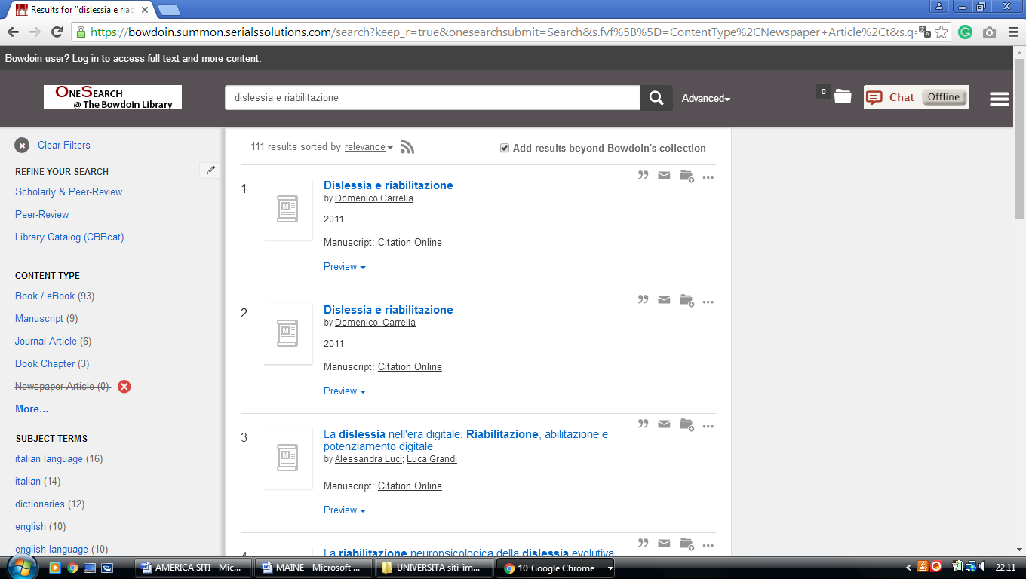**

**4**  **[FOGLER LIBRARY](http://www.library.umaine.edu/" \t "_blank" \o "Fogler Library)** – (Orono, Maine, Usa)

[http://umaine.summon.serialssolutions.com/search?s.fvf%5B%5D=ContentType%2CNewspaper+Article%2Ct&s.q=dislessia+e+riabilitazione#!/search?ho=f&fvf=ContentType,Newspaper%20Article,t&l=en&q=dislessia%20e%20riabilitazione](http://umaine.summon.serialssolutions.com/search?s.fvf%5B%5D=ContentType%2CNewspaper+Article%2Ct&s.q=dislessia+e+riabilitazione" \l "!/search?ho=f&fvf=ContentType,Newspaper%20Article,t&l=en&q=dislessia%20e%20riabilitazione)

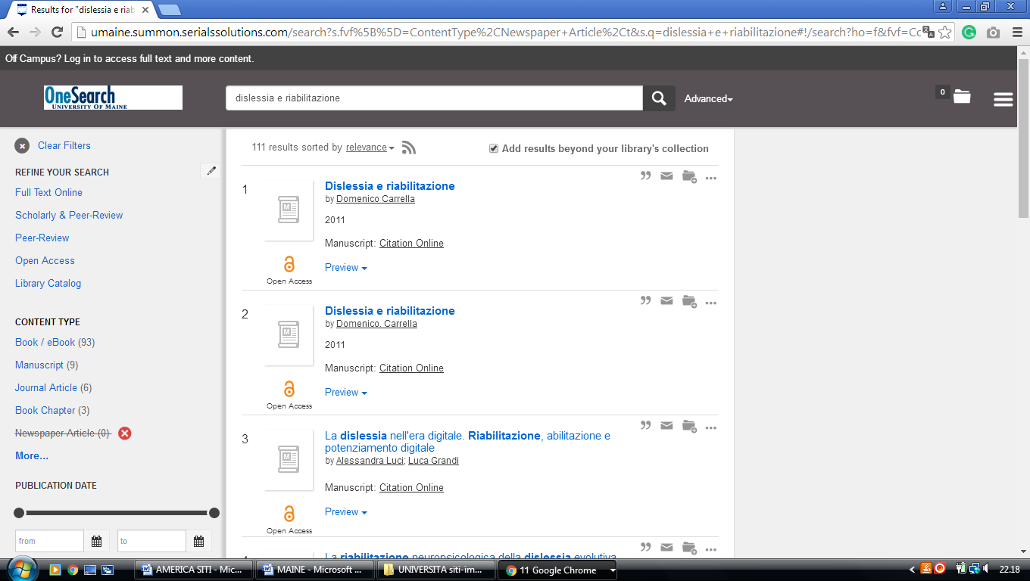

**5**  **[MANTOR LIBRARY](http://library.umf.maine.edu/" \t "_blank" \o "Mantor Library)** - (Farmington, Maine, Usa)

[http://umfarm.summon.serialssolutions.com/search?s.q=dislessia+e+riabilitazione&spellcheck=true#!/search?ho=f&l=en&q=dislessia%20e%20riabilitazione](http://umfarm.summon.serialssolutions.com/search?s.q=dislessia+e+riabilitazione&spellcheck=true" \l "!/search?ho=f&l=en&q=dislessia%20e%20riabilitazione)

**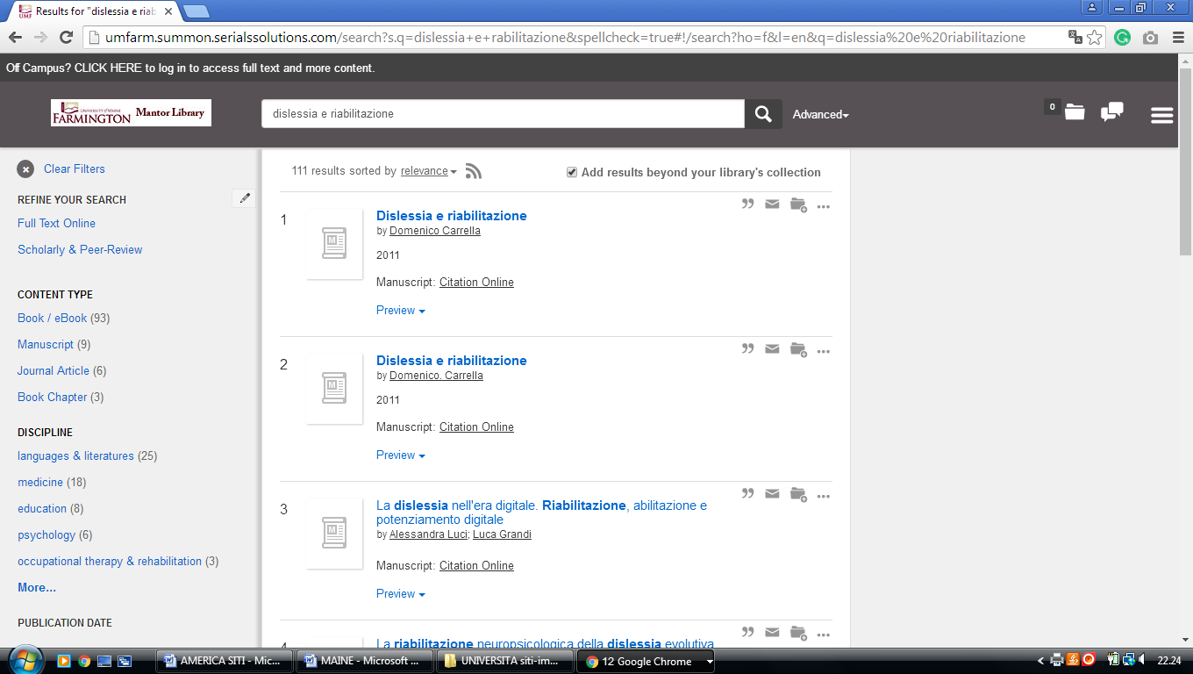**

**6** **[UNIVERSITY OF NEW ENGLAND](http://www.une.edu/library/" \t "_blank" \o "University of New England Library) LIBRARY** - (Biddeford, Maine, Usa)

[https://une.summon.serialssolutions.com/search?utf8=%E2%9C%93&s.q=dislessia+e+riabilitazione&s.fvf%5B%5D=ContentType%2CNewspaper+Article%2Ct&s.fvf%5B%5D=ContentType%2CBook+Review%2Ct&keep\_r=true#!/search?ho=f&fvf=ContentType,Newspaper%20Article,t%7CContentType,Book%20Review,t&l=en&q=dislessia%20e%20riabilitazione](https://une.summon.serialssolutions.com/search?utf8=%E2%9C%93&s.q=dislessia+e+riabilitazione&s.fvf%5B%5D=ContentType%2CNewspaper+Article%2Ct&s.fvf%5B%5D=ContentType%2CBook+Review%2Ct&keep_r=true" \l "!/search?ho=f&fvf=ContentType,Newspaper%20Article,t%7CContentType,Book%20Review,t&l=en&q=dislessia%20e%20riabilitazione)

**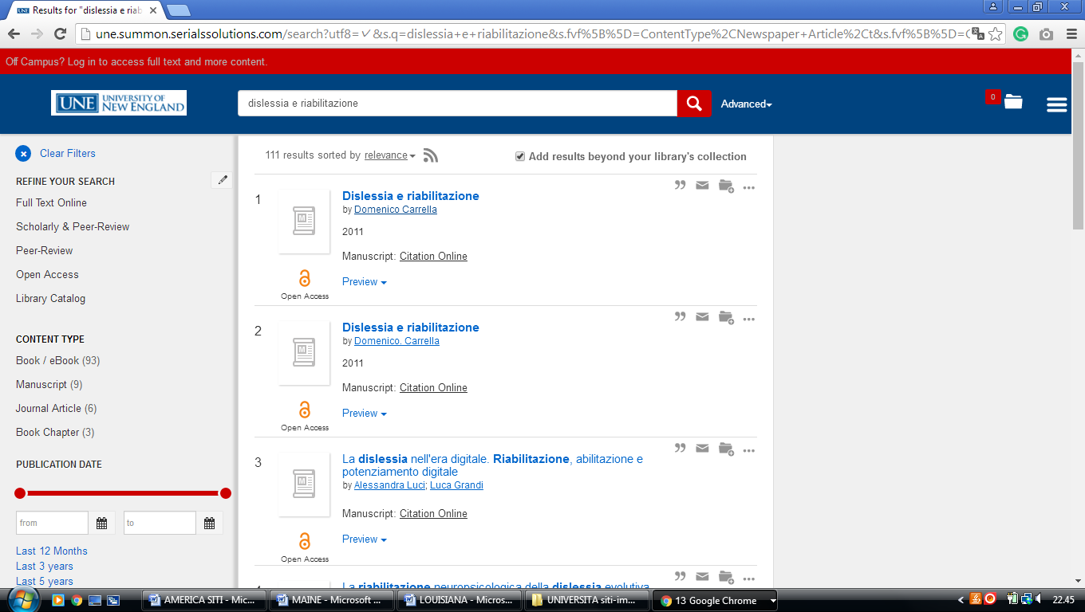**

### 7 [USM LIBRARIES | UNIVERSITY OF SOUTHERN MAINE](https://usm.maine.edu/library) - (Portland, Maine, Usa)

<https://usm.summon.serialssolutions.com/search?s.q=dislessia+e+riabilitazione&s.fvf%5B%5D=ContentType%2CNewspaper+Article%2Ct%7CContentType%2CBook+Review%2Ct#!/search?ho=f&fvf=ContentType,Newspaper%20Article,t%7CContentType,Book%20Review,t&l=en&q=dislessia%20e%20riabilitazione>

