**LOUISIANA = 3**

**1 THE UNIVERSITY *of* NEW ORLEANS LIBRARY - (**New Orleans, Louisiana, Usa)

<http://eds.a.ebscohost.com/eds/results?vid=0&sid=edad883e-7077-4a91-a852-d017c48ccf09%40sessionmgr4006&bquery=dislessia+e+riabilitazione&bdata=JnR5cGU9MCZzaXRlPWVkcy1saXZlJnNjb3BlPXNpdGU%3d>

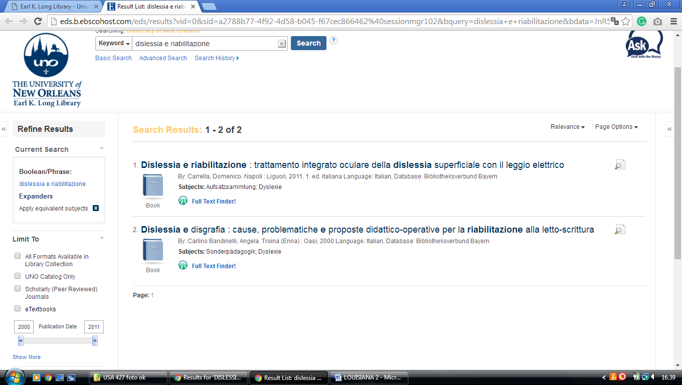

**2**  **[HOWARD-TILTON MEMORIAL](http://library.tulane.edu/" \t "_blank" \o "Howard-Tilton Memorial Library) LIBRARY - (**New Orleans, Louisiana, Usa)

<http://tulprimo.hosted.exlibrisgroup.com/primo_library/libweb/action/search.do?mode=Basic&vid=tref&vl(freeText0)=dislessia%20e%20riabilitazione&fn=search&tab=articles&>

**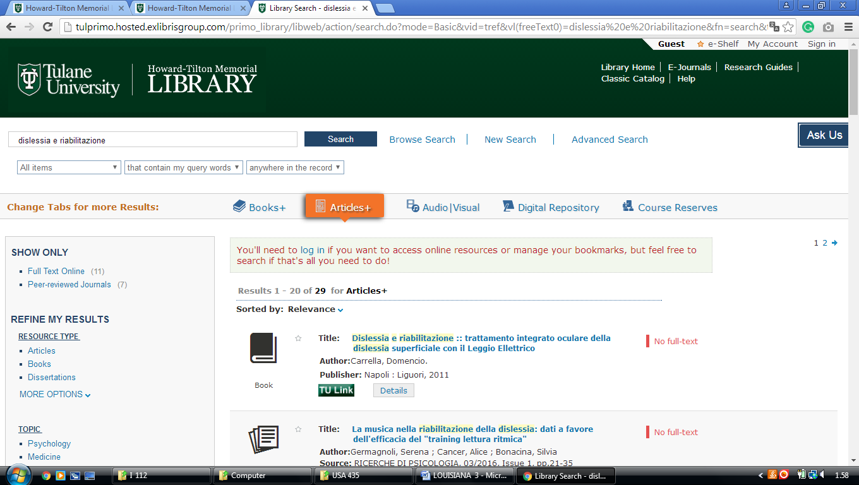**

### 3 [THE LATIN AMERICAN LIBRARY - TULANE UNIVERSITY](http://lal.tulane.edu/) – (Luisiana, Usa)

<http://tulprimo.hosted.exlibrisgroup.com/primo_library/libweb/action/search.do?mode=Basic&vid=tref&vl(freeText0)=dislessia%20e%20riabilitazione&fn=search&tab=articles&>

