**KENTUCKY = 10**

### 1 [HOME PAGE | LIBRARIES | EASTERN KENTUCKY UNIVERSITY](https://library.eku.edu/) – (Richmond, Kentucky, Usa)

<https://eku.on.worldcat.org/search?databaseList=&queryString=dislessia+e+riabilitazione>

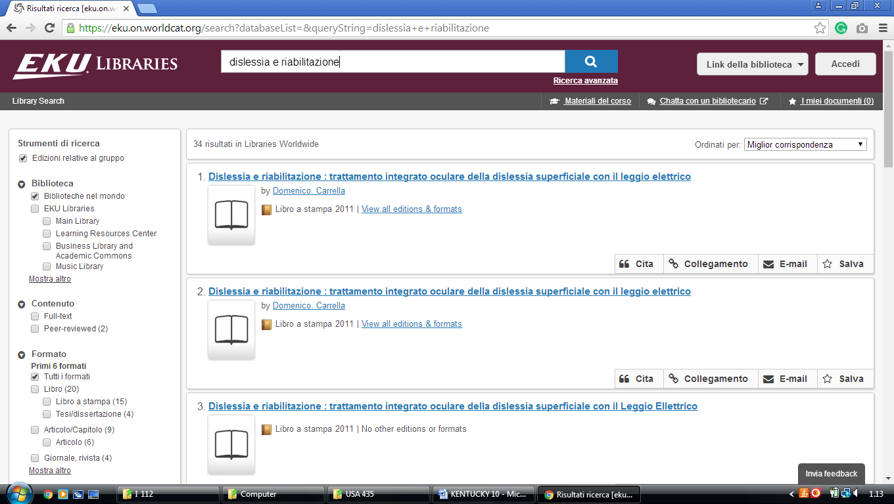

**2**  [**ENSOR LEARNING RESOURCE CENTER**](http://www.georgetowncollege.edu/library/) **LIBRARY** – (Georgetown, KY, Usa)

<https://georgetowncollege.on.worldcat.org/search?queryString=dislessia+e+riabilitazione>

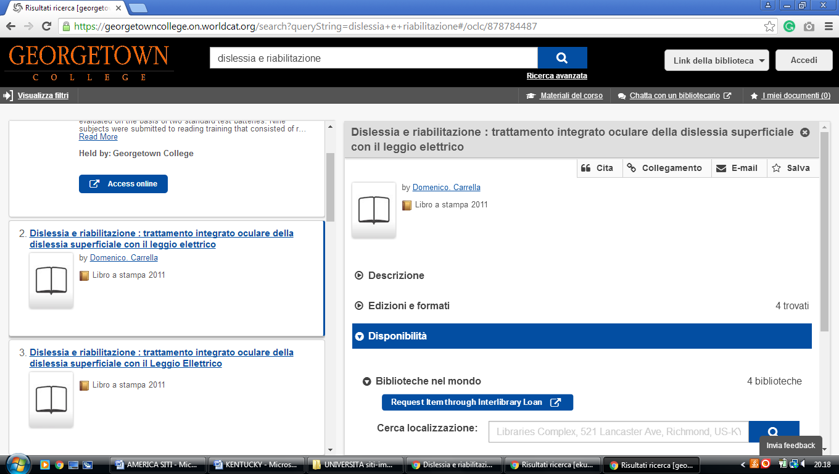

**3** [**MURRAY STATE UNIVERSITY LIBRARIES**](http://lib.murraystate.edu/) – (Murray, Kentucky, Usa)

<http://saa-primo.hosted.exlibrisgroup.com/primo_library/libweb/action/search.do?ct=facet&pcAvailabiltyMode=true&pcAvailClicked=true&rfnGrpCounter=1&query=any%2Ccontains%2C%20dislessia%20e%20riabilitazione&indx=1&fn=search&mulIncFctN=facet_rtype&mulIncFctN=facet_rtype&dscnt=0&search_scope=default_scope&scp.scps=scope%3A(MSU)%2Cscope%3A(MSU_ALMA)%2Cprimo_central_multiple_fe&rfnIncGrp=1&rfnIncGrp=1&displayMode=full&mode=Basic&vid=MSU&queryTemp=%20dislessia%20e%20riabilitazione&ct=search&bulkSize=10&highlight=true&institution=MSU&tab=default_tab&vl(148295174UI0)=any&displayField=all&vl(freeText0)=%20dislessia%20e%20riabilitazione&dum=true&fctIncV=media&fctIncV=books&dstmp=1521505257012&fromDL>

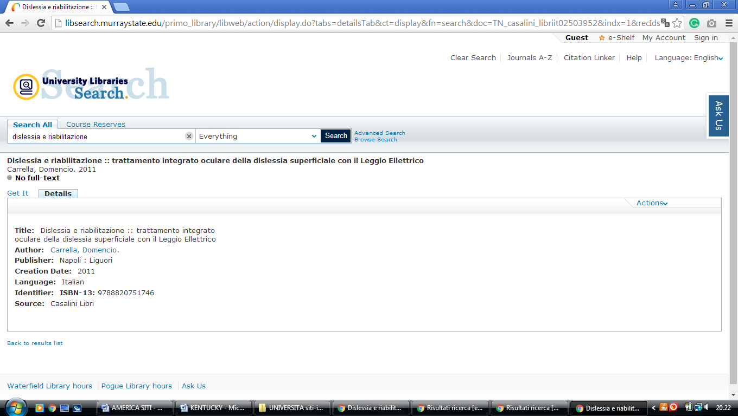

**4**  [**PAUL G. BLAZER LIBRARY**](http://www.kysu.edu/academics/library/) – (Frankfort, Kentucky, Usa)

<https://kysu.on.worldcat.org/search?sortKey=BEST_MATCH&databaseList=&queryString=dislessia+e+riabilitazione&changedFacet=scope&clusterResults=on&scope=&scope=wz%3A2163>

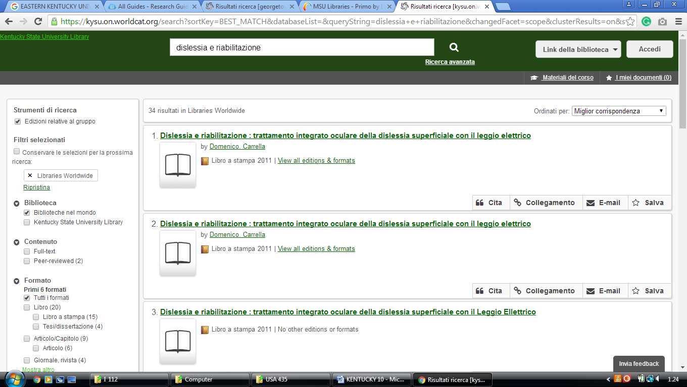

**5** [**UNIVERSITY OF LOUISVILLE LIBRARIES**](http://louisville.edu/library/) – (Louisville, Kentucky, Usa)

<https://uofl.on.worldcat.org/search?sortKey=LIBRARY_PLUS_RELEVANCE&databaseList=638&queryString=dislessia+e+riabilitazione>

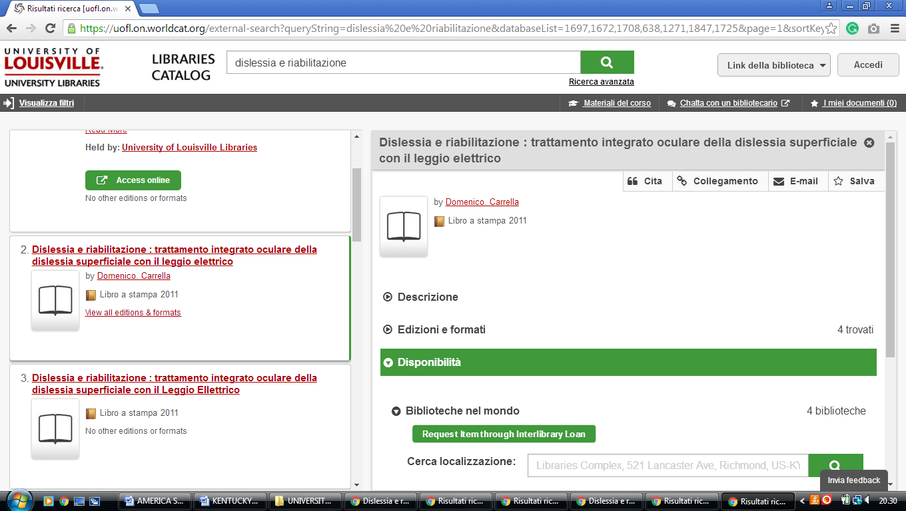

**6** [**W. FRANK STEELY LIBRARY**](http://library.nku.edu/) **HIGHLAND HEIGHTS** – (Kentucky, Usa)

<http://eds.b.ebscohost.com/eds/results?vid=2&sid=b8ccafb5-455c-45c7-8090-3695a6ca8a30%40pdc-v-sessmgr01&bquery=(dislessia+AND+e+AND+riabilitazione)&bdata=JnR5cGU9MCZzaXRlPWVkcy1saXZl>

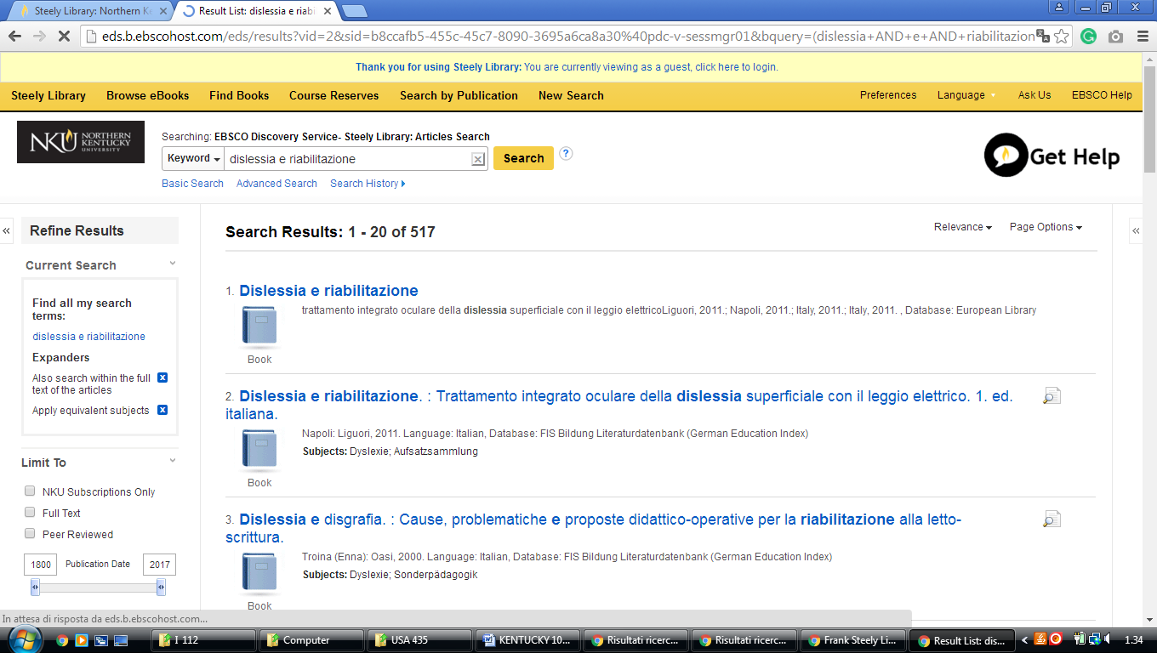

**7** [**EASTERN KENTUCKY UNIVERSITY**](http://www.library.eku.edu/) **LIBRARIES - (**Richmond, Kentucky, Usa)

<https://eku.on.worldcat.org/search?databaseList=&queryString=dislessia+e+riabilitazione>

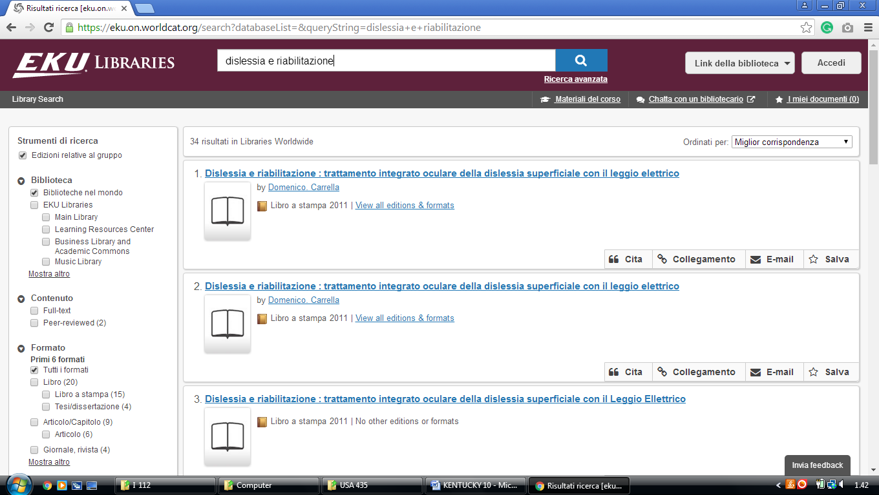

**8**  **ENSOR LEARNING RESOURCE CENTER LIBARY – (**Georgetown, kY, Usa)

<https://georgetowncollege.on.worldcat.org/search?queryString=dislessia+e+riabilitazione>

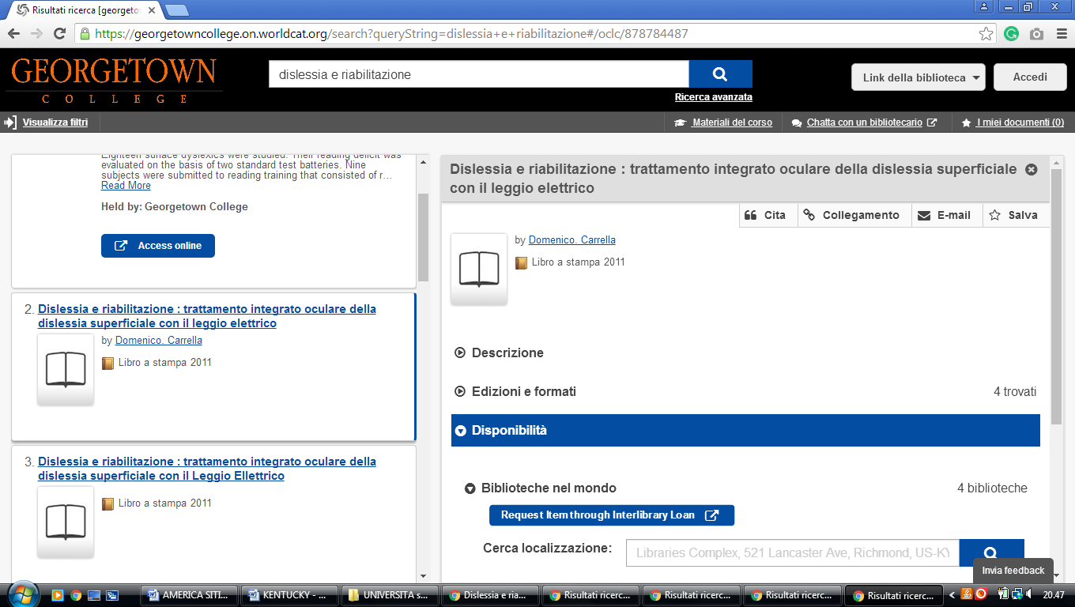

**9**  [**MURRAY STATE UNIVERSITY**](http://lib.murraystate.edu/) **LIBRARIES - (**Murray, Kentucky, Usa)

<http://saa-primo.hosted.exlibrisgroup.com/primo_library/libweb/action/search.do?ct=facet&pcAvailabiltyMode=true&pcAvailClicked=true&rfnGrpCounter=1&query=any%2Ccontains%2C%20dislessia%20e%20riabilitazione&indx=1&fn=search&mulIncFctN=facet_rtype&mulIncFctN=facet_rtype&dscnt=0&search_scope=default_scope&scp.scps=scope%3A(MSU)%2Cscope%3A(MSU_ALMA)%2Cprimo_central_multiple_fe&rfnIncGrp=1&rfnIncGrp=1&displayMode=full&mode=Basic&vid=MSU&queryTemp=%20dislessia%20e%20riabilitazione&ct=search&bulkSize=10&highlight=true&institution=MSU&tab=default_tab&vl(148295174UI0)=any&displayField=all&vl(freeText0)=%20dislessia%20e%20riabilitazione&dum=true&fctIncV=media&fctIncV=books&dstmp=1521506820002&fromDL>

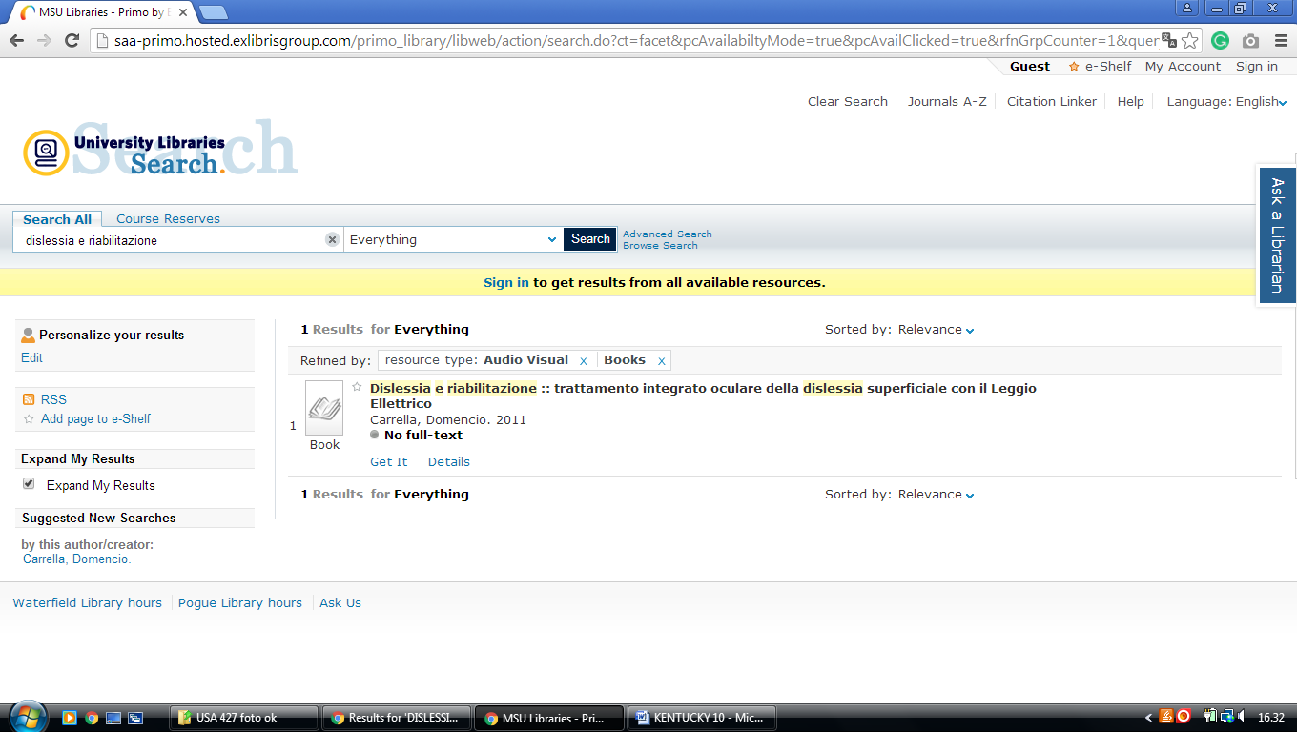

**10** [**UNIVERSITY OF LOUISVILLE**](http://louisville.edu/library/) **LIBRARIES – (**Louisville, Kentucky, Usa)

<https://uofl.on.worldcat.org/search?sortKey=LIBRARY_PLUS_RELEVANCE&databaseList=638&queryString=dislessia+e+riabilitazione>

