**IOWA = 3**

### 1 [BUSSE LIBRARY | MOUNT MERCY UNIVERSITY](https://www.mtmercy.edu/busse-library) – (Cedar Rapids, Iowa, Usa)

<https://mountmercy.on.worldcat.org/search?sortKey=BEST_MATCH&databaseList=&queryString=dislessia+e+riabilitazione&changedFacet=author&scope=&format=all&database=all&author=Carrella%2C+Domenico&year=all&yearFrom=&yearTo=&language=all&topic=all>

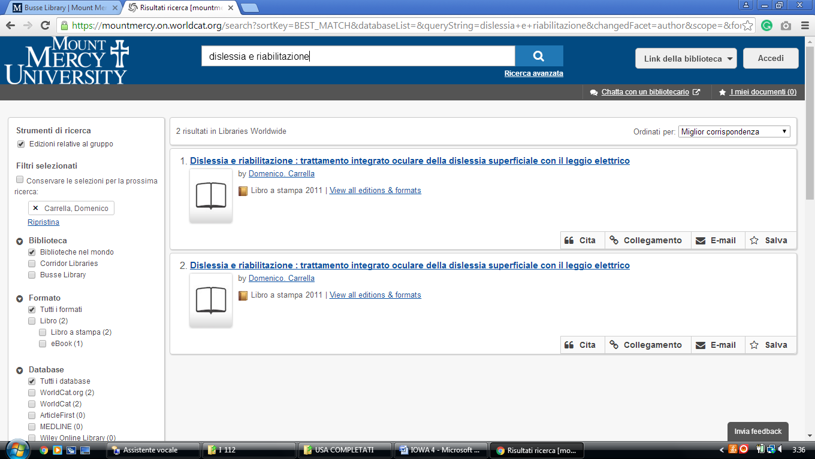

### 2 [BUSSE LIBRARY | MOUNT MERCY UNIVERSITY](https://www.mtmercy.edu/busse-library)– (Decorah, Iowa, Usa)

<https://luther.on.worldcat.org/search?sortKey=LIBRARY&databaseList=&queryString=dislessia+e+riabilitazione&changedFacet=author&scope=&format=all&database=all&author=Carrella%2C+Domenico&year=all&yearFrom=&yearTo=&language=all&topic=all>

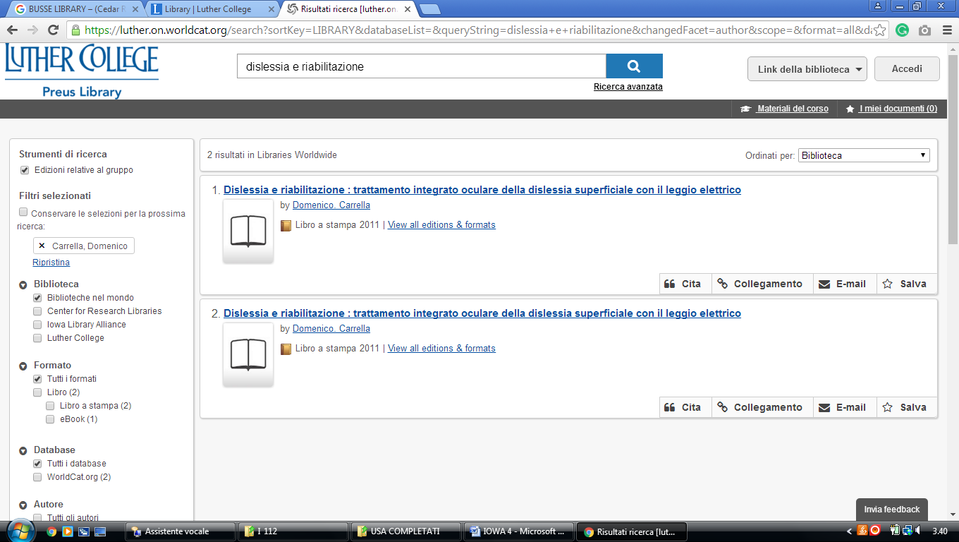

**3** [**RAMAKER LIBRARY**](http://library.nwciowa.edu/) - (Orange City, Iowa, Usa)

<https://nwciowa.on.worldcat.org/search?queryString=dislessia+e+riabilitazione>

