**INDIANA = 22**

**1** [**LIBRARY AMBS LIBRARY-ANABAPTIST MENNONITE**](https://www.google.it/url?sa=t&rct=j&q=&esrc=s&source=web&cd=2&cad=rja&uact=8&ved=0ahUKEwiZpvT5_5PVAhXBsxQKHa2aAF8QFggsMAE&url=https%3A%2F%2Fwww.ambs.edu%2Flibrary&usg=AFQjCNFx0310axgRBloiQgmyk_6Qzu4B9Q) **BIBLICAL SEMINARY** - (Elkhart, Indiana, Usa)

<https://ambslibrary.on.worldcat.org/search?queryString=dislessia+e+riabilitazione>

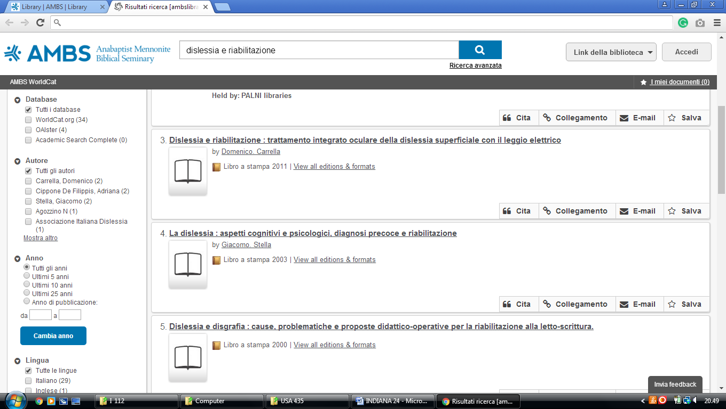

**2 BUTLER UNIVERSITY LIBRARIES -** ([Indianapolis](https://it.wikipedia.org/wiki/Indianapolis), Indiana, Usa)

<https://ambslibrary.on.worldcat.org/search?queryString=dislessia+e+riabilitazione>

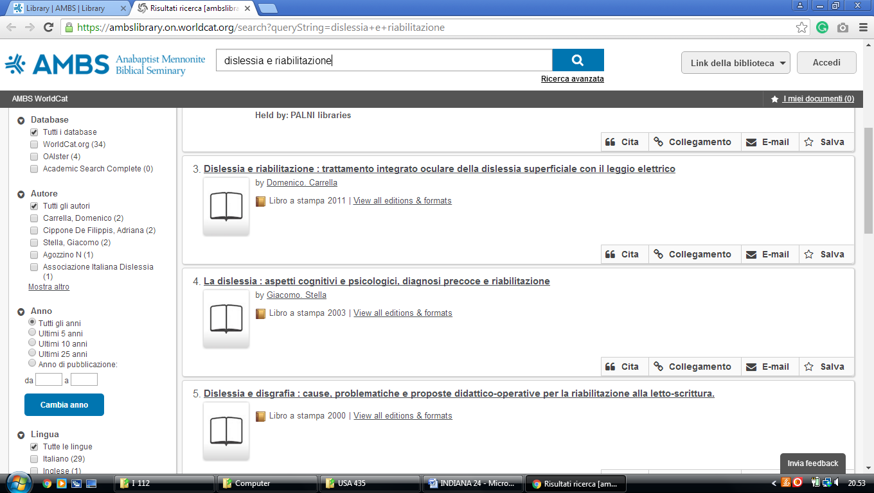

**3**  [**CUNNINGHAM MEMORIAL LIBRARY**](http://library.indstate.edu/) - (Terre Haute, Indiana, Usa)

<http://indstate.summon.serialssolutions.com/?#!/search?ho=f&l=en&q=dislessia%20e%20riabilitazione>

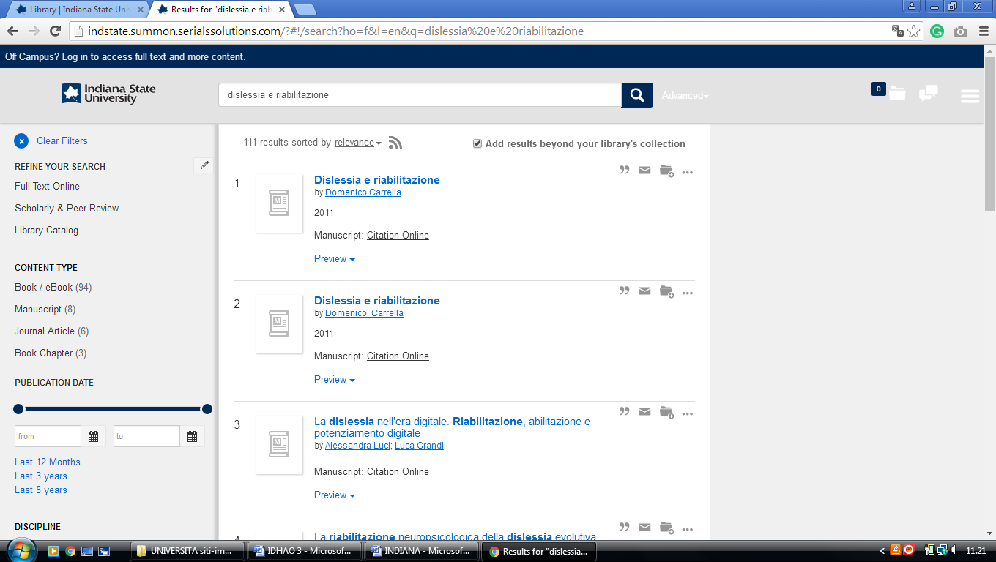

**4** [**GRACE COLLEGE MORGAN LIBRARY**](http://www.grace.edu/resources/library) - (Winona Lake, Indiana, Usa)

<https://grace.on.worldcat.org/search?sortKey=LIBRARY&databaseList=&queryString=dislessia+e+riabilitazione&changedFacet=author&scope=&format=all&database=all&author=Carrella%2C+Domenico&year=all&yearFrom=&yearTo=&language=all&topic=all>

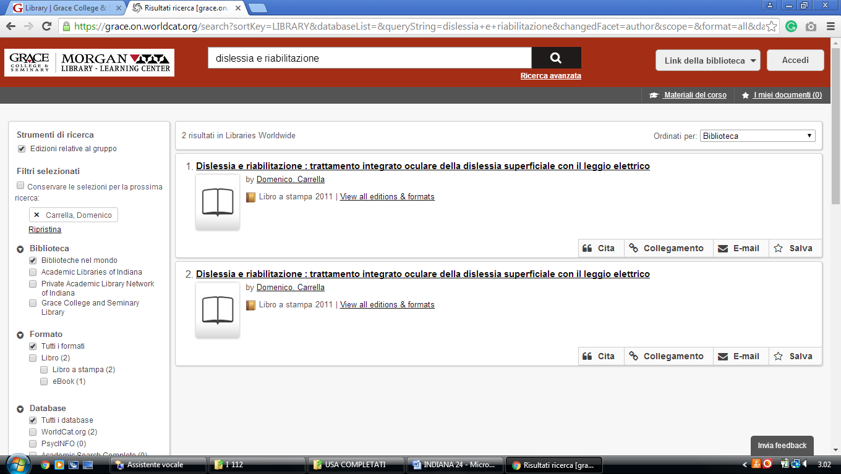

### 5 [HAMILTON LIBRARY HOME - FRANKLIN COLLEGE](http://library.franklincollege.edu/) - (Franklin, Indiana, Usa)

<https://franklincollege.on.worldcat.org/search?sortKey=LIBRARY&databaseList=&queryString=dislessia+e+riabilitazione&changedFacet=author&scope=&format=all&database=all&author=Carrella%2C+Domenico&year=all&yearFrom=&yearTo=&language=all&topic=all>

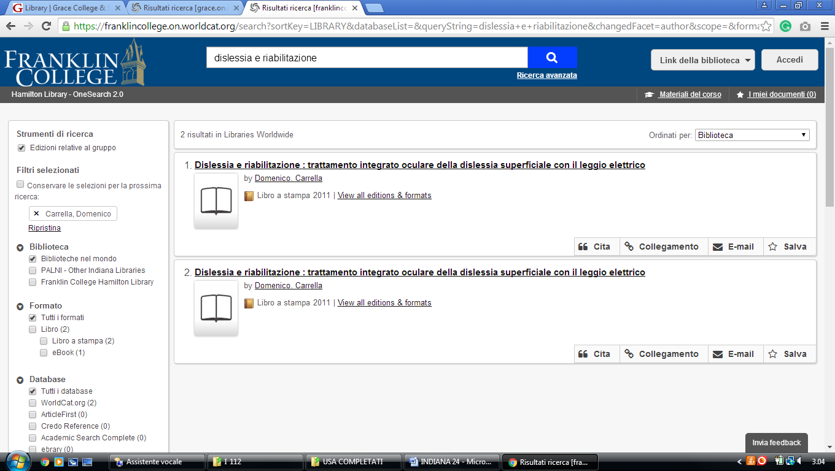

**6** [**CHRISTOPHER CENTER LIBRARY SERVICES**](http://library.valpo.edu/) – (Valparaiso, Indiana, Usa)

<http://valpo.summon.serialssolutions.com/search?s.q=dislessia+e+riabilitazione#!/search?ho=f&l=en&q=dislessia%20e%20riabilitazione>

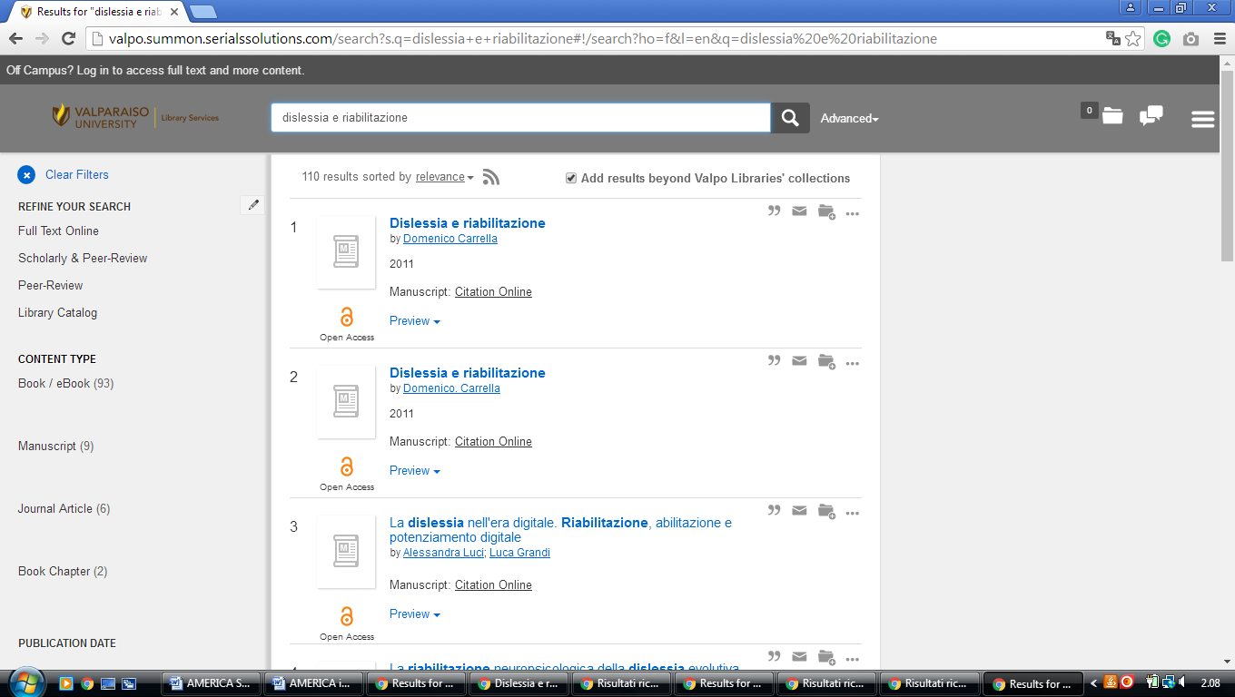

**7** [**CUNNINGHAM MEMORIAL LIBRARY**](http://library.indstate.edu/) – (Terre Haute, Indiana, Usa)

<http://indstate.summon.serialssolutions.com/?#!/search?ho=f&l=en&q=dislessia%20e%20riabilitazione>

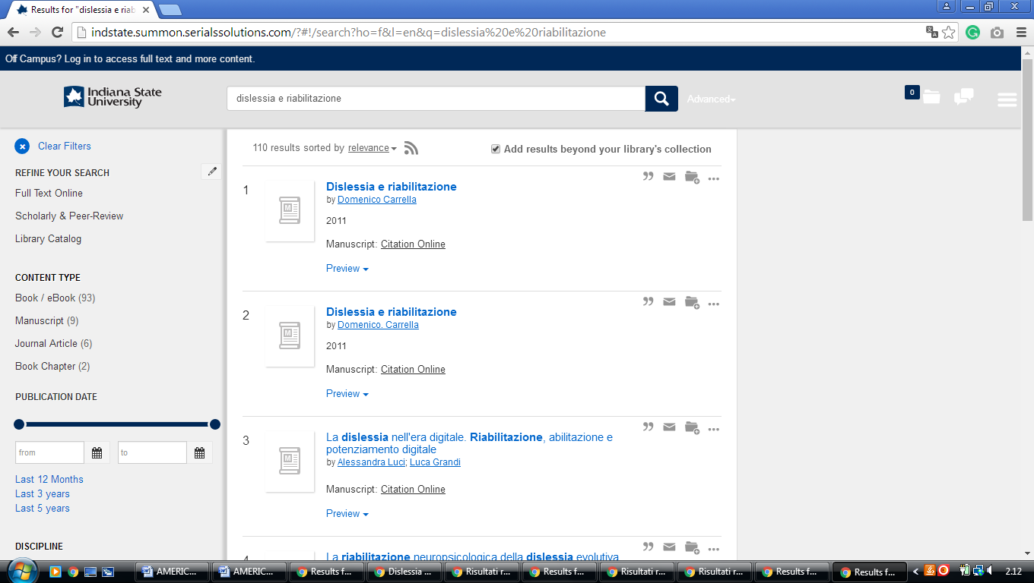

**8**  [**DEPAUW LIBRARIES**](http://www.depauw.edu/libraries/) – (Greencastle, Indiana, Usa)

<https://940.on.worldcat.org/search?sortKey=LIBRARY&databaseList=&queryString=dislessia+e+riabilitazione&changedFacet=author&scope=&format=all&database=all&author=Carrella%2C+Domenico&year=all&yearFrom=&yearTo=&language=all&topic=all>

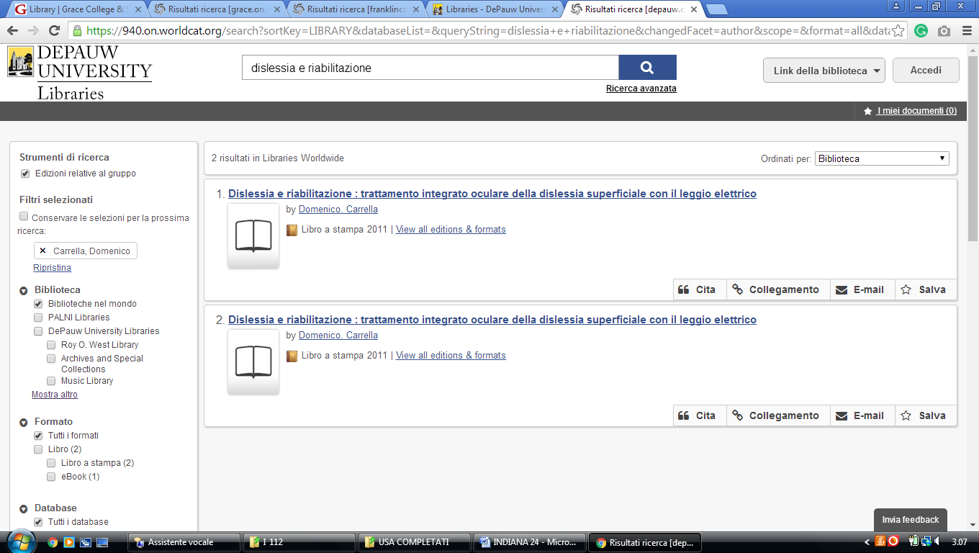

**9** [**DUGGAN LIBRARY**](http://library.hanover.edu/) - (Hanover, Indiana, Usa)

<https://hanover.on.worldcat.org/search?sortKey=BEST_MATCH&databaseList=&queryString=dislessia+e+riabilitazione&changedFacet=scope&clusterResults=off&stickyFacetsChecked=on&scope=&scope=wz%3A1076>

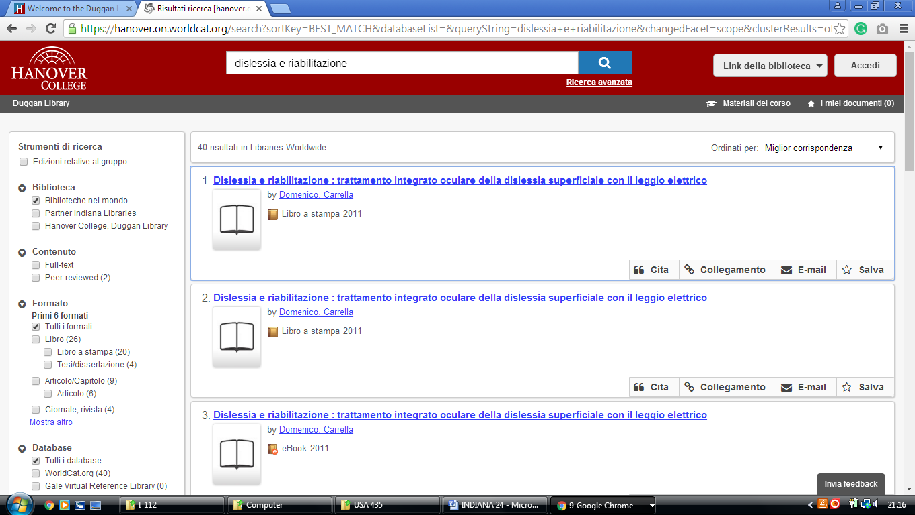

**10** [**EARLHAM COLLEGE LIBRARIES**](http://legacy.earlham.edu/~libr/) – (Richmond, Indiana, Usa)

<http://earlham.worldcat.org/search?qt=affiliate&ai=wclocal_earlham&q=dislessia+e+riabilitazione&scope=0&oldscope>=

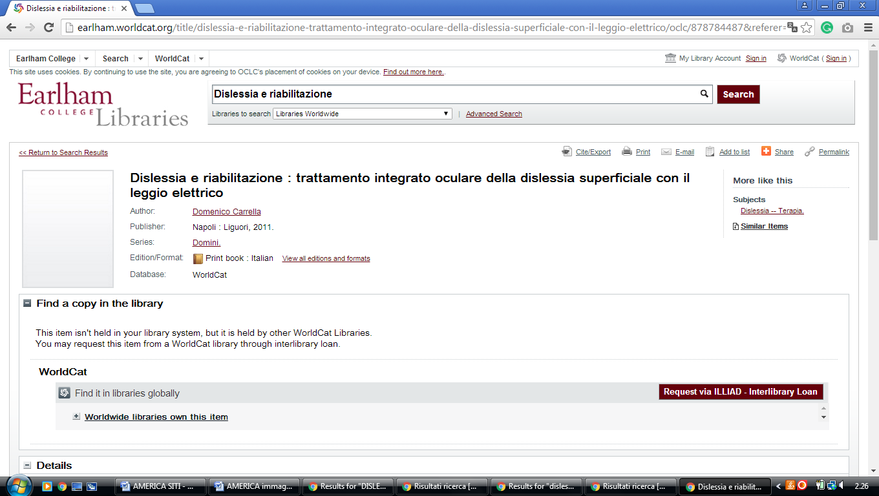

### 11 [Good Library - Goshen College](https://library.goshen.edu/) – (Goshen, Indiana, Usa)

<https://goshen.on.worldcat.org/search?sortKey=LIBRARY&databaseList=638&queryString=dislessia+e+riabilitazione&changedFacet=author&scope=&format=all&database=all&author=Carrella%2C+Domenico&year=all&yearFrom=&yearTo=&language=all&topic=all>

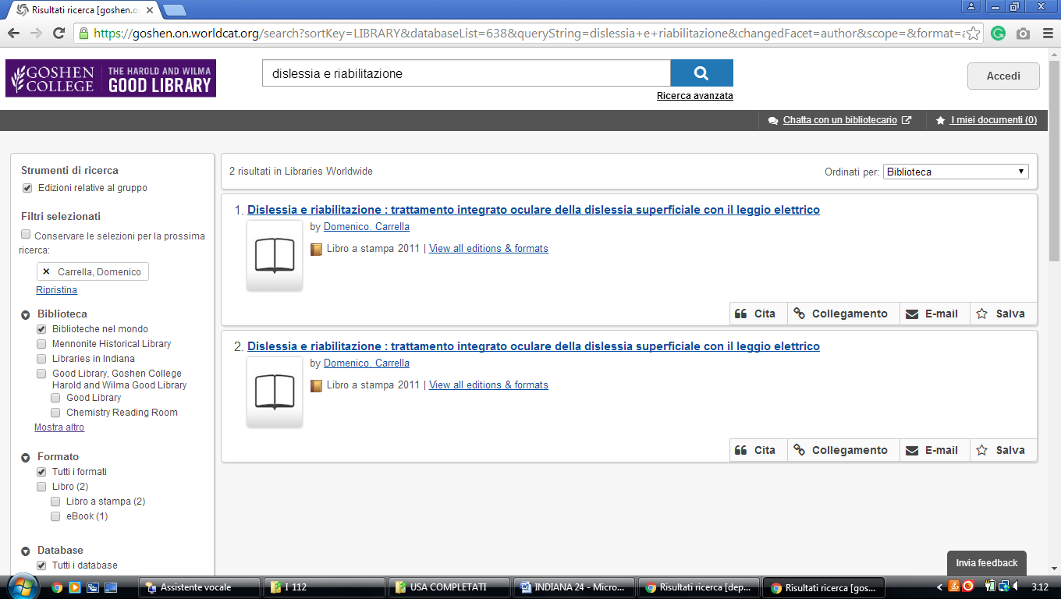

### 12 [HAMILTON LIBRARY HOME - FRANKLIN COLLEGE](http://library.franklincollege.edu/) - (Indiana, Usa)

<https://franklincollege.on.worldcat.org/search?sortKey=LIBRARY&databaseList=&queryString=dislessia+e+riabilitazione&changedFacet=author&scope=&format=all&database=all&author=Carrella%2C+Domenico&year=all&yearFrom=&yearTo=&language=all&topic=all>

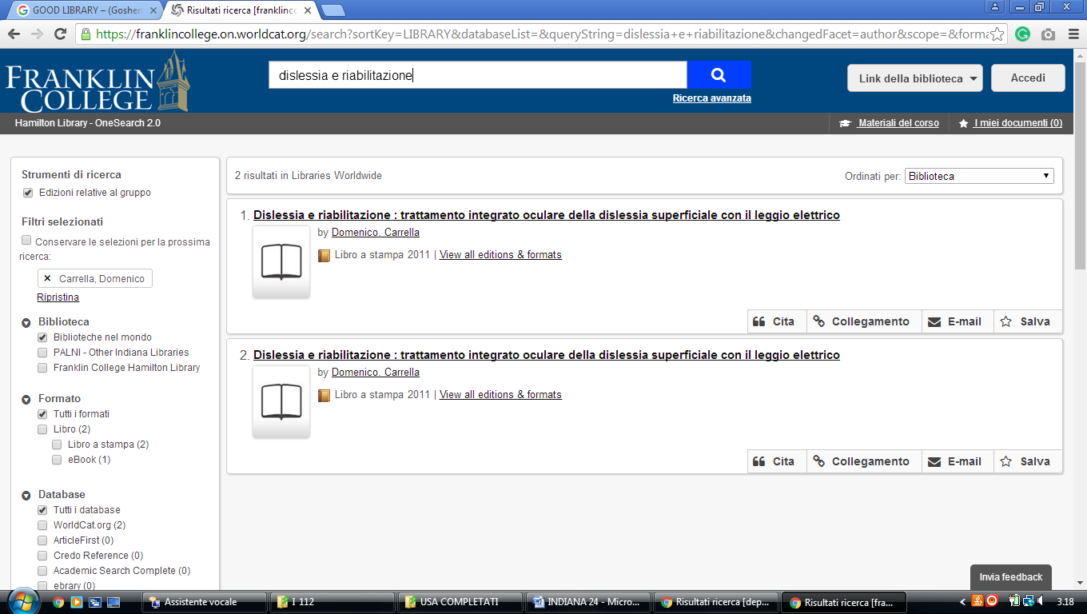

### 13 [KRANNERT MEMORIAL LIBRARY - UINDY](http://uindy.edu/library/) – (Indianapolis, Indiana, Usa)

<https://uindy.on.worldcat.org/search?sortKey=LIBRARY_PLUS_RELEVANCE&queryString=dislessia+e+riabilitazione&scope=&format=Book&subformat=Book%253A%253Abook_printbook&subformat=Book%3A%3Abook_digital&subformat=Book%3A%3Abook_thsis&subformat=Book%3A%3Abook_mic&subformat=Book%3A%3Abook_largeprint&subformat=Book%3A%3Abook_braille&subformat=Book%3A%3Abook_continuing>

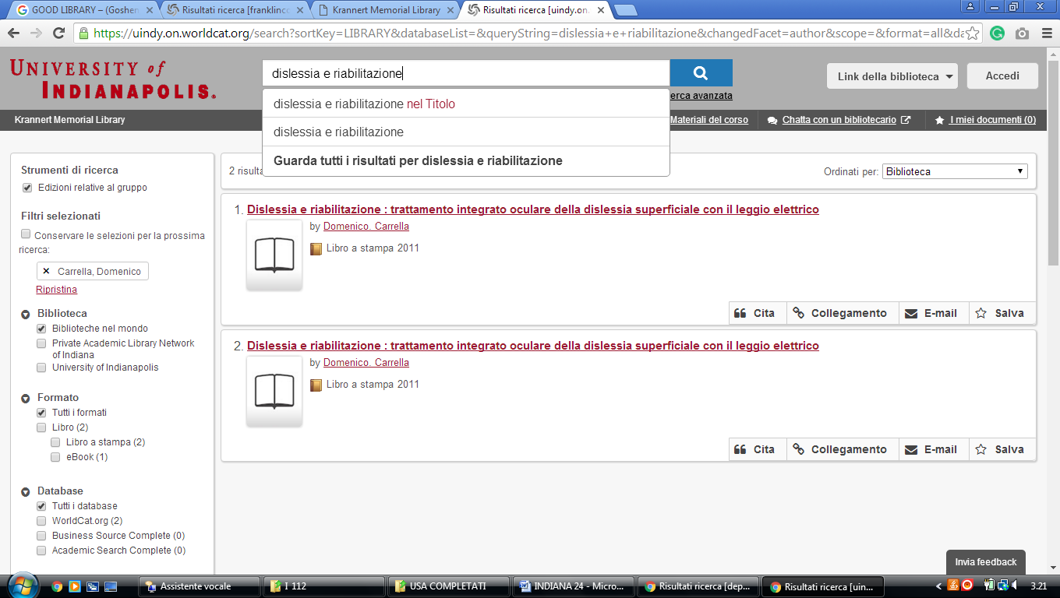

**14** [**LEE AND JIM VANN LIBRARY**](http://www.sf.edu/sf/library/) - (Fort Wayne, Indiana, Usa)

<https://uindy.on.worldcat.org/search?sortKey=LIBRARY&databaseList=&queryString=dislessia+e+riabilitazione&changedFacet=author&scope=&format=all&database=all&author=Carrella%2C+Domenico&year=all&yearFrom=&yearTo=&language=all&topic=all>

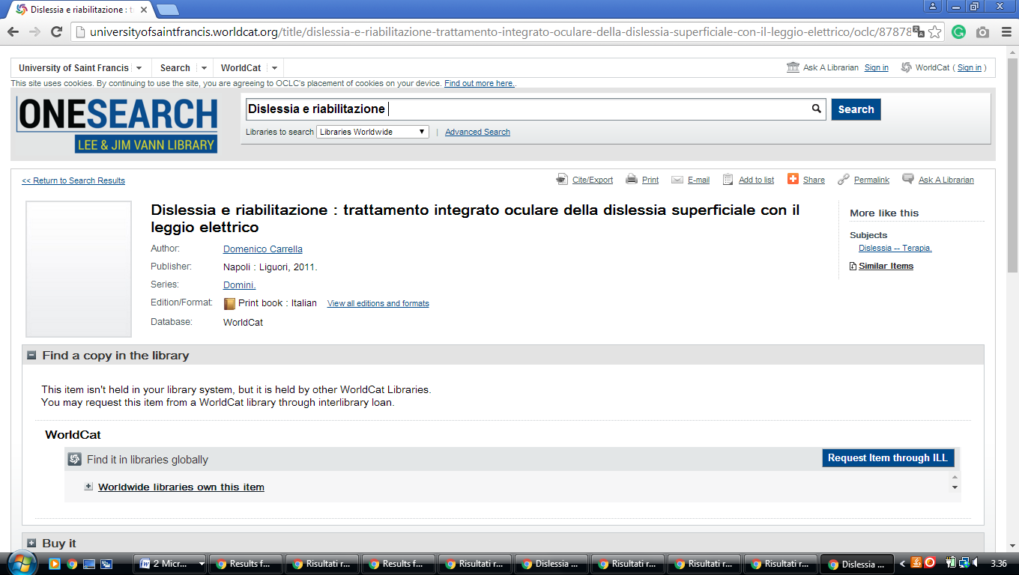

**15** [**MANCHESTER UNIVERSITY FUNDERBURG LIBRARY**](http://www.manchester.edu/OAA/Library/index.htm) - (Indiana, Usa)

<https://manchester.on.worldcat.org/search?queryString=dislessia+e+riabilitazione&databaseList=283>

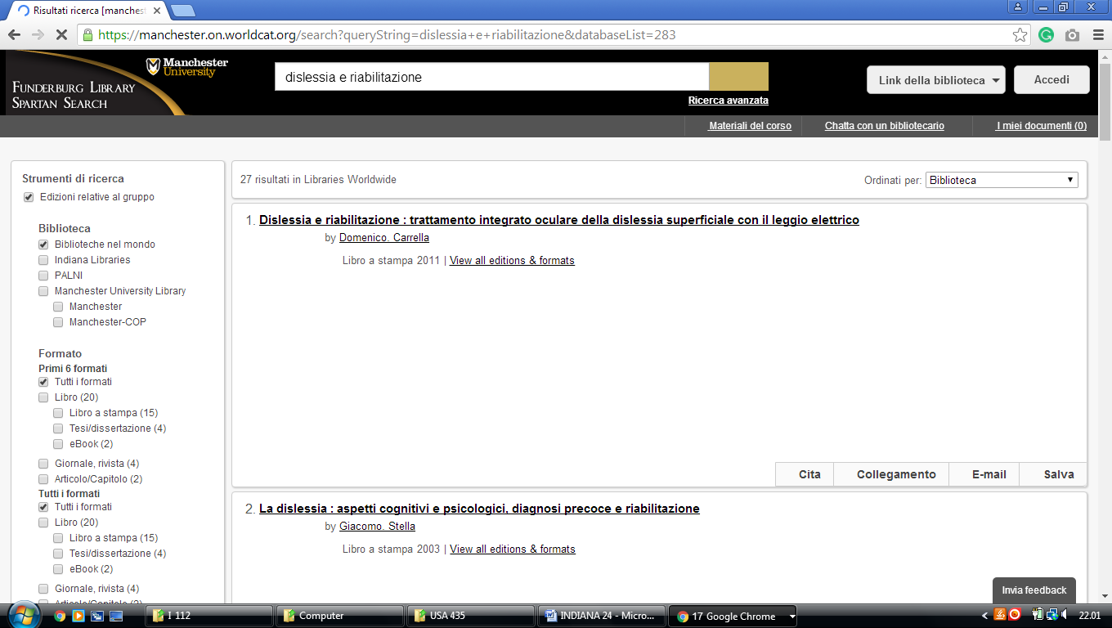

**16** [**MOTHER THERESA HACKELMEIER**](http://www.marian.edu/library/Pages/default.aspx) **LIBRARY MEMORIAL** - (Indiana, Usa)

<https://marianunivindianapolis.on.worldcat.org/search?sortKey=LIBRARY&databaseList=&queryString=dislessia+e+riabilitazione&changedFacet=author&scope=&format=all&database=all&author=Carrella%2C+Domenico&year=all&yearFrom=&yearTo=&language=all&topic=all>

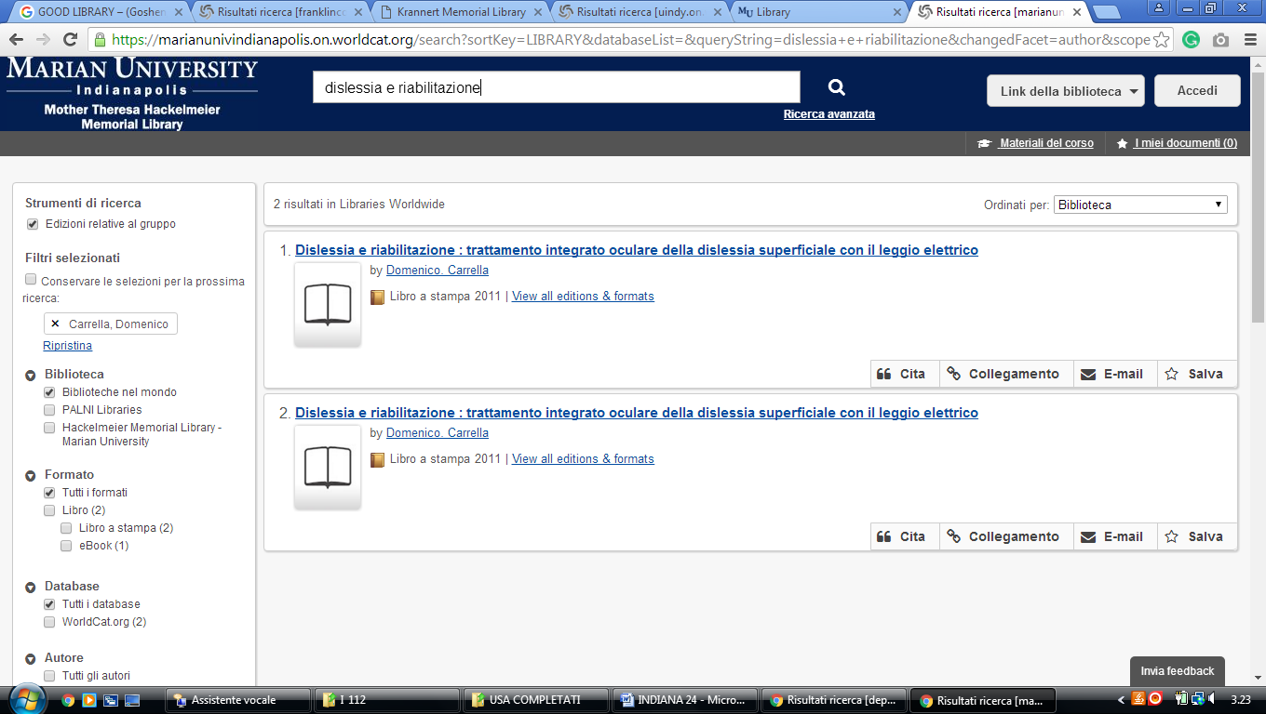

**17** [**NICHOLSON LIBRARY**](http://library.anderson.edu/) - (Indiana, Usa)

<https://anderson.on.worldcat.org/search?sortKey=LIBRARY_PLUS_RELEVANCE&databaseList=1708%2C1920%2C2513%2C197%2C2175%2C1978%2C1736%2C638%2C283%2C1279%2C1719&queryString=dislessia+e+riabilitazione&format=Book&format=Msscr&format=Jrnl&subformat=Book%3A%3Abook_printbook&subformat=Book%3A%3Abook_digital&subformat=Book%3A%3Abook_thsis&subformat=Book%3A%3Abook_mic&subformat=Book%3A%3Abook_largeprint&subformat=Book%3A%3Abook_braille&author=all&year=all&yearFrom=&yearTo=&language=all&scope>=

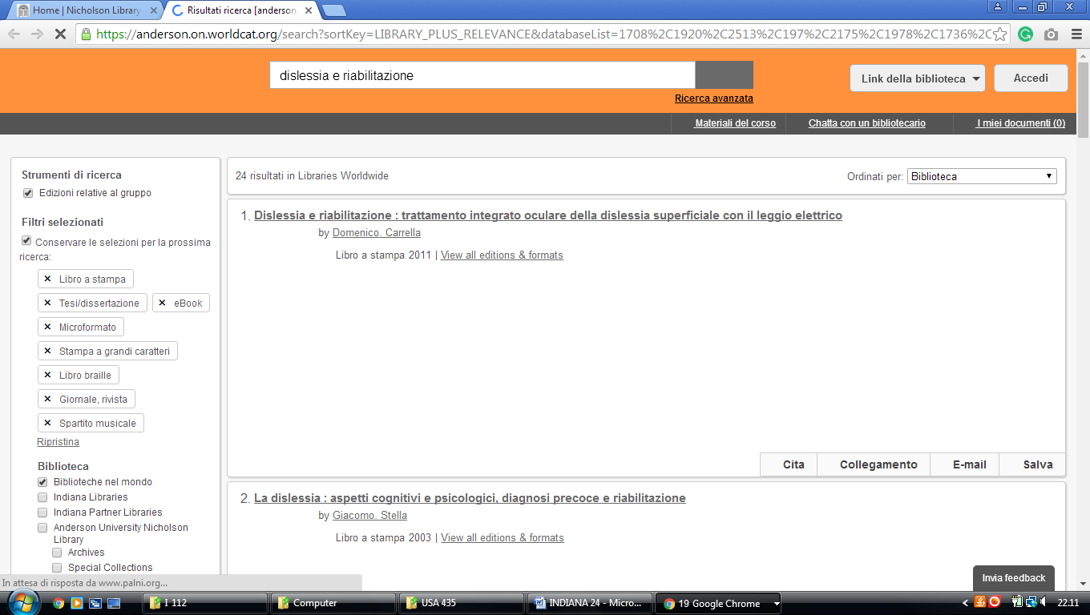

**18** [**RICHLYN LIBRARY**](http://www.huntington.edu/library/) - (Huntington, Indiana, Usa)

<http://huntington.worldcat.org/search?qt=wc_org_huntington&q=dislessia+e+riabilitazione&scope=0&oldscope=&wcsbtn2w=Search&fq=&dblist=638>

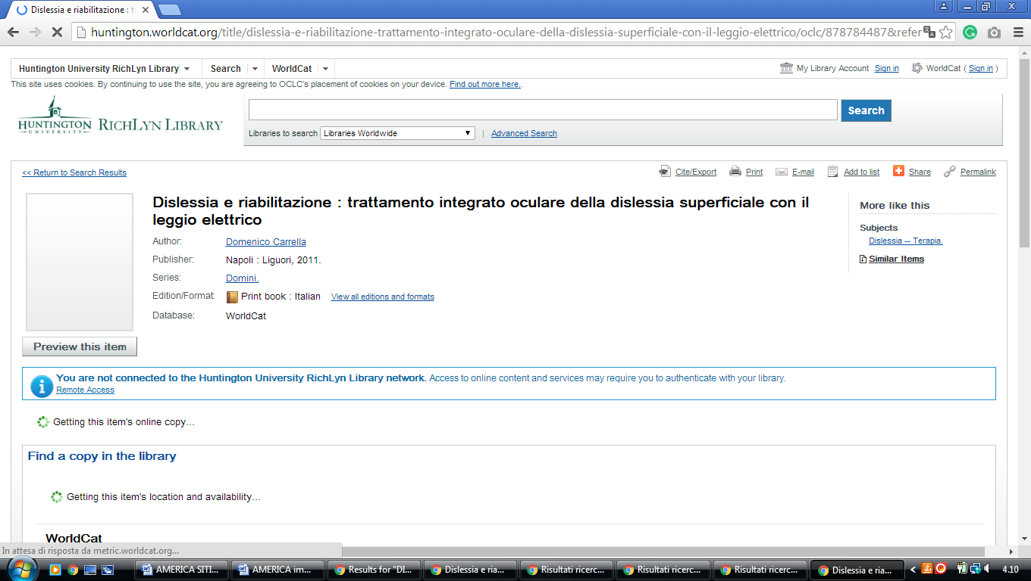

**19** [**VINCENNES UNIVERSITY LIBRARIES**](http://www.vinu.edu/libraries) – (Vincennes, Indiana, Usa)

<https://vinu.worldcat.org/search?q=dislessia+e+riabilitazione&qt=results_page&dblist=638&scope=0&oldscope=3&fq>=

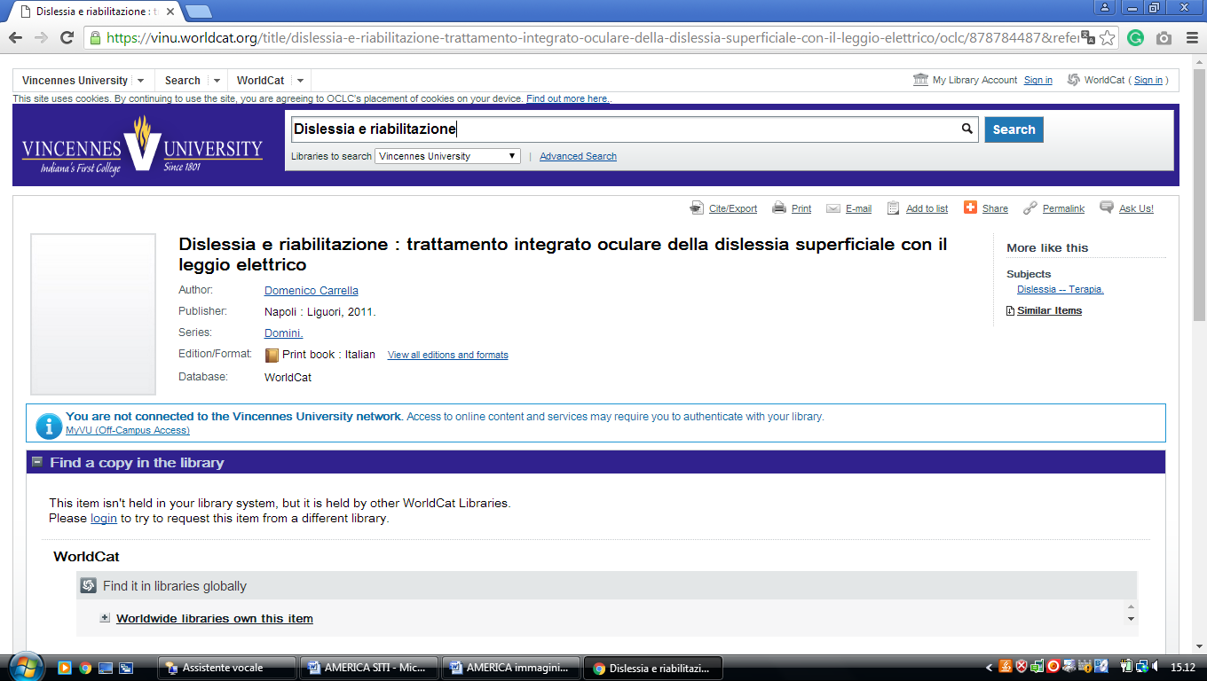

**20** [**WALTHER LIBRARY**](http://www.ctsfw.edu/library/) – (Ft. Wayne, Indiana, Usa)

<https://ctsfw.on.worldcat.org/search?sortKey=LIBRARY&databaseList=&queryString=dislessia+e+riabilitazione&changedFacet=author&scope=&format=all&database=all&author=Carrella%2C+Domenico&year=all&yearFrom=&yearTo=&language=all&topic=all>

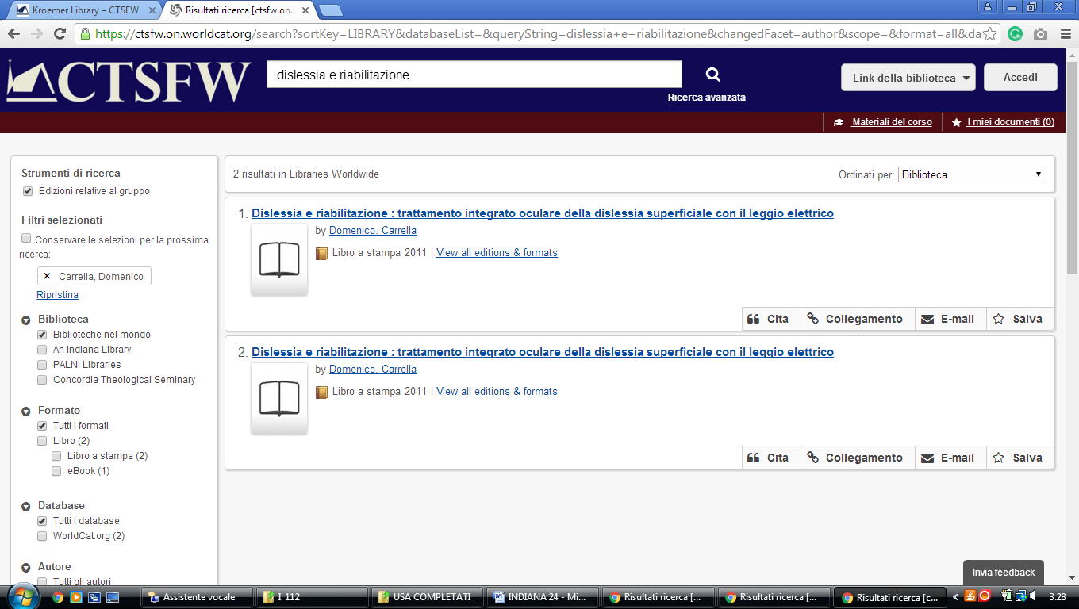

**21** [**ZONDERVAN LIBRARY**](http://library.taylor.edu/) - (Upland, Indiana, Usa)

<http://taylor.worldcat.org/search?dblist=283&q=dislessia+e+riabilitazione&Search=Search>

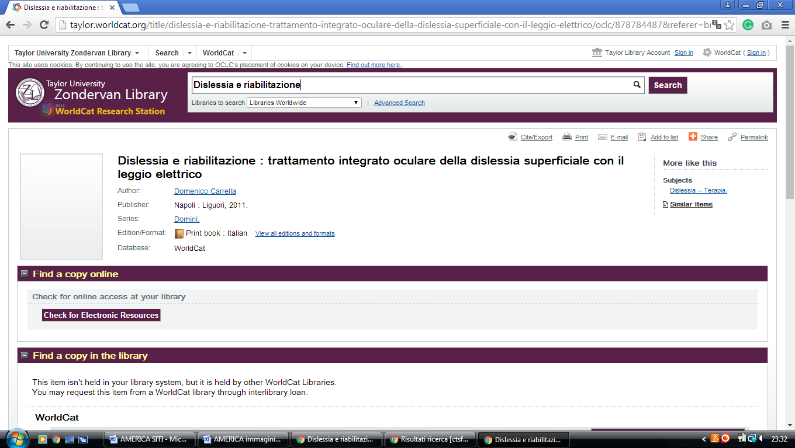

**22**  [**COLE LIBRARY**](http://www.cornellcollege.edu/library/) - (Mount Vernon, Indiana, Usa)

<http://colelibrary.worldcat.org/search?q=dislessia+e+riabilitazione>

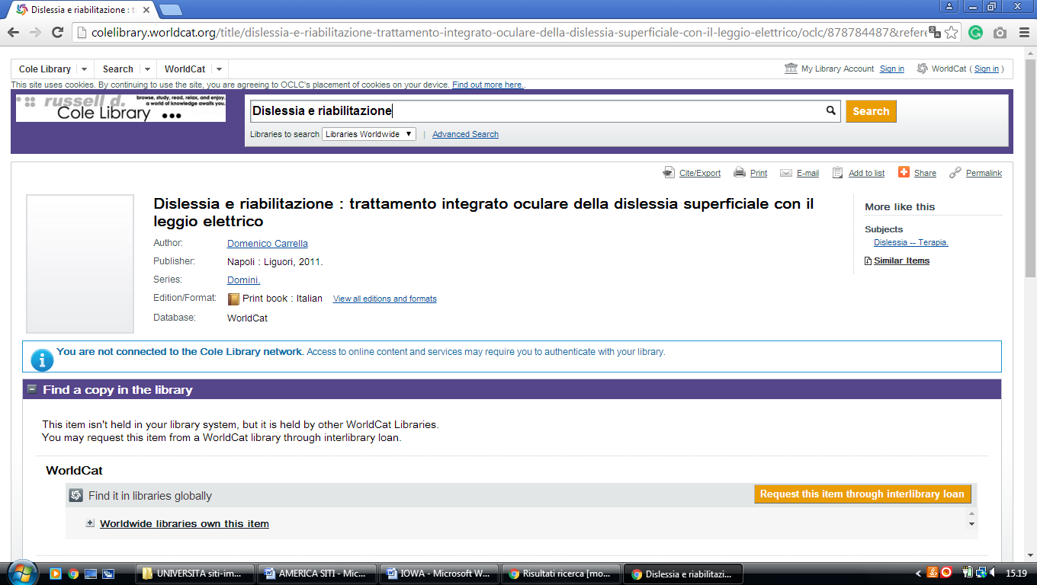

### [Purdue Libraries - Purdue University West Lafayette](https://www.lib.purdue.edu/)

https://purdueuniversity.on.worldcat.org/search?databaseList=&queryString=dislessia%20e%20riabilitazione

