**ILLINOIS = 21**

### 1 BUSWELL LIBRARY - (Wheaton, Illinois, Usa)

<https://buswell.on.worldcat.org/search?sortKey=LIBRARY&databaseList=&queryString=dislessia+e+riabilitazione&changedFacet=scope&scope=&format=all&database=all&author=all&year=all&yearFrom=&yearTo=&language=all&topic=all>

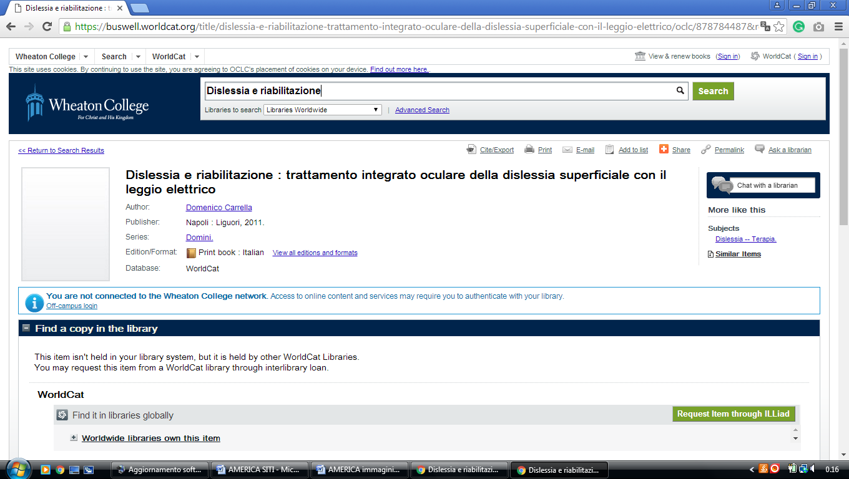

### 2 [THE LIBRARY AT CATHOLIC THEOLOGICAL UNION – A GRADUATE SCHOOL OF ...](http://library.ctu.edu/) – (Illinois, Usa)

<https://ctulibrary.on.worldcat.org/search?sortKey=LIBRARY&databaseList=&queryString=dislessia+e+riabilitazione&changedFacet=author&scope=&format=all&database=all&author=Carrella%2C+Domenico&year=all&yearFrom=&yearTo=&language=all&topic=all>

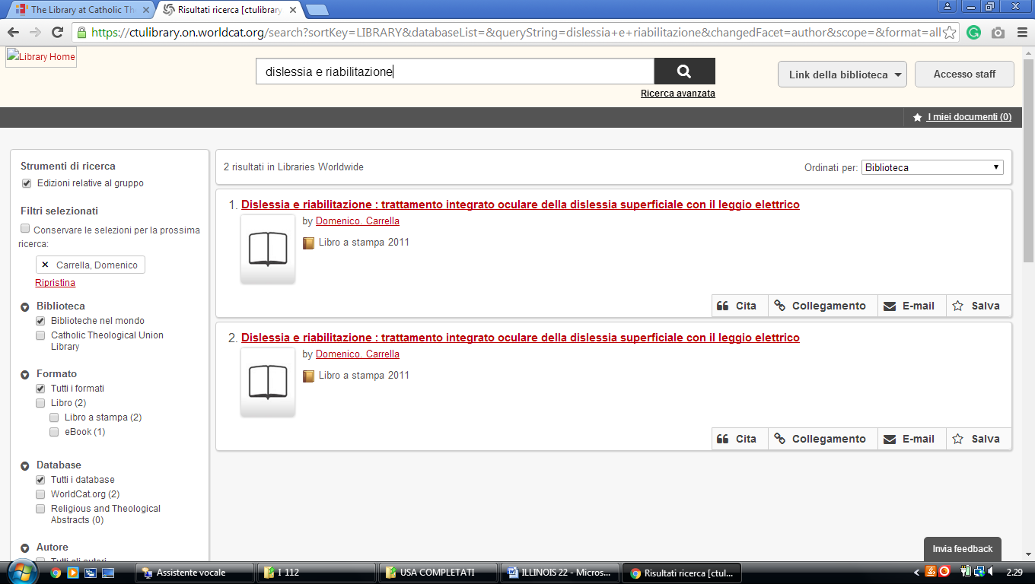

### 3 [LIBRARY - THE CHICAGO SCHOOL OF PROFESSIONAL PSYCHOLOGY](https://www.thechicagoschool.edu/library/)

# (Chicago Library, Usa)

<https://thechicagoschool-chi.worldcat.org/title/dislessia-e-riabilitazione-trattamento-integrato-oculare-della-dislessia-superficiale-con-il-leggio-elettrico/oclc/878784487&referer=brief_results>

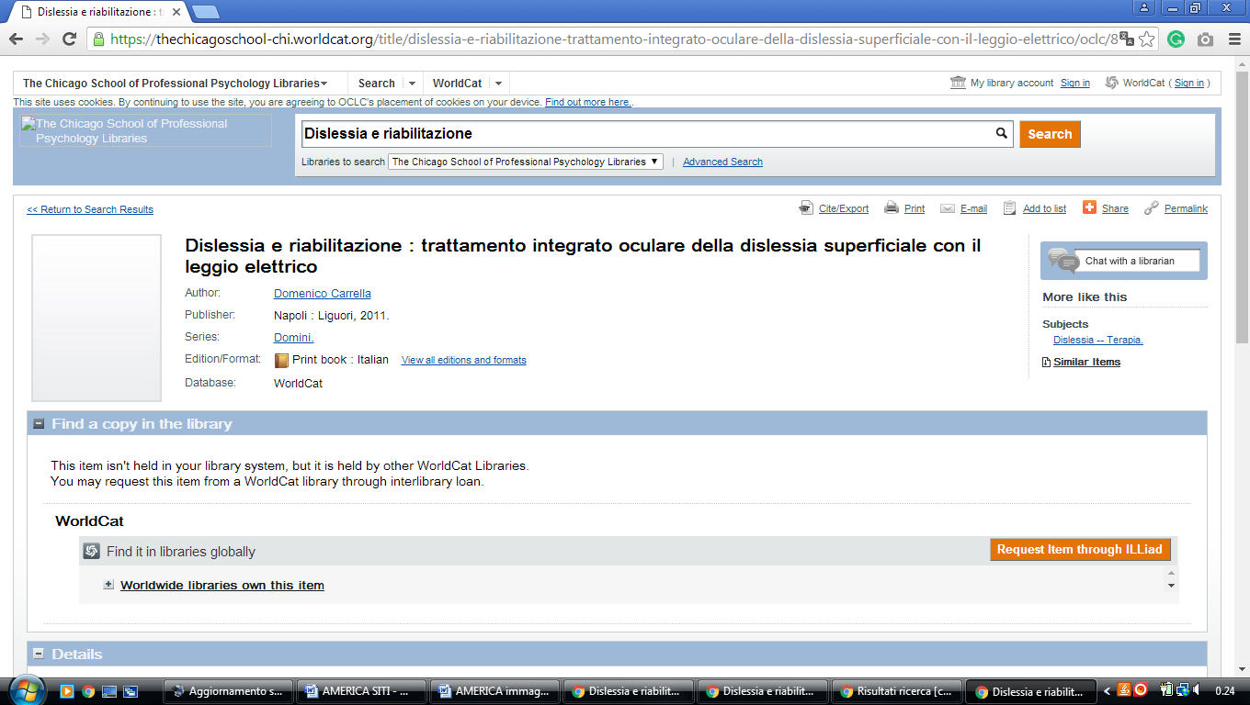

**4** [**COLLEGE OF DUPAGE LIBRARY**](https://www.cod.edu/library/) - (Glen Ellyn, Illinois, Usa)

<https://cod.on.worldcat.org/search?sortKey=BEST_MATCH&databaseList=&queryString=dislessia+e+riabilitazione&changedFacet=author&clusterResults=on&stickyFacetsChecked=on&scope=&subformat=Book%3A%3Abook_printbook&subformat=Book%3A%3Abook_digital&subformat=Book%3A%3Abook_largeprint&subformat=Book%3A%3Abook_braille&subformat=Book%3A%3Abook_continuing&format=Jrnl&format=Audiobook&subformat=Video%3A%3Avideo_dvd&subformat=Video%3A%3Avideo_vhs&subformat=Video%3A%3Avideo_film&subformat=Video%3A%3Avideo_digital&subformat=Video%3A%3Avideo_bluray&database=all&author=Carrella%2C+Domenico&year=all&yearFrom=&yearTo=&language=all&topic=all>

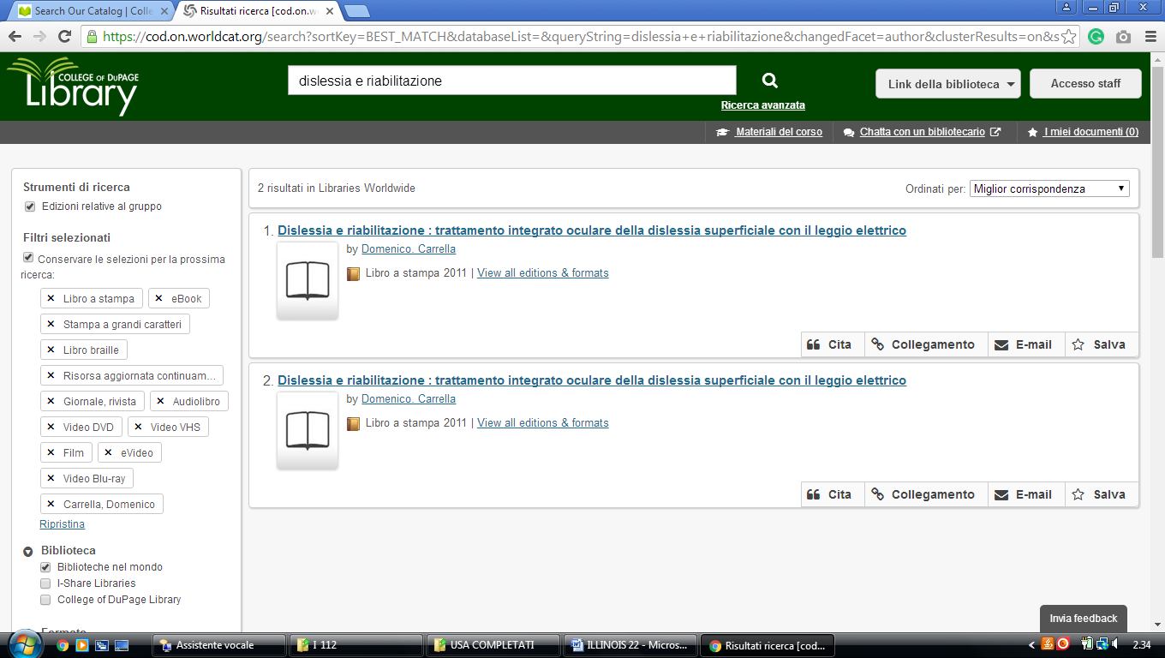

**5** [**DOMINICAN UNIVERSITY LIBRARY**](http://www.dom.edu/library) - (River Forest, Illinois, Usa)

<http://dom.worldcat.org/search?q=dislessia+e+riabilitazione&qt=results_page&dblist=638&scope=0&oldscope=2>

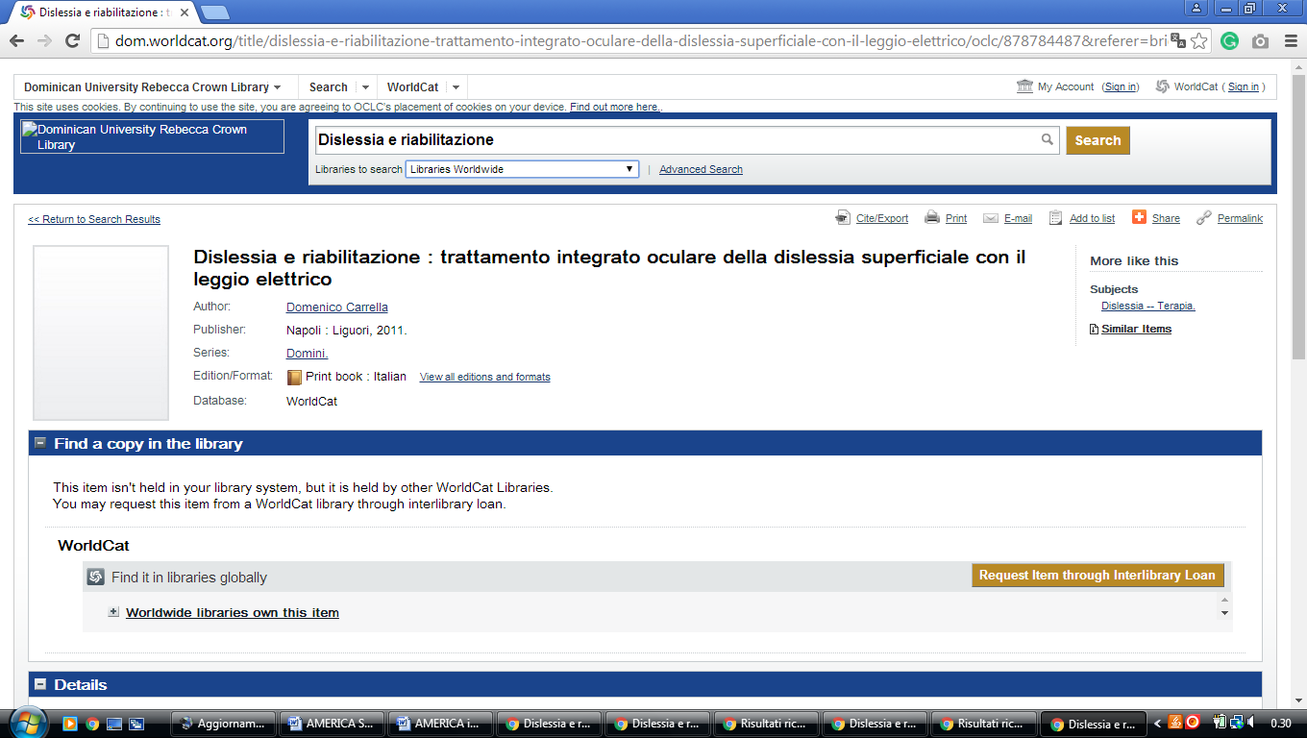

### 6 [HARPER COLLEGE LIBRARY](http://dept.harpercollege.edu/library/) - (Palatine, Illinois, Usa)

<http://harpercollege.summon.serialssolutions.com/search?s.q=dislessia+e+riabilitazione#!/search?ho=f&l=en&q=dislessia%20e%20riabilitazione>

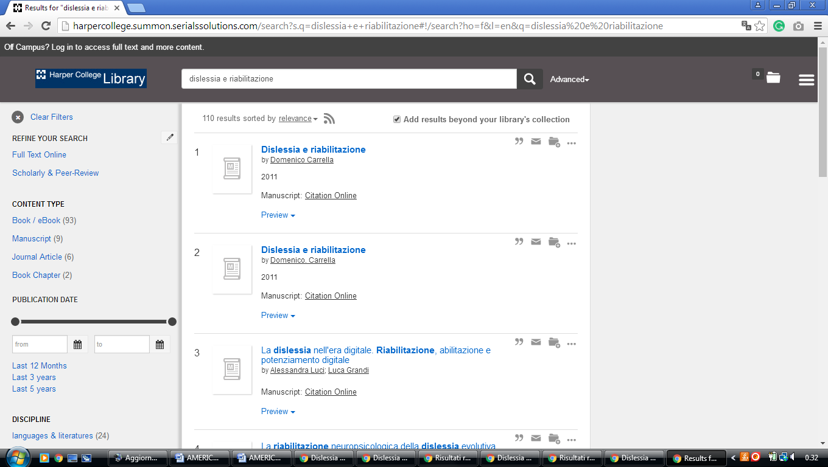

**7** [**LAKE LAND COLLEGE LIBRARY**](http://www.lakeland.cc.il.us/as/ls/index.cfm) - (Mattoon, Illinois, Usa)

<http://lakelandcollege.summon.serialssolutions.com/search?s.q=dislessia+e+riabilitazione&submit=Search+SUMMON#!/search?ho=f&l=en&q=dislessia%20e%20riabilitazione>

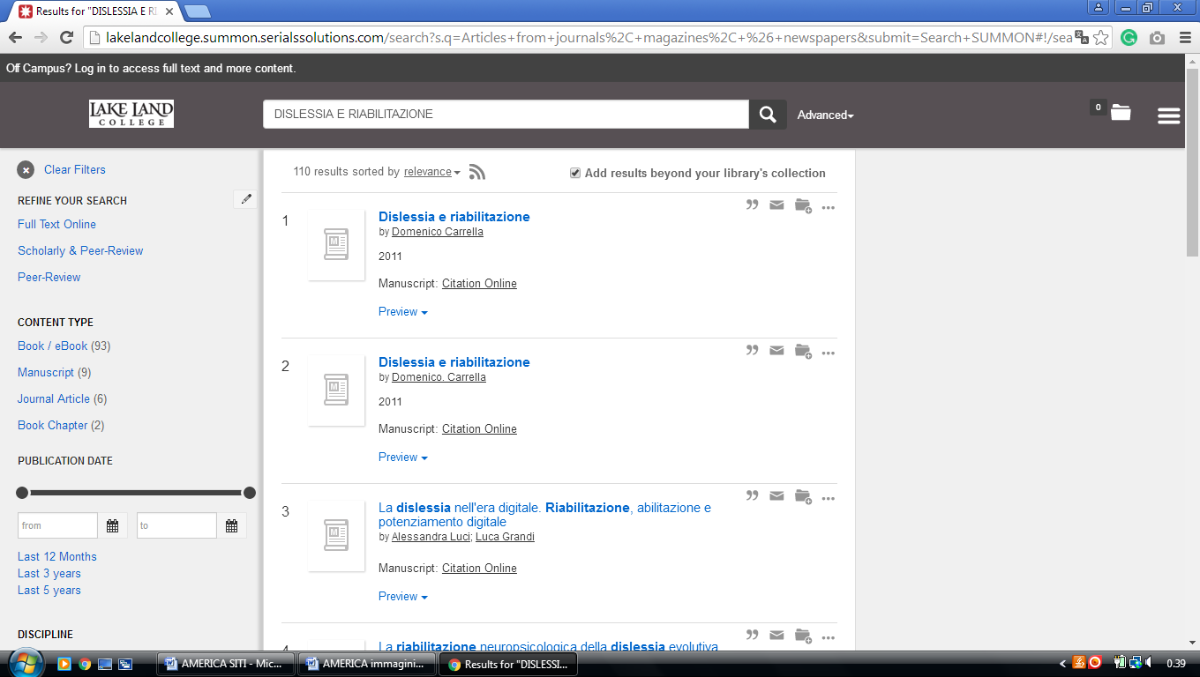

**8** [**LEWIS UNIVERSITY LIBRARY**](http://www.lewisu.edu/academics/library/) - (Romeoville, Illinois, Usa)

<http://lewisu.summon.serialssolutions.com/?#!/search?ho=f&l=en&q=dislessia%20e%20riabilitazione>

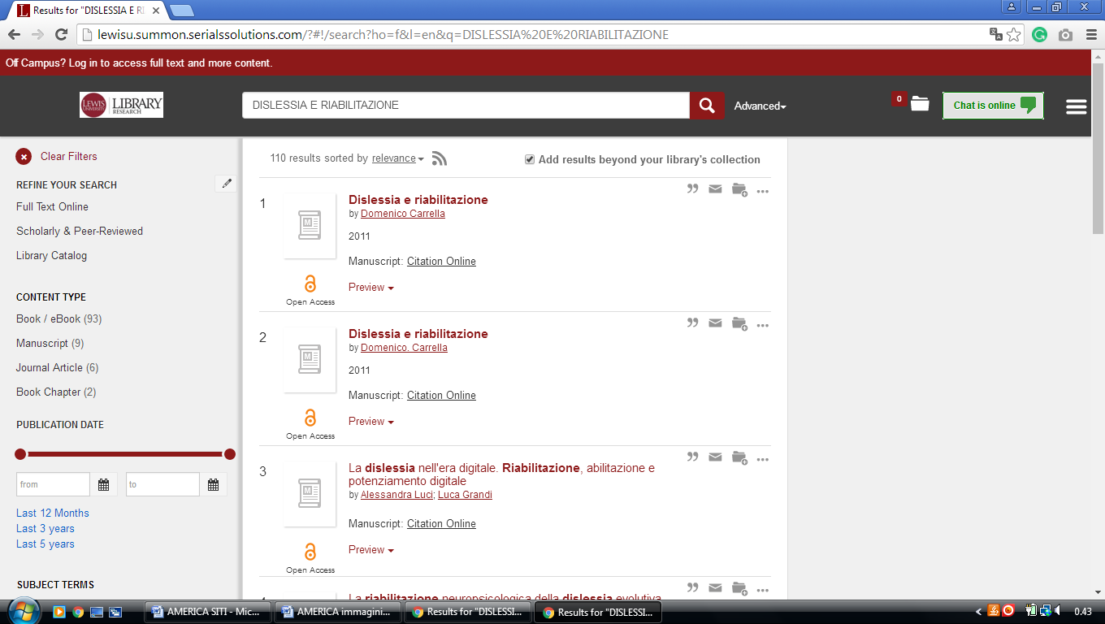

**9** [**LOYOLA UNIVERSITY CHICAGO LIBRARIES –**](http://libraries.luc.edu/) (Chicago, Illinois, Usa)

<http://luclibrary.worldcat.org/search?qt=wc_org_luclibrary&q=dislessia+e+riabilitazione&scope=0&oldscope=&wcsbtn2w=Search&dblist=283>

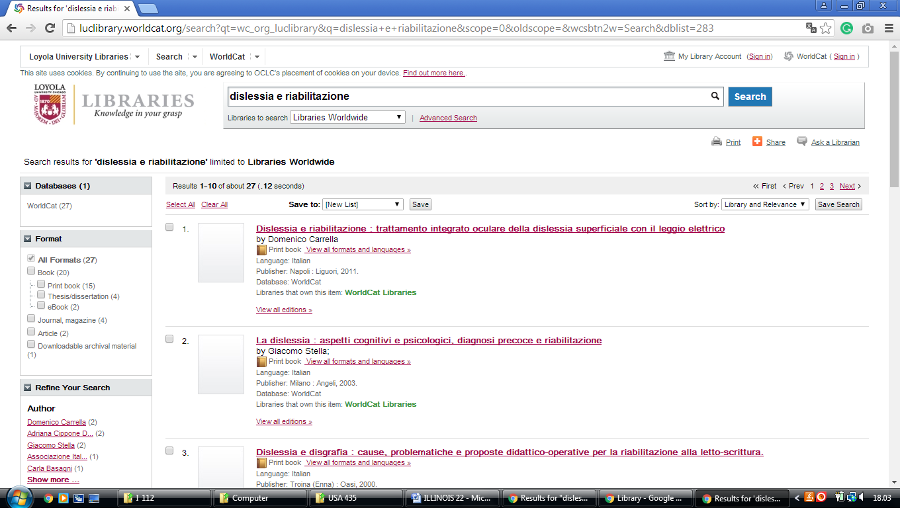

**10** [**NEIU RONALD WILLIAMS LIBRARY**](http://library.neiu.edu/) – (Chicago, Illinois, Usa)

<https://neiulibrary.worldcat.org/search?q=dislessia+e+riabilitazione>

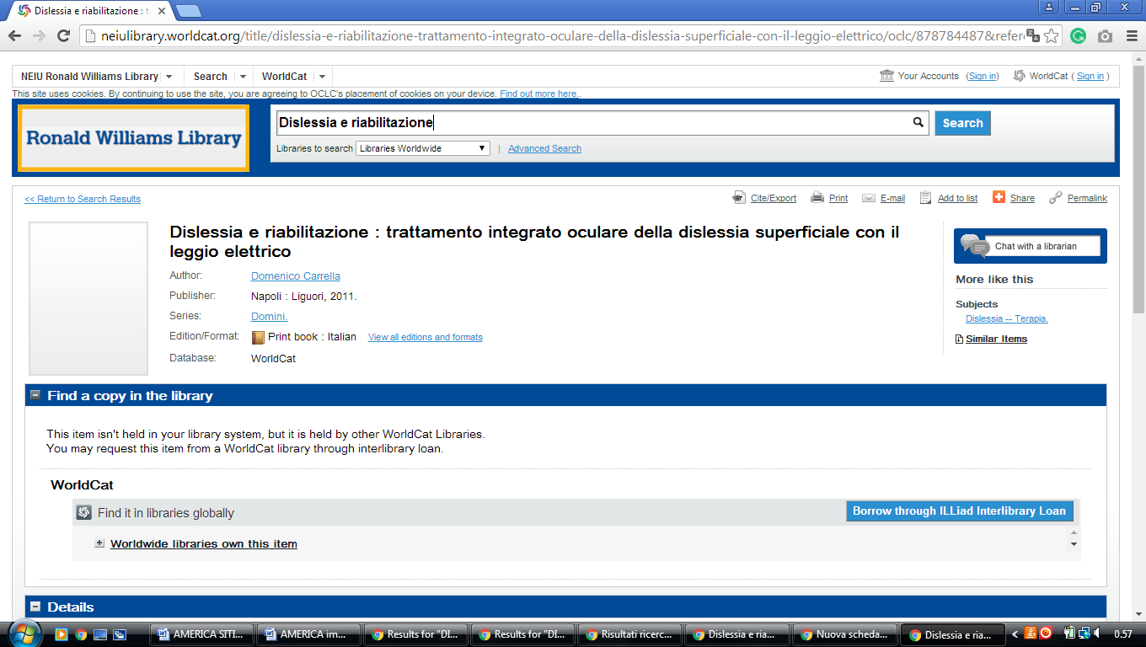

### 11 [BROOKENS LIBRARY: HOME](https://library.uis.edu/) – (Springfield, Illinois, Usa)

<https://uisbrookenslibrary.on.worldcat.org/search?sortKey=LIBRARY&databaseList=&queryString=dislessia+e+riabilitazione&changedFacet=author&scope=&format=all&database=all&author=Carrella%2C+Domenico&year=all&yearFrom=&yearTo=&language=all&topic=all>

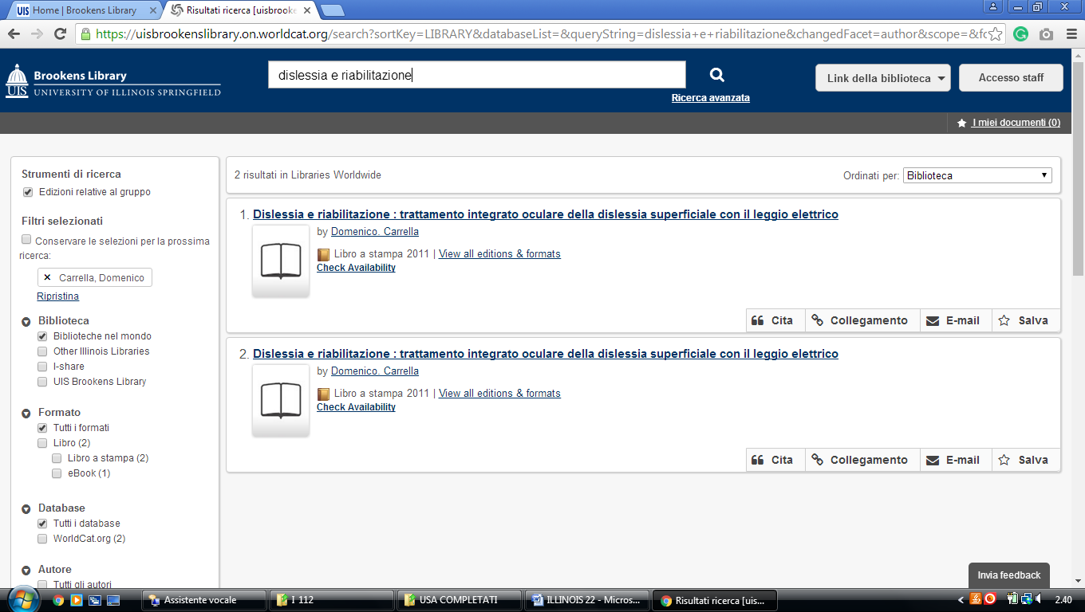

### 12 [LIBRARY & LEARNING SUPPORT - NATIONAL LOUISS UNIVERSITY](https://www.google.it/search?rlz=1C1CHIK_itIT460IT464&q=Library+%26+Learning+Support+-+National+Louiss+University&spell=1&sa=X&ved=0ahUKEwjJnIDv-pPVAhXJvxQKHV5PDqcQBQgjKAA) WHEATON – (ILL. Usa)

<https://national.worldcat.org/search?qt=affiliate&ai=wclocal_national&q=dislessia+e+riabilitazione&wcsbtn2w=Go&scope=0&oldscope>=

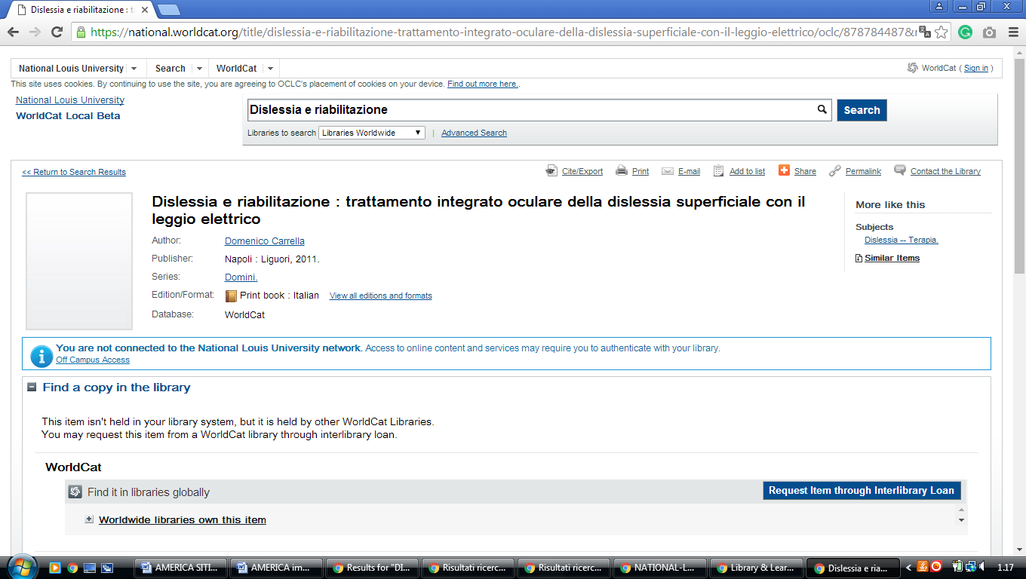

**13** [**ROOSEVELT UNIVERSITY LIBRARY**](http://www.roosevelt.edu/Library.aspx) – (Chicago, Illinois, Usa)

<http://roosevelt.summon.serialssolutions.com/search?s.q=dislessia+e+riabilitazione&fvf=#!/search?ho=f&l=en&q=dislessia%20e%20riabilitazione>

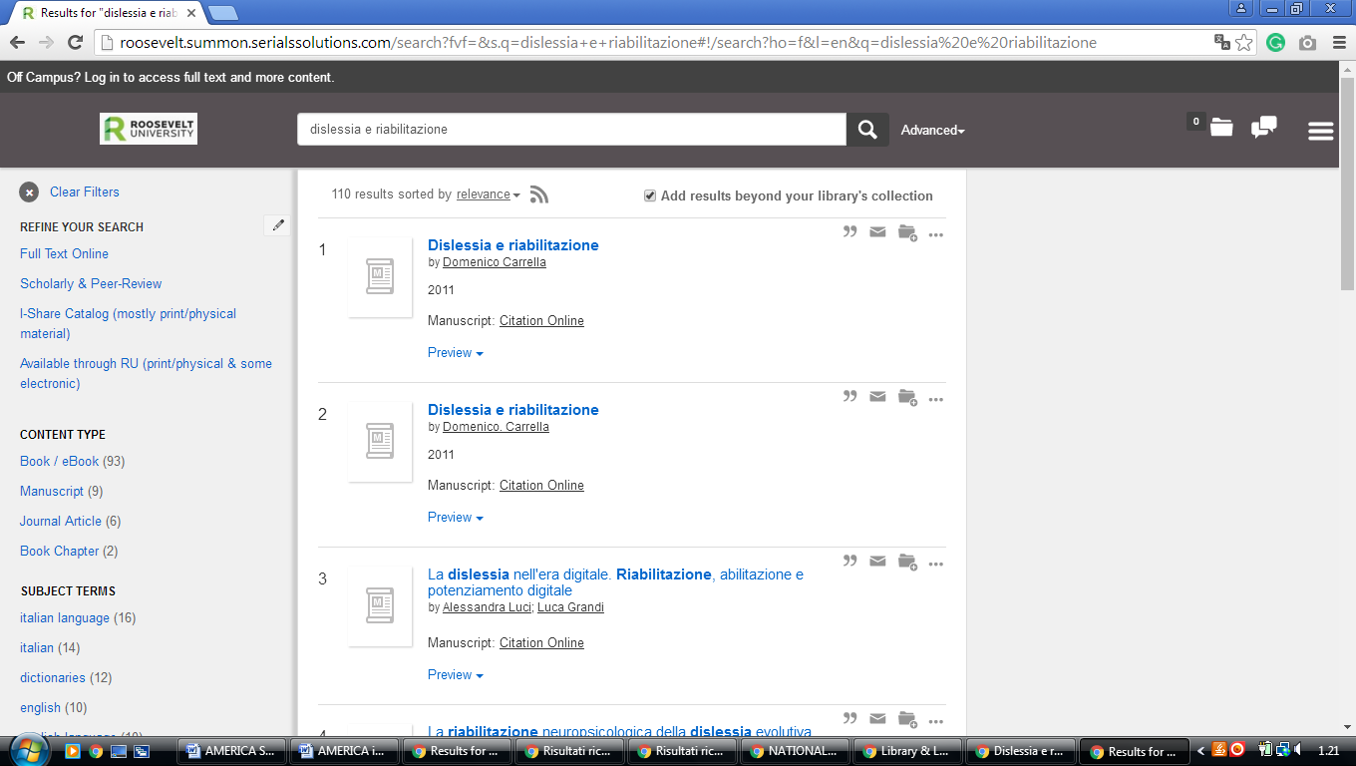

**14** [**SOUTHERN ILLINOIS UNIVERSITY EDWARDSVILLE LOVEJOY LIBRARY - WORLDCAT**](http://siue.worldcat.org/m)  [- (Edwardsville](https://en.wikipedia.org/wiki/Edwardsville,_Illinois), [Illinois](https://en.wikipedia.org/wiki/Illinois), Usa)

### <http://siue.worldcat.org/search?qt=wc_org_siue&q=dislessia++e+riabilitazione&scope=0&oldscope=&wcsbtn2w=Search&dblist=638>

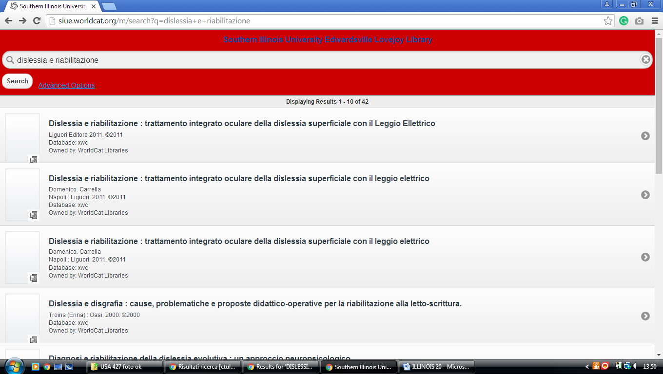

**15 UNIVERSITY OF ILLINOIS LIBRARY URBANA-**[**CHAMPAIGN**](https://www.google.it/search?rlz=1C1CHIK_itIT460IT464&q=UNIVERSITY+OF+ILLINOIS+LIBRARY+URBANA-CHAMPAIGN&spell=1&sa=X&ved=0ahUKEwitiZD01JTZAhXLCMAKHaApCEcQkeECCCQoAA) **-**

### <https://uiuclib.on.worldcat.org/search?databaseList=&queryString=dislessia+e+riabilitazione>

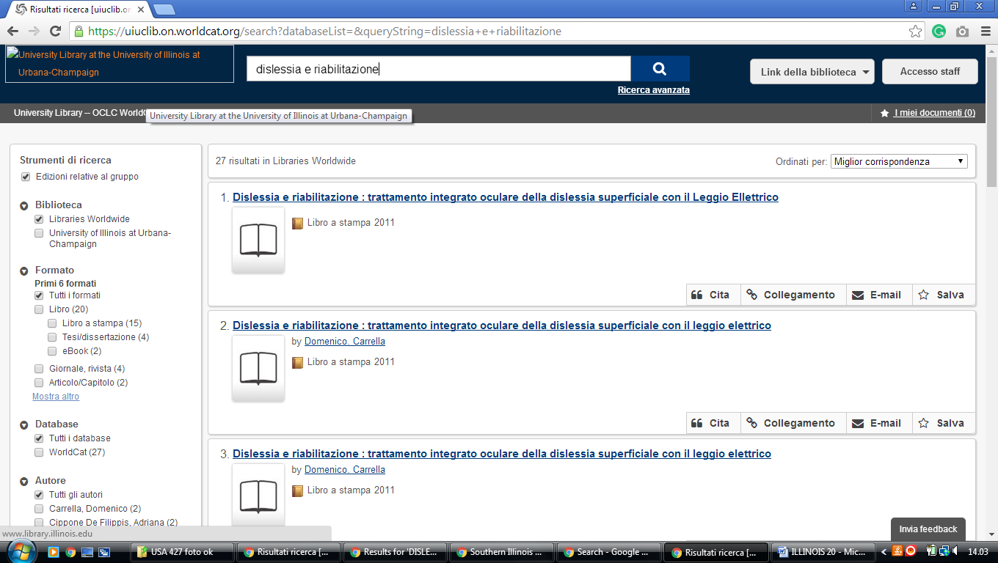

# 16 WIULIBRARIES.WORLDCAT.ORG - (Western Illinois [University](http://www.wiu.edu/) Libraries Macomb, ILL)

# <http://wiulibraries.worldcat.org/search?qt=wc_org_wiulibraries&q=dislessia+e+riabilitazione&scope=0&oldscope=&wcsbtn2w=Search>

# 

# 

### 17 [INTERLIBRARY LOAN - RESEARCH GUIDES AT BRANDEIS UNIVERSITY](http://guides.library.brandeis.edu/interlibraryloan) - (Brandeis University Libraries Peoria, illinois Usa)

<https://brandeis.on.worldcat.org/search?sortKey=LIBRARY&databaseList=&queryString=dislessia+e+riabilitazione&changedFacet=author&scope=&format=all&database=all&author=Carrella%2C+Domenico&year=all&yearFrom=&yearTo=&language=all&topic=all>

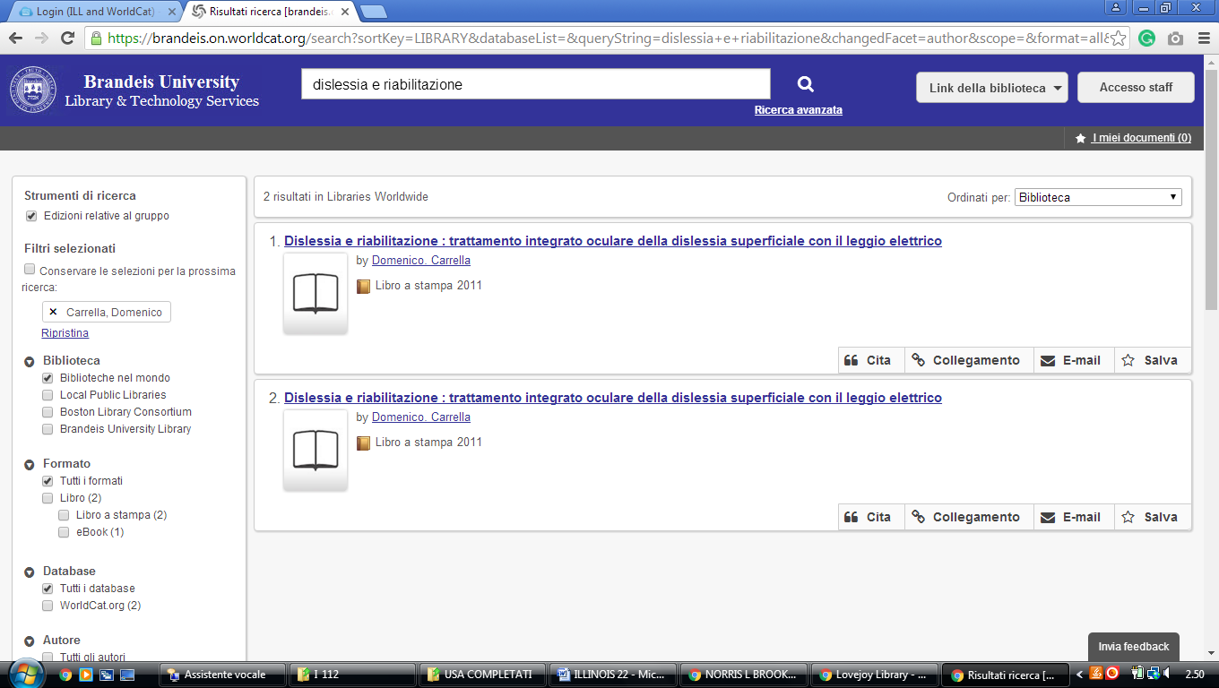

**18 CHICAGO STATE UNIVERSITY LIBRARY** – ([Illinois](https://it.wikipedia.org/wiki/Illinois), Usa)

<http://csulibrary.worldcat.org/title/dislessia-e-riabilitazione-trattamento-integrato-oculare-della-dislessia-superficiale-con-il-leggio-elettrico/oclc/878784487&referer=brief_results>

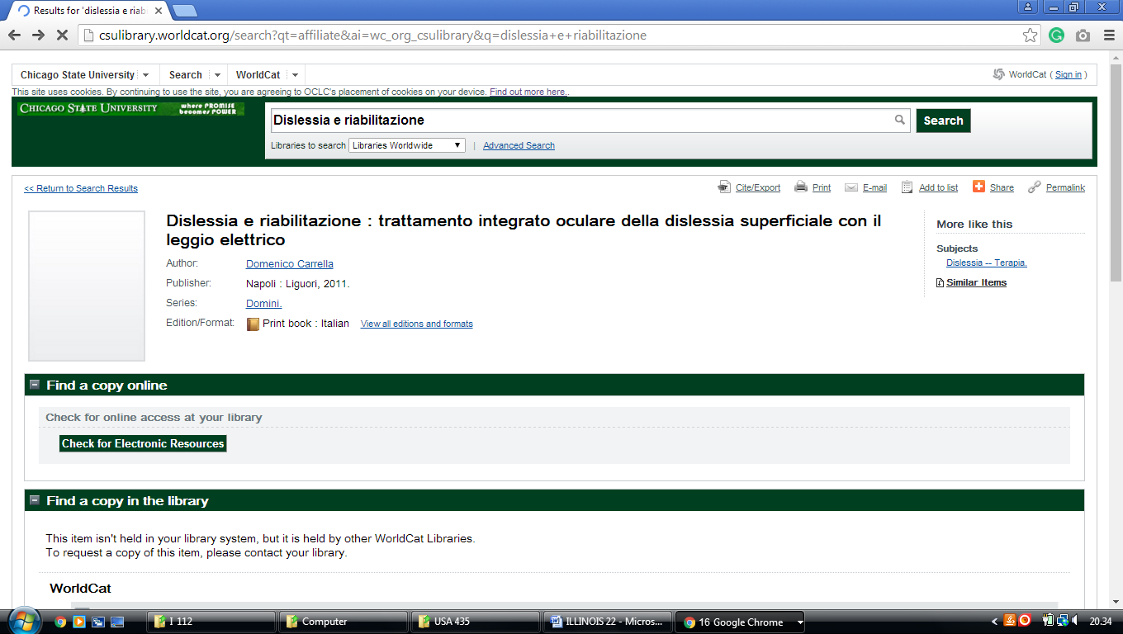

**19 DEPAUL UNIVERSITY LIBRARIES** - ([Chicago](https://it.wikipedia.org/wiki/Chicago), [Illinois](https://en.wikipedia.org/wiki/Illinois), Usa)

<https://depaul.worldcat.org/wcpa/servlet/org.oclc.lac.search.SearchServlet?dblist=2572%2C1708%2C1271%2C1711%2C1953%2C1941%2C1725%2C239%2C1672%2C638&q=dislessia%20e%20riabilitazione&qt=affiliate&scope=0&ai=wclocal_813&fq>=

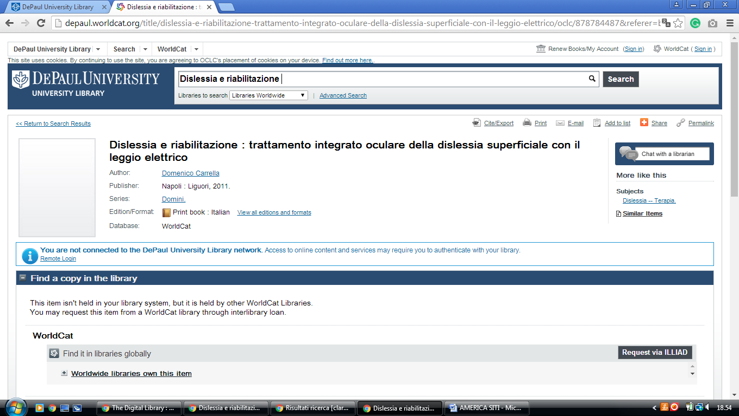

**20** [**HOLMAN LIBRARY | LEBANON, ILLINOIS | MCKENDREE UNIVERSITY**](http://www.mckendree.edu/offices/library/) [(Lebanon](https://en.wikipedia.org/wiki/Lebanon,_Illinois), [Illinois](https://en.wikipedia.org/wiki/Illinois), [Usa).](https://en.wikipedia.org/wiki/United_States)

<http://holman.worldcat.org/search?qt=wc_org_holman&q=dislessia+e+riabilitazione&scope=0&oldscope=&wcsbtn2w=Search&dblist=638>

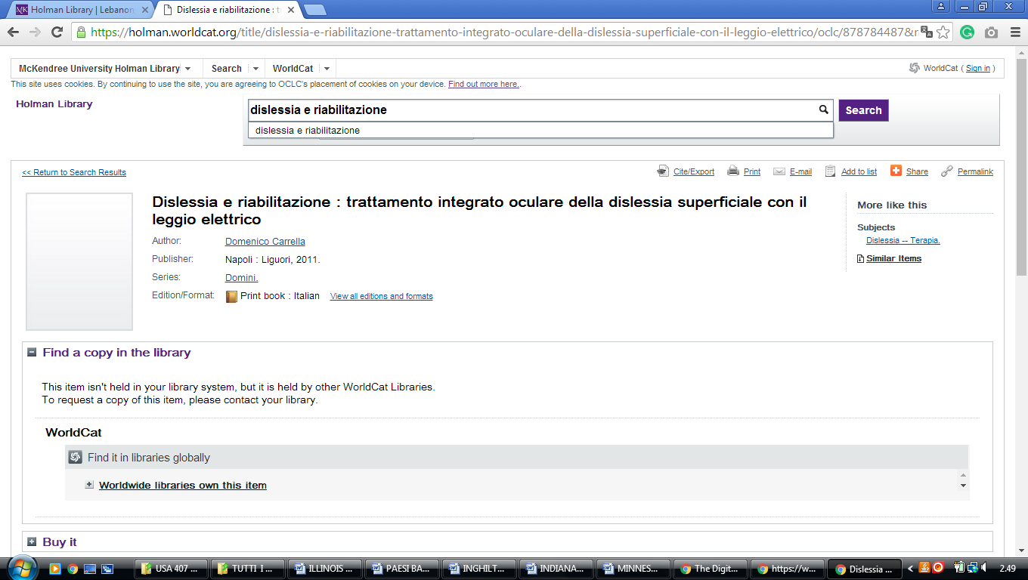

### 21 [HOME - LIBRARY HOME - MWU LIBRARY AT MIDWESTERN UNIVERSITY](https://library.midwestern.edu/). [(Downers Grove, Illinois](https://en.wikipedia.org/wiki/Downers_Grove,_Illinois),Usa)

### <https://midwestern.summon.serialssolutions.com/search?s.q=dislessia+e+riabilitazione&spellcheck=true&keep_r=true#!/search?ho=f&l=en&q=dislessia%20e%20riabilitazione>

