**IDAHO = 3**

### 1 [CRUZEN-MURRAY LIBRARY | THE COLLEGE OF IDAHO](https://www.collegeofidaho.edu/library) - (Caldwell, Idaho, Usa)

<https://collegeofidaho.on.worldcat.org/search?sortKey=LIBRARY&databaseList=&queryString=dislessia+e+riabilitazione&changedFacet=author&scope=&format=all&database=all&author=Carrella%2C+Domenico&year=all&yearFrom=&yearTo=&language=all&topic=all>

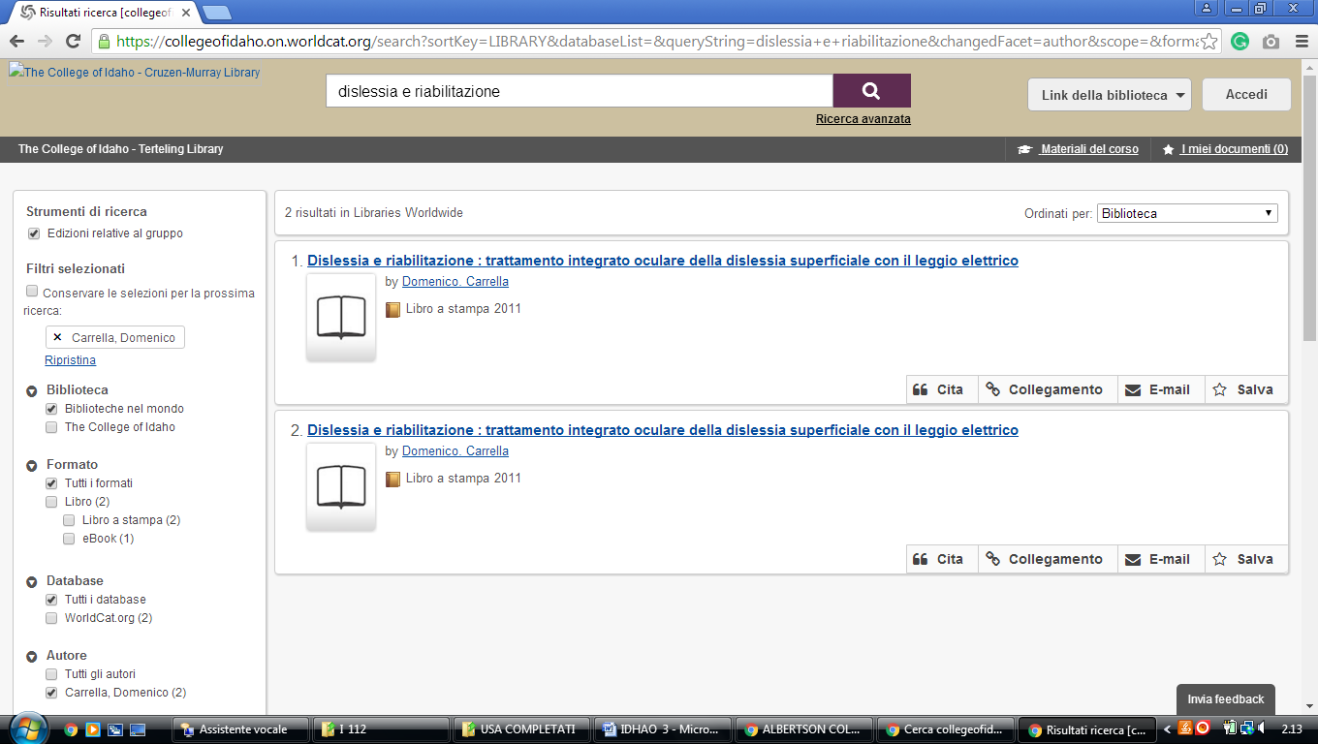

**2**  [**ALBERTSONS LIBRARY**](http://library.boisestate.edu/) - (Boise, Idaho, Usa)

<https://boisestate.worldcat.org/title/dislessia-e-riabilitazione-trattamento-integrato-oculare-della-dislessia-superficiale-con-il-leggio-elettrico/oclc/878784487&referer=brief_results>

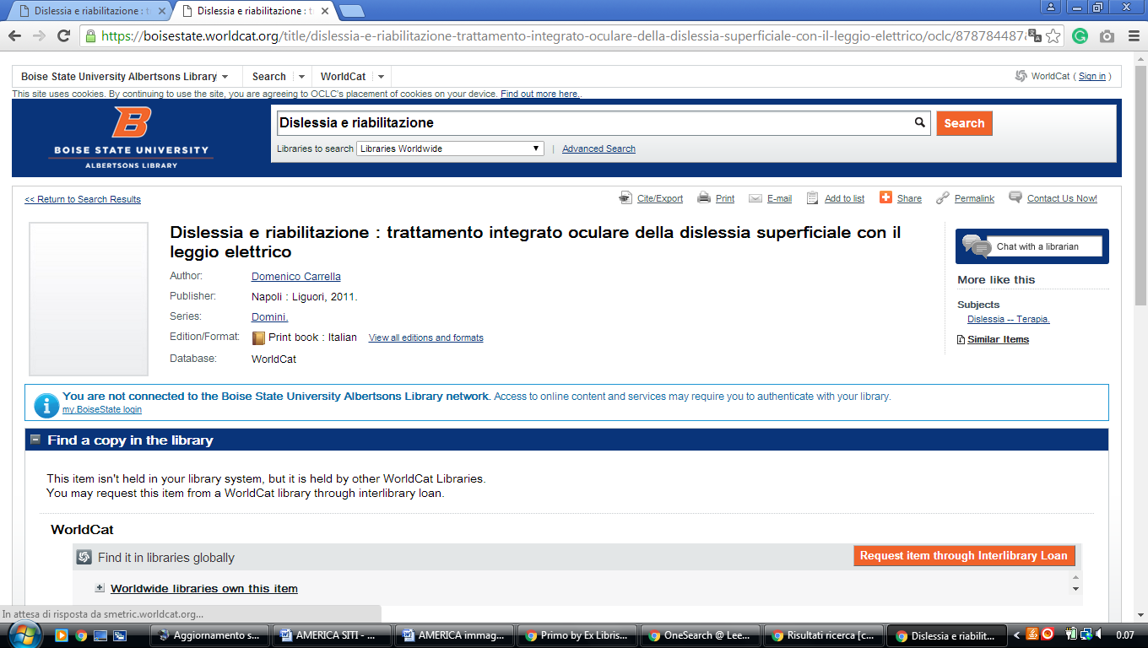

### 3 JOHN E. RILEY LIBRARY - NORTHWEST NAZARENE UNIVERSITY –

 (Nampa, ID, Stati Uniti)

### <https://nnu.on.worldcat.org/search?sortKey=LIBRARY&databaseList=1080%2C2650%2C2572%2C2175%2C2272%2C2229%2C1931%2C2624%2C1996%2C1059%2C2269%2C2620%2C897%2C217%2C1619%2C638%2C1913%2C1912%2C1978%2C1911%2C2626%2C1271%2C283%2C2260%2C1525%2C2217%2C1941%2C2513%2C2138%2C1621%2C2237%2C2676%2C1563%2C1708%2C2616&queryString=dislessia+e+riabilitazione&changedFacet=author&scope=&format=all&database=all&author=Carrella%2C+Domenico&year=all&yearFrom=&yearTo=&language=all&topic=all>

### 

### (Nampa, Idaho, Usa)

<https://nnu.on.worldcat.org/search?queryString=dislessia%20e%20riabilitazione&databaseList=1080,2650,2572,2175,2272,2229,1931,2624,1996,1059,2269,2620,897,217,1619,638,1913,1912,1978,1911,2626,1271,283,2260,1525,2217,1941,2513,2138,1621,2237,2676,1563,1708,2616&page=1&queryType=search&stickyFacetsChecked=false#/oclc/878784487>