**GEORGIA = 6**

**1** [**BERRY COLLEGE MEMORIAL LIBRARY**](http://www.berry.edu/library/) - (Mount Berry, Georgia, Usa)

<https://berry.on.worldcat.org/search?queryString=DISLESSIA%20E%20RIABILITAZIONE>

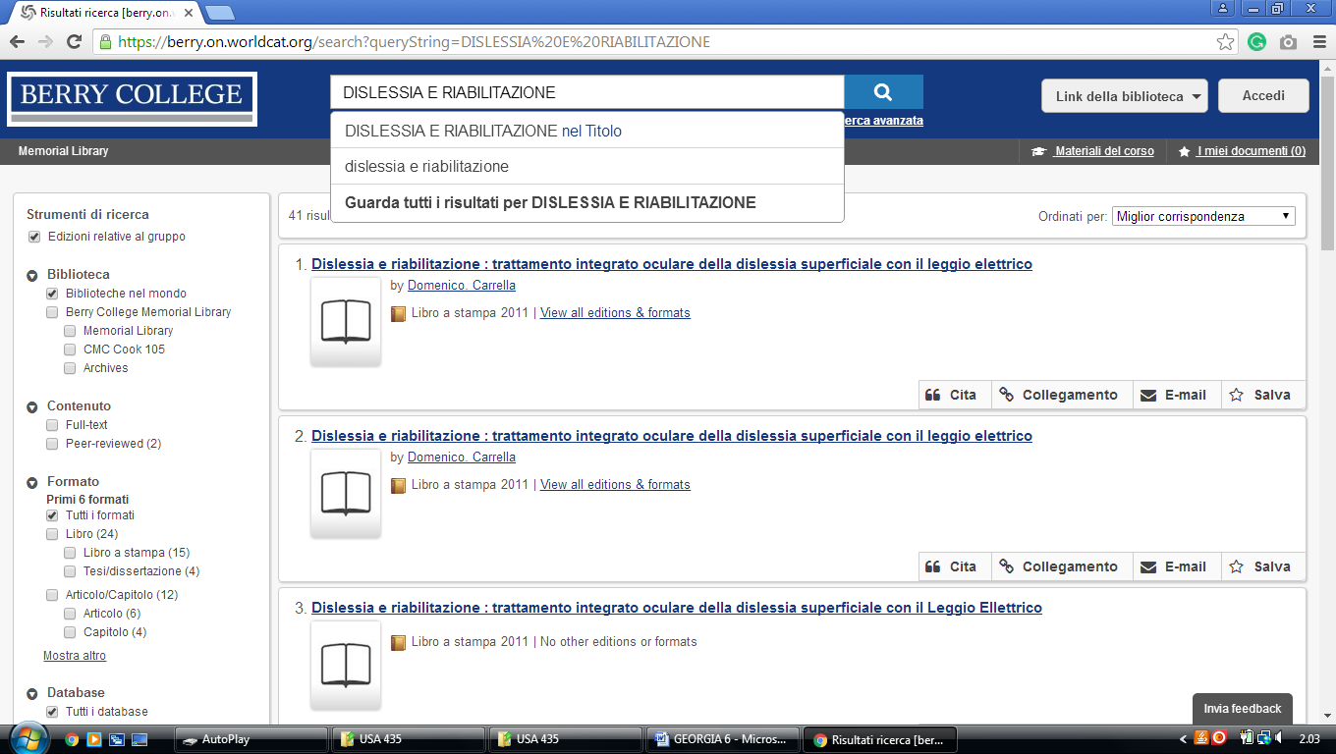

**2**  [**BRENAU TRUSTEE LIBRARY**](http://libguides.brenau.edu/Library) – (Gainesville, Georgia, Usa)

<https://brenau.on.worldcat.org/search?sortKey=LIBRARY_PLUS_RELEVANCE&databaseList=&queryString=dislessia+e+riabilitazione&changedFacet=author&scope=&format=all&database=all&author=Carrella%2C+Domenico&year=all&yearFrom=&yearTo=&language=all&topic=all>

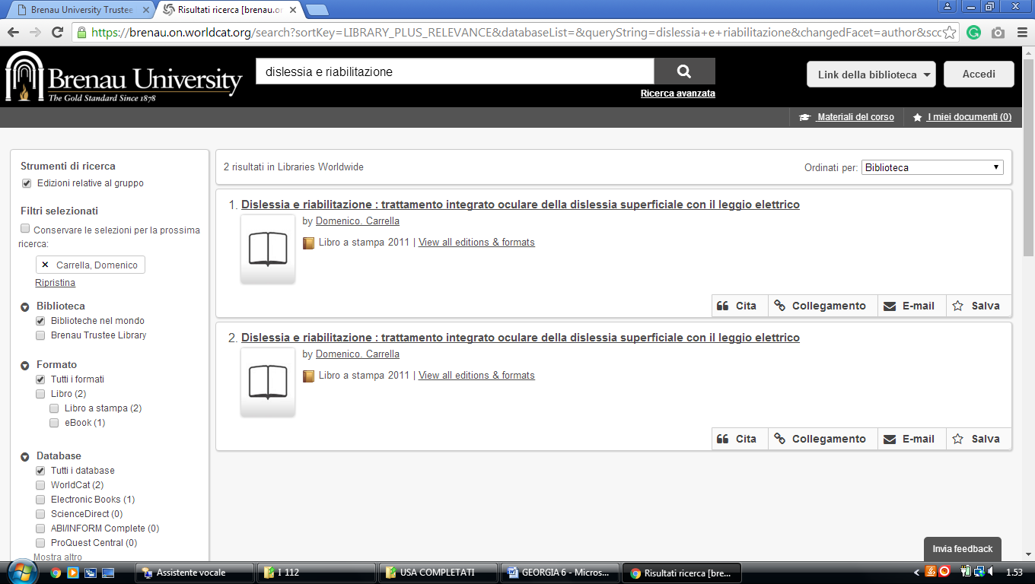

**3** [**ROBERT W. W. LIBRARY**](http://www.auctr.edu/) **ATLANTA UNIVERSITY CENTER** - (Georgia, Usa)

<https://auctr.on.worldcat.org/search?sortKey=LIBRARY&databaseList=&queryString=dislessia+e+riabilitazione&changedFacet=format&scope=&database=all&author=all&year=all&yearFrom=&yearTo=&language=all&topic=all>

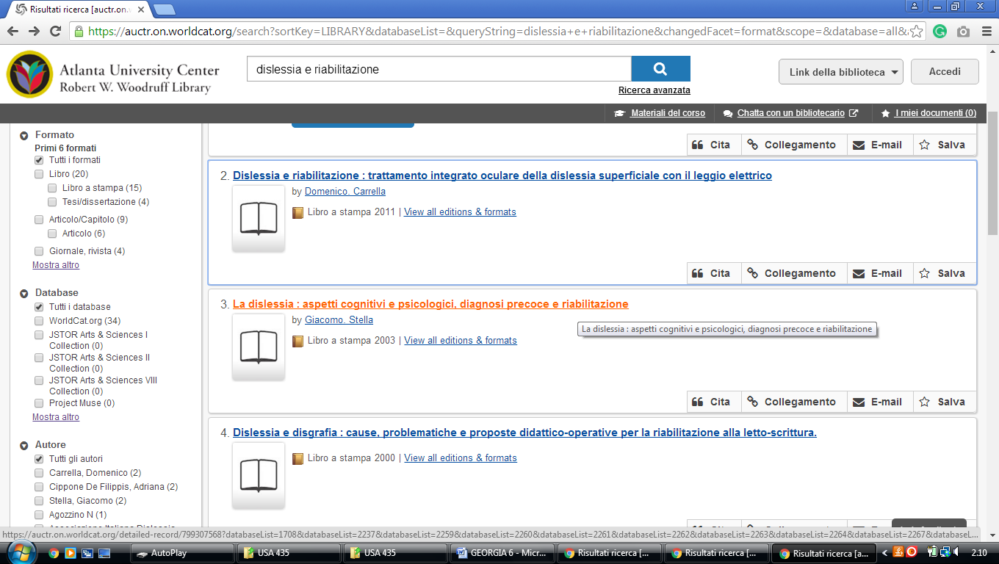

### 4 [SCAD LIBRARIES](http://library.scad.edu/) - [Savannah College Of Art A](http://library.scad.edu/)nd Design Libraries – (Georgia, Usa)

<http://scad.summon.serialssolutions.com/?#!/search?ho=f&l=en&q=dislessia%20e%20riabilitazione>

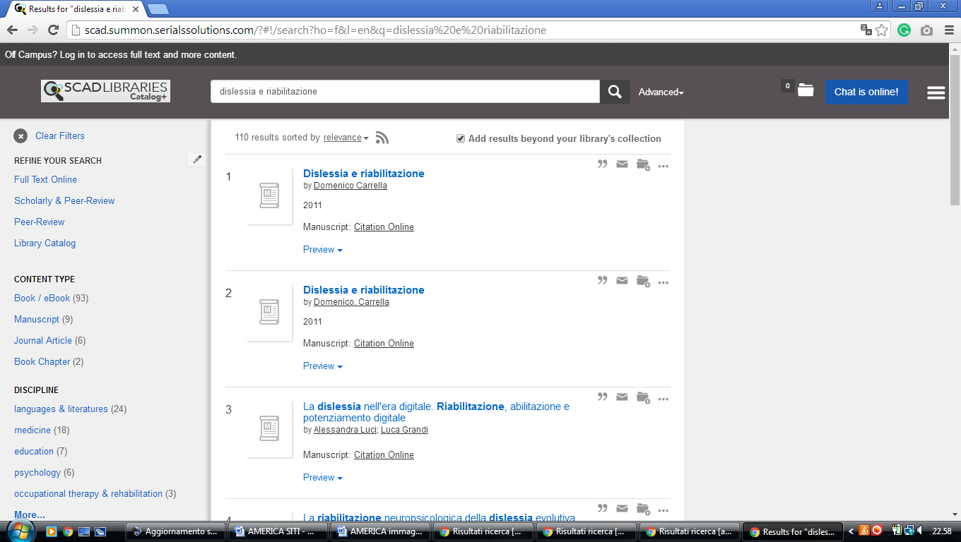

**5**  [**THOMAS UNIVERSITY LIBRARY**](http://www.thomasu.edu/Content/Default/14/64/0/library/library.html) - (Thomasville, Georgia, Usa)

<https://thomasu.on.worldcat.org/search?databaseList=&queryString=dislessia+e+riabilitazione>

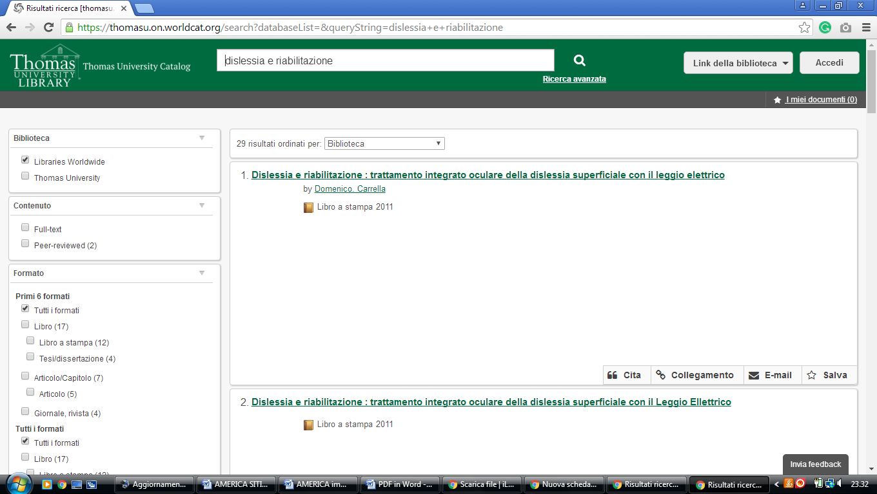

**6**  [**ZACH S. HENDERSON LIBRARY**](http://library.georgiasouthern.edu/) - (Statesboro, Georgia, Usa)

<http://eds.a.ebscohost.com/eds/results?vid=4&sid=63f8ee48-99a8-46e0-b3b8-73c5e1fcc980%40sessionmgr4008&bquery=(dislessia+AND+e+AND+riabilitazione)&bdata=JnR5cGU9MA%3d%3d>

