**FLORIDA = 12**

**1** [**CARL S. SWISHER LIBRARY**](http://www.cookman.edu/academics/library/index.html) – (Daytona Beach, Florida, Usa)

<https://bethune.on.worldcat.org/search?sortKey=LIBRARY&databaseList=2650%2C1461%2C1082%2C2229%2C1953%2C1996%2C2006%2C2622%2C1697%2C3313%2C1719%2C638%2C1639%2C1913%2C1638%2C1934%2C1271%2C2261%2C3548%2C1941%2C2676%2C3369%2C1542%2C2477%2C1708%2C1609%2C1728&queryString=dislessia+e+riabilitazione&changedFacet=author&clusterResults=on&scope=&format=all&database=all&author=Carrella%2C+Domenico&year=all&yearFrom=&yearTo=&language=all&topic=all>

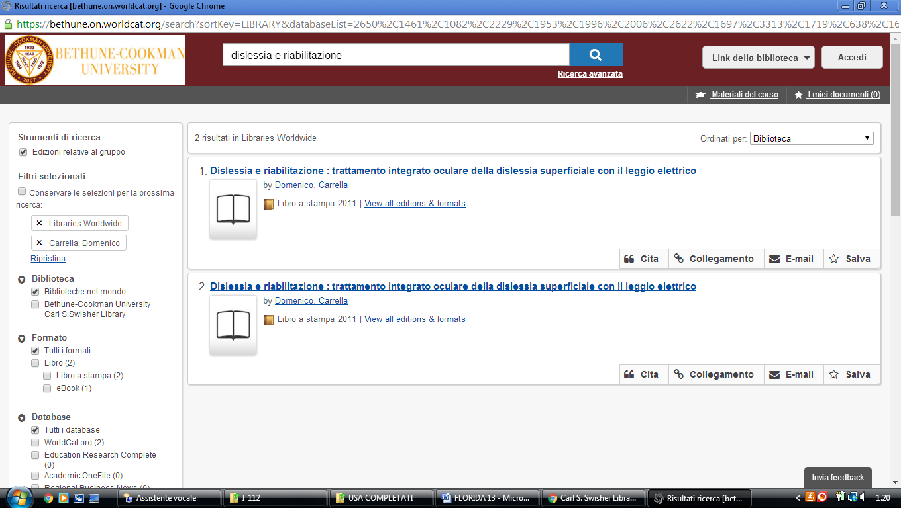

### [2 LIBRARY HOME - DANIEL A. CANNON MEMORIAL ... - SAINT LEO UNIVERSITY](http://slulibrary.saintleo.edu/) - (Florida, Usa)

<https://saintleo.on.worldcat.org/search?sortKey=BEST_MATCH&databaseList=&queryString=dislessia+e+riabilitazione&changedFacet=scope&clusterResults=on&scope>=

**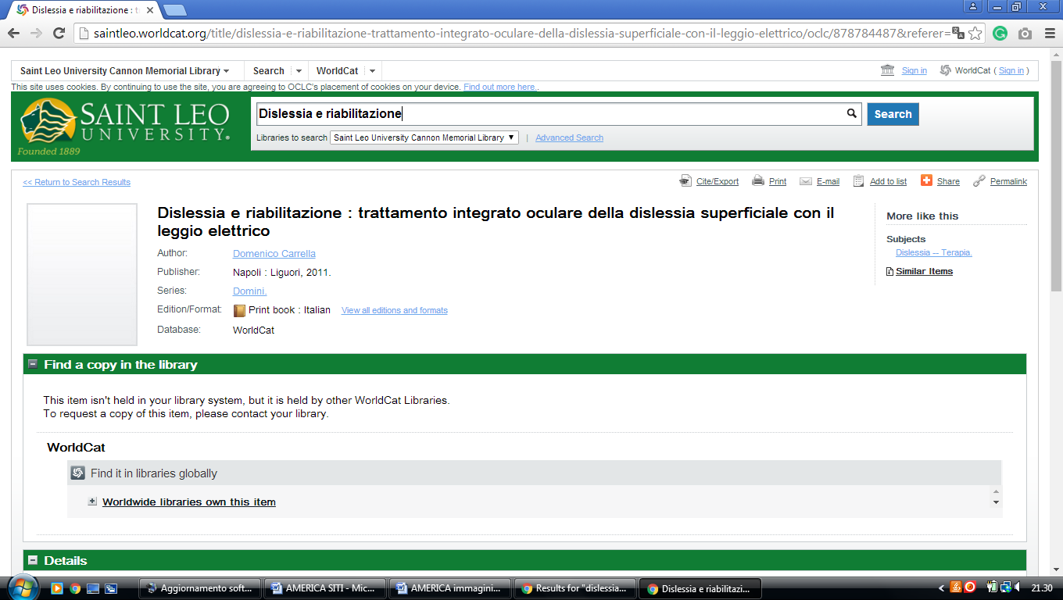**

### 3 [ONESEARCH - PROQUEST](http://ufl.summon.serialssolutions.com/) – (George a. Smathe0rs libraries, Gainesville, Florida, Usa)

<http://ufl.summon.serialssolutions.com/#!/search?ho=f&l=en&q=dislessia%20e%20riabilitazione>

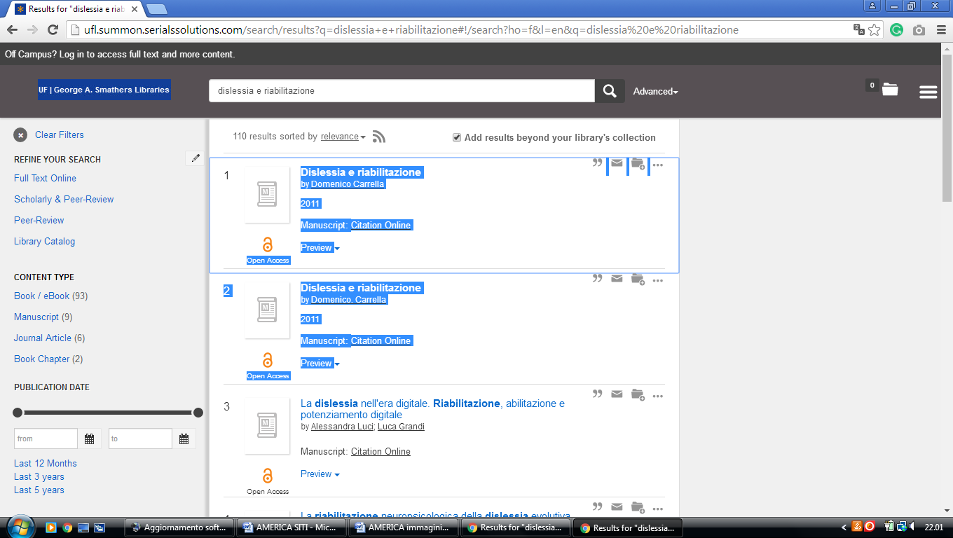

**4** **[JOHN H. EVANS LIBRARY & LEARNING COMMONS](http://lib.fit.edu/" \t "_blank" \o "John H. Evans Library & Learning Commons) -** (Melbourne, Florida, Usa)

<https://fit.summon.serialssolutions.com/search?s.q=dislessia+e+riabilitazione&Search+Library+Summon=Search#!/search?ho=f&l=it-IT&q=dislessia%20e%20riabilitazione>

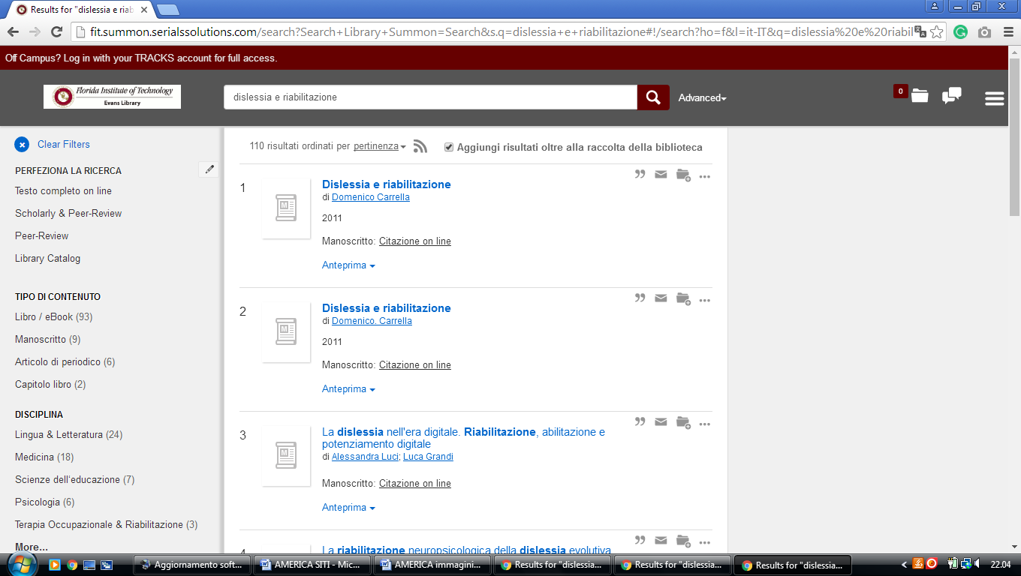

**5**  [**NATHAN W. COLLIER LIBRARY**](http://www.fmuniv.edu/library/) - (Miami, Florida, Usa)

<https://floridamemorialuniversity.on.worldcat.org/search?sortKey=LIBRARY&databaseList=&queryString=dislessia+e+riabilitazione&changedFacet=author&scope=&format=all&database=all&author=Carrella%2C+Domenico&year=all&yearFrom=&yearTo=&language=all&topic=all>

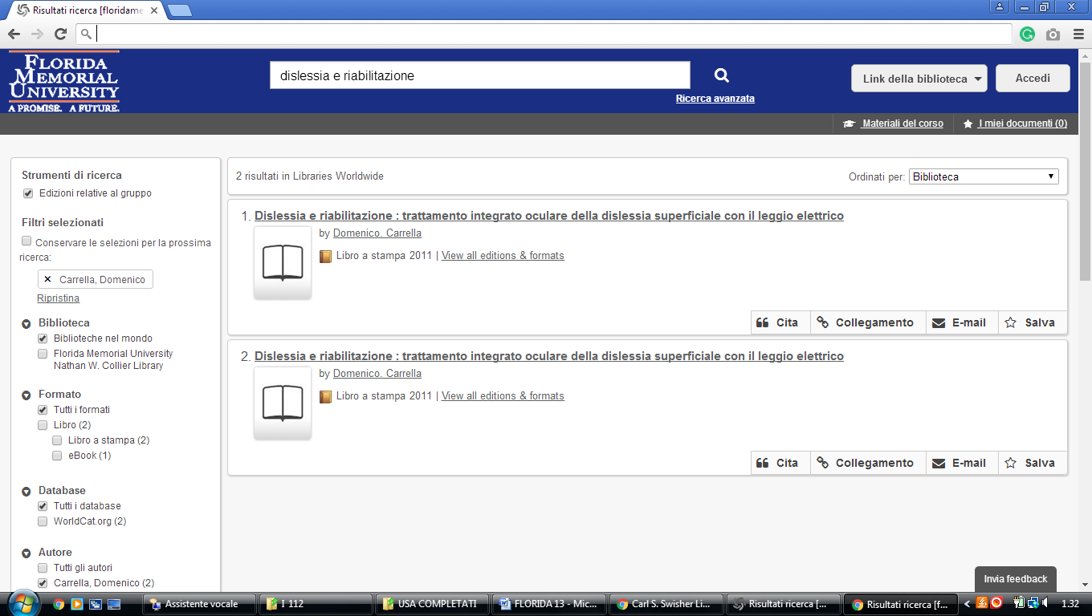

**6 UNIVERSITY OF SOUTH FLORIDA LIBRARIES –** [(Tampa](https://en.wikipedia.org/wiki/Tampa,_Florida), [Florida](https://en.wikipedia.org/wiki/Florida), Usa)

<http://eds.b.ebscohost.com/eds/results?vid=4&sid=4697d7c3-3ed4-4bc0-af77-bc130725b099%40pdc-v-sessmgr01&bquery=dislessia+e+riabilitazione&bdata=JnR5cGU9MCZzaXRlPWVkcy1saXZl>

**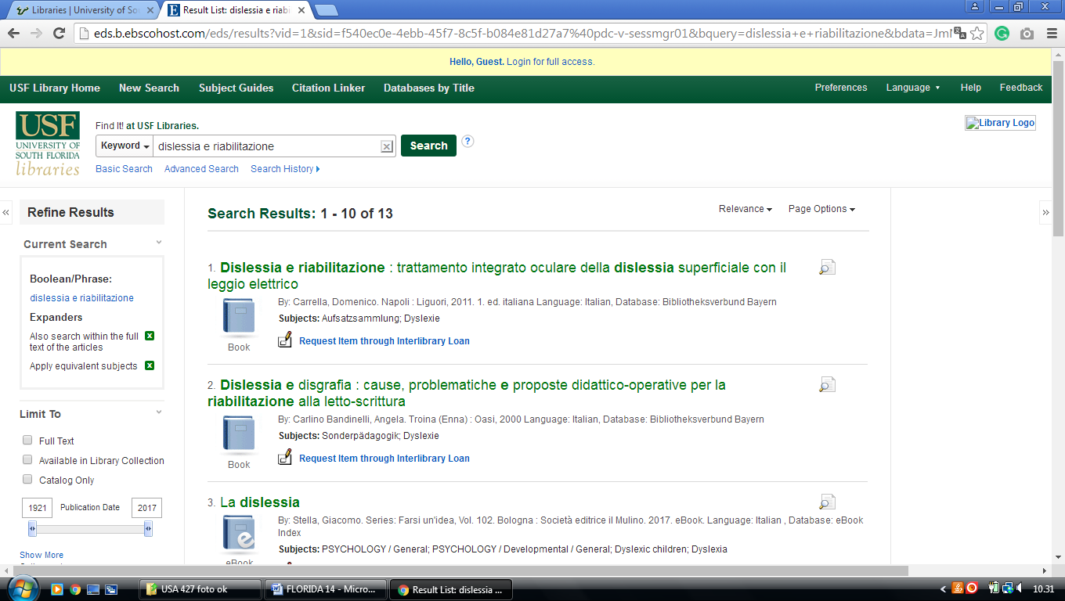**

**7** [**STEELMAN LIBRARY**](http://www.seu.edu/library/) - (Lakeland, Florida, Usa)

<https://seu.on.worldcat.org/search?sortKey=LIBRARY&databaseList=&queryString=dislessia+e+riabilitazione&changedFacet=author&scope=&format=all&database=all&author=Carrella%2C+Domenico&year=all&yearFrom=&yearTo=&language=all&topic=all>

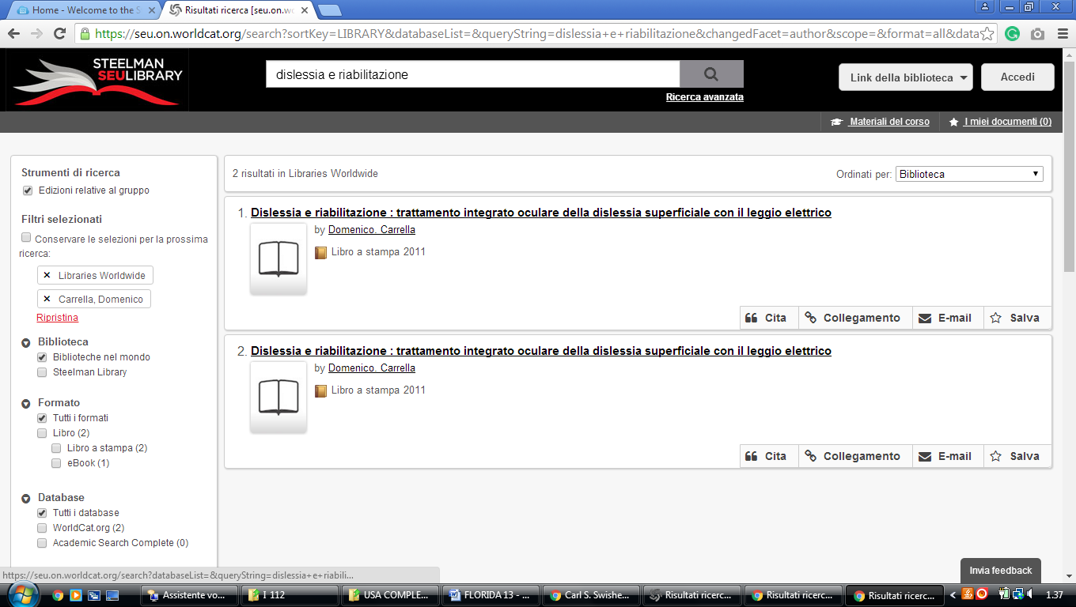

### 8 MILLER SCHOOL OF MEDICINE LIBRARY – (University Of Miami Fl, Usa)

<http://miami-primo.hosted.exlibrisgroup.com/primo_library/libweb/action/search.do?ct=facet&pcAvailabiltyMode=true&pcAvailClicked=true&vid=med&mode=Basic&tab=everything&fn=search&indx=1&dscnt=0&vl(freeText0)=dislessia%20e%20riabilitazione&dstmp=1521420831579>

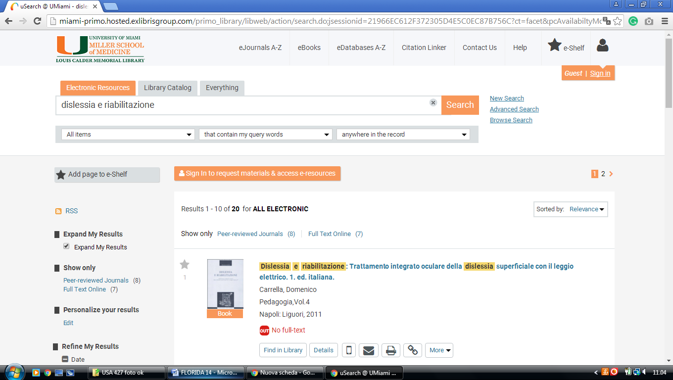

**9** [**UNIVERSITY OF MIAMI LIBRARIES**](http://library.miami.edu/) - (Coral Gable, Florida, Usa)

<https://miami-primo.hosted.exlibrisgroup.com/primo_library/libweb/action/search.do?ct=facet&pcAvailabiltyMode=true&pcAvailClicked=true&query=any%2Ccontains%2Cdislessia%20e%20riabilitazione&fn=search&indx=1&search_scope=Everything&dscnt=0&vl(1UIStartWith0)=contains&scp.scps=scope%3A(01UOML_DIGITALCOMMONS)%2Cscope%3A(01UOML_CONTENTDM)%2Cscope%3A(%2201UOML%22)%2Cscope%3A(01UOML_ALMA)%2Cprimo_central_multiple_fe&displayMode=full&mode=Basic&vid=uml&institution=01UOML&bulkSize=10&vl(672718000UI0)=any&ct=search&highlight=true&tab=everything&displayField=all&vl(freeText0)=dislessia%20e%20riabilitazione&dum=true&dstmp=1521416354117&fromDL>

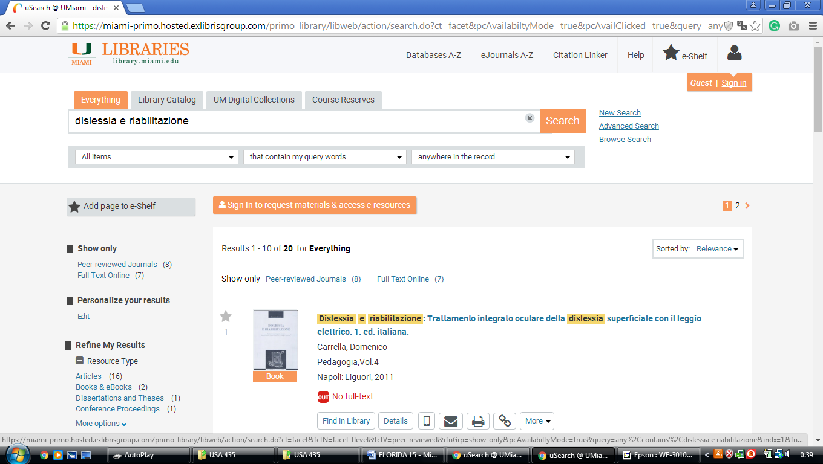

### 10 [FLORIDA MEMORIAL UNIVERSITY » LIBRARY](http://www.fmuniv.edu/library/)- ([Miami Gardens](https://en.wikipedia.org/wiki/Miami_Gardens,_Florida" \o "Miami Gardens, Florida), [Florida](https://en.wikipedia.org/wiki/Florida) Usa)

<https://floridamemorialuniversity.on.worldcat.org/search?sortKey=LIBRARY&databaseList=&queryString=dislessia+e+riabilitazione&changedFacet=format&clusterResults=off&scope=&database=all&author=all&year=all&yearFrom=&yearTo=&language=all&topic=all>

**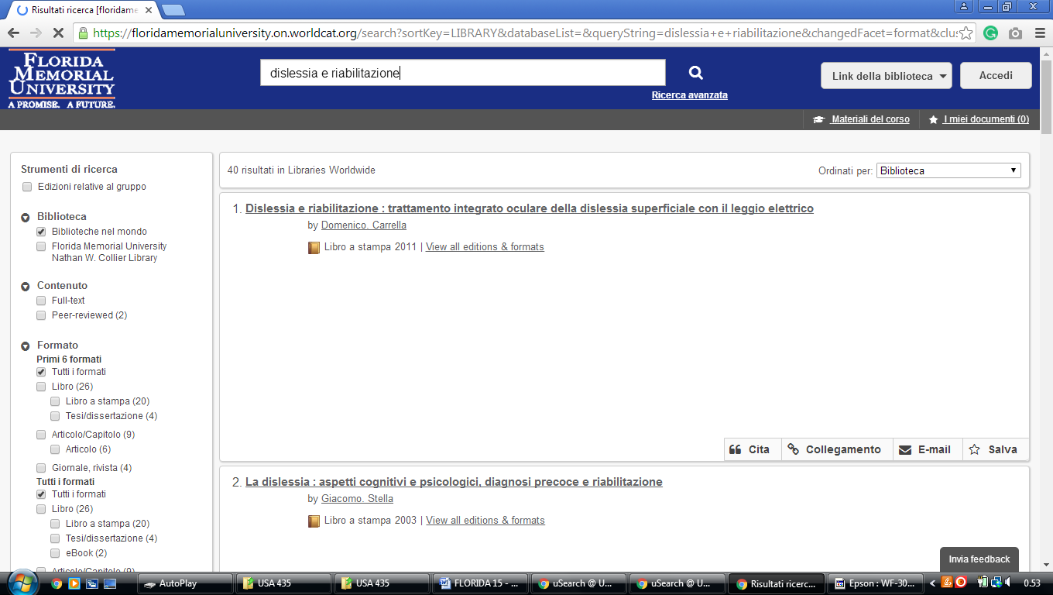**

### 11 LIBRARIES – UNIVERSITY LIBRARIES – UNIVERSITY OF ST. THOMAS – FLORIDA - (Usa)

<http://stulibrary.worldcat.org/title/dislessia-e-riabilitazione-trattamento-integrato-oculare-della-dislessia-superficiale-con-il-leggio-elettrico/oclc/878784487&referer=brief_results>

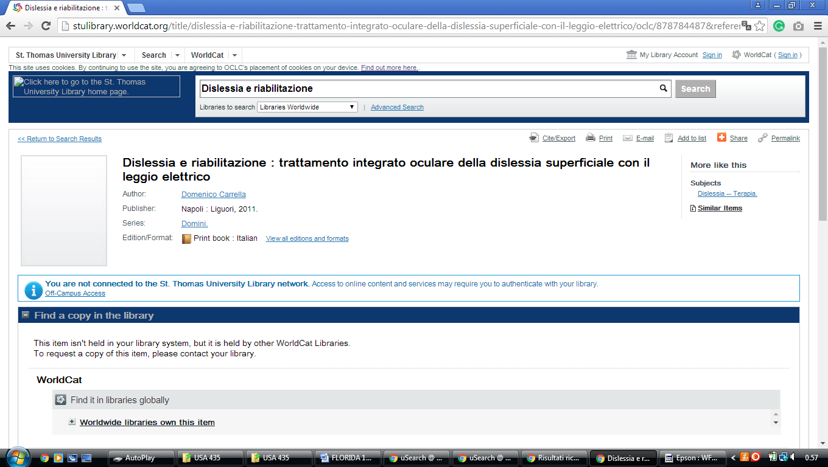

### 12 [EAGLESEARCH - PROQUEST](http://erau.summon.serialssolutions.com/)

<http://erau.summon.serialssolutions.com/#!/search?ho=f&l=en&q=dislessia%20e%20riabilitazione>

**