**DISTRECT OF COLUMBIA = 8**

**1** [**AMERICAN UNIVERSITY**](http://www.american.edu/library/) **LIBRARY WASHINGTON – (**District of Columbia, Usa)

<https://american.summon.serialssolutions.com/search?s.q=dislessia+e+riabilitazione#!/search?ho=f&l=en&q=dislessia%20e%20riabilitazione>

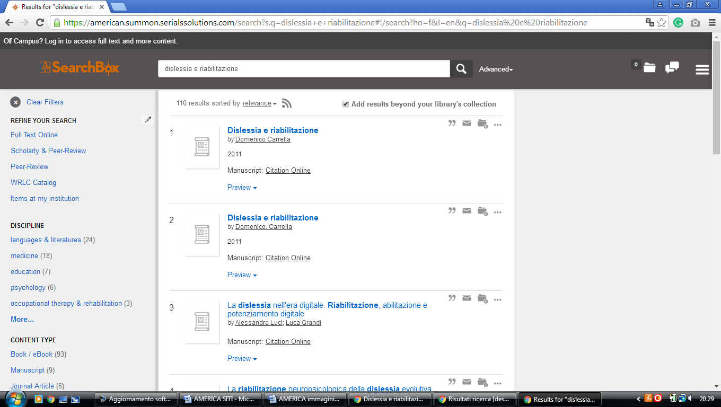

**2** [**GALLAUDET UNIVERSITY LIBRARY**](http://www.gallaudet.edu/library.html) **WASHINGTON** – (District of Columbia, Usa)

<http://gallaudet.summon.serialssolutions.com/search?s.q=dislessia+e+riabilitazione&s.fvf%5B%5D=ContentType%2CBook+Review%2Ct&s.fvf%5B%5D=ContentType%2CNewspaper+Article%2Ct#!/search?ho=f&fvf=ContentType,Book%20Review,t%7CContentType,Newspaper%20Article,t&l=en&q=dislessia%20e%20riabilitazione>

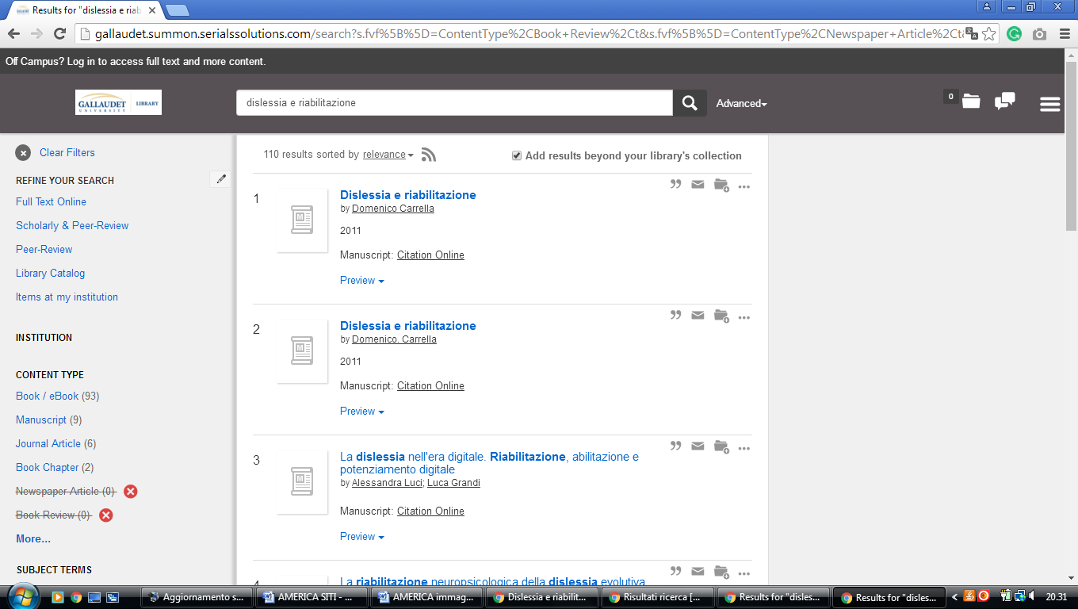

**3 [GEORGETOWN UNIVERSITY LIBRARY](http://www.library.georgetown.edu/" \t "_blank" \o "Georgetown University Library)** **WASHINGTON** – (District of Columbia, Usa)

<https://gt.summon.serialssolutions.com/?q=dislessia+e+riabilitazione#!/search?ho=f&l=en&q=dislessia%20e%20riabilitazione>

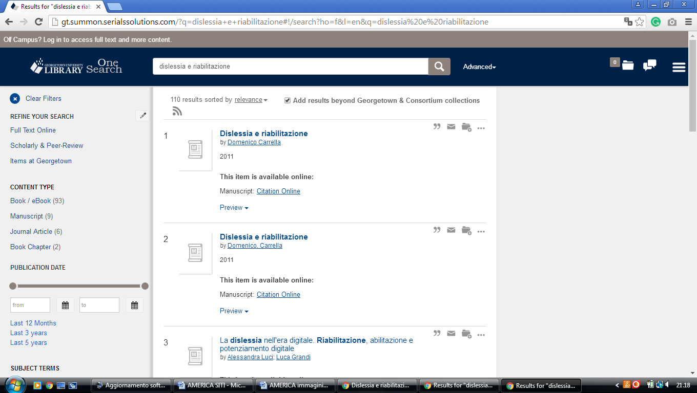

**4** [**HOWARD UNIVERSITY LIBRARIES**](http://www.howard.edu/library/) **WASHINGTON –** (District of Columbia, Usa)

<http://hu.summon.serialssolutions.com/search/results?spellcheck=true&q=dislessia+e+riabilitazione#!/search?ho=f&l=en&q=dislessia%20e%20riabilitazione>

**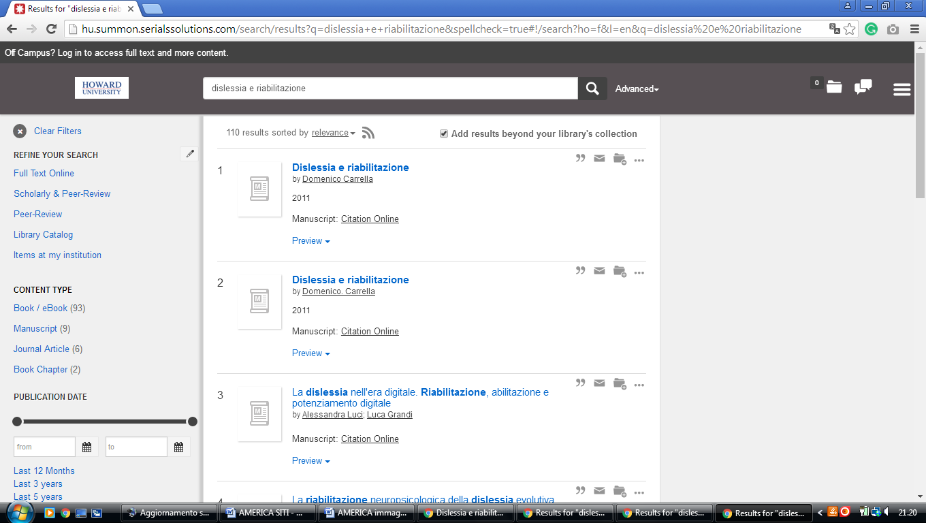**

**5** [**THE CATHOLIC UNIVERSITY OF AMERICA**](http://libraries.cua.edu/) **LIBRARY** – (Washington, Usa)

<http://cua.summon.serialssolutions.com/search?keep_r=true&s.fvf%5B%5D=ContentType%2CJournal+Article&s.q=dislessia+e+riabilitazione&x=0&y=0#!/search?ho=f&l=en&q=dislessia%20e%20riabilitazione>

**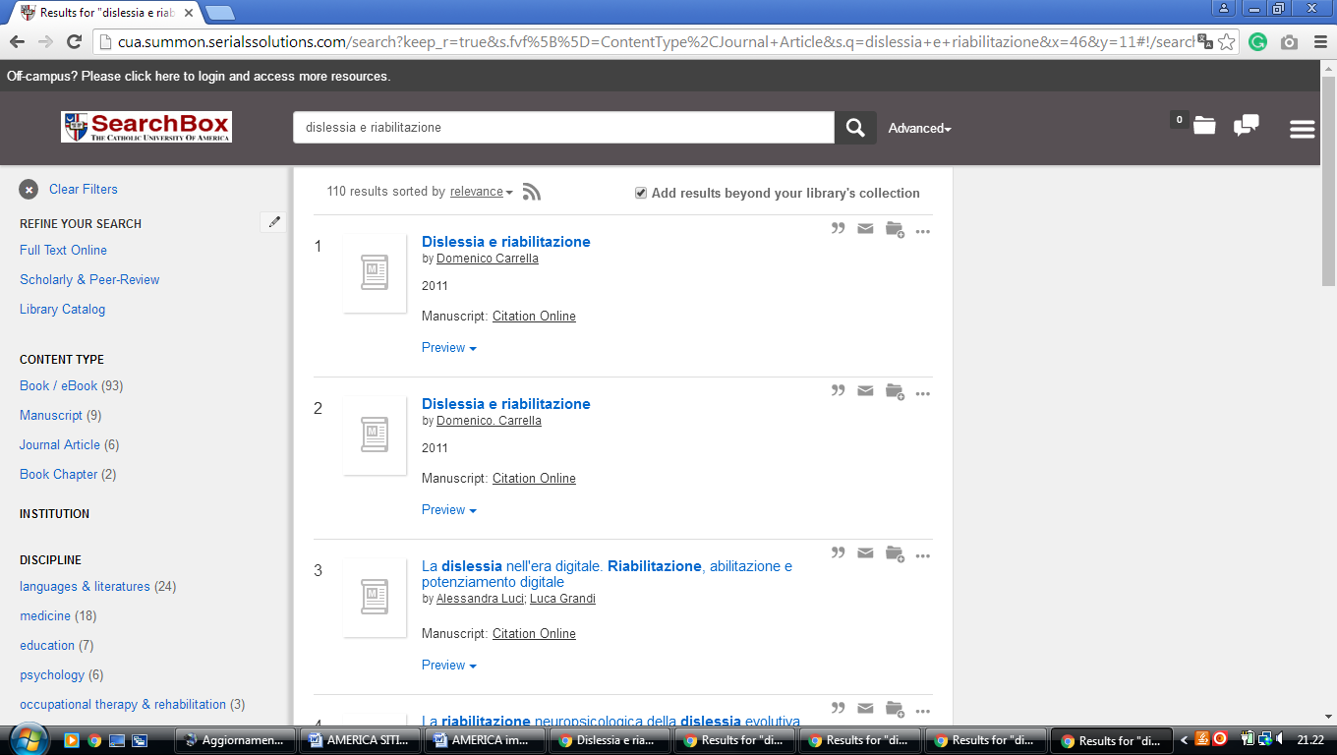**

**6** [**THE GEORGE WASHINGTON UNIVERSITY**](http://gw.summon.serialssolutions.com/) [- (Washington](https://it.wikipedia.org/wiki/Washington), Usa)

<http://gw.summon.serialssolutions.com/#!/search?ho=f&l=en&q=dislessia%20e%20riabilitazione>

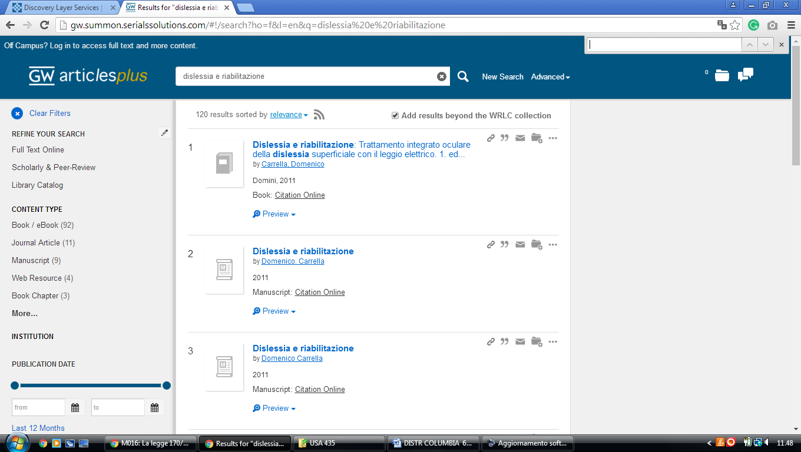

**7** [**MARYMOUNT UNIVERSITY**](http://marymount.summon.serialssolutions.com/#!/) **–** ([Arlington County](https://en.wikipedia.org/wiki/Arlington_County,_Virginia), [Virginia](https://en.wikipedia.org/wiki/Virginia" \o "Virginia),Usa)

<http://marymount.summon.serialssolutions.com/#!/search?ho=f&l=en&q=dislessia%20e%20riabilitazione>

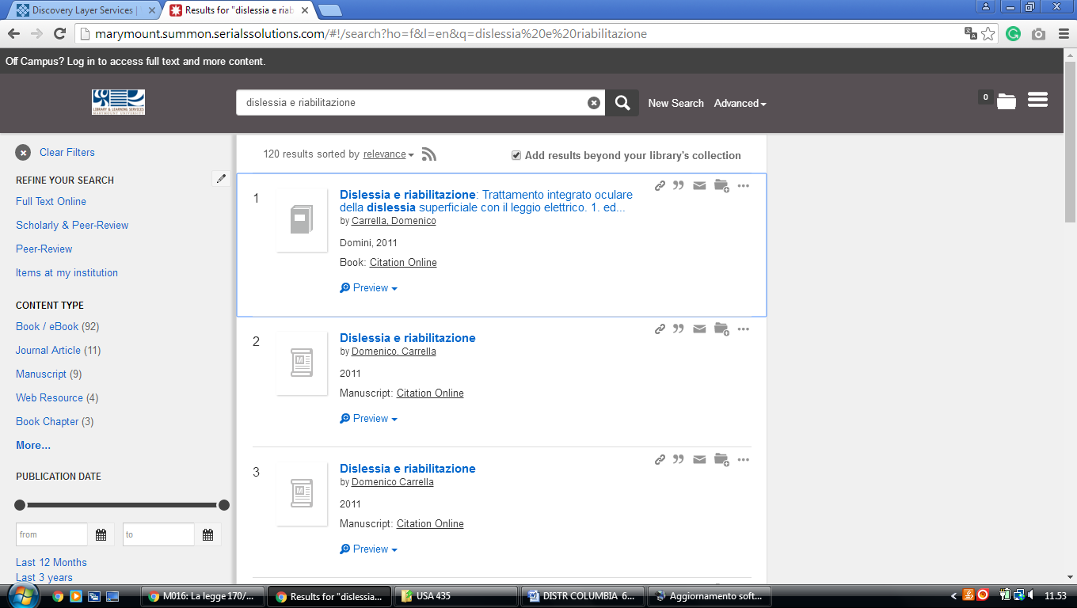

**8** [**THE UNIVERSITY OF THE DISTRICT OF COLUMBIA**](http://udc.summon.serialssolutions.com/) **-** ([Washington, D.C.](https://en.wikipedia.org/wiki/Washington,_D.C.), Usa)

<http://udc.summon.serialssolutions.com/#!/search?ho=f&l=en&q=dislessia%20e%20riabilitazione>

