**DELAWARE = 3**

### 1 [DELCAT DISCOVERY • UNIVERSITY OF DELAWARE LIBRARY](https://library.udel.edu/databases/delcat/) - (Newark Delaware, Usa)

<http://delcat.worldcat.org/title/dislessia-e-riabilitazione-trattamento-integrato-oculare-della-dislessia-superficiale-con-il-leggio-elettrico/oclc/878784487&referer=brief_results>

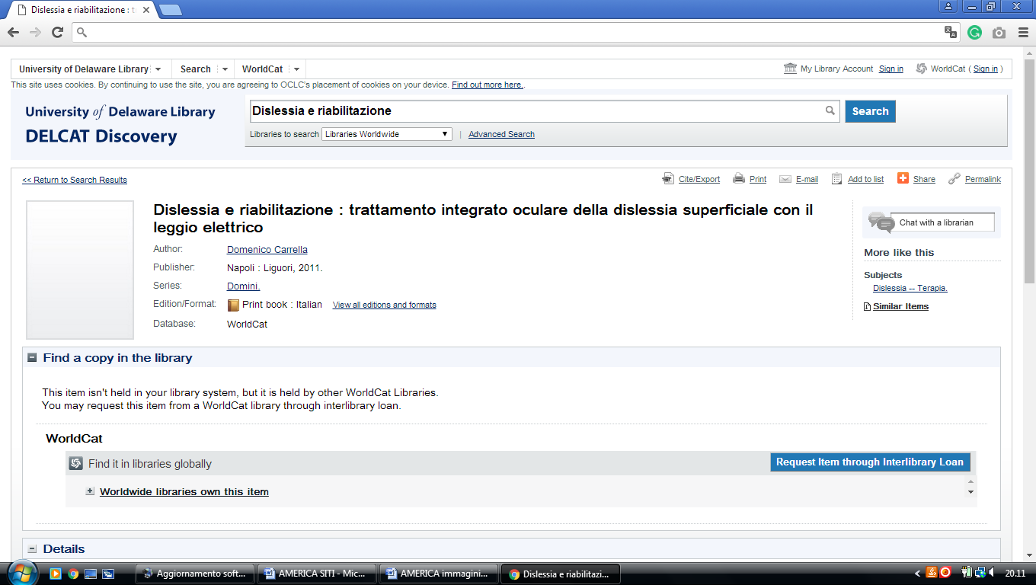

**2 DELAWARE STATE UNIVERSITY LIBRARY** - (Dover, [Delaware](https://en.wikipedia.org/wiki/Delaware), [Usa](https://en.wikipedia.org/wiki/United_States" \o "United States))

<https://desu.on.worldcat.org/search?queryString=kw%3A%28DISLESSIA+E+RIABILITAZIONE%29&databaseList=638&origPageViewName=pages%2Fadvanced-search-page&clusterResults=true&scope>=

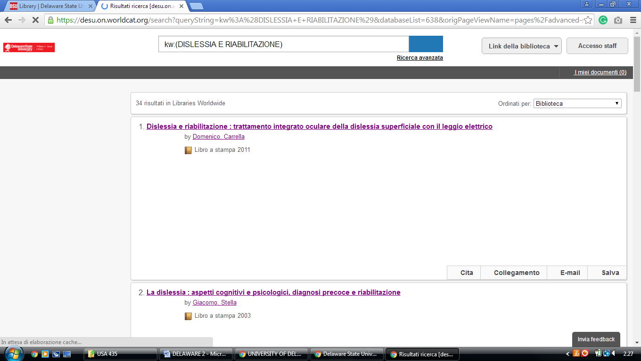

### 3 [LIBRARY | DELAWARE STATE UNIVERSITY](https://www.desu.edu/academics/library) - (Dover, Delaware Usa)

<https://desu.summon.serialssolutions.com/search?fvf=ContentType%2CBook+%2F+eBook&q=dislessia+e+riabilitazione&spellcheck=true#!/search?ho=f&fvf=ContentType,Book%20%2F%20eBook,f&l=it-IT&q=dislessia%20e%20riabilitazione>

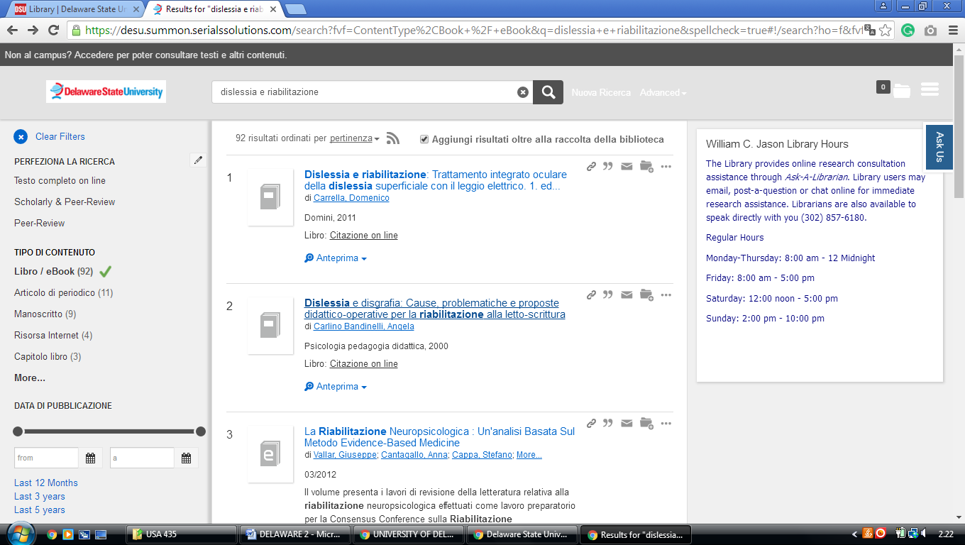

### Wilmington University Library,

### https://wilmu.on.worldcat.org/search?queryString=kw:dislessia%20e%20riabilitazione

