**COLORADO = 3**

**1** [**KRAEMER FAMILY LIBRARY**](http://www.uccs.edu/~library/) - (Colorado Springs, Colorado, Usa)

[https://uccs.summon.serialssolutions.com/search?s.q=dislessia+e+riabilitazione&spellcheck=true&keep_r=true&x=35&y=22#!/search?ho=f&l=en&q=dislessia%20e%20riabilitazione](https://uccs.summon.serialssolutions.com/search?s.q=dislessia+e+riabilitazione&spellcheck=true&keep_r=true&x=35&y=22%23!/search?ho=f&l=en&q=dislessia%20e%20riabilitazione)

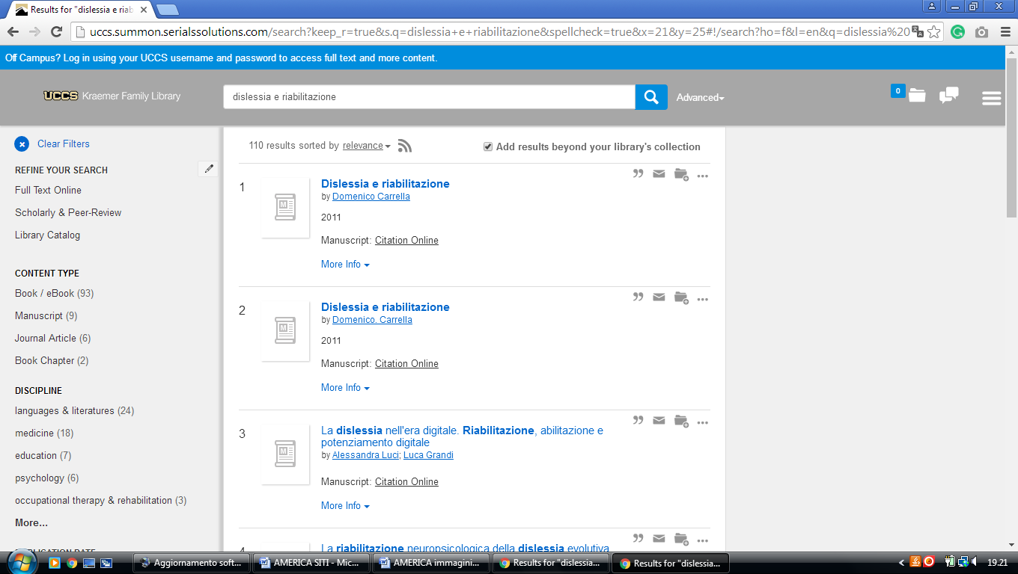

**2** [**UNIVERSITY OF COLORADO BOULDLER LIBRARIES -**](http://ucblibraries.colorado.edu/) (Pleasant St. Boulder, Usa)

<http://ucblibraries.summon.serialssolutions.com/#!/search?ho=f&l=en&q=dislessia%20e%20riabilitazione>

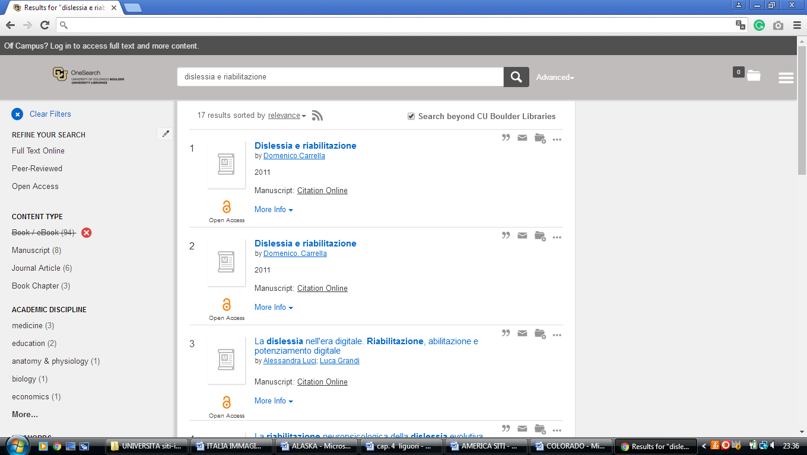

### 3 [Libraries - University of Northern Colorado](http://www.unco.edu/library/) - (Greeley, Usa)

<http://unco.summon.serialssolutions.com/search?s.fvf%5B%5D=ContentType%2CNewspaper+Article%2Ct&s.q=dislessia+e+riabilitazione#!/search?ho=f&fvf=ContentType,Newspaper%20Article,t&l=en&q=dislessia%20e%20riabilitazione>

