**ARIZONA = 4**

**1** [**GCC LIBRARY - GLENDALE COLLEGE LIBRARY**](https://gcc.glendale.edu/gcclibrary/) [– (Glendale](https://en.wikipedia.org/wiki/Glendale,_California), [California](https://en.wikipedia.org/wiki/California), Usa)

<https://gcc.on.worldcat.org/search?sortKey=LIBRARY&databaseList=2276%2C2229%2C2603%2C2625%2C2646%2C2602%2C2624%2C2007%2C2601%2C2645%2C2623%2C2006%2C2600%2C2622%2C1895%2C2643%2C2620%2C2641%2C2585%2C638%2C2605%2C2604%2C2626%2C2584%2C2483%2C2482%2C2260%2C2513%2C2259%2C2617%2C2638%2C2616%2C2615%2C2637&queryString=dislessia+e+riabilitazione&changedFacet=scope&scope=&scope=wz%3A2324&format=all&database=all&author=all&year=all&yearFrom=&yearTo=&language=all#/oclc/878784487>

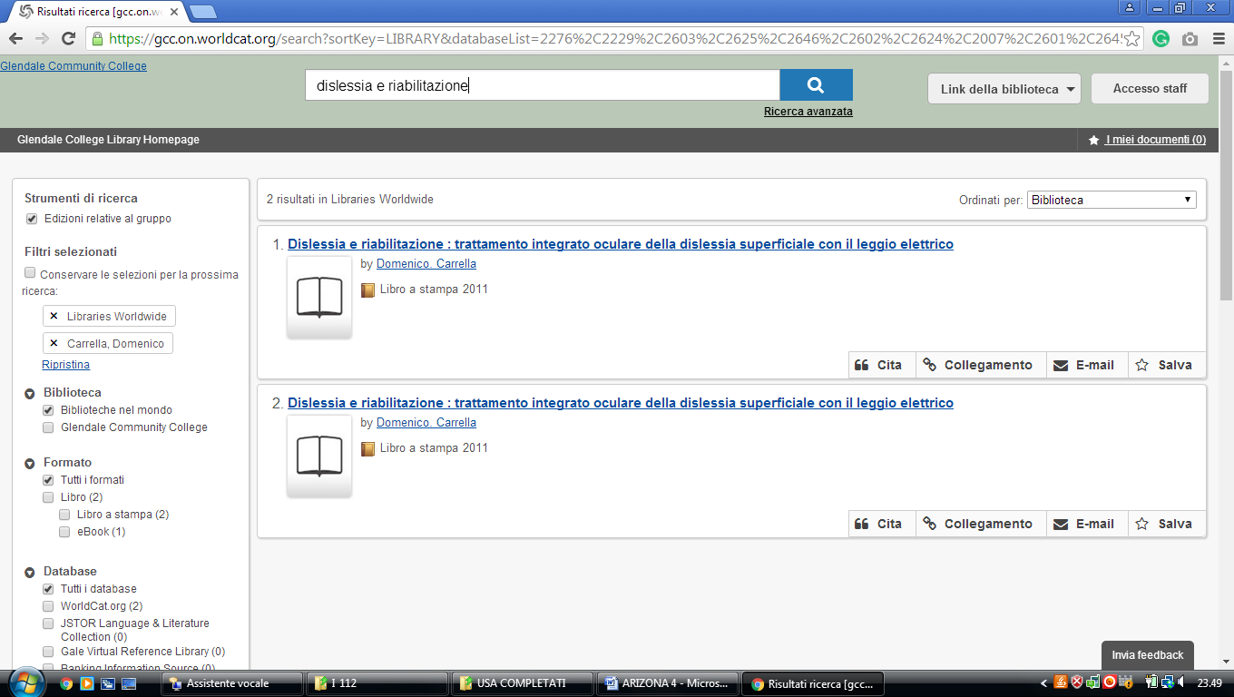

**2**  [**GCC LIBRARIES**](http://lib.gccaz.edu/)– (Prescott, Arizona, Usa)

### <http://gccaz.summon.serialssolutions.com/#!/search?ho=f&fvf=ContentType,Newspaper%20Article,t%7CContentType,Book%20Review,t&l=en&q=dislessia%20e%20riabilitazione>

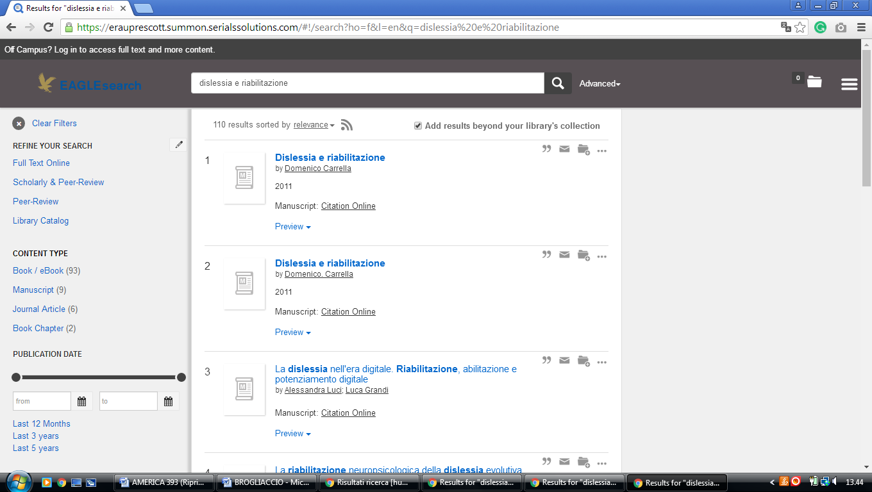

**3** [**NORTHERN ARIZONA UNIVERSITY**](http://library.nau.edu/) **LIBRARY** – (Arizona, Usa)

<https://arizona-nau-primo.hosted.exlibrisgroup.com/primo-explore/search?institution=01NAU&vid=01NAU&tab=default_tab&search_scope=Everything&mode=Basic&displayMode=full&bulkSize=10&highlight=true&dum=true&query=any,contains,dislessia%20e%20riabilitazione&displayField=all&primoQueryTemp=dislessia%20e%20riabilitazione&sortby=rank&lang=en_US&pcAvailability=true>

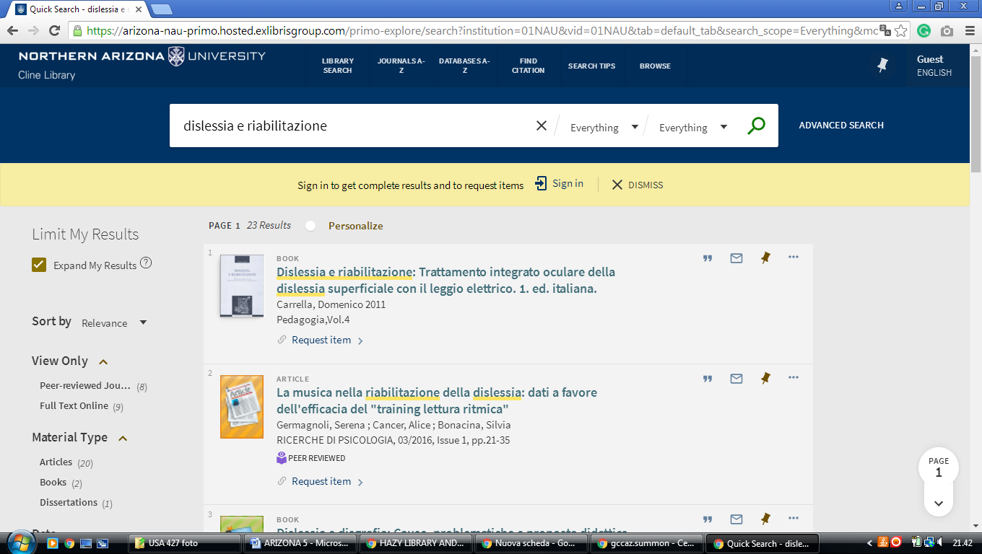

**4** [**ARIZONA UNIVERSITY**](http://lib.asu.edu/) **LIBRARIES SUMMON** - (Tempe, Arizona, Usa)

<http://arizona.summon.serialssolutions.com/search?q=dislessia%20e%20riabilitazione&fvf=ContentType%2CBook%20Review%2Ct%7CContentType%2CNewspaper%20Article%2Ct#!/search?ho=f&fvf=ContentType,Book%20Review,t%7CContentType,Newspaper%20Article,t&l=en&q=dislessia%20e%20riabilitazione>

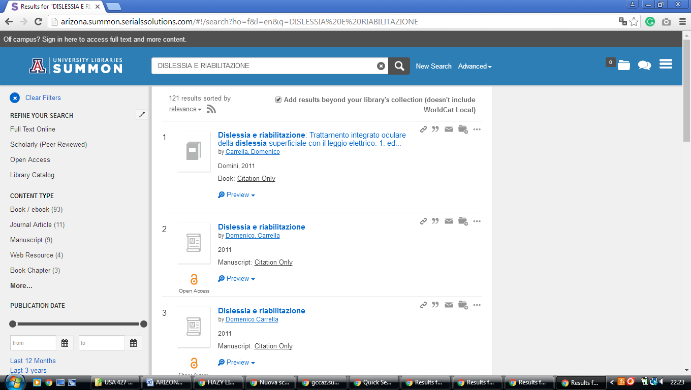

[University of Arizona Libraries |](https://new.library.arizona.edu/)

https://arizona-primo.hosted.exlibrisgroup.com/primo-explore/search?query=any,contains,dislessia%20e%20riabilitazione&search_scope=Everything&tab=default_tab&lang=en_US&institution=01UA_INST&vid=01UA&pcAvailability=true

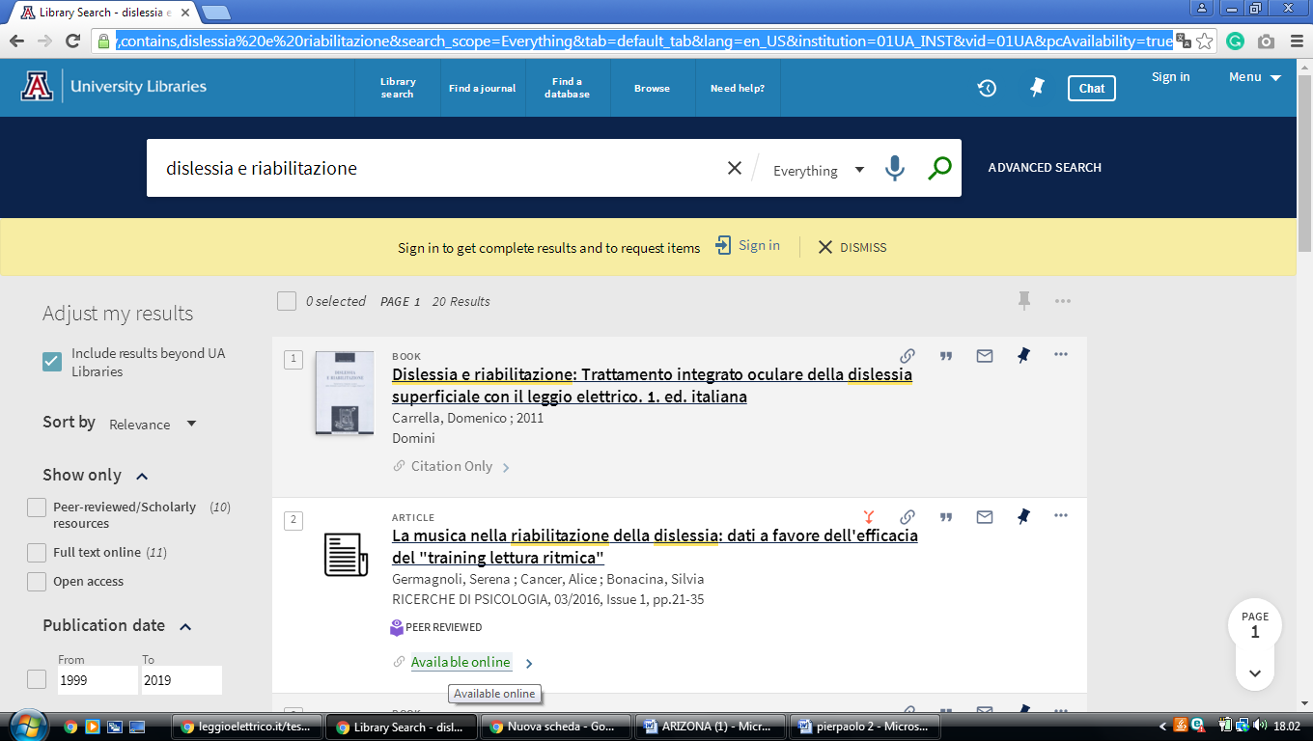

[polytechnic - Asu Library - Arizona State University,](https://lib.asu.edu/polytechnic)

https://arizona-asu-primo.hosted.exlibrisgroup.com/primo-explore/search?query=any,contains,DISLESSIA%20E%20RIABILITAZIONE&institution=01ASU_INST&vid=01ASU&search_scope=Everything&mode=Basic&displayField=all&sortby=rank&lang=en_US&pcAvailability=true

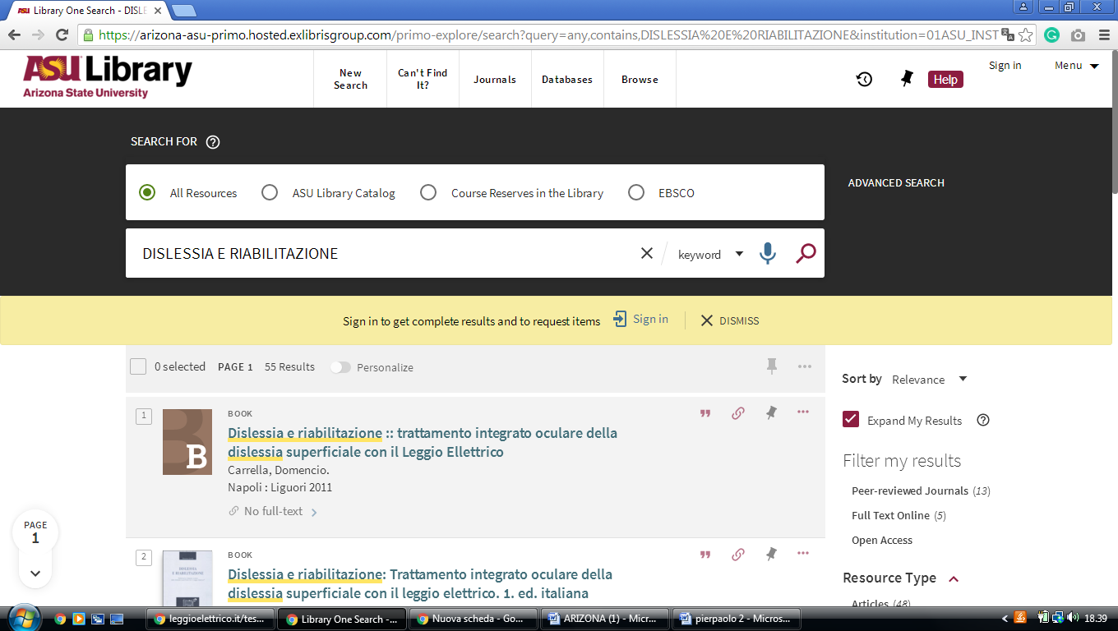

[Mwu library at midwestern university](https://library.midwestern.edu/)

home - library home**,**

<https://midwestern.summon.serialssolutions.com/search?s.q=dislessia+e+riabilitazione&spellcheck=true&keep_r=true#!/search?ho=f&l=en&q=dislessia%20e%20riabilitazione>

