**1** [**SZEGED UNIVERSITY**](http://ww2.bibl.u-szeged.hu/index.php/en/) **LIBRARY –** (Szeged, Hungary)<http://eds.a.ebscohost.com/eds/results?vid=0&sid=eb83b99a-984b-46b4-b9b0-9ae359cf4819%40sessionmgr4007&bquery=dislessia+e+riabilitazione&bdata=JnR5cGU9MCZzaXRlPWVkcy1saXZl>

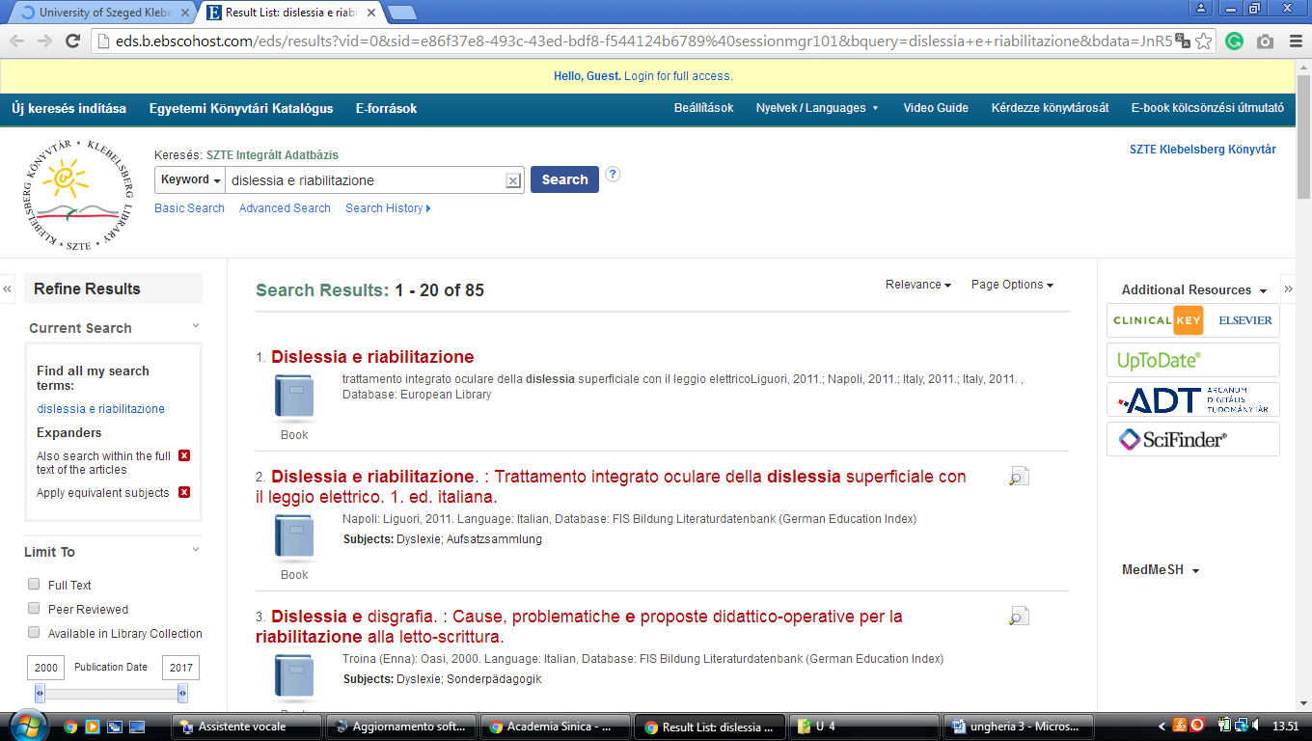

**2** [**LIBRARY - BUDAPESTI CORVINUS EGYETEM EGYETEMI KÖNYVTÁR**](http://www.lib.uni-corvinus.hu/eng)(Budapest Ungheria)

<http://eds.a.ebscohost.com/eds/results?vid=0&sid=5c2d75d7-8ac0-4c2a-b39d-eb9ea68a8583%40sessionmgr4009&bquery=dislessia+e+riabilitazione&bdata=JnR5cGU9MCZzaXRlPWVkcy1saXZl>

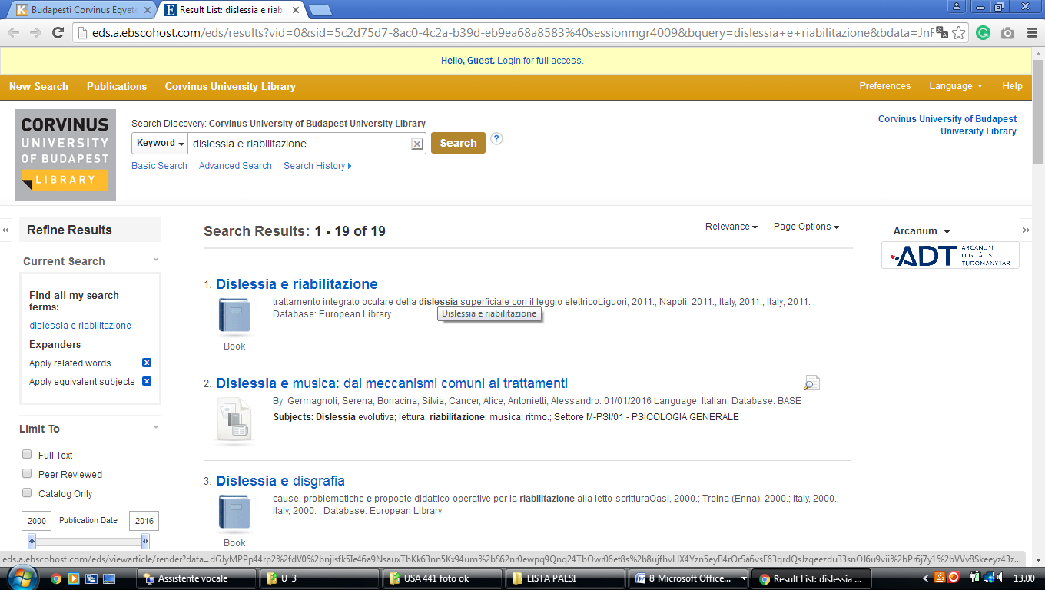

### 3 [LIBRARY OF THE HUNGARIAN PARLIAMENT - THE EUROPEAN LIBRARY](http://www.theeuropeanlibrary.org/tel4/contributor/P01356)

### ([Hungary)](https://en.wikipedia.org/wiki/Hungary)

<http://www.theeuropeanlibrary.org/tel4/contributor/P01356>

<http://www.theeuropeanlibrary.org/tel4/search?query=dislessia%20e%20riabilitazione>

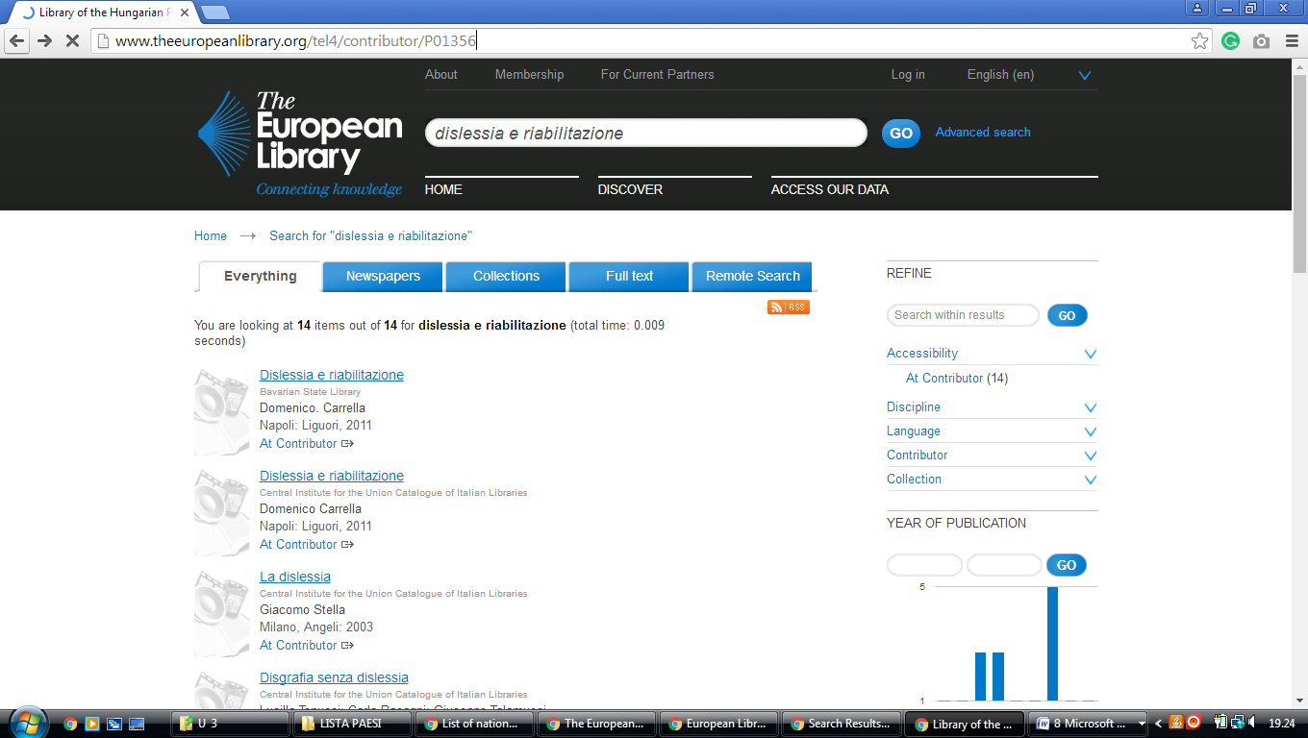

**1. SZTE KLEBELSBERG LIBRARY, Szeged, UNGHERIA**

[**Szegedi Tudományegyetem Klebelsberg Kuno Könyvtára**](https://www.google.com/url?sa=t&rct=j&q=&esrc=s&source=web&cd=1&cad=rja&uact=8&ved=2ahUKEwiWvLnM2KboAhVvxaYKHbDxDwgQFjAAegQIFhAD&url=http%3A%2F%2Fwww.ek.szte.hu%2F&usg=AOvVaw3gEFlh8kSkRqvoM5yTCAJn)

### <http://www.ek.szte.hu/?lang=en>

### - utilizza Online resources nel quadro

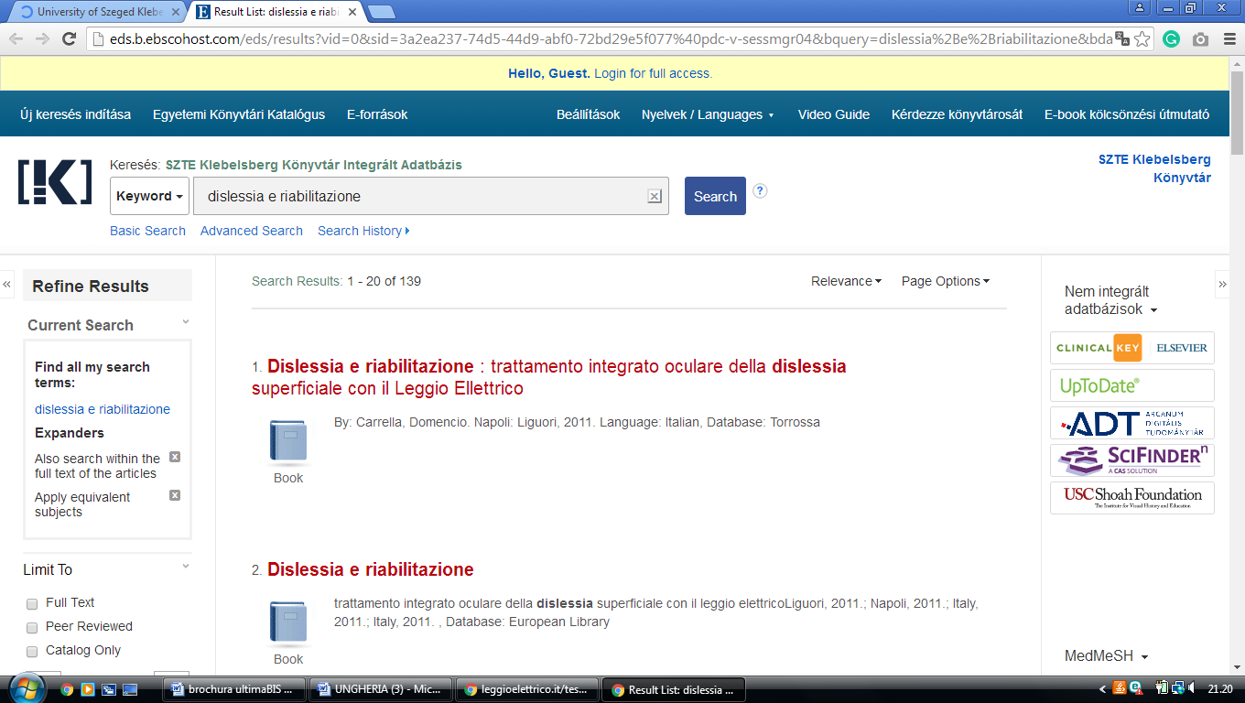

,

**LIBRARY UNIVERSITY OF** [**DEBRECEN**](https://en.wikipedia.org/wiki/Debrecen)**,** [**HUNGARY**](https://en.wikipedia.org/wiki/Hungary)

**library University of Debrecen**

https://lib.unideb.hu/en/search/deenk/DISLESSIA%20E%20RIABILITAZIONE

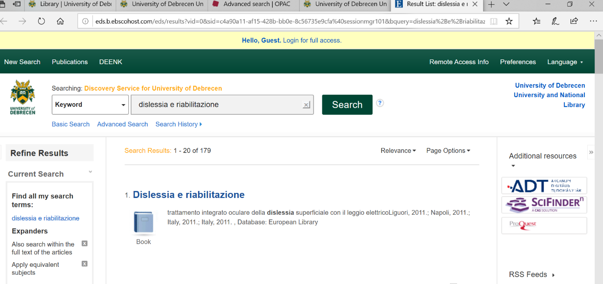

[**Debrecen University Library**](http://www.lib.unideb.hu/kn/bemutatkozas.htm), **UNGHERIA**

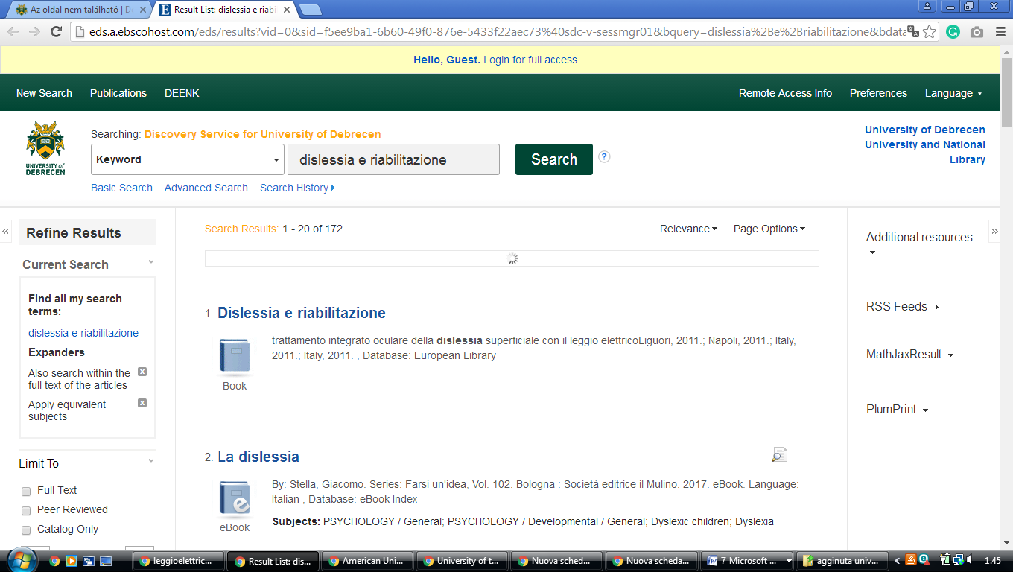http://eds.b.ebscohost.com/eds/results?vid=0&sid=b2e99a48-100c-4cf6-b399-603a39763167%40sessionmgr102&bquery=dislessia%2Be%2Briabilitazione&bdata=JkF1dGhUeXBlPWlwLHVpZCZ0eXBlPTAmc2VhcmNoTW9kZT1BbmQmc2l0ZT1lZHMtbGl2ZQ%3d%3d