### [1 ANADOLU ÜNIVERSITESI KÜTÜPHANESI](http://www.kdm.anadolu.edu.tr/) – (Eskisehir, Turkey)

<http://eds.b.ebscohost.com/eds/results?vid=0&sid=7cdb1c5b-1f22-4a0c-889b-60a29033720d%40sessionmgr102&bquery=dislessia+e+riabilitazione&bdata=JmNsaTA9RlQxJmNsdjA9WSZsYW5nPXRyJnR5cGU9MCZzaXRlPWVkcy1saXZl>

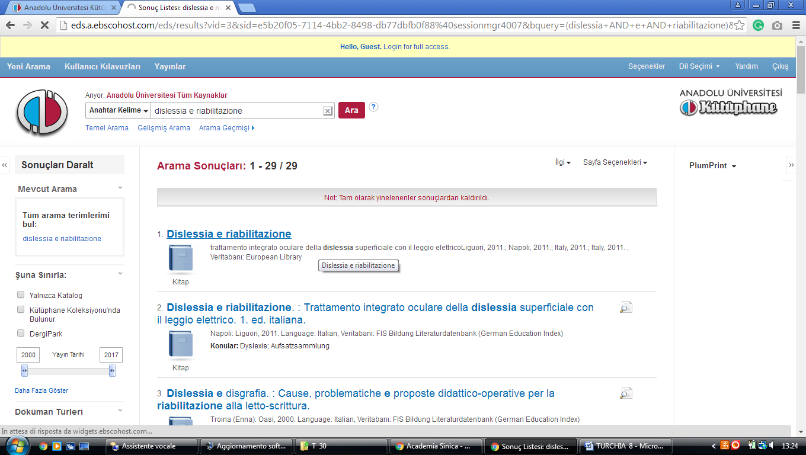

[**2 BILKENT UNIVERSITY LIBRARY**](http://library.bilkent.edu.tr/)– (Ankara, Turkey)

<http://eds.a.ebscohost.com/eds/results?vid=1&sid=07959a15-bfb0-4f25-9cd5-f495867914cf%40sessionmgr4008&bquery=(dislessia+AND+e+AND+riabilitazione)&bdata=JnR5cGU9MCZzaXRlPWVkcy1saXZl>

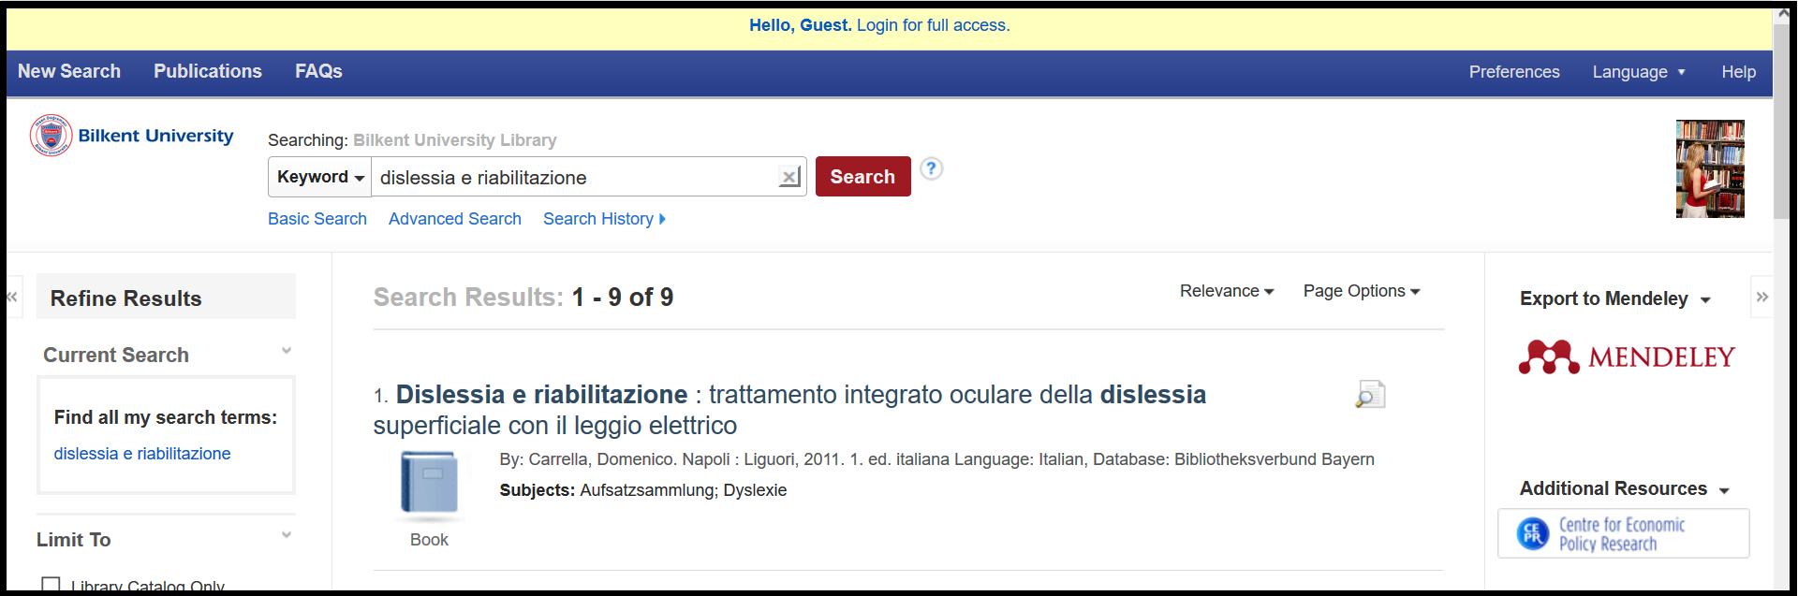

[**3 BOGAZICI UNIVERSITY LIBRARY**](http://www.library.boun.edu.tr/)– (Istanbul,Turkey)

[http://boun.summon.serialssolutions.com/search?s.q=dislessia+e+riabilitazione#!/search?ho=f&l=en&q=dislessia%20e%20riabilitazione](http://boun.summon.serialssolutions.com/search?s.q=dislessia+e+riabilitazione%23!/search?ho=f&l=en&q=dislessia%20e%20riabilitazione)

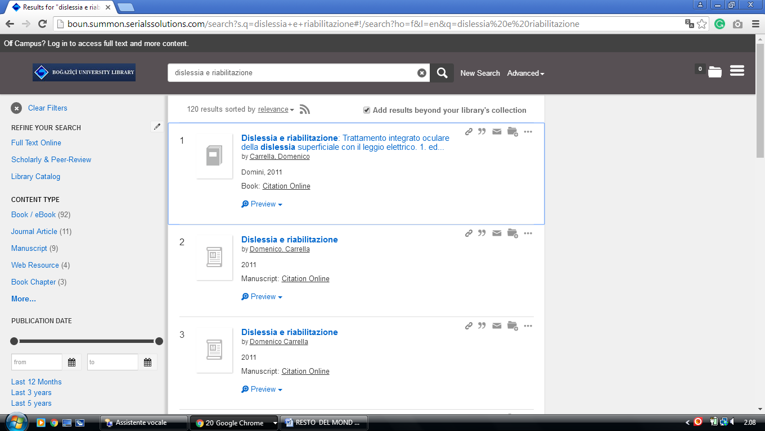

[**4 ISTANBUL TECHNICAL UNIVERSITY**](http://www.library.itu.edu.tr/) - (Istanbul, Turkey)

<http://eds.a.ebscohost.com/eds/results?vid=0&sid=00184404-db85-4829-b83a-c1ca7cef8c05%40sessionmgr4007&bquery=dislessia+e+riabilitazione&bdata=JmNsaTA9RlQxJmNsdjA9WSZ0eXBlPTAmc2l0ZT1lZHMtbGl2ZQ%3d%3d>

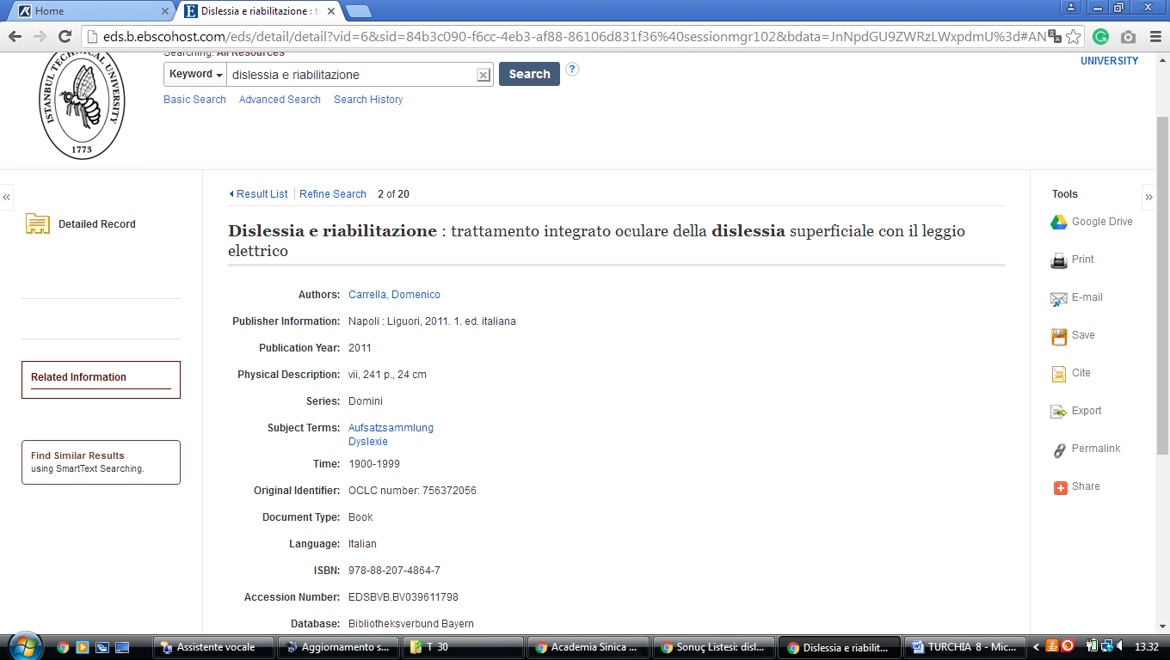

[**5 SAKARYA UNIVERSITY**](http://www.kutuphane.sakarya.edu.tr/) **LIBRARY** – (Adapazari, Sakarya, Turkey)

<http://eds.a.ebscohost.com/eds/results?vid=1&sid=c7637ec6-5cc2-40d5-ae20-3e31f30d0b52%40sessionmgr4008&bquery=(dislessia+AND+e+AND+riabilitazione)&bdata=Jmxhbmc9dHImdHlwZT0wJnNpdGU9ZWRzLWxpdmUmc2NvcGU9c2l0ZQ%3d%3d>

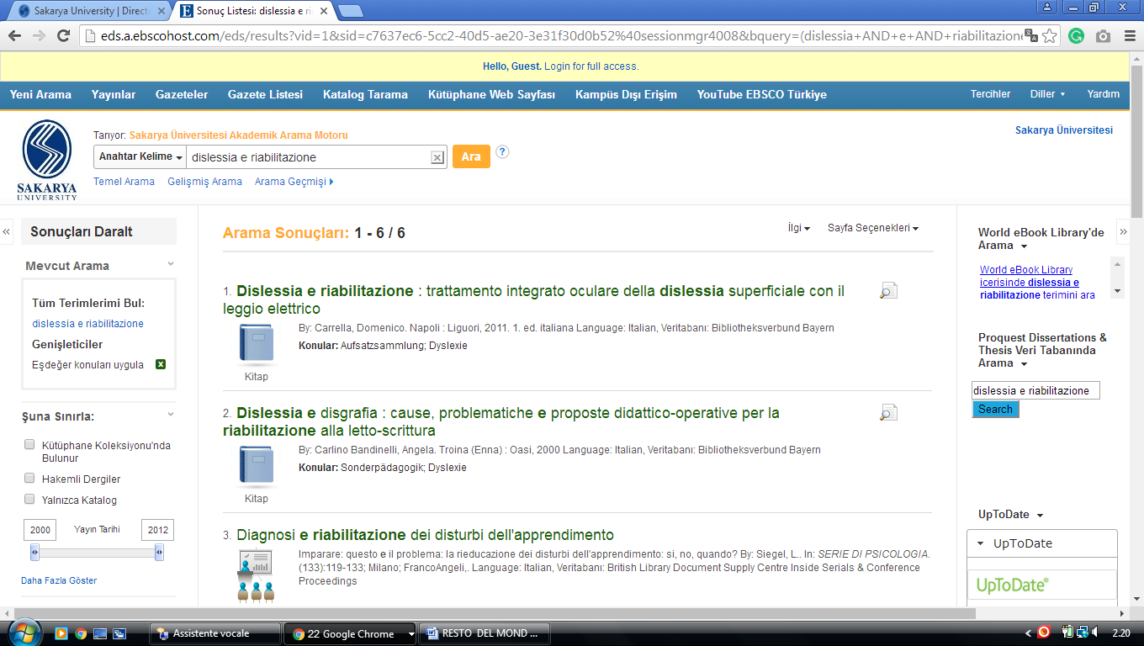

### [6 COMÜ - KÜTÜPHANE VE DOKÜMANTASYON D.BŞK.](http://lib.comu.edu.tr/) – (Erzioğlu Campus (Main Campus), [Çanakkale](https://en.wikipedia.org/wiki/%C3%87anakkale" \o "Çanakkale), [Çomü](https://en.wikipedia.org/w/index.php?title=%C3%87OM%C3%9C&action=edit&redlink=1)turkey)

<http://eds.b.ebscohost.com/eds/results?vid=1&sid=af017453-8894-46b3-96fa-e602b99b043d%40pdc-v-sessmgr01&bquery=(dislessia+AND+e+AND+riabilitazione)&bdata=Jmxhbmc9dHImdHlwZT0wJnNpdGU9ZWRzLWxpdmU%3d>

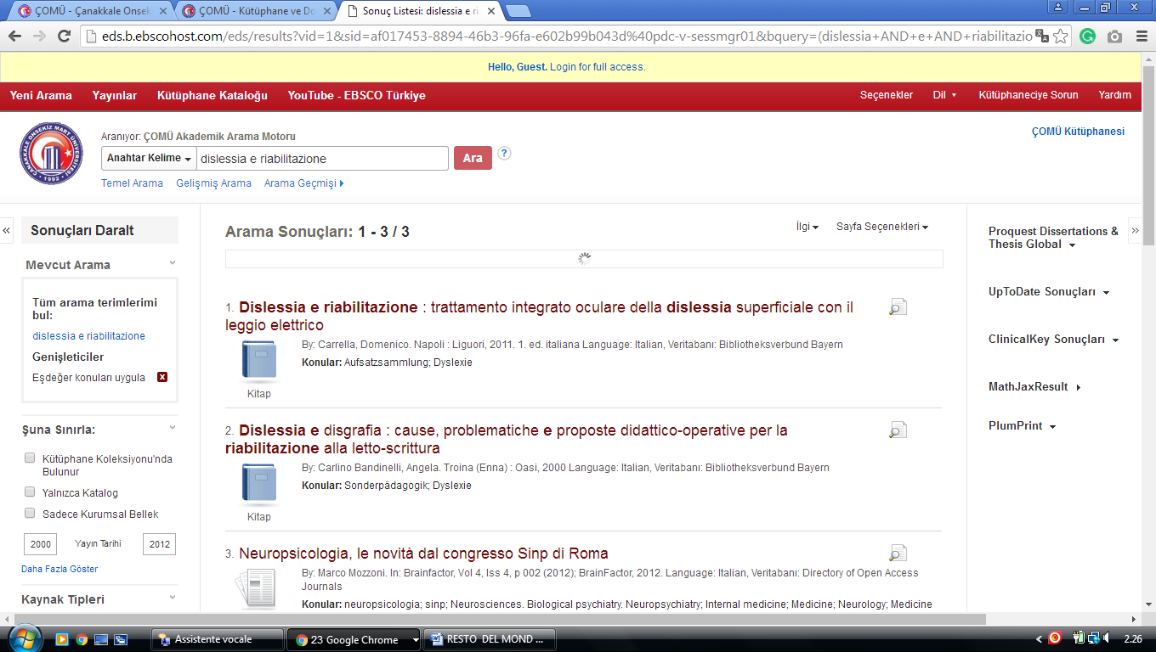

[**7 YAŞAR ÜNİVERSİTESİ – Bilgi Merkez**i](https://library.yasar.edu.tr/) - ([Izmir](https://en.wikipedia.org/wiki/Izmir), [Turkey](https://en.wikipedia.org/wiki/Turkey))

<http://eds.b.ebscohost.com/eds/results?vid=1&sid=fe965ed4-cf7c-4dd1-9c6e-8442d5549860%40sessionmgr120&bquery=(dislessia+AND+e+AND+riabilitazione)&bdata=JnR5cGU9MCZzaXRlPWVkcy1saXZl>

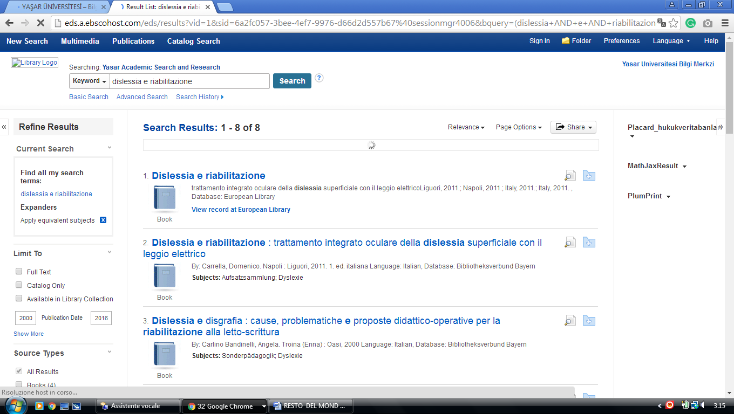

[**Özay Oral Library - EMU**](https://library.emu.edu.tr/)**, TURCHIA**

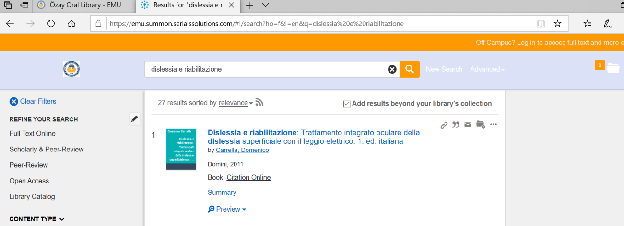https://emu.summon.serialssolutions.com/#!/search?ho=f&l=en&q=dislessia%20e%20riabilitazione

[**Süleyman Demirel Üniversitesi Bilgi Merkezi**](http://tara.sdu.edu.tr/vufind/)[**Isparta**](https://librarytechnology.org/libraries/search.pl?City=Isparta&Country=Turkey)**, Turkey**

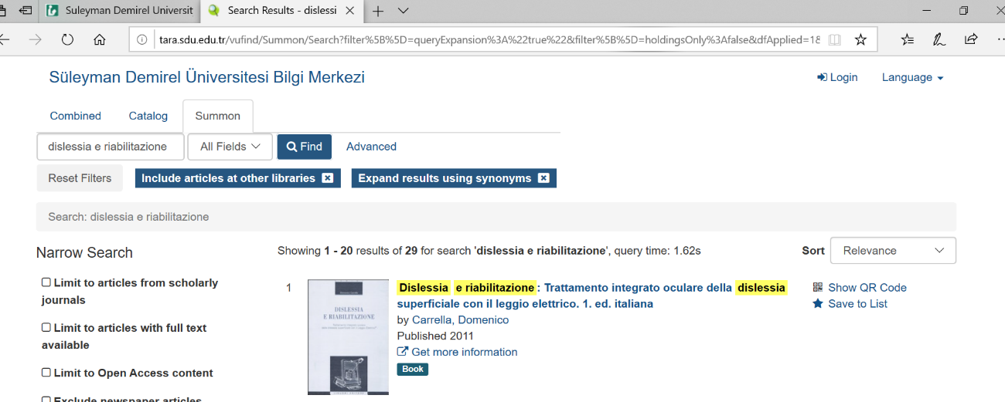tara.sdu.edu.tr/vufind/Summon/Search?filter%5B%5D=queryExpansion%3A%22true%22&filter%5B%5D=holdingsOnly%3Afalse&dfApplied=1&lookfor=dislessia+e+riabilitazione&type=AllFields