**CONSORTIUM OF TANZANIA UNIVERSITY, Dar Es Salaam, TANZANIA**

[College Libraries – COTUL](https://www.google.com/url?sa=t&rct=j&q=&esrc=s&source=web&cd=11&cad=rja&uact=8&ved=2ahUKEwjCi-Kt6s_oAhVk7aYKHR_ODtQQFjAKegQIARAB&url=http%3A%2F%2Fwww.cotul.or.tz%2Findex.php%2Four-members%2F94-our-members%2F99-college-libraries&usg=AOvVaw2S_hIANiBlj33D1rio-veR)

[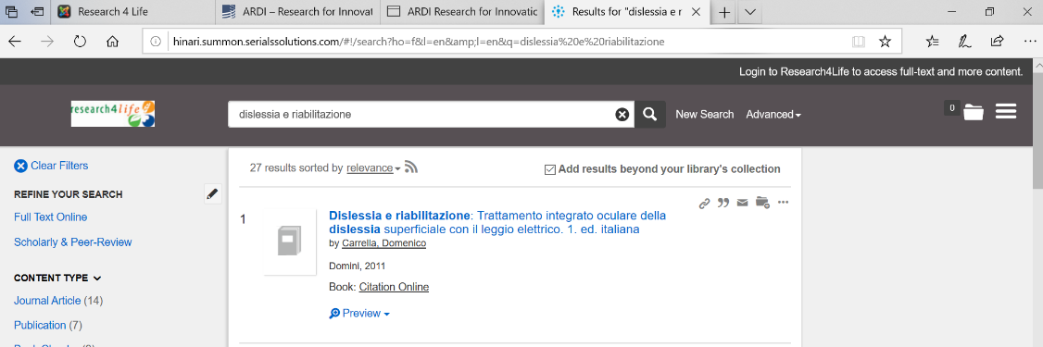](https://www.google.com/url?sa=t&rct=j&q=&esrc=s&source=web&cd=11&cad=rja&uact=8&ved=2ahUKEwjCi-Kt6s_oAhVk7aYKHR_ODtQQFjAKegQIARAB&url=http%3A%2F%2Fwww.cotul.or.tz%2Findex.php%2Four-members%2F94-our-members%2F99-college-libraries&usg=AOvVaw2S_hIANiBlj33D1rio-veR)