**[1 NATIONAL TAIWAN UNIVERSITY](http://www.lib.ntu.edu.tw/" \t "_blank" \o "National Taiwan University) LIBRARY**T – (Aipei, Taiwan)

<http://primo.lib.ntu.edu.tw/primo_library/libweb/action/search.do?ct=facet&pcAvailabiltyMode=true&pcAvailClicked=true&indx=1&fn=search&vl(1UI0)=contains&dscnt=0&tb=t&mode=Basic&vid=NTU&srt=rank&tab=default_tab&SUBMIT=&vl(56823557UI0)=any&dum=true&vl(freeText0)=dislessia%20e%20riabilitazione&dstmp=1518513208854>

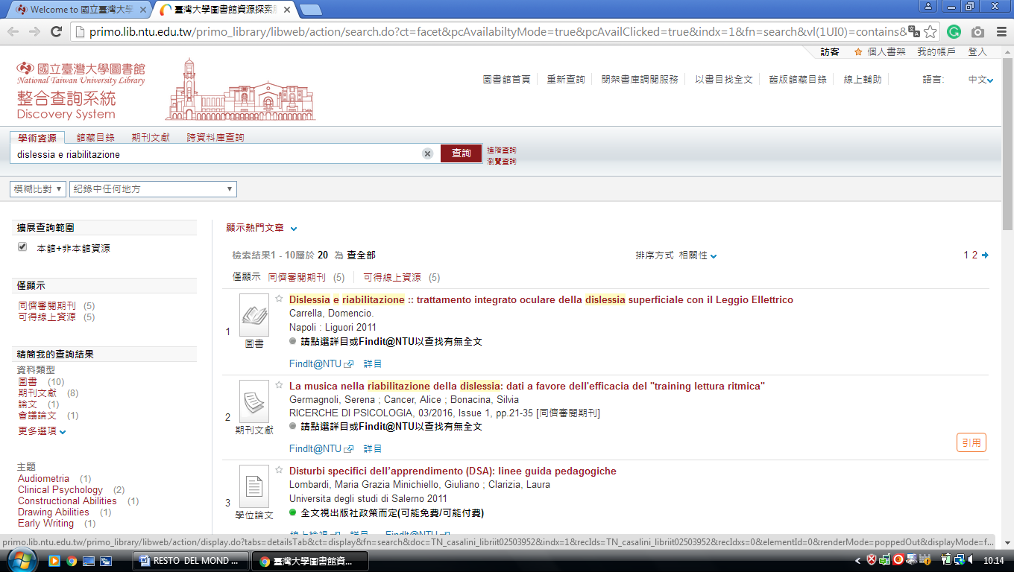

[**2 ACADEMIA SINICA LIFE SCIENCE LIBRARY**](http://lsl.sinica.edu.tw/en/index_e.php) – (TaipeiTaiwan)

[http://sinica.summon.serialssolutions.com/search?s.q=dislessia+e+riabilitazione#!/search?ho=f&l=en&q=dislessia%20e%20riabilitazione](http://sinica.summon.serialssolutions.com/search?s.q=dislessia+e+riabilitazione%23!/search?ho=f&l=en&q=dislessia%20e%20riabilitazione)

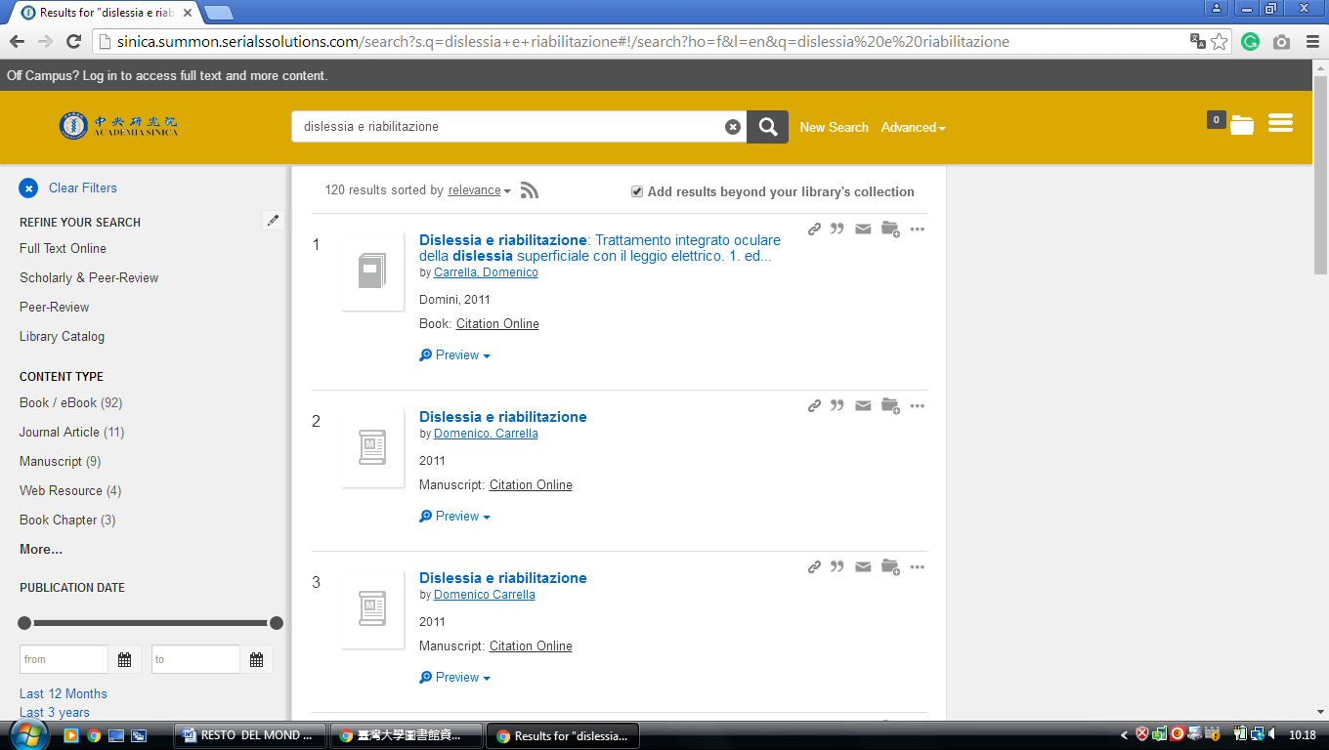

**3 CHANG GUNG UNIVERSITY LIBRARY** – ([Guishan](https://en.wikipedia.org/wiki/Guishan_District" \o "Guishan District), [Taoyuan City](https://en.wikipedia.org/wiki/Taoyuan_City), Taiwan)

<http://primo.lib.cgu.edu.tw/primo_library/libweb/action/search.do?fn=search&mode=Basic&tab=default_tab&indx=1&dum=true&srt=rank&frbg=&vid=CGU&vl%28freeText0%29=dislessia+e+riabilitazione>

**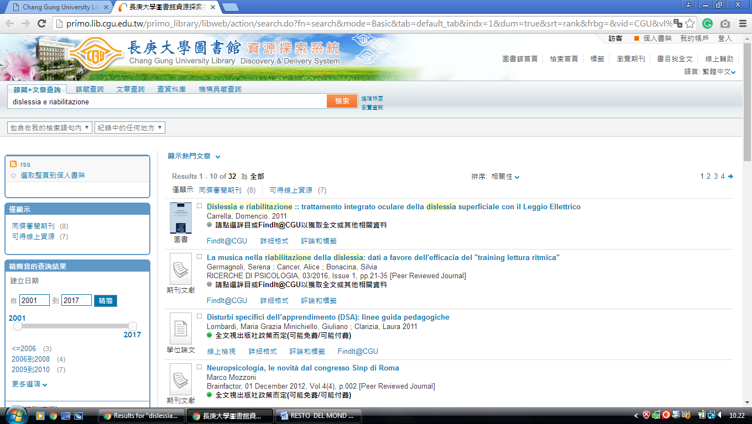**

**4 CHUNG HUA UNIVERSITY LIBRARY**  - ([Guishan](https://en.wikipedia.org/wiki/Guishan_District" \o "Guishan District), [Taoyuan City](https://en.wikipedia.org/wiki/Taoyuan_City), Taiwan)

<http://ustcate.lib.nctu.edu.tw/primo_library/libweb/action/search.do?ct=facet&pcAvailabiltyMode=true&dscnt=0&scp.scps=scope%3A(NTHU)%2Cprimo_central_multiple_fe&frbg=&tab=pc_ils&dstmp=1518513997287&srt=rank&ct=search&mode=Basic&vl(147200900UI0)=any&dum=true&indx=1&tb=t&vl(147200899UI1)=all_items&vl(1UIStartWith0)=contains&vl(freeText0)=dislessia%20e%20riabilitazione&fn=search&vid=NTHU>

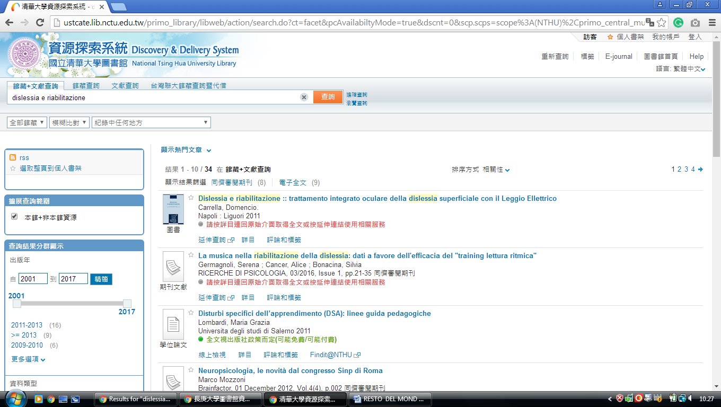

-------------------------------------------------------------------------------------------------------------------------------

### [5 CHUNG YUAN CHRISTIAN UNIVERSITY CHANG CHING YU MEMORIAL LIBRARY](https://www.lib.cycu.edu.tw/www-n-c&e/) -  ([Taoyuan City](https://en.wikipedia.org/wiki/Taoyuan_City), [Taiwan](https://en.wikipedia.org/wiki/Taiwan))

[http://eds.a.ebscohost.com/eds/detail/detail?vid=2&sid=8f9bddd8-fa5f-40b2-8d87-5bb5d00129a8%40sessionmgr4008&bdata=Jmxhbmc9emgtdHcmc2l0ZT1lZHMtbGl2ZQ%3d%3d#AN=EDSBVB.BV039611798&db=edsbvb](http://eds.a.ebscohost.com/eds/detail/detail?vid=2&sid=8f9bddd8-fa5f-40b2-8d87-5bb5d00129a8%40sessionmgr4008&bdata=Jmxhbmc9emgtdHcmc2l0ZT1lZHMtbGl2ZQ%3d%3d%23AN=EDSBVB.BV039611798&db=edsbvb)

**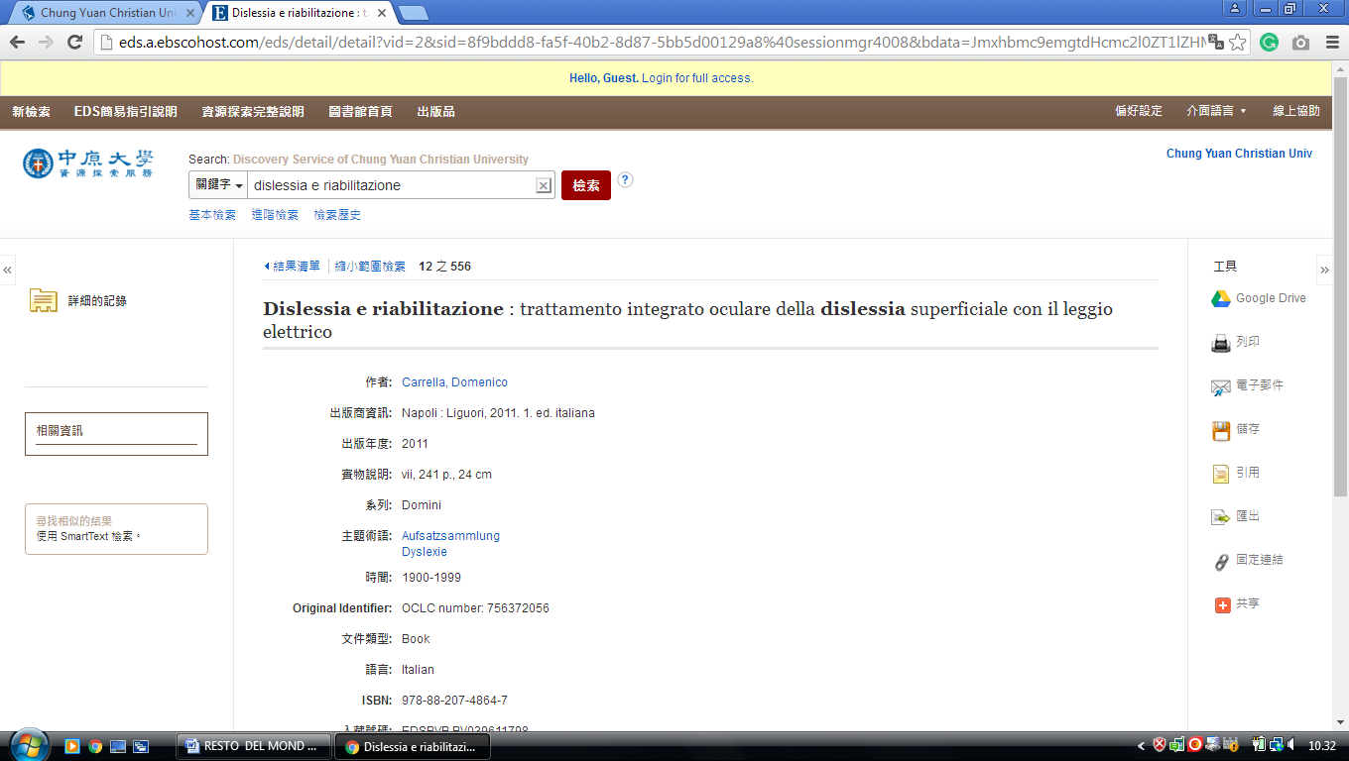**

**6 PRIMO.LIB.CCU.EDU.TW - (**Ling Tung University [Nantun](https://en.wikipedia.org/wiki/Nantun_District), [Taichung](https://en.wikipedia.org/wiki/Taichung), [Taiwan](https://en.wikipedia.org/wiki/Taiwan))

<http://primo.lib.ccu.edu.tw/primo_library/libweb/action/search.do?ct=facet&pcAvailabiltyMode=true&pcAvailClicked=true&vid=CCU&mode=Basic&pcAvailabiltyMode=false&tab=default_tab&fn=search&indx=1&dscnt=0&vl(freeText0)=DISLESSIA%20E%20RIABILITAZIONE&scp.scps=primo_central_multiple_fe&adjacent1=Y&dstmp=1501549993940>

**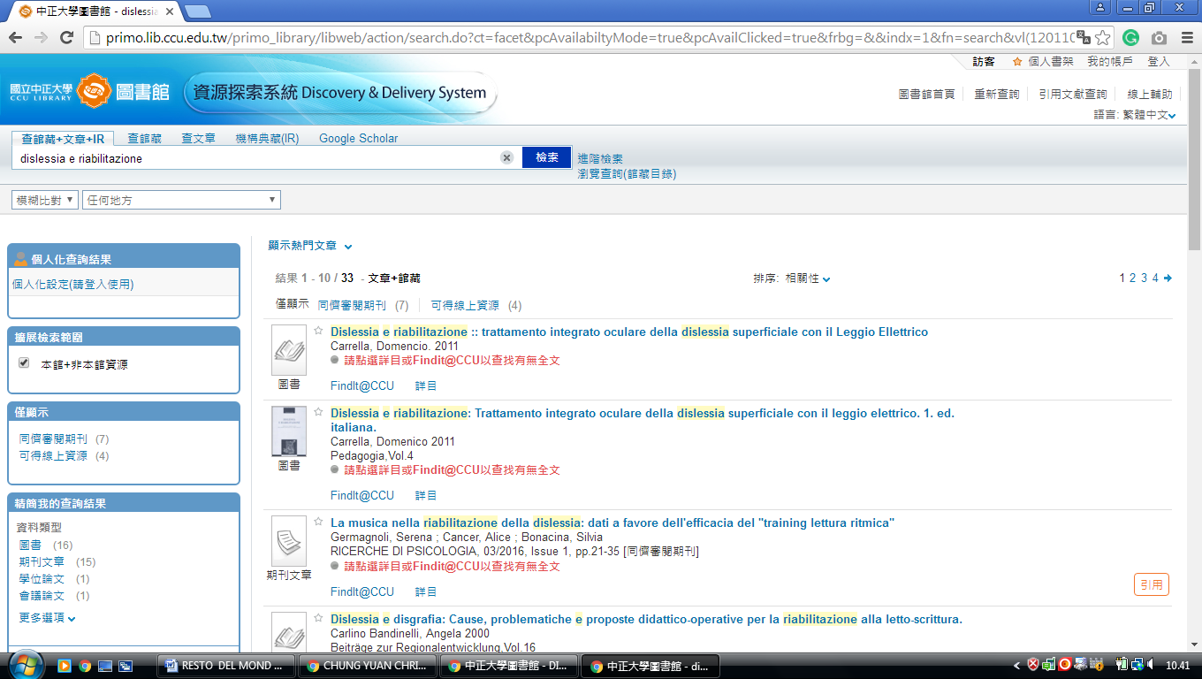**

[**7 NATIONAL CHUNG HSING UNIVERSITY LIBRARY**](http://www.lib.nchu.edu.tw/lib_english/eng_index.htm) – ([South District](https://en.wikipedia.org/wiki/South_District,_Taichung),[Taichung](https://en.wikipedia.org/wiki/Taichung),

[Taiwan](https://en.wikipedia.org/wiki/Taiwan))

<http://primo.lib.ccu.edu.tw/primo_library/libweb/action/search.do?ct=facet&pcAvailabiltyMode=true&pcAvailClicked=true&vid=CCU&mode=Basic&pcAvailabiltyMode=false&tab=default_tab&fn=search&indx=1&dscnt=0&vl(freeText0)=dislessia%20e%20riabilitazione&scp.scps=primo_central_multiple_fe&adjacent1=Y&dstmp=1518515345400>

**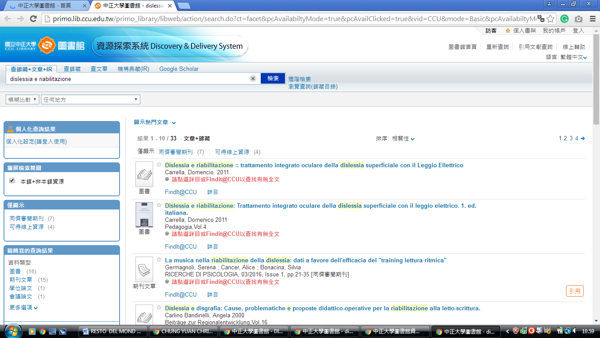**

[**8 NATIONAL CHUNG CHENG UNIVERSITY LIBRARY**](http://www.lib.ccu.edu.tw/joomla/) **-** ([Chiayi County](https://en.wikipedia.org/wiki/Chiayi_County), [Taiwan](https://en.wikipedia.org/wiki/Taiwan))

<http://primo.lib.ccu.edu.tw/primo_library/libweb/action/search.do?ct=facet&pcAvailabiltyMode=true&pcAvailClicked=true&vid=CCU&mode=Basic&pcAvailabiltyMode=false&tab=default_tab&fn=search&indx=1&dscnt=0&vl(freeText0)=dislessia%20e%20riabilitazione&scp.scps=primo_central_multiple_fe&adjacent1=Y&dstmp=1518515783709>

**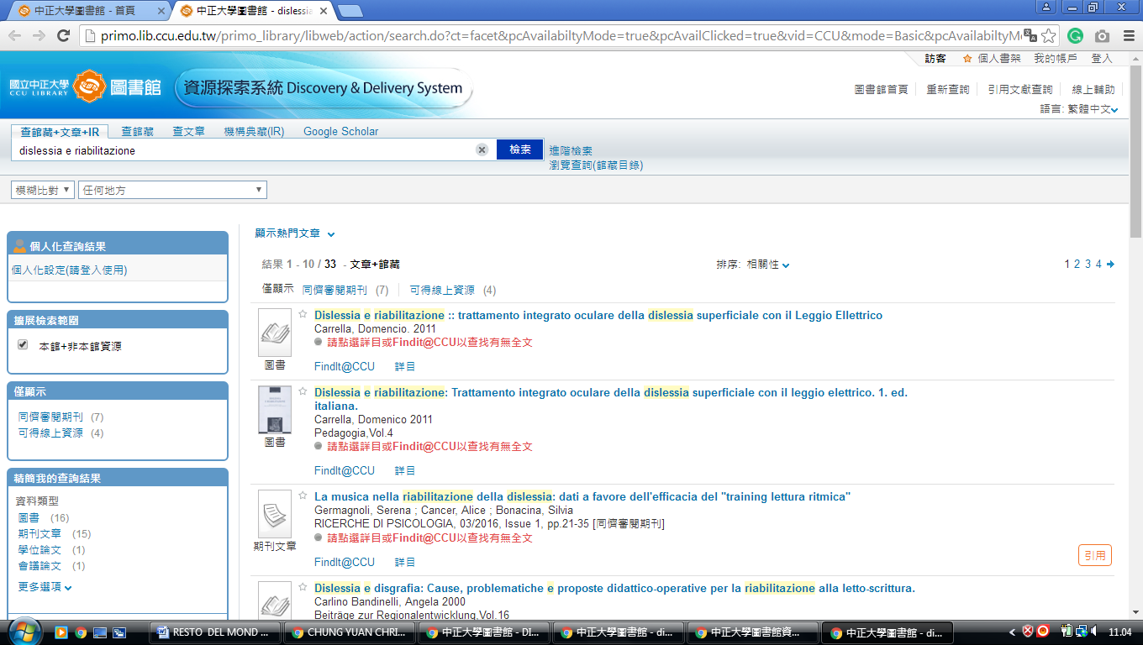**

[**9 Chang Jung Christian University Library**](http://eservice.lib.cjcu.edu.tw/site/) **-** [(Guiren](https://en.wikipedia.org/wiki/Guiren_District), [Tainan](https://en.wikipedia.org/wiki/Tainan), [Taiwan](https://en.wikipedia.org/wiki/Taiwan))

<http://discovery.lib.cjcu.edu.tw/primo_library/libweb/action/search.do?ct=facet&pcAvailabiltyMode=true&dscnt=0&dum=true&indx=1&frbg=&tab=ils_pc&dstmp=1518515739399&srt=rank&vl(freeText0)=dislessia%20e%20riabilitazione&vid=CJCU&fn=search&mode=Basic>

**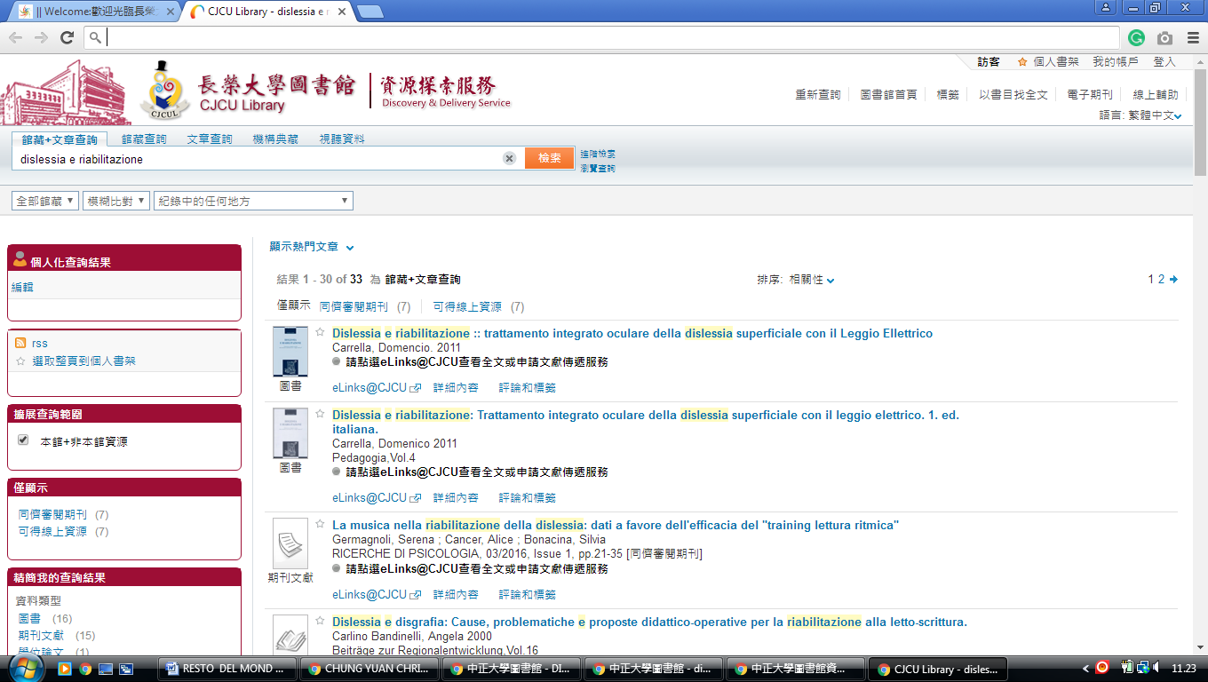**

[**10 NATIONAL CHIAO TUNG UNIVERSITY LIBRARY**](http://www.lib.nctu.edu.tw/index/langid-2/) **-** (Hsinchu City, [Taiwan](https://www.google.it/search?rlz=1C1CHIK_itIT460IT464&q=Provincia+di+Taiwan&stick=H4sIAAAAAAAAAOPgE-LUz9U3MEkpzzJT4gAxM3KNirXkspOt9HPykxNLMvPz4AyrgqL8ssy85FQAU6YTiDcAAAA&sa=X&ved=0ahUKEwjR9OvE4_DZAhXGDOwKHWXLBuUQmxMIngEoATAU))

<http://ustcate.lib.nctu.edu.tw/primo_library/libweb/action/search.do?vl%28freeText0%29=dislessia+e+riabilitazione&prefLang=en_US&vl%281UI0%29=contains&scp.scps=scope%3A%28NCTU%29%2Cprimo_central_multiple_fe&tb=t&frbg=&vid=NCTU&srt=rank&dum=true&index=1&tab=ils_article&mode=Basic&initialSearch=true&ct=search&fn=search>

**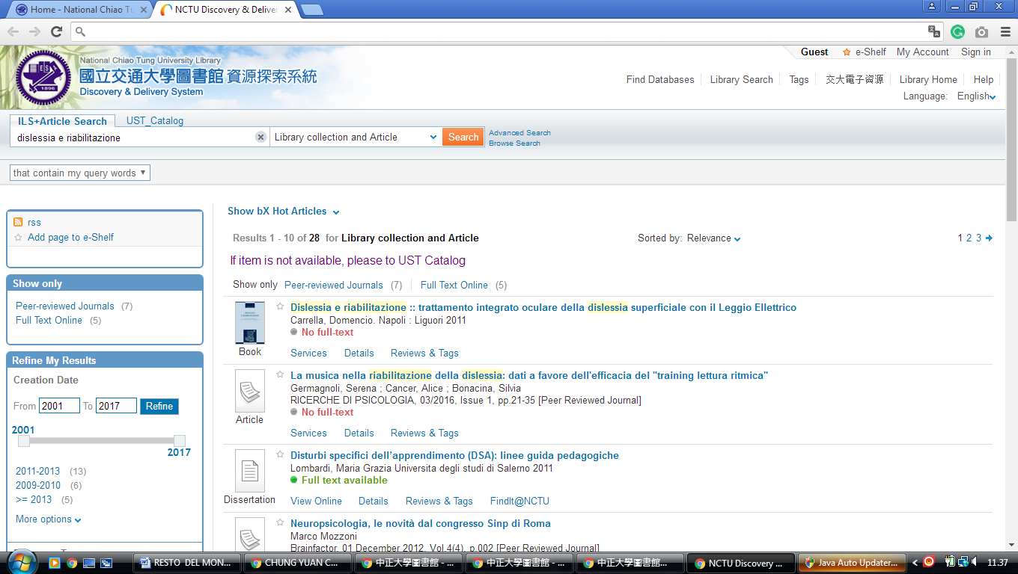**

[**11 NATIONAL TSING HUA UNIVERSITY LIBRARY**](http://www.lib.nthu.edu.tw/en/) **-** ([Hsinchu City](https://en.wikipedia.org/wiki/Hsinchu_City), [Taiwan](https://en.wikipedia.org/wiki/Taiwan))

<http://ustcate.lib.nctu.edu.tw/primo_library/libweb/action/search.do?ct=facet&pcAvailabiltyMode=true&dscnt=0&scp.scps=scope%3A(NTHU)%2Cprimo_central_multiple_fe&frbg=&tab=pc_ils&dstmp=1518518457171&srt=rank&ct=search&mode=Basic&vl(147200900UI0)=any&dum=true&indx=1&tb=t&vl(147200899UI1)=all_items&vl(1UIStartWith0)=contains&vl(freeText0)=dislessia%20e%20riabilitazione&fn=search&vid=NTHU>

**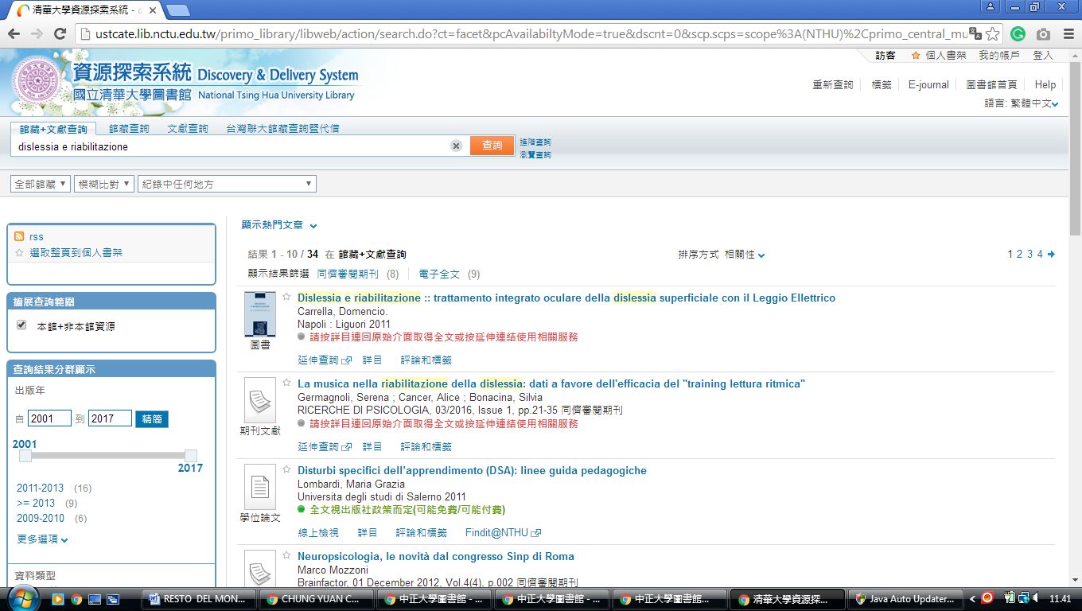**

**12** [**PRIMO.LIB.CCU.EDU.TW**](http://primo.lib.ccu.edu.tw) **- (**National Changhua University Of Education Library Changhua City, [Taiwan](https://en.wikipedia.org/wiki/Taiwan))

<http://primo.lib.ccu.edu.tw/primo_library/libweb/action/search.do?ct=facet&pcAvailabiltyMode=true&pcAvailClicked=true&frbg=&&indx=1&fn=search&vl(12011063UI0)=any&dscnt=0&scp.scps=scope%3A(%22CCU%22)%2Cscope%3A(CCU_IR_NCL)%2Cscope%3A(CCU_ALEPH)%2Cscope%3A(CCU_SFX)%2Cprimo_central_multiple_fe&vl(1UIStartWith0)=contains&tb=t&vid=CCU&mode=Basic&ct=search&srt=rank&tab=default_tab&dum=true&vl(freeText0)=dislessia%20e%20riabilitazione&dstmp=1518603134682>

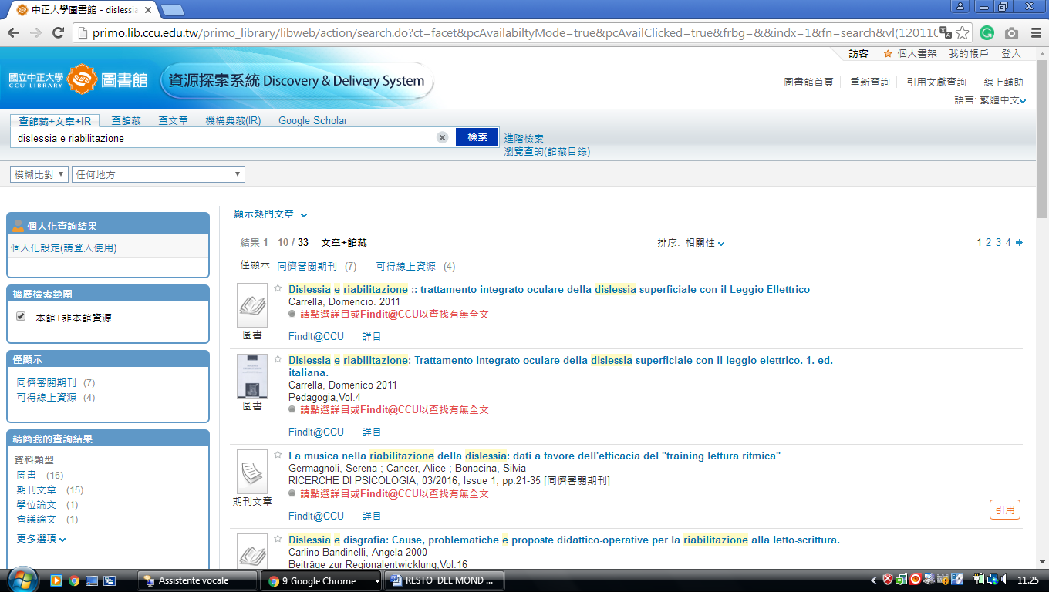

[**13 NATIONAL CHIAO TUNG UNIVERSITY LIBRARY**](http://www.lib.nctu.edu.tw/index/langid-2/) **-**  (Hsinchu, Taiwan)

<http://ustcate.lib.nctu.edu.tw/primo_library/libweb/action/search.do?vl%28freeText0%29=dislessia+e+riabilitazione&prefLang=en_US&vl%281UI0%29=contains&scp.scps=scope%3A%28NCTU%29%2Cprimo_central_multiple_fe&tb=t&frbg=&vid=NCTU&srt=rank&dum=true&index=1&tab=ils_article&mode=Basic&initialSearch=true&ct=search&fn=search>

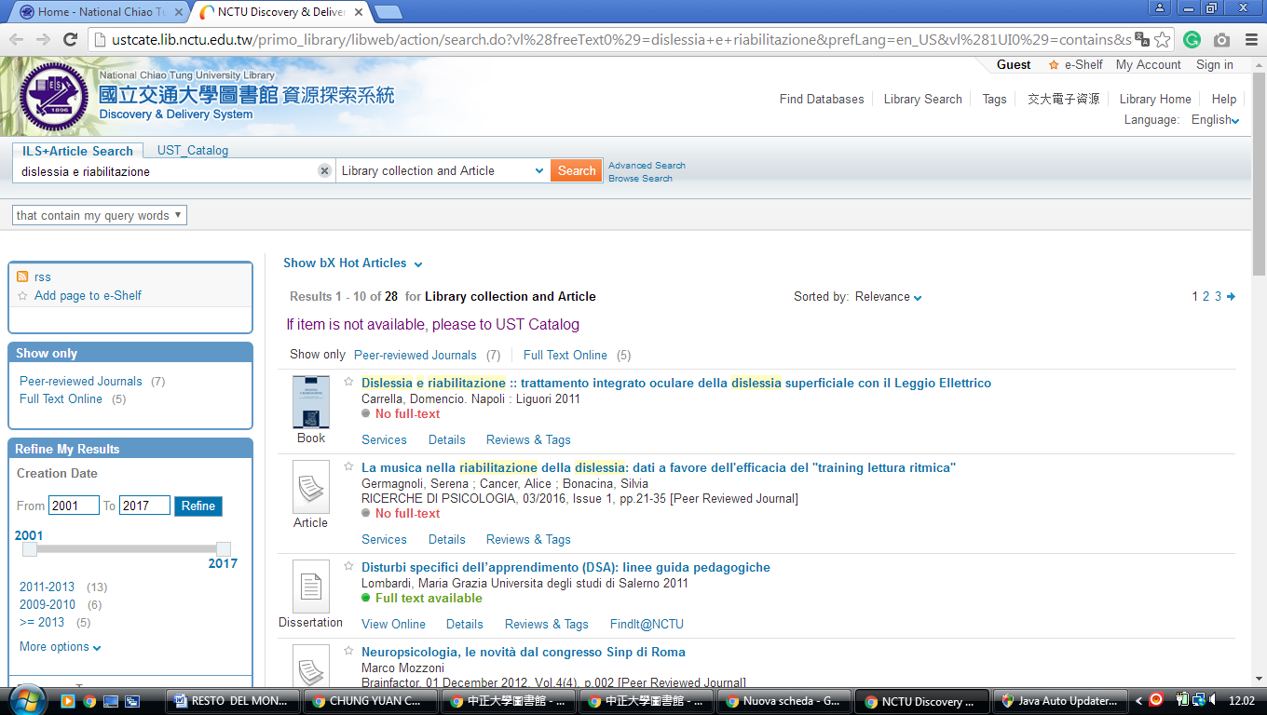

[**14 NATIONAL TSING HUA UNIVERSITY LIBRARY**](http://www.lib.nthu.edu.tw/en/) [- (Hsinchu City](https://en.wikipedia.org/wiki/Hsinchu_City), [Taiwan](https://en.wikipedia.org/wiki/Taiwan))

<http://ustcate.lib.nctu.edu.tw/primo_library/libweb/action/search.do?ct=facet&pcAvailabiltyMode=true&dscnt=0&scp.scps=scope%3A(NTHU)%2Cprimo_central_multiple_fe&frbg=&tab=pc_ils&dstmp=1518519883269&srt=rank&ct=search&mode=Basic&vl(147200900UI0)=any&dum=true&indx=1&tb=t&vl(147200899UI1)=all_items&vl(1UIStartWith0)=contains&vl(freeText0)=dislessia%20e%20riabilitazione&fn=search&vid=NTHU>

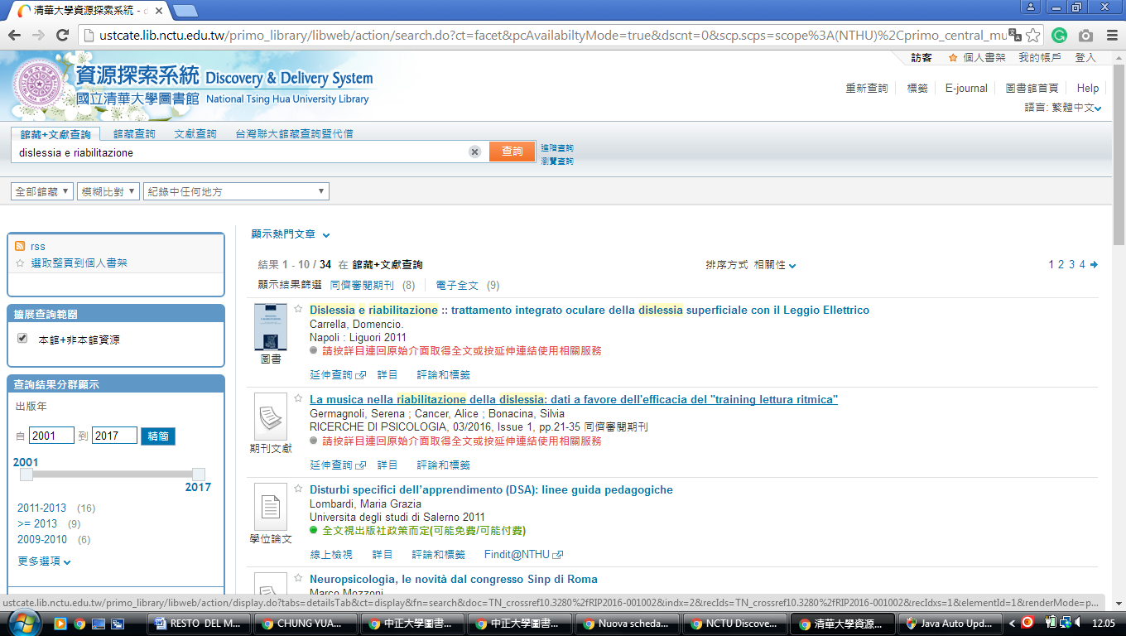

### [Providence University Library](http://www.lib.pu.edu.tw/english/)

[Distretto di shalu](https://translate.googleusercontent.com/translate_c?depth=1&hl=it&prev=search&rurl=translate.google.com&sl=en&sp=nmt4&u=https://en.m.wikipedia.org/wiki/Shalu_District&xid=17259,15700023,15700186,15700191,15700256,15700259,15700262,15700265,15700271&usg=ALkJrhhQzwdFcISozVCC9qCeZqI9TeDf3w), [taichung city,](https://translate.googleusercontent.com/translate_c?depth=1&hl=it&prev=search&rurl=translate.google.com&sl=en&sp=nmt4&u=https://en.m.wikipedia.org/wiki/Taichung_City&xid=17259,15700023,15700186,15700191,15700256,15700259,15700262,15700265,15700271&usg=ALkJrhj5ucZxwcCIiUPJQDC_h1Pd06otQQ)

ds.b.ebscohost.com/eds/results?vid=0&sid=73bebe4e-5a8d-41b4-b5ed-418a2c41dacd%40pdc-v-sessmgr01&bquery=dislessia%2Be%2Briabilitazione&bdata=Jmxhbmc9ZW5nJnR5cGU9MCZzZWFyY2hNb2RlPUFuZCZzaXRlPWVkcy1saXZl

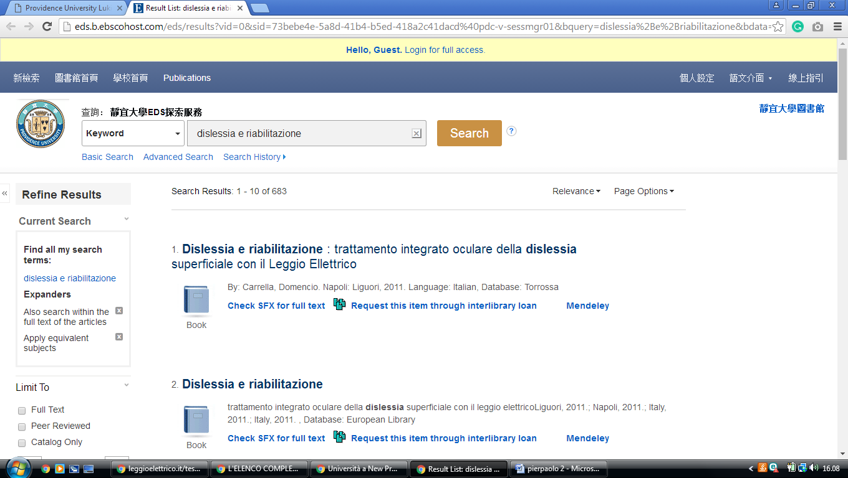

[**National Chiao Tung University Library, TAIWAN**](http://www.lib.nctu.edu.tw/eng1.html)

https://ustcate0.lib.nctu.edu.tw/primo\_library/libweb/action/search.do?ct=facet&pcAvailabiltyMode=true&pcAvailClicked=true&frbg=&&indx=1&fn=search&index=1&vl(1UI0)=contains&dscnt=0&scp.scps=scope%3A(NCTU\_AV)%2Cscope%3A(NCTU\_BOOK)%2Cscope%3A(NCTU\_DT)%2Cscope%3A(NCTU\_JOURNAL)%2Cscope%3A(NCTU)%2Cprimo\_central\_multiple\_fe&tb=t&vid=NCTU&mode=Basic&ct=search&srt=rank&tab=ils\_article&prefLang=en\_US&dum=true&vl(freeText0)=dislessia%20e%20riabilitazione&dstmp=1582230878966

