**[1 LES BIBLIOTHÈQUES DE L'UNIVERSITÉ DE FRIBOURG](http://www3.unifr.ch/biblio/fr/)** - (Zürich, Svizzera)

<https://explore.rero.ch/fr_CH/fr/result?se=DISLESSIA+E+RIABILITAZIONE&submit=&fd=any&pr=contains&ex=1&so=rank>

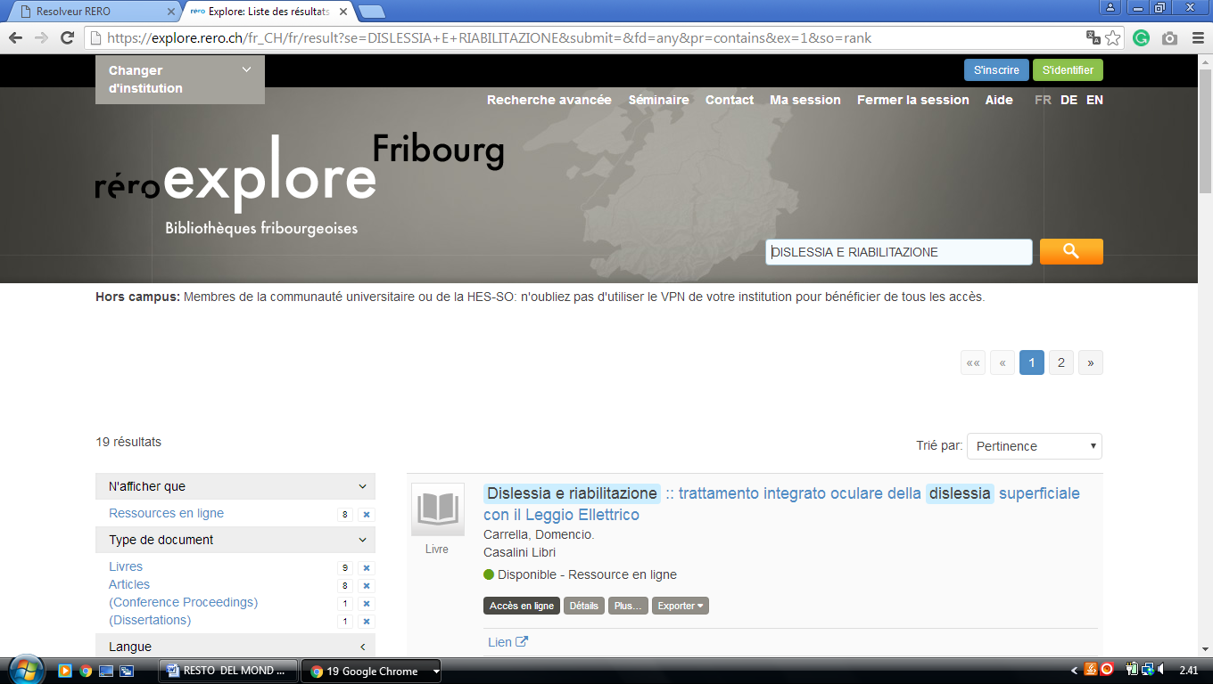

**2 ILUPLUS.HOSTED.EXLIBRISGROUP.COM – (**[Central And University Library Of Lucerne](http://www.zhbluzern.ch/), Lucerne, Switzerland)

<http://iluplus.hosted.exlibrisgroup.com/primo_library/libweb/action/search.do?ct=facet&pcAvailabiltyMode=true&pcAvailClicked=true&frbg=&&fn=search&indx=1&dscnt=0&scp.scps=scope%3A(41ZBL_DG_DDA)%2Cscope%3A(41ZBL_WILEY_HSLU)%2Cscope%3A(41ZBL_DH)%2Cscope%3A(41ZBL_BLACK)%2Cscope%3A(41ZBL_EBC_DDA_HSLU)%2Cscope%3A(41ZBL_BRILL)%2Cscope%3A(41ZBL_KNOVEL_HSLU)%2Cscope%3A(41ZBL_SPR_HSLU)%2Cscope%3A(41ZBL_SFX)%2Cscope%3A(41ZBL_Aleph)%2Cscope%3A(41ZBL_DIBIZ)%2Cscope%3A(41ZBL_NML)%2Cscope%3A(41ZBL_UTB_STUDI)%2Cscope%3A(41ZBL_DBIS_HSLU)%2Cscope%3A(41ZBL_DIBIZ_ZS)%2Cscope%3A(41ZBL_SPR_HSLUW)%2Cscope%3A(41ZBL_DG_HSLU)%2Cscope%3A(41ZBL_MATARCH)%2Cscope%3A(41ZBL_VAHLEN_HSLU)%2Cscope%3A(41ZBL_EBC_DDA_ZHB)%2Cscope%3A(41ZBL_LARA)%2Cscope%3A(41ZBL_SAFARI)%2Cscope%3A(41ZBL_CS_ZHB)%2Cscope%3A(41ZBL_CS_HSLU)%2Cscope%3A(41ZBL_LORY)%2Cscope%3A(41ZBL_RISM)%2Cscope%3A(41ZBL_VAHLEN_ZHB)%2Cscope%3A(41ZBL_NOMOS)%2Cscope%3A(41ZBL_OXFORD_ART_HSLU)%2Cscope%3A(41ZBL_DBIS)%2Cscope%3A(41ZBL_RISM_HSLU)%2Cscope%3A(41ZBL_OD)%2Cscope%3A(41ZBL_SPR_ZHB_AKT)%2Cscope%3A(41ZBL_SPR_ZHB_ARC)%2Cscope%3A(41ZBL_SPR_ZHB)%2Cscope%3A(41ZBL_OECD)%2Cscope%3A(41ZBL_BECK)%2Cscope%3A(41ZBL_HANSER_HSLU)%2Cscope%3A(41ZBL_HAN)%2Cscope%3A(41ZBL_OBP)%2Cscope%3A(41ZBL_ELGAR)%2Cscope%3A(41ZBL_SPR_HSLU_AKT)%2Cprimo_central_multiple_fe&tb=t&mode=Basic&vid=41ZBL&ct=search&srt=rank&tab=default_tab&dum=true&vl(freeText0)=dislessia%20e%20riabilitazione&dstmp=1521292660168>

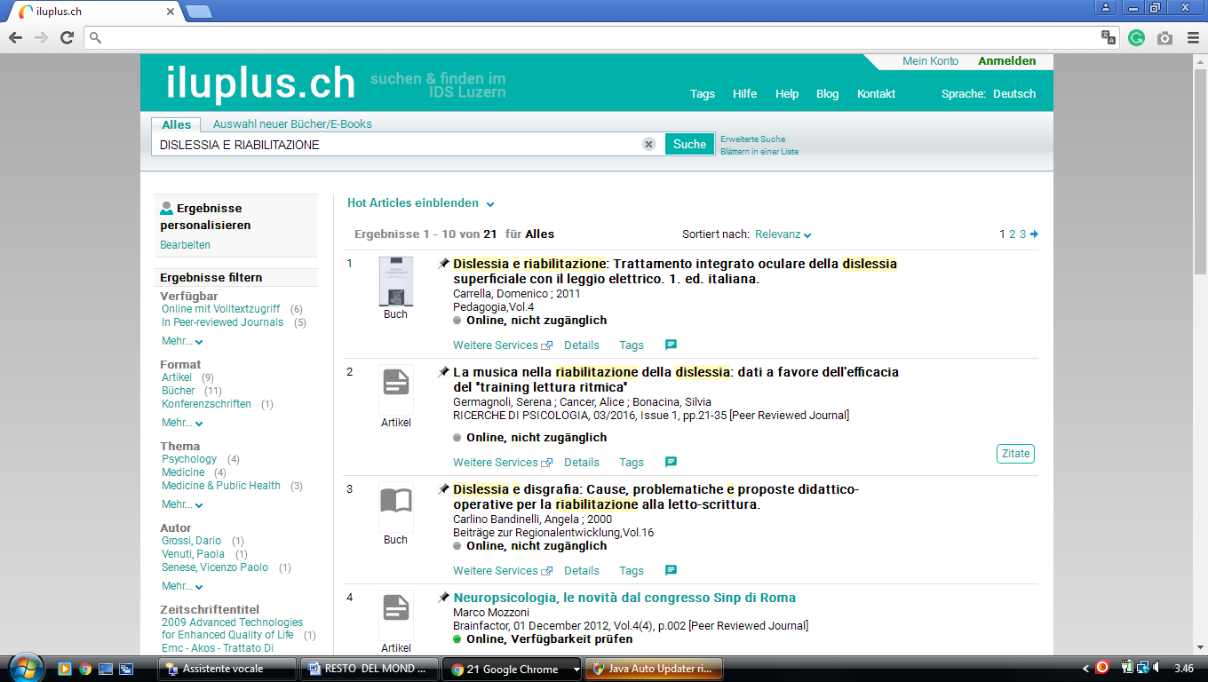

**3** [**CENTRAL LIBRARY ZURICH**](http://www.zb.uzh.ch/) - (Zurich, Switzerland)

[http://www.theeuropeanlibrary.org/tel4/search?query=dislessia%20e%20riabilitazione](%20http:/www.theeuropeanlibrary.org/tel4/search?query=dislessia%20e%20riabilitazione)

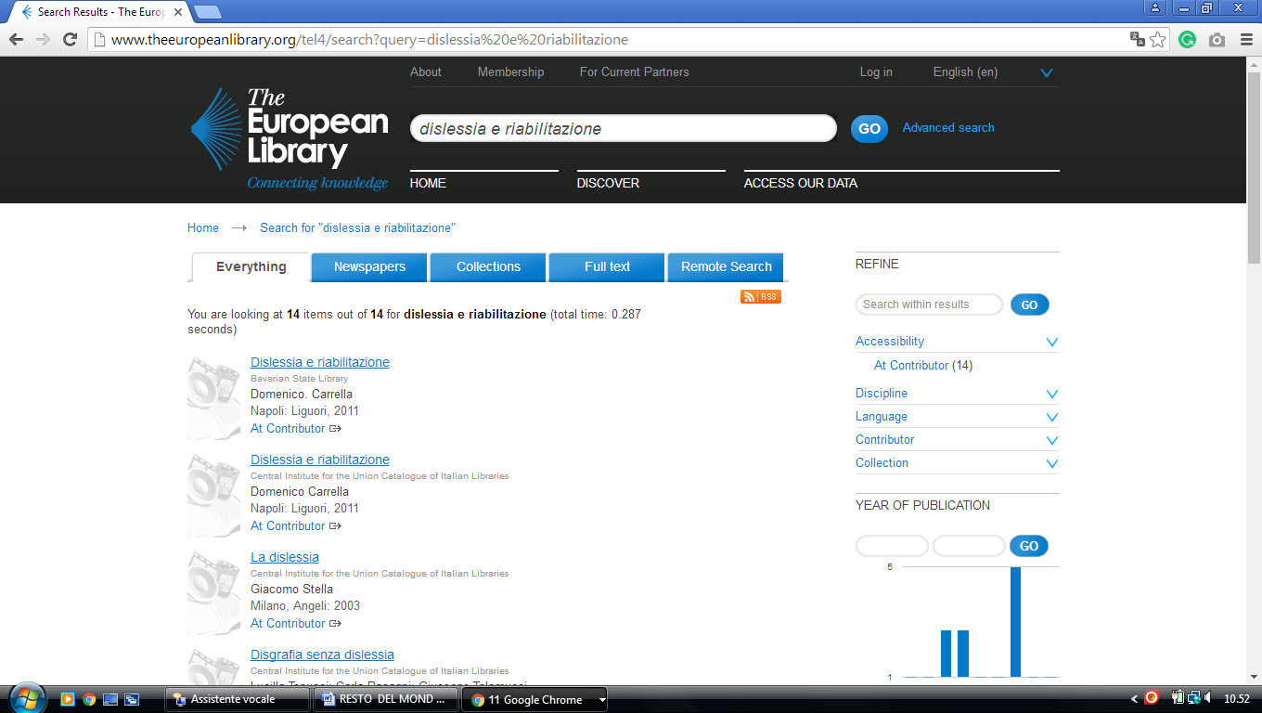

### 4 [SISTEMA BIBLIOTECARIO TICINESE: SBT](https://www.sbt.ti.ch/) - (Bellinzona, Switzerland)

<http://aleph.sbt.ti.ch/F?local_base=SBS01&func=find-c&ccl_term=WRD=dislessia%20e%20riabilitazione>

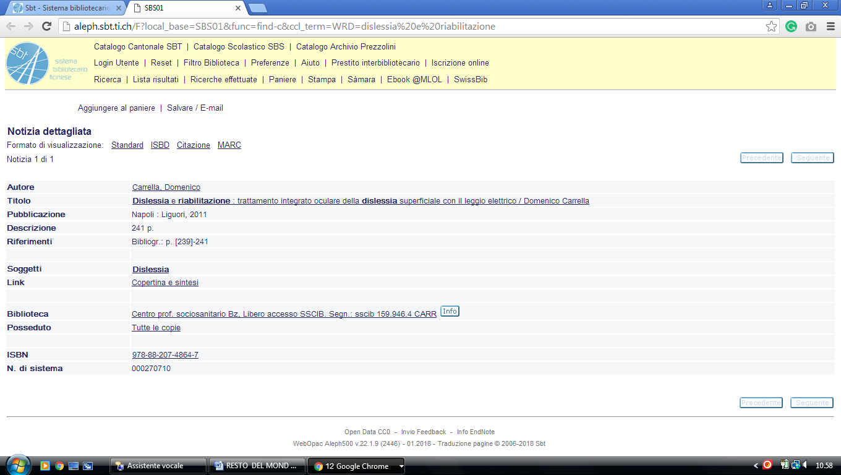

### 5 [RECHERCHEPORTAL](http://www.recherche-portal.ch/) [UNIVERSITÄT](http://www.unibe.ch/)ZÜRICH - (Svizzera)

<http://www.recherche-portal.ch/primo_library/libweb/action/display.do?tabs=detailsTab&ct=display&fn=search&doc=TN_casalini_libriit02503952&indx=1&recIds=TN_casalini_libriit02503952&recIdxs=0&elementId=0&renderMode=poppedOut&displayMode=full&frbrVersion=&vid=ZAD&mode=Basic&tab=primo_central&dscnt=0&vl(freeText0)=dislessia%20e%20riabilitazione&dstmp=1496092080115&gathStatIcon=tru>

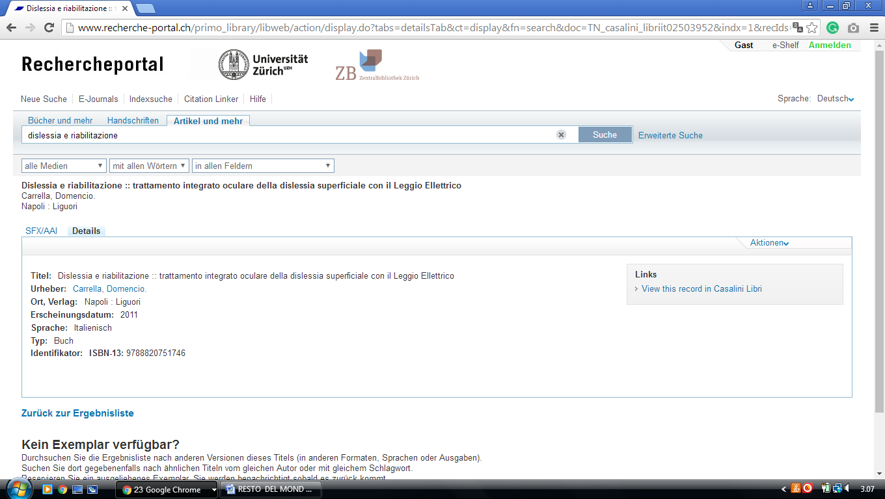

### 6[WISSENSPORTAL ETH-BIBLIOTHEK - Eth Zürich](http://www.library.ethz.ch/) – (Svizzera)

<http://www.library.ethz.ch/primo_library/libweb/action/search.do?mode=Basic&vid=DADS&vl(freeText0)=dislessia%20e%20riabilitazione&fn=search&tab=primo_central&>

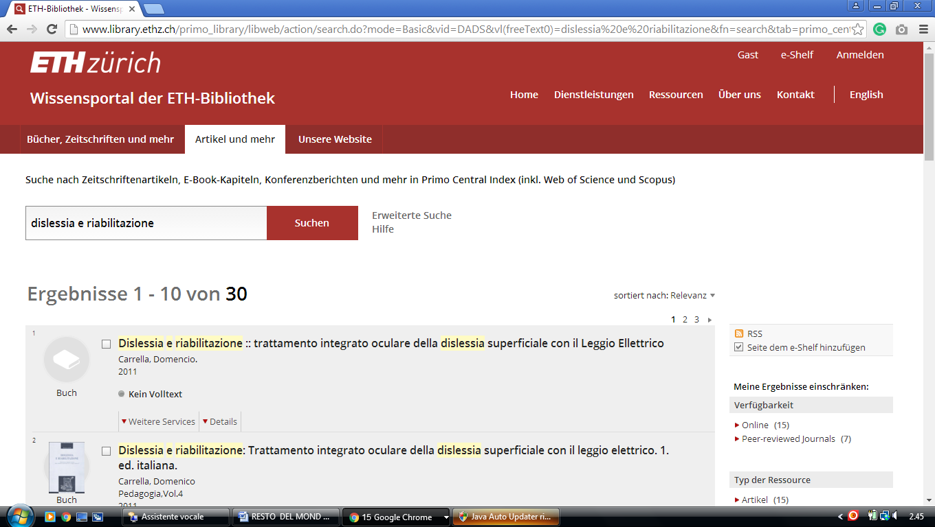

### 7 [UNIVERSITY OF BERN - THE EUROPEAN LIBRARY](http://www.theeuropeanlibrary.org/tel4/contributor/P01388) – (Bern, Svizzera)

<http://www.theeuropeanlibrary.org/tel4/contributor/P01388>

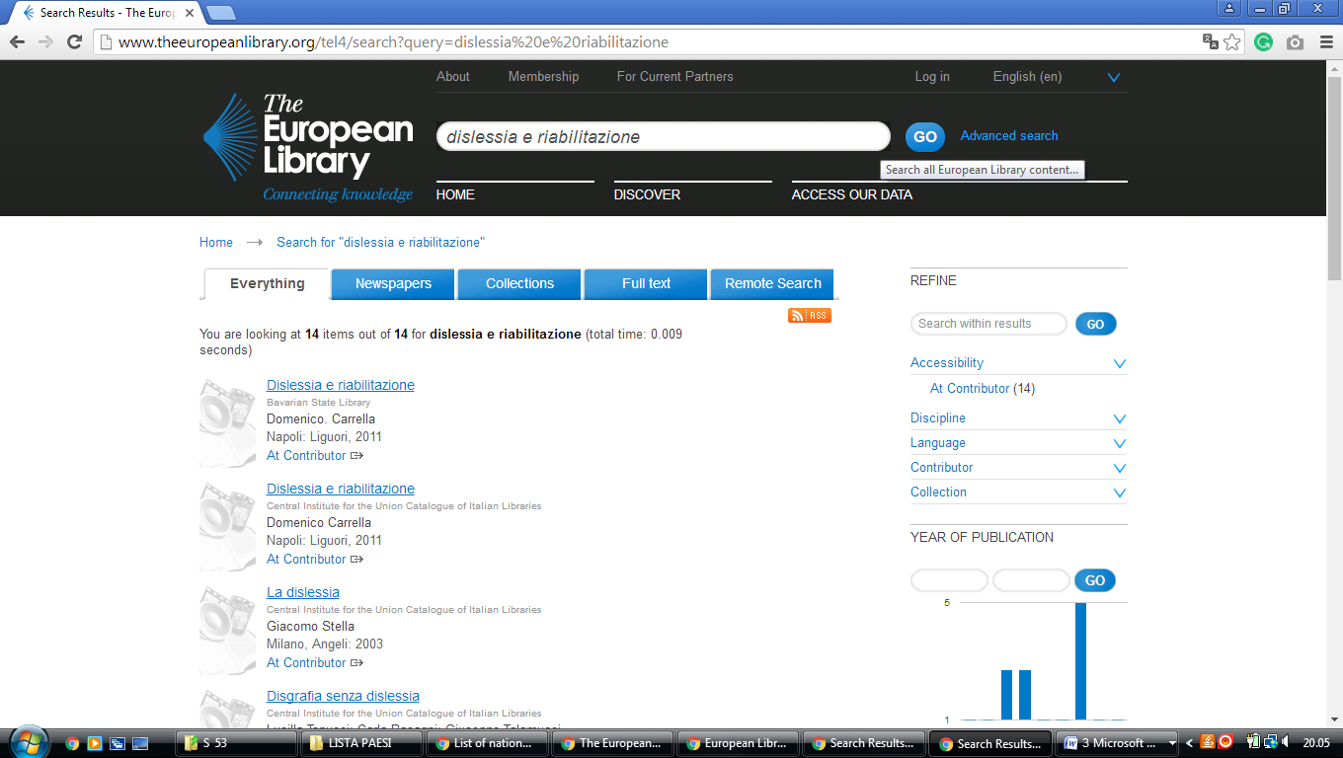

[NEBIS portale delle biblioteche svizzere](https://www.nebis.ch/de/startseite/)

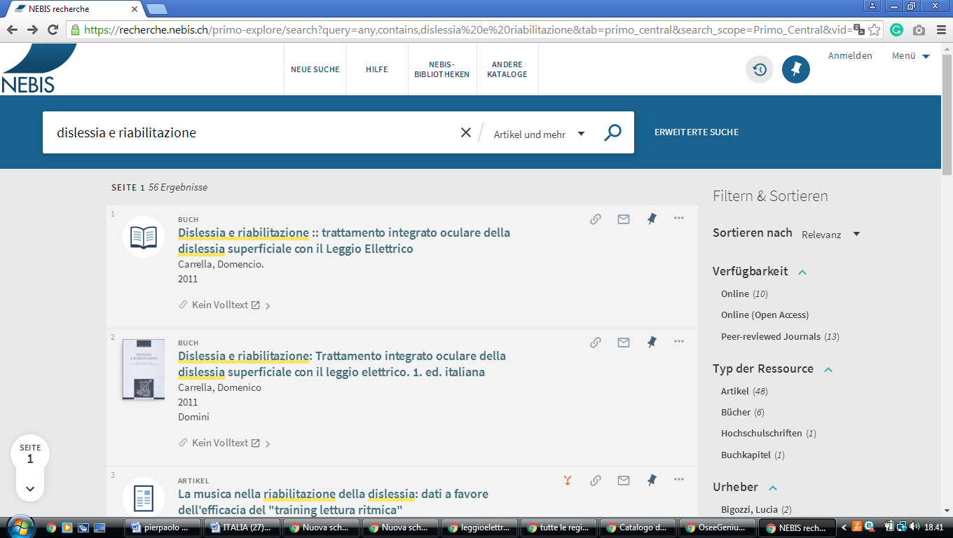https://recherche.nebis.ch/primo-explore/search?query=any,contains,dislessia%20e%20riabilitazione&tab=primo_central&search_scope=Primo_Central&vid=NEBIS&lang=de_DE&offset=0

[Biblioteca UniversitariaLugano It.bul.sbu.usi.ch](https://it.bul.sbu.usi.ch/)

lumen.sbu.usi.ch/primo_library/libweb/action/search.do?ct=facet&pcAvailabiltyMode=true&pcAvailClicked=true&frbg=&&fn=search&indx=1&dscnt=0&scp.scps=primo_central_multiple_fe&tb=t&mode=Basic&vid=bul&ct=search&srt=rank&tab=ulisse&dum=true&vl(freeText0)=dislessia%20e%20riabilitazione&dstmp=1579476332066

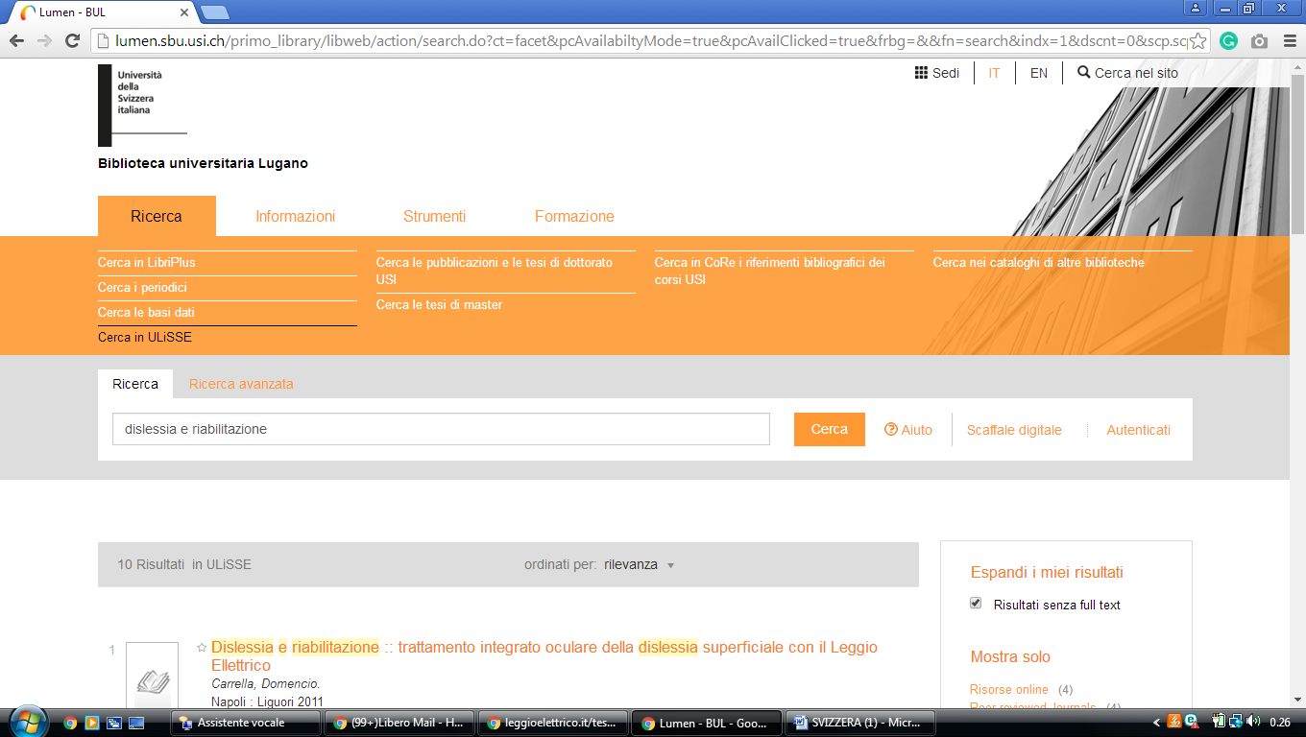

RERO DOC: bibliothèque numérique Réseau des ... bibliotecadigitale.cab.unipd.it › Risorse metalib

https://explore.rero.ch/fr_CH/nj/result?fd=any&pr=contains&ex=1&so=rank&se=DISLESSIA+E+RIABILITAZIONE&submit=

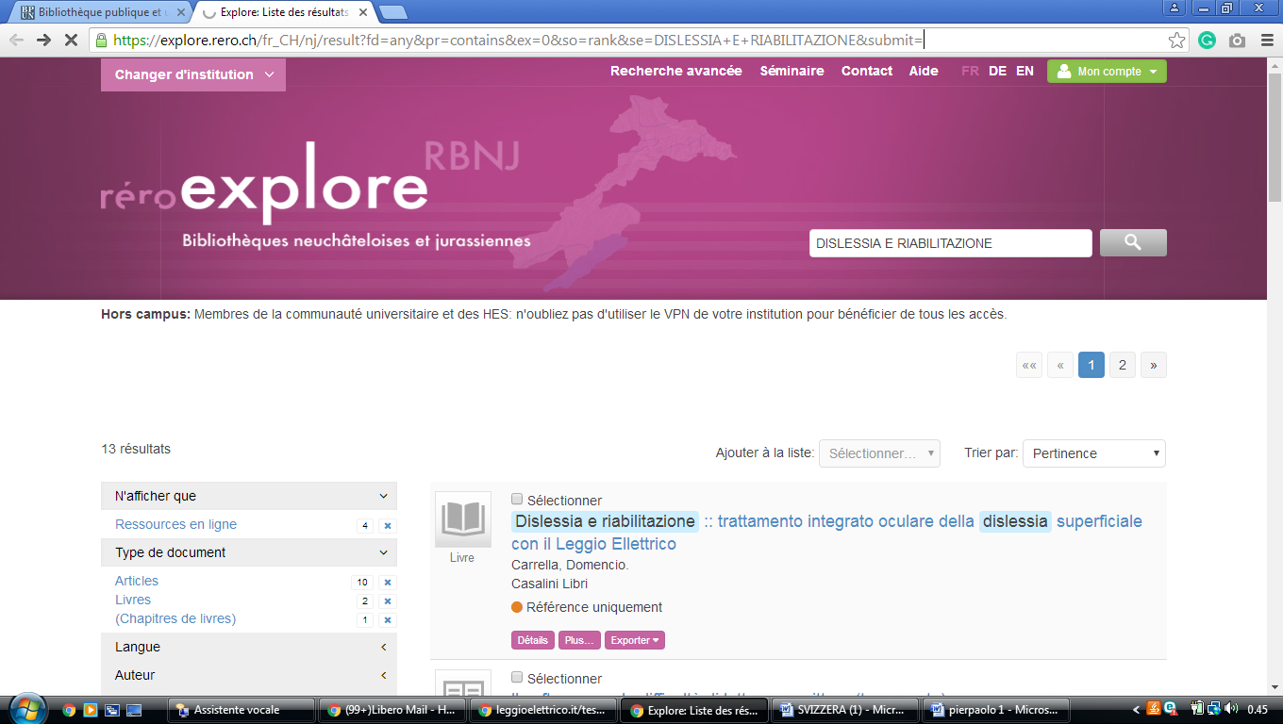

[Supsi biblioteca del dipartimento formazione e ... – nebis (SUPSI Biblioteca del Dipartimento formazione **e** apprendimento della Scuola universitaria professionale della Svizzera italiana) ...](https://www.nebis.ch/en/libraries/supsi-biblioteca-del-dipartimento-formazione-e-apprendimento-della-scuola-universitaria-professionale-della-svizzera-italiana/)

<https://recherche.nebis.ch/primo-explore/search?query=any,contains,dislessia%20e%20riabilitazione%20&tab=primo_central&search_scope=Primo_Central&vid=NEBIS&lang=en_US&offset=0>

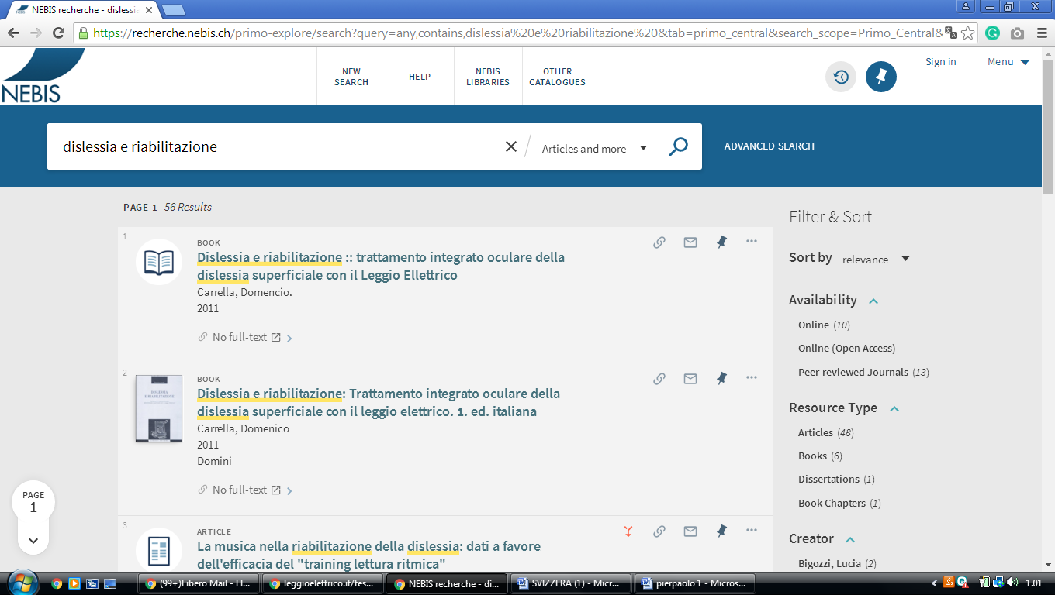

# University Library Bern

https://baselbern.swissbib.ch/Summon/Search?lookfor=dislessia+e+riabilitazione&type=AllFields&filter%5B%5D=includeWithoutFulltext%3Atrue

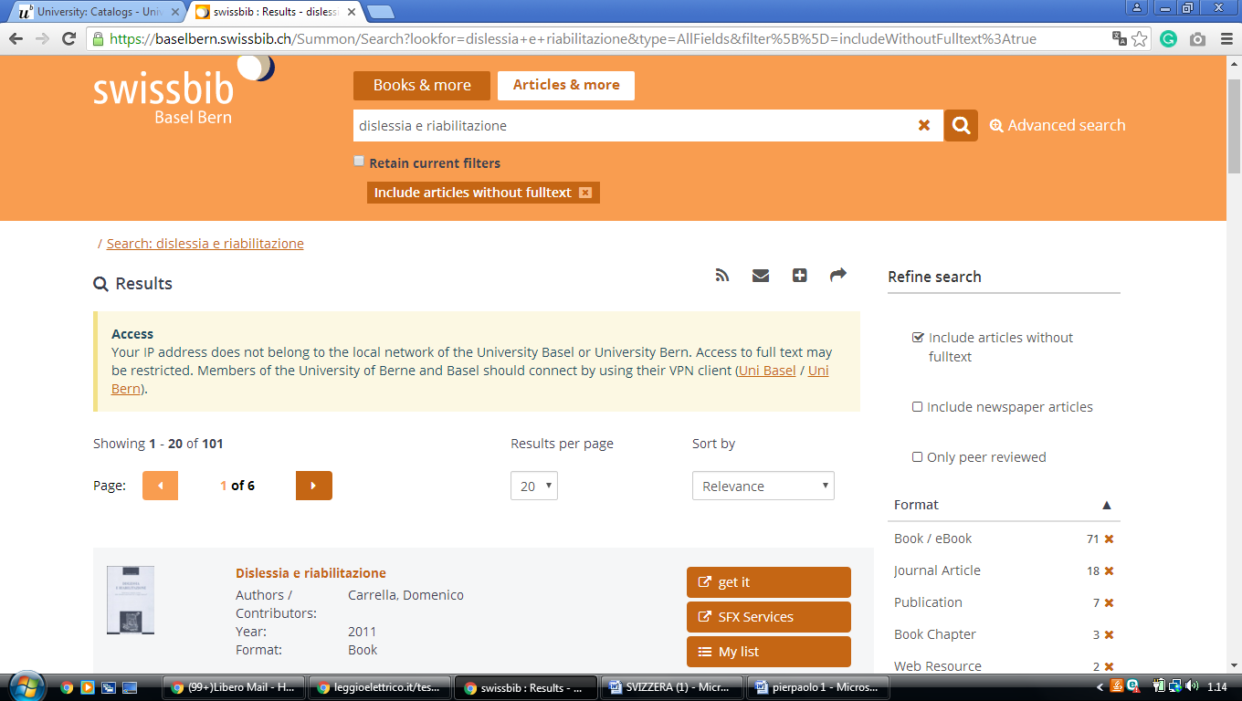

[Biblioteca UniversitariaLugano - Università della **Svizzera** ... It.bul.sbu.usi.ch](https://it.bul.sbu.usi.ch/)

lumen.sbu.usi.ch/primo_library/libweb/action/search.do?ct=facet&pcAvailabiltyMode=true&pcAvailClicked=true&frbg=&&fn=search&indx=1&dscnt=0&scp.scps=primo_central_multiple_fe&tb=t&mode=Basic&vid=bul&ct=search&srt=rank&tab=ulisse&dum=true&vl(freeText0)=dislessia%20e%20riabilitazione&dstmp=1579476332066



RERO DOC: bibliothèque numérique Réseau des ... bibliotecadigitale.cab.unipd.it › Risorse metalib

https://explore.rero.ch/fr_CH/nj/result?fd=any&pr=contains&ex=1&so=rank&se=DISLESSIA+E+RIABILITAZIONE&submit=



[Supsi biblioteca del dipartimento formazione e ... – nebis (SUPSI Biblioteca del Dipartimento formazione **e** apprendimento della Scuola universitaria professionale della Svizzera italiana) ...](https://www.nebis.ch/en/libraries/supsi-biblioteca-del-dipartimento-formazione-e-apprendimento-della-scuola-universitaria-professionale-della-svizzera-italiana/)

<https://recherche.nebis.ch/primo-explore/search?query=any,contains,dislessia%20e%20riabilitazione%20&tab=primo_central&search_scope=Primo_Central&vid=NEBIS&lang=en_US&offset=0>



# University Library Bern

https://baselbern.swissbib.ch/Summon/Search?lookfor=dislessia+e+riabilitazione&type=AllFields&filter%5B%5D=includeWithoutFulltext%3Atrue

[NEBIS portale delle biblioteche svizzere](https://www.nebis.ch/de/startseite/)

https://recherche.nebis.ch/primo-explore/search?query=any,contains,dislessia%20e%20riabilitazione&tab=primo_central&search_scope=Primo_Central&vid=NEBIS&lang=de_DE&offset=0

