**1 NATIONAL LIBRARY OF SWEDEN –** (Stockholm, Svezia)

<http://libris.kb.se/bib/16164839>

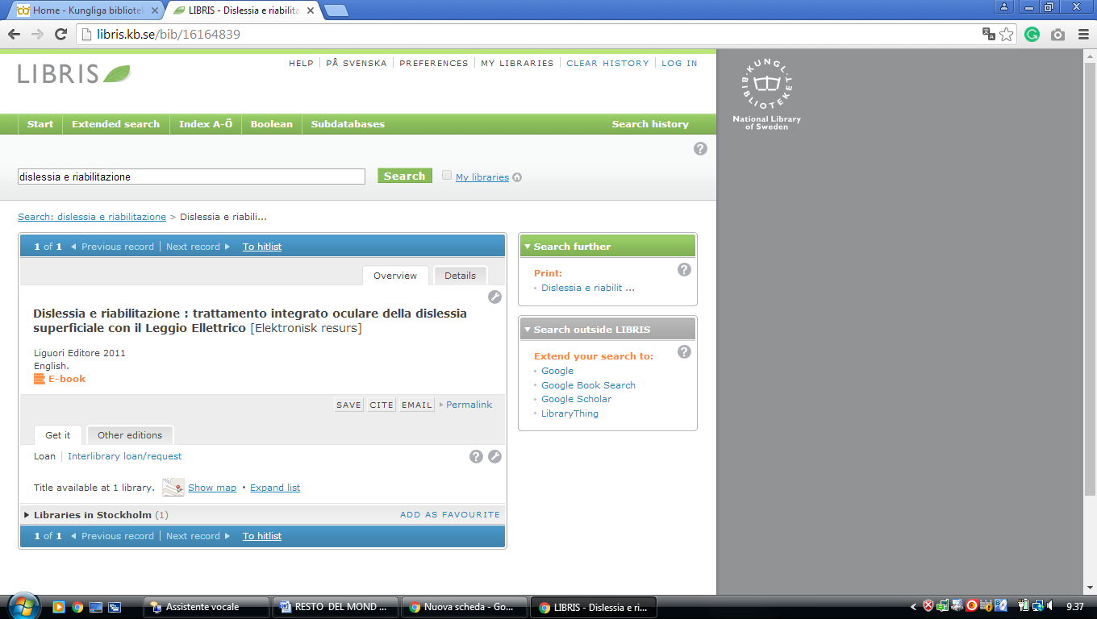

**2 LIBRARY** [**BLEKINGE INSTITUTE OF TECHNOLOGY**](http://www.bth.se/bibliotek/) **–** (Karlskrona, Sweden)

[http://bth.summon.serialssolutions.com/en/search?ho=t&l=en&q=DISLESSIA+E+RIABILITAZIONE#!/search?ho=f&l=en&q=DISLESSIA%20E%20RIABILITAZIONE](http://bth.summon.serialssolutions.com/en/search?ho=t&l=en&q=DISLESSIA+E+RIABILITAZIONE%23!/search?ho=f&l=en&q=DISLESSIA%20E%20RIABILITAZIONE)

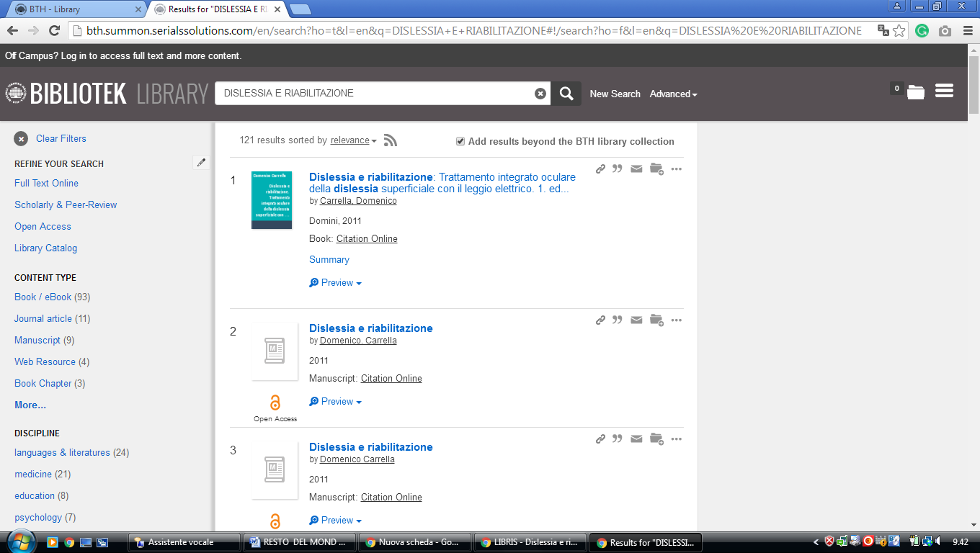

### 3 [Library | HKR.se](https://www.hkr.se/en/study-at-hkr/service-and-support/library--learning-resource-centre/library/) - ([Kristianstad Libraries](http://www.hkr.se/biblioteket" \t "_blank" \o "Kristianstad Libraries) Scania, Sweden)

[http://hkr.summon.serialssolutions.com/?s.q=dislessia+e+riabilitazione#!/search?ho=f&l=it-IT&q=dislessia%20e%20riabilitazione](http://hkr.summon.serialssolutions.com/?s.q=dislessia+e+riabilitazione%23!/search?ho=f&l=it-IT&q=dislessia%20e%20riabilitazione)

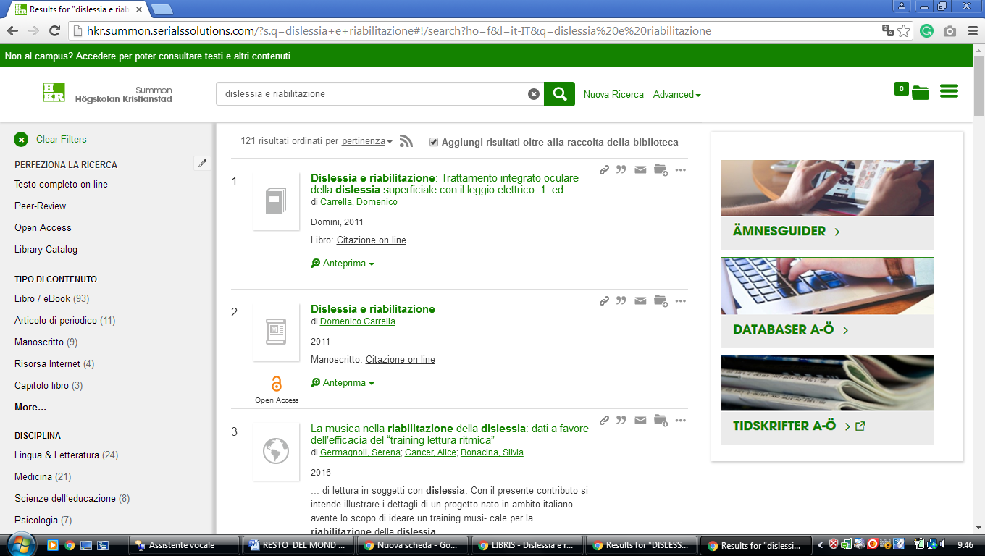

**4**  [**UMEÅ UNIVERSITY**](http://www.ub.umu.se/) **LIBRARY - (**Umeå, Sweden)

<https://umea-primo.hosted.exlibrisgroup.com/primo-explore/search?institution=UMUB&vid=UmUB&tab=default_tab_umub&search_scope=default_scope&mode=Basic&displayMode=full&bulkSize=10&highlight=true&dum=true&query=any,contains,dislessia%20e%20riabilitazione&displayField=all&lang=en_US&pcAvailabiltyMode=true>

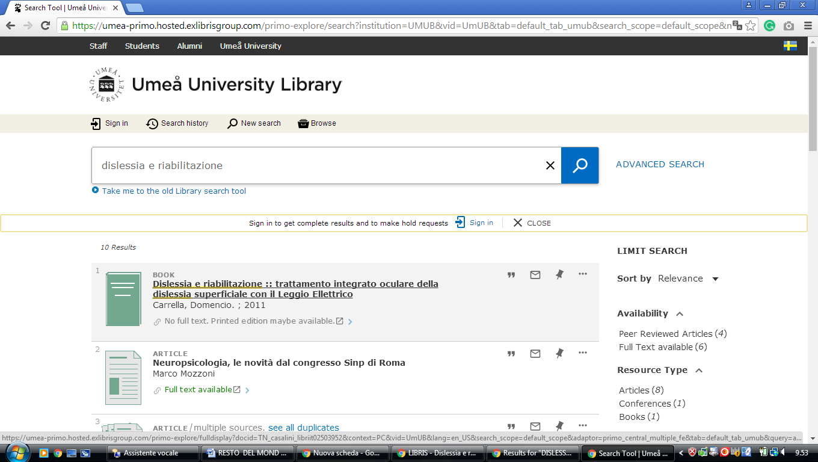

### 5 [LIBRARY SPOTLIGHT - UNIVERSITY OF SKÖVDE – ([Skövde](https://en.wikipedia.org/wiki/Sk%C3%B6vde), [Sweden](https://en.wikipedia.org/wiki/Sweden))](http://www.his.se/en/Library/library/Library-Spotlight/)

[https://his.on.worldcat.org/search?sortKey=LIBRARY&databaseList=233%2C1875%2C1842%2C1697%2C203%2C1672%2C239%2C2375%2C1708%2C638%2C1847%2C1834&queryString=DISLESSIA+E+RIABILITAZIONE&changedFacet=scope&scope=&scope=wz%3A65324&format=all&database=all&author=all&year=all&yearFrom=&yearTo=#/oclc/878784487](https://his.on.worldcat.org/search?sortKey=LIBRARY&databaseList=233%2C1875%2C1842%2C1697%2C203%2C1672%2C239%2C2375%2C1708%2C638%2C1847%2C1834&queryString=DISLESSIA+E+RIABILITAZIONE&changedFacet=scope&scope=&scope=wz%3A65324&format=all&database=all&author=all&year=all&yearFrom=&yearTo=%23/oclc/878784487)

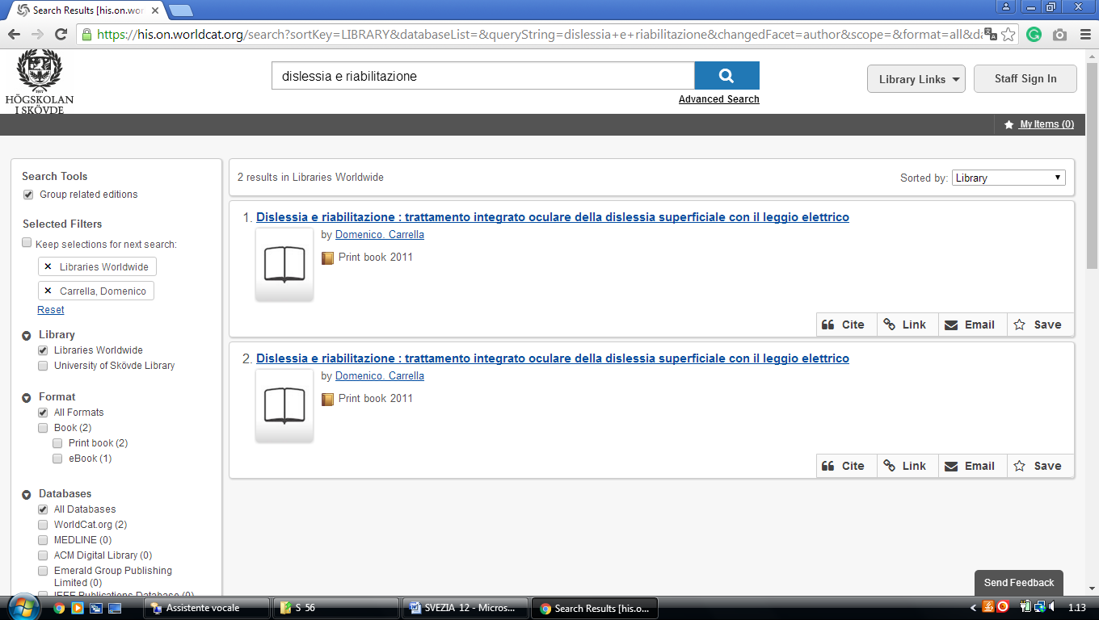

**6** [**ANNA LINDH LIBRARY**](http://www.annalindhbiblioteket.se/) - (Stockholm, Sweden)

<https://annalindh-primo.hosted.exlibrisgroup.com/primo-explore/search?query=any,contains,DISLESSIA%20E%20RIABILITAZIONE&tab=default_tab&search_scope=default_scope&sortby=rank&vid=46ALB_VU1&lang=us_EN&offset=0&pcAvailability=true>

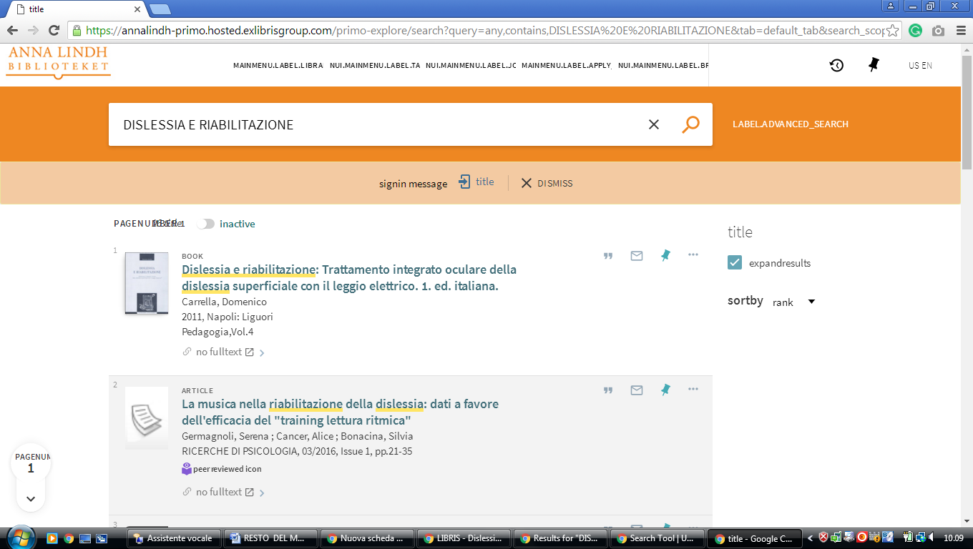

**7** [**Library - Dalarna University**](http://www.du.se/en/library/) **–** ([Falun](https://en.wikipedia.org/wiki/Falun" \o "Falun) and [Borlänge](https://en.wikipedia.org/wiki/Borl%C3%A4nge" \o "Borlänge),[Dalarna](https://en.wikipedia.org/wiki/Dalarna), [Sweden](https://en.wikipedia.org/wiki/Sweden))

### [http://dalarna.summon.serialssolutions.com/en/search?ho=t#!/search?ho=f&l=en&q=DISLESSIA%20E%20RIABILITAZIONE](http://dalarna.summon.serialssolutions.com/en/search?ho=t%23!/search?ho=f&l=en&q=DISLESSIA%20E%20RIABILITAZIONE)

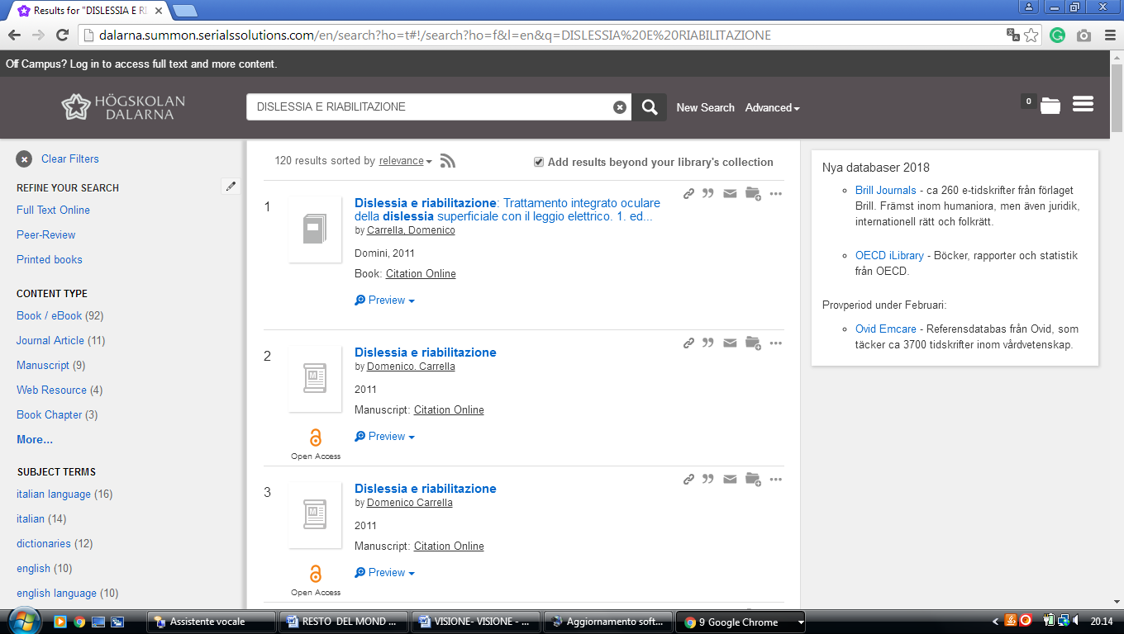

**8 LIBRARY** [**GÖTEBORG UNIVERSITY**](http://www.ub.gu.se/) **–** (Göteborg, Sweden)

<https://gu-se-primo.hosted.exlibrisgroup.com/primo-explore/search?query=any,contains,dislessia%20e%20riabilitazione&vid=46GUB_VU1&search_scope=default_scope&sortby=rank&lang=sv_SE&pcAvailability=true>

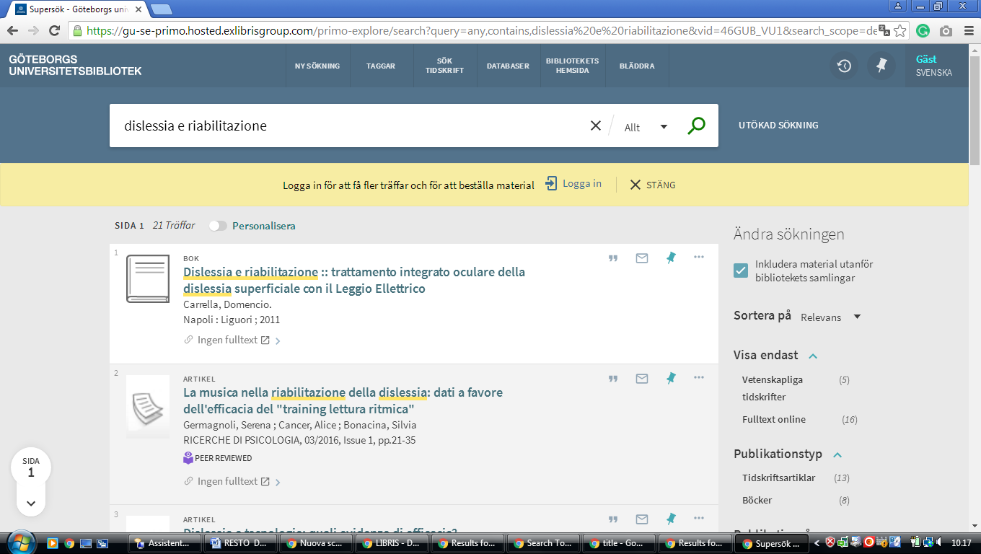

**9** [**UPPSALA: UNIVERSITY LIBRARY**](http://www.ub.uu.se/) **–** (Uppsala, Svezia)

[https://uu.summon.serialssolutions.com/sv-SE/search?fvf=ContentType,Book%20Review,t%7CContentType,Newspaper%20Article,t&q=DISLESSIA%20E%20RIABILITAZIONE#!/search?ho=f&fvf=ContentType,Book%20Review,t%7CContentType,Newspaper%20Article,t&l=sv-SE&q=DISLESSIA%20E%20RIABILITAZIONE](https://uu.summon.serialssolutions.com/sv-SE/search?fvf=ContentType,Book%20Review,t%7CContentType,Newspaper%20Article,t&q=DISLESSIA%20E%20RIABILITAZIONE%23!/search?ho=f&fvf=ContentType,Book%20Review,t%7CContentType,Newspaper%20Article,t&l=sv-SE&q=DISLESSIA%20E%20RIABILITAZIONE)

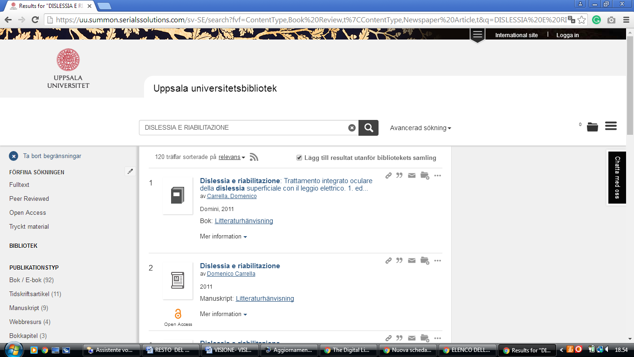

### 10 karlstad university library - (Karlstad, Svezia)

<https://eds.a.ebscohost.com/eds/results?vid=1&sid=ca2b258a-fc21-46ee-87c0-2ae0c6cc46e7%40sessionmgr4010&bquery=(dislessia+AND+e+AND+riabilitazione)&bdata=JnR5cGU9MCZzaXRlPWVkcy1saXZl>

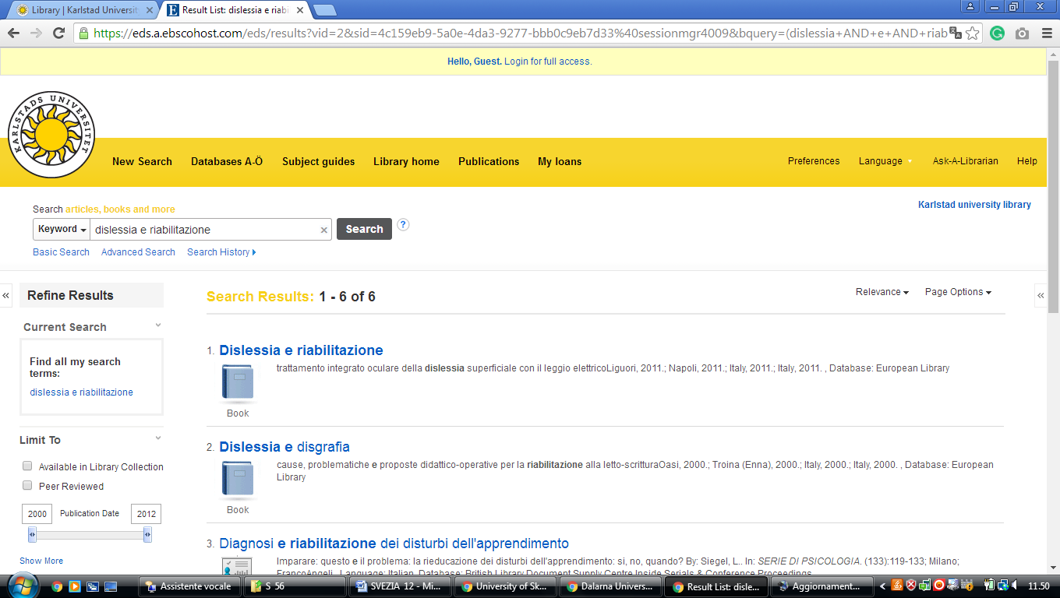

**11** [**CHALMERS BIBLIOTEK**](http://www.lib.chalmers.se/) **–** (University of Technology Library Göteborg, Svezia)

[https://chalmers.summon.serialssolutions.com/en/search?ho=t&q=dislessia%20e%20riabilitazione#!/search?ho=f&l=en&q=dislessia%20e%20riabilitazione](https://chalmers.summon.serialssolutions.com/en/search?ho=t&q=dislessia%20e%20riabilitazione%23!/search?ho=f&l=en&q=dislessia%20e%20riabilitazione)

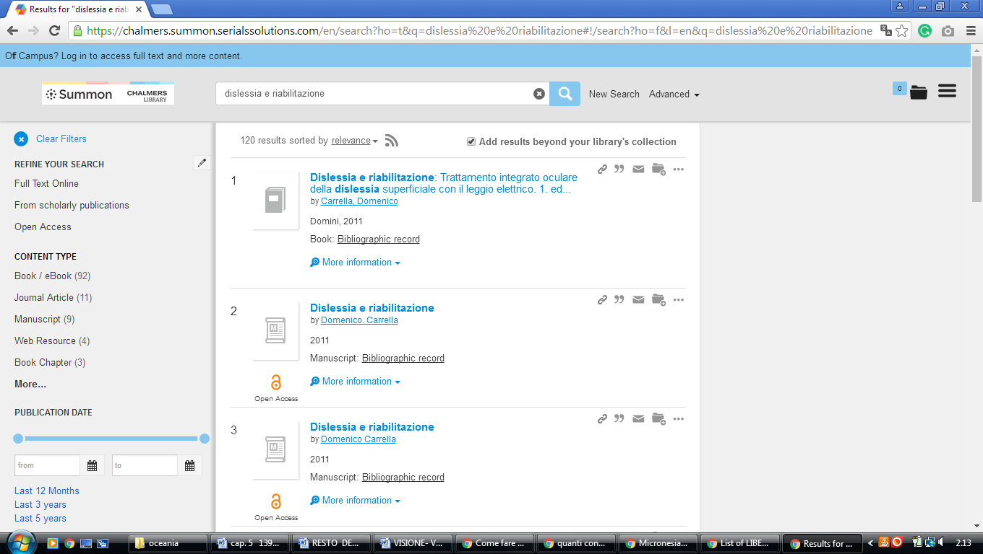

### 12 [LUND UNIVERSITY - LAW - THE EUROPEAN LIBRARY](http://www.theeuropeanlibrary.org/tel4/collection/a1235) - (Svezia)

<http://www.theeuropeanlibrary.org/tel4/search?query=dislessia%20e%20riabilitazione>

