### 1 [UCT LIBRARIES](http://www.lib.uct.ac.za/) - (University Of Cape Town, **South Africa)**

<https://uct.primo.exlibrisgroup.com/discovery/search?query=any,contains,dislessia%20e%20riabilitazione&tab=Everything&search_scope=MyInst_and_CI&vid=27UCT_INST:27UCT&offset=0&sortby=rank&pcAvailability=true>

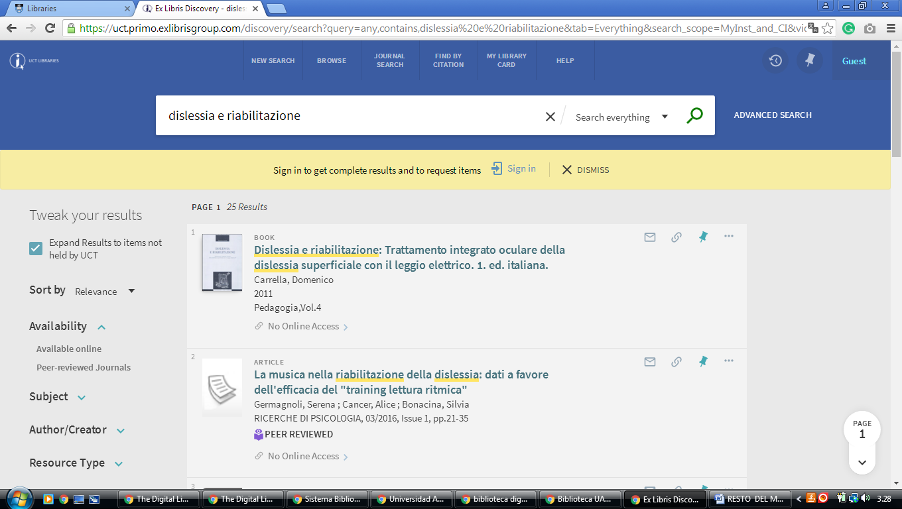

[**2 NELSON MANDELA METROPOLITAN UNIVERSITY**](http://library.nmmu.ac.za/) **LIBRARY –** (Port

Elizabeth, South Africa)

<https://nmmu.on.worldcat.org/search?sortKey=LIBRARY&databaseList=&queryString=dislessia+e+riabilitazione&changedFacet=scope&scope=&scope=sz%3A33861&format=all&database=all&author=all&year=all&yearFrom=&yearTo=&language=all>

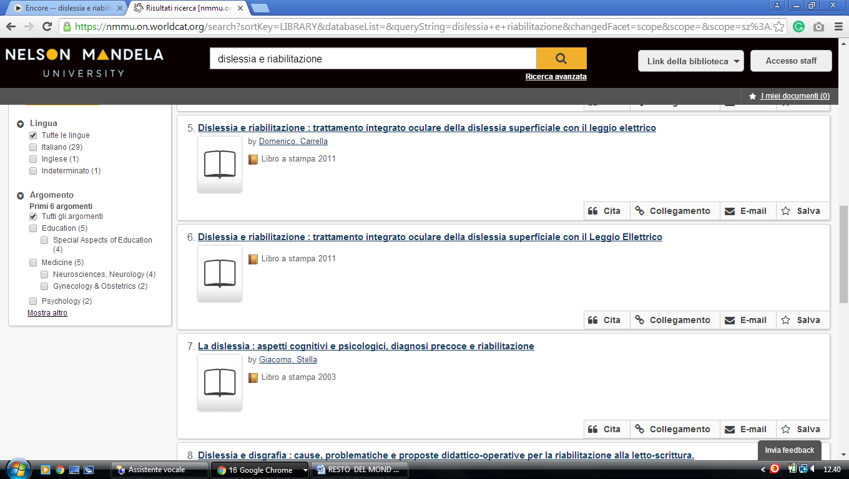

**3 LIBRARY** [**UNIVERSITY OF PRETORIA**](http://www.ais.up.ac.za/index.htm) **–** (Pretoria, South Africa)

<https://univofpretoria.on.worldcat.org/search?sortKey=LIBRARY&databaseList=&queryString=dislessia+e+riabilitazione&changedFacet=scope&scope=&scope=sz%3A33860&format=all&database=all&author=all&year=all&yearFrom=&yearTo>=

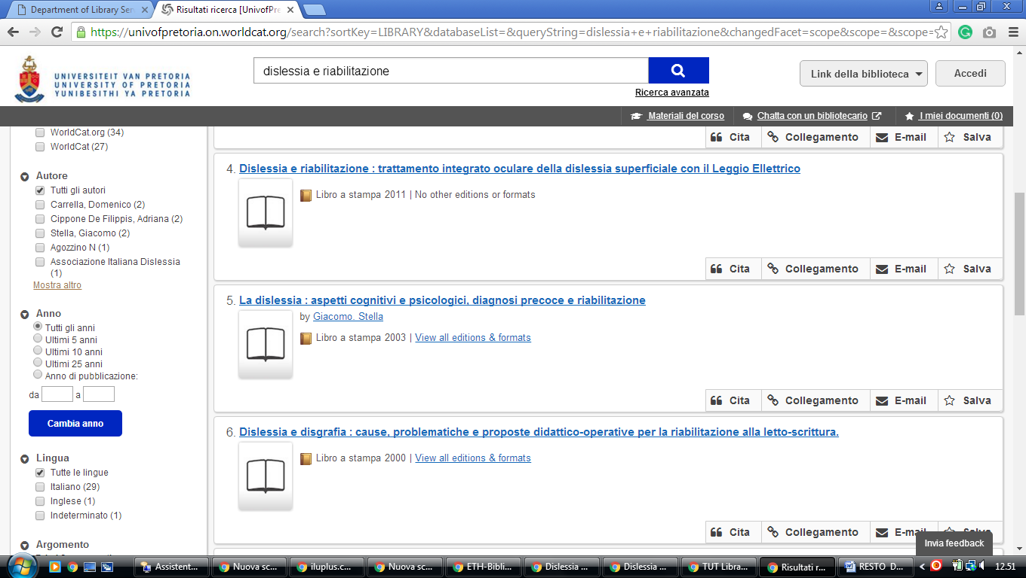

[**4 UNIVERSITY OF THE WESTERN CAPE LIBRARY**](http://lib.uwc.ac.za/) – (Bellville, South Africa)

<https://uwc.primo.exlibrisgroup.com/discovery/search?institution=27UWC_INST&vid=27UWC_INST:UWC&tab=Everything&search_scope=MyInst_and_CI&mode=Basic&displayMode=full&bulkSize=10&highlight=true&dum=true&query=any,contains,dislessia%20e%20riabilitazione&displayField=all&pcAvailabiltyMode=true&sortby=rank&pcAvailability=true>

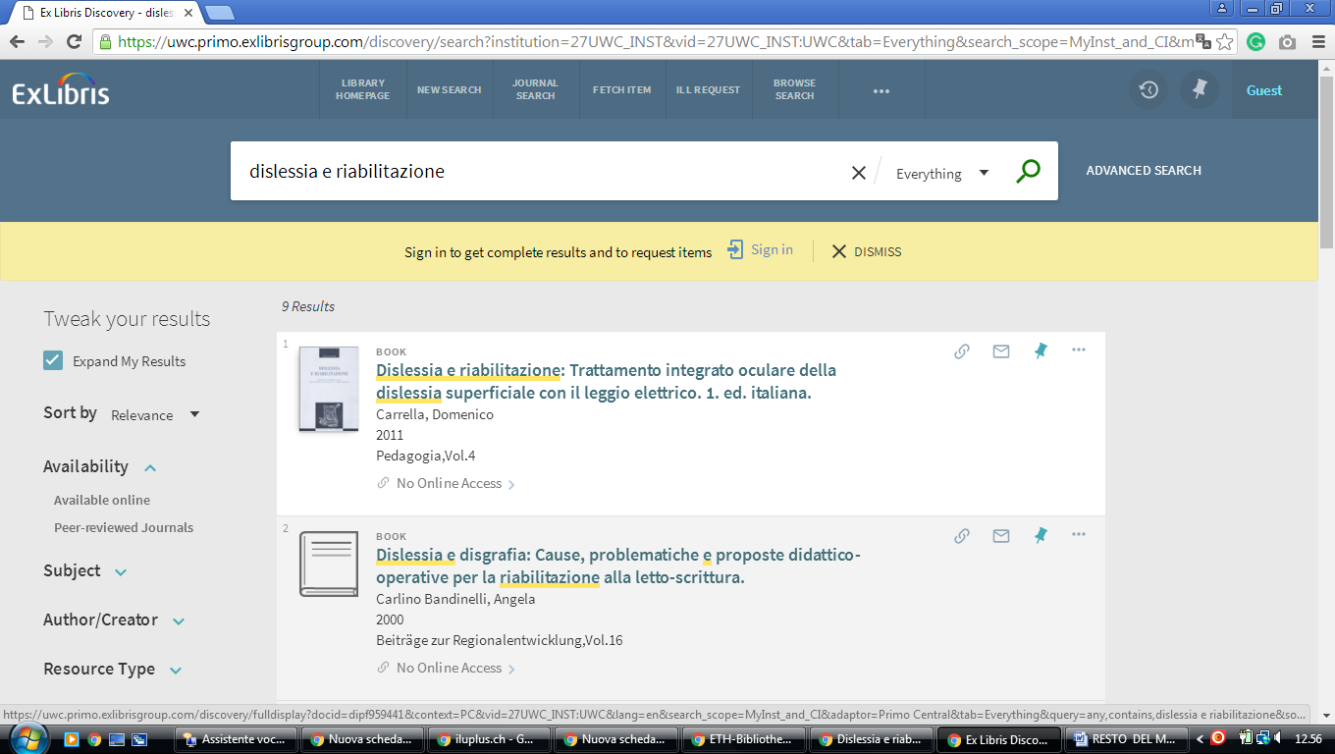

**5 UNIVERSITY OF CAPE TOWN LIBRARIES** - (South Africa)

<https://uct.primo.exlibrisgroup.com/discovery/search?query=any,contains,dislessia%20e%20riabilitazione&tab=Everything&search_scope=MyInst_and_CI&vid=27UCT_INST:27UCT&offset=0&sortby=rank&pcAvailability=true>

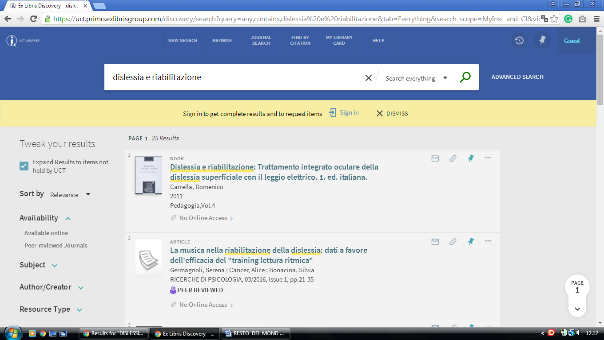

### 6 UKZN LIBRAR, [Kwazulu-Natal](https://en.wikipedia.org/wiki/KwaZulu-Natal) - (South Africa)

<http://ukzn.worldcat.org/title/dislessia-e-riabilitazione-trattamento-integrato-oculare-della-dislessia-superficiale-con-il-leggio-elettrico/oclc/878784487&referer=brief_results>

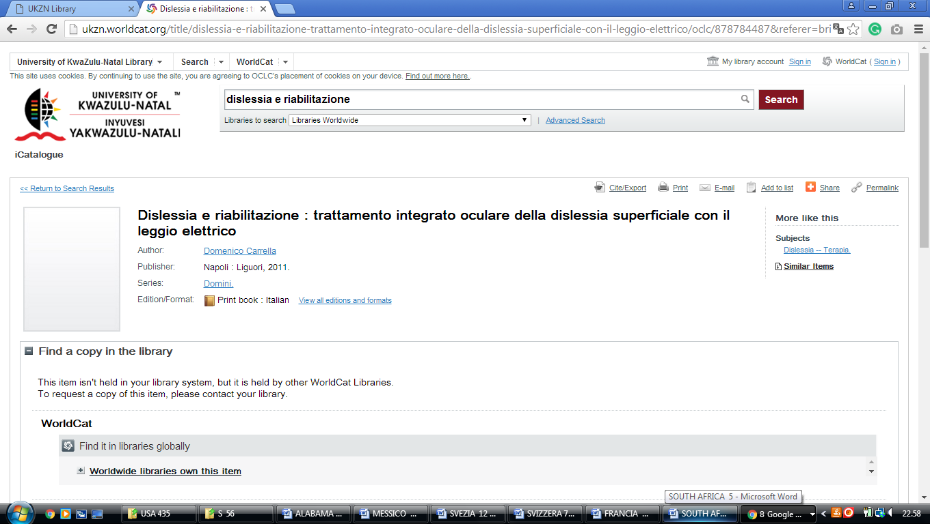

### 7 [LIBRARY HOME - UWC Library](https://lib.uwc.ac.za/index.php/32-uwc-library.html) - ([Cape Town](https://en.wikipedia.org/wiki/Cape_Town), [Western Cape](https://en.wikipedia.org/wiki/Western_Cape), [South Africa](https://en.wikipedia.org/wiki/South_Africa))

<https://uwc.primo.exlibrisgroup.com/discovery/search?institution=27UWC_INST&vid=27UWC_INST:UWC&tab=Everything&search_scope=MyInst_and_CI&mode=Basic&displayMode=full&bulkSize=10&highlight=true&dum=true&query=any,contains,dislessia%20e%20riabilitazione&displayField=all&pcAvailabiltyMode=true&sortby=rank&pcAvailability=true>

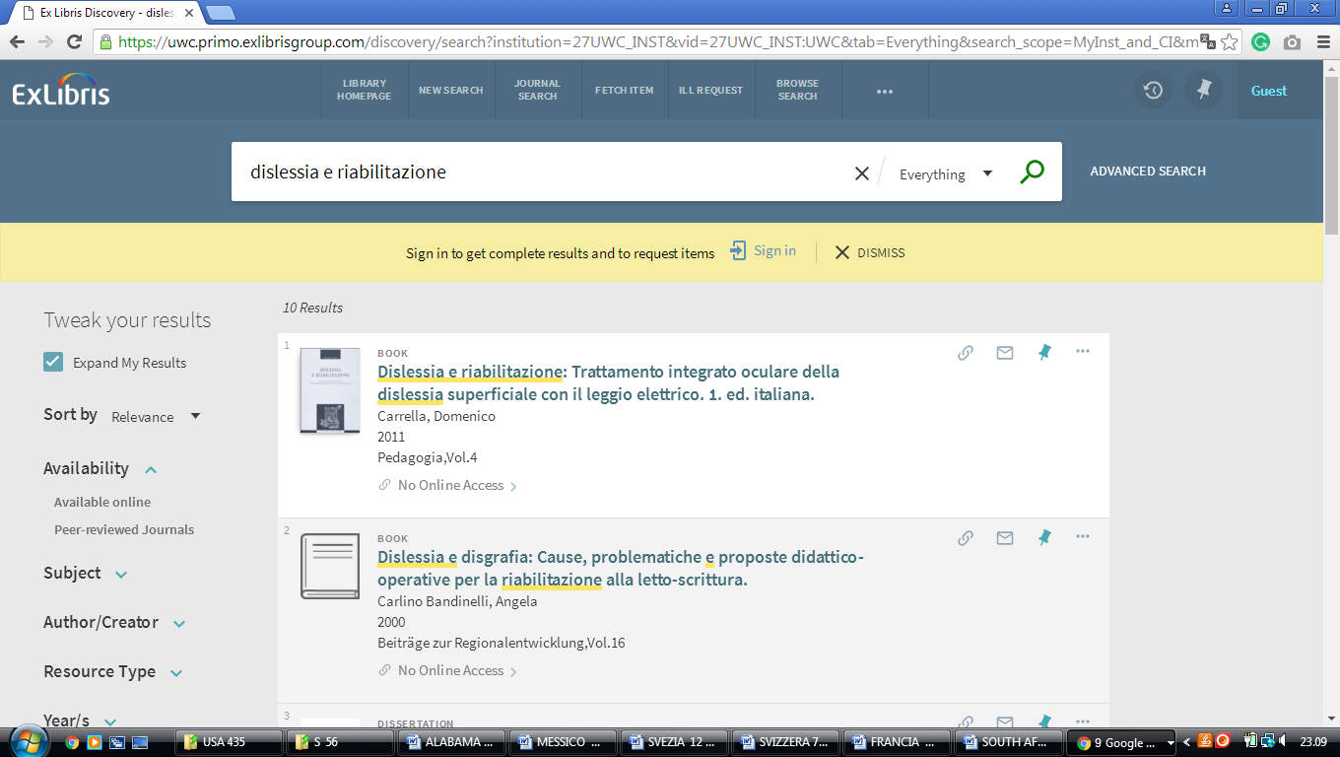

### 8 [LIBRARY CATALOGUE | UNIVERSITY OF FORT HARE LIBRARIES](http://www.ufh.ac.za/library/catalogue) - ([Eastern Cape](https://en.wikipedia.org/wiki/Eastern_Cape),[South Africa](https://en.wikipedia.org/wiki/South_Africa))

<http://ufh.worldcat.org/search?q=dislessia+e+riabilitazione&qt=results_page&scope=0&oldscope=0>

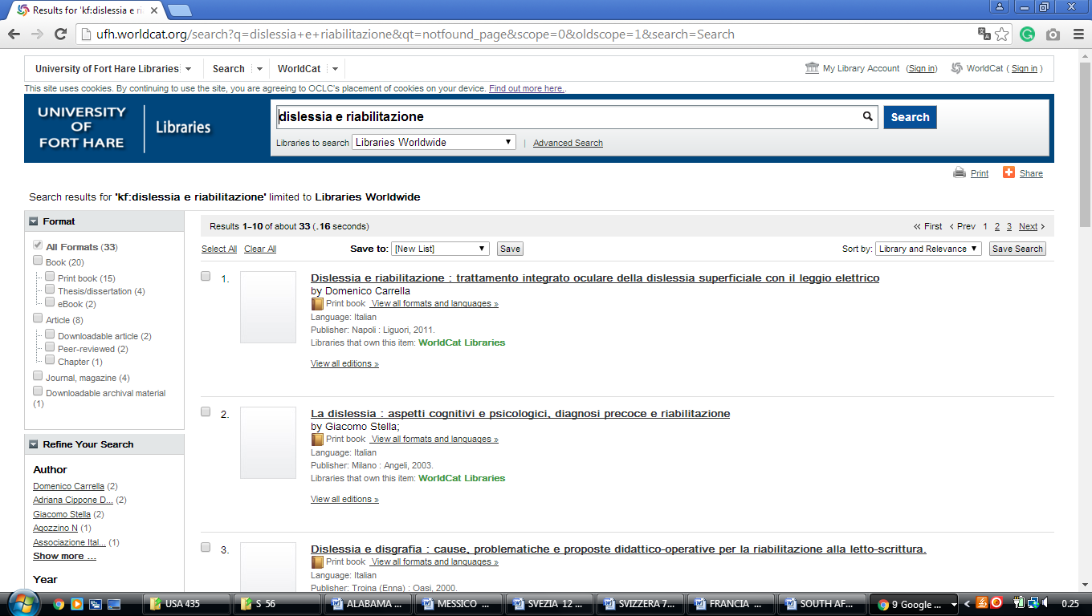

### 9 [CENTRAL UNIVERSITY OF TECHNOLOGY FREE STATE – (Librarycut, South Africa](http://www.cut.ac.za/library/))

[https://centralunivoftechlib.on.worldcat.org/external-search?queryString=dislessia+e+riabilitazione&wcsbtn2w.x=9&wcsbtn2w.y=23#/oclc/878784487](https://centralunivoftechlib.on.worldcat.org/external-search?queryString=dislessia+e+riabilitazione&wcsbtn2w.x=9&wcsbtn2w.y=23%23/oclc/878784487)

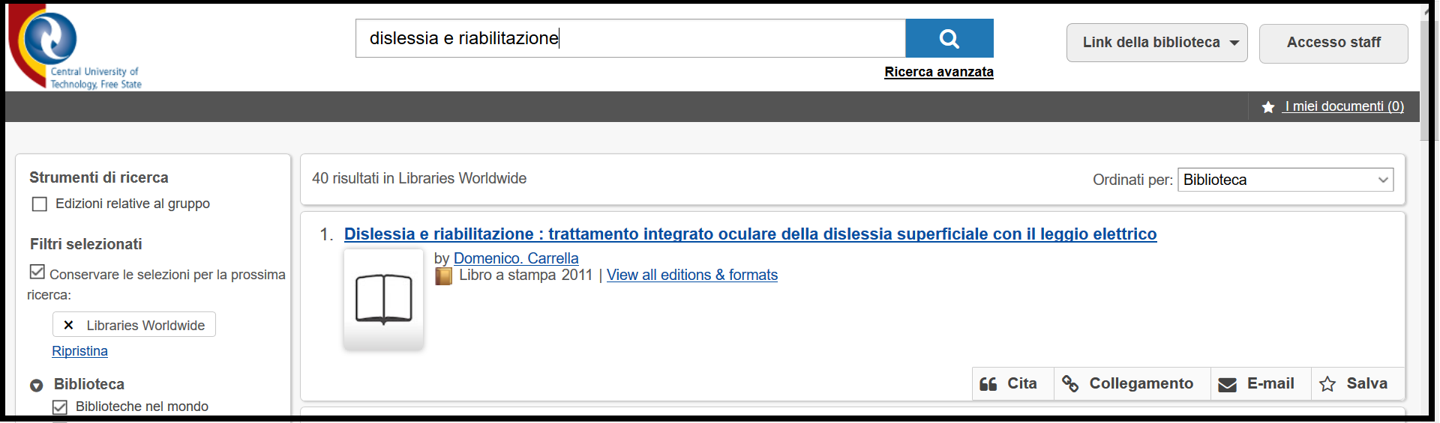

[**Libraries - Libraries – CPUT Cape Peninsula University of Technology, Cape Town, SUD AFRICA**](https://www.cput.ac.za/lib)

https://cput.primo.exlibrisgroup.com/discovery/search?query=any,contains,%20dislessia%20e%20riabilitazione&tab=WorldCat&search_scope=Worldcat&vid=27CPUT_INST:CPUT&offset=0&pcAvailability=true

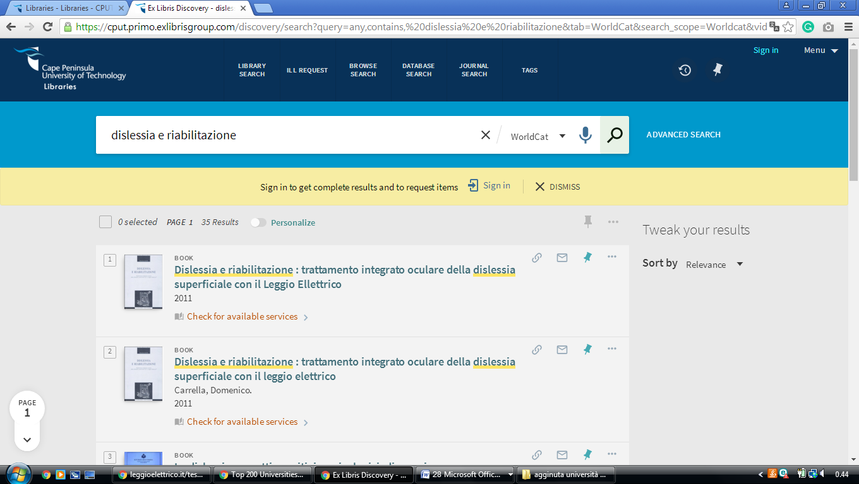

Cape Peninsula University of Technology Library

**Cape Peninsula University of Technology**

[**Cape Town**](https://librarytechnology.org/libraries/search.pl?City=Cape%20Town&Country=South%20Africa), South Africa

https://cput.on.worldcat.org/search?queryString=dislessia%20e%20riabilitazione&databaseList=283,1666,638&sortKey=LIBRARY&clusterResults=true&scope=&page=2

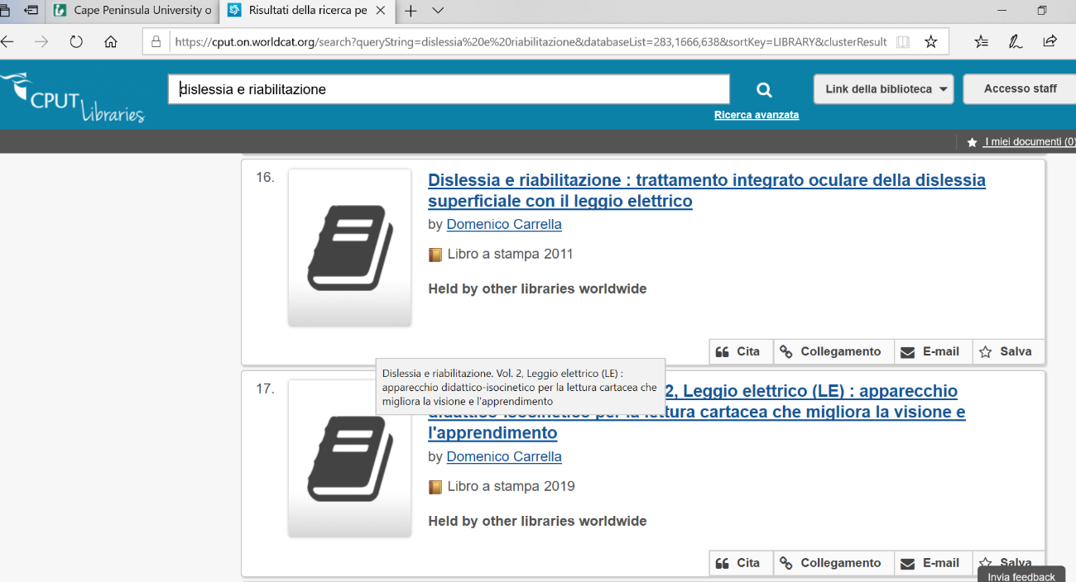

[**Libraries - Libraries – CPUT Cape Peninsula University of Technology, Cape Town, SUD AFRICA**](https://www.cput.ac.za/lib)

https://cput.primo.exlibrisgroup.com/discovery/search?query=any,contains,%20dislessia%20e%20riabilitazione&tab=WorldCat&search_scope=Worldcat&vid=27CPUT_INST:CPUT&offset=0&pcAvailability=true