**[1 CAI INTER](http://cai.inter.edu/) -** ([Universidad Interamericana de Puerto Rico](javascript:__doPostBack('ctl00$ctl00$FindField$customerLogo');))

<http://eds.b.ebscohost.com/eds/results?vid=0&sid=0e132854-48b2-46b3-b29a-52a4b67192b3%40sessionmgr101&bquery=dislessia+e+riabilitazione&bdata=JmNsaTA9RlQxJmNsdjA9WSZsYW5nPWVzJnR5cGU9MCZzaXRlPWVkcy1saXZlJnNjb3BlPXNpdGU%3d>

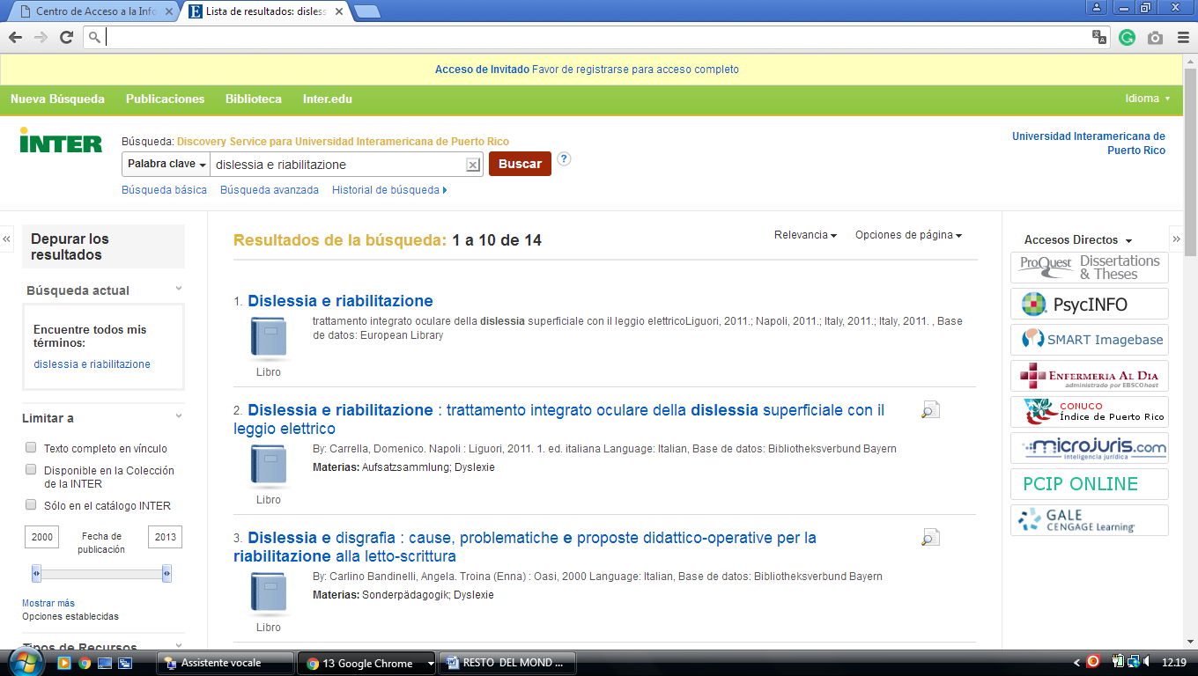

### 2 [CAI - UNIVERSIDAD INTERAMERICA DE PUERTO RICO, RECINTO DE PONCE](http://www.ponce.inter.edu/cai/) - (Mercedita, Ponce, Porto Rico)

<http://eds.a.ebscohost.com/eds/results?vid=0&sid=e4ba2b93-be42-4768-ae84-efd72f5cf2d2%40sessionmgr4007&bquery=dislessia+e+riabilitazione&bdata=Jmxhbmc9ZXMmdHlwZT0wJnNpdGU9ZWRzLWxpdmU%3d>

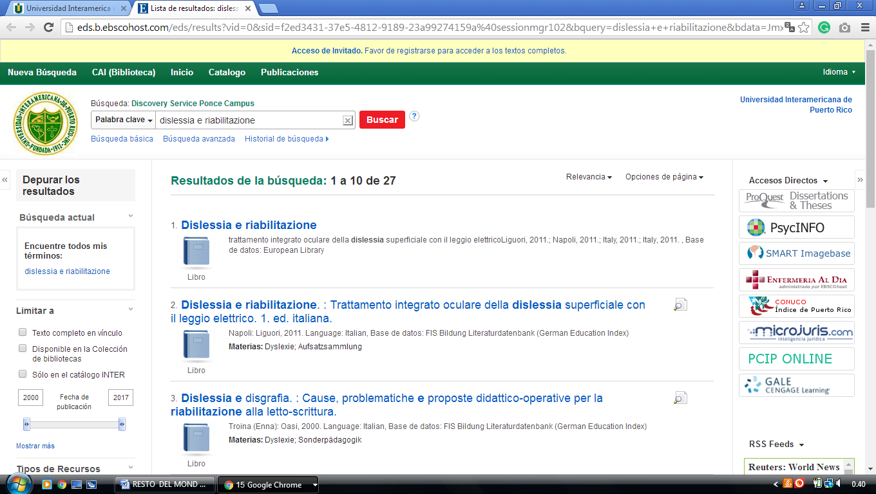

### 3 [BIBLIOTECA GENERAL - UPR](http://www.upr.edu/biblioteca-rum/) - ([Universidad De Puerto Rico, Recinto De Mayagüez](https://www.4icu.org/reviews/3901.htm))

<http://uprm.summon.serialssolutions.com/search?ho=t&q=DISLESSIA%20E%20RIABILITAZIONE#!/search?ho=f&l=en&q=DISLESSIA%20E%20RIABILITAZIONE>

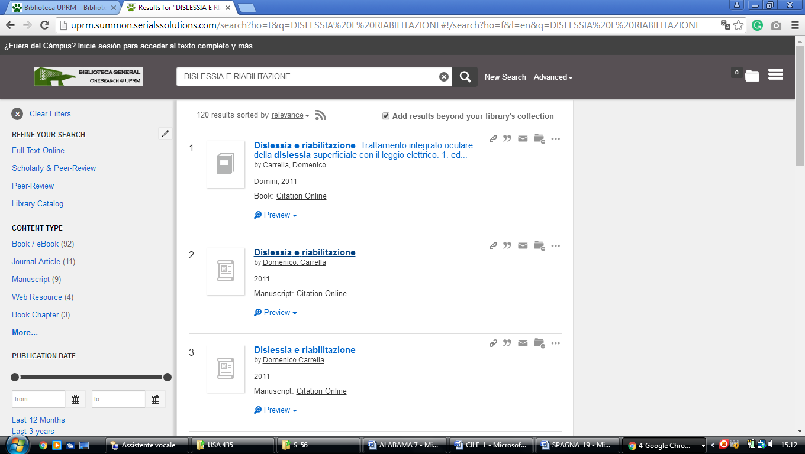

### 4 [CAI INTER](http://cai.inter.edu/) – (Puerto Rico)

<http://eds.a.ebscohost.com/eds/results?vid=1&sid=3d3cc364-6522-49ea-b466-042f8b2bb84e%40sessionmgr4007&bquery=(dislessia+AND+e+AND+riabilitazione)&bdata=Jmxhbmc9ZXMmdHlwZT0wJnNpdGU9ZWRzLWxpdmUmc2NvcGU9c2l0ZQ%3d%3d>

