**1 Universidad de Lima -**  (Lima, Perù)

http://ulima.summon.serialssolutions.com/#!/search?ho=f&l=es-ES&q=DISLESSIA%20E%20RIABILITAZIONE

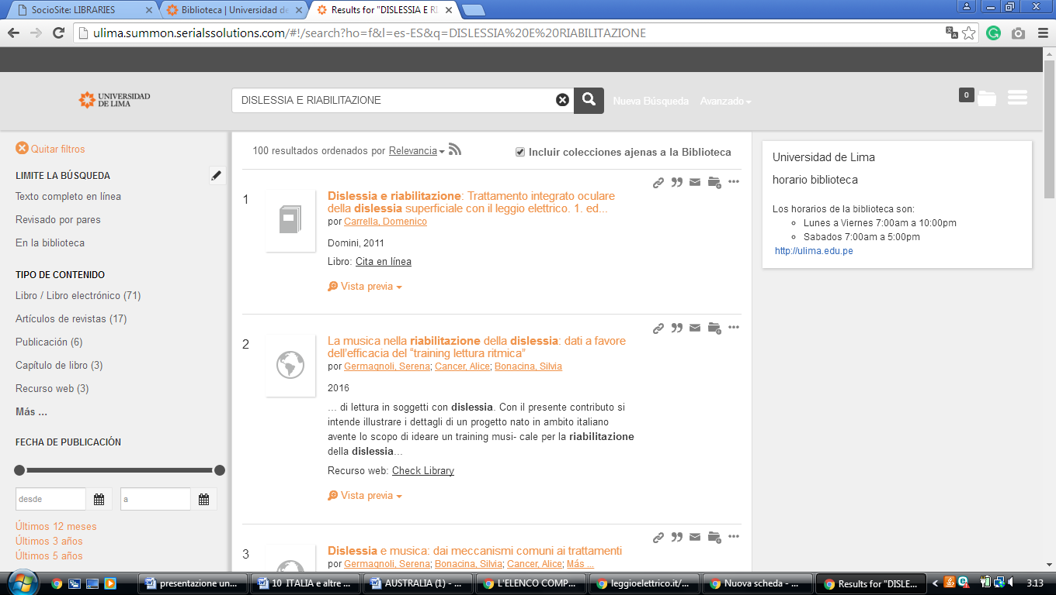

[Library at Edgewood College – Home - Peru & Arequipa](https://library.edgewood.edu/peru)

http://eds.b.ebscohost.com/eds/results?vid=3&sid=41016f33-1c66-4db7-8c88-0bbe1bd6659e%40pdc-v-sessmgr01&bquery=dislessia+e+riabilitazione&bdata=JnR5cGU9MCZzZWFyY2hNb2RlPUFuZCZzaXRlPWVkcy1saXZlJnNjb3BlPXNpdGU%3d

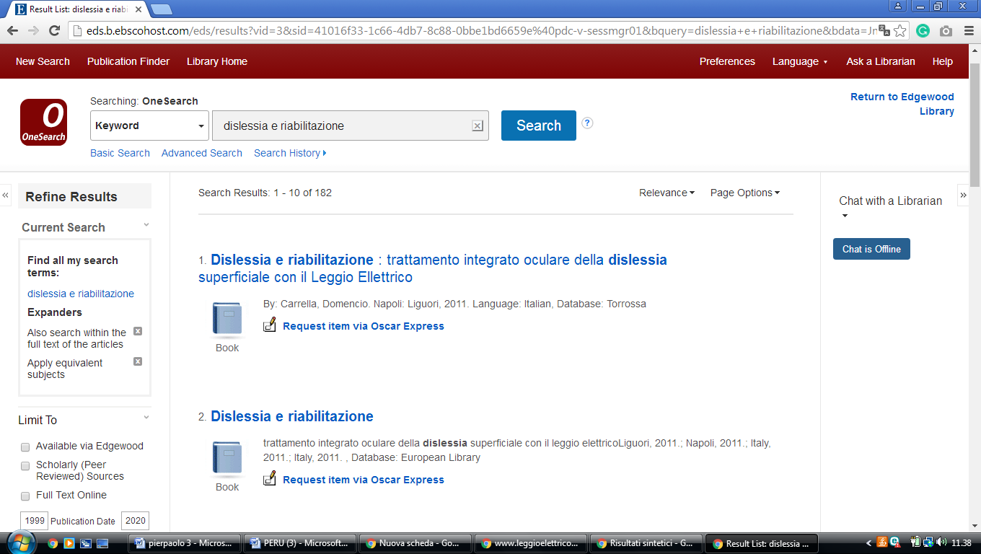

**UNIVERSIDAD ESAN LIMA PERU**

ESAN/Cendoc, Biblioteca y Centro de Información

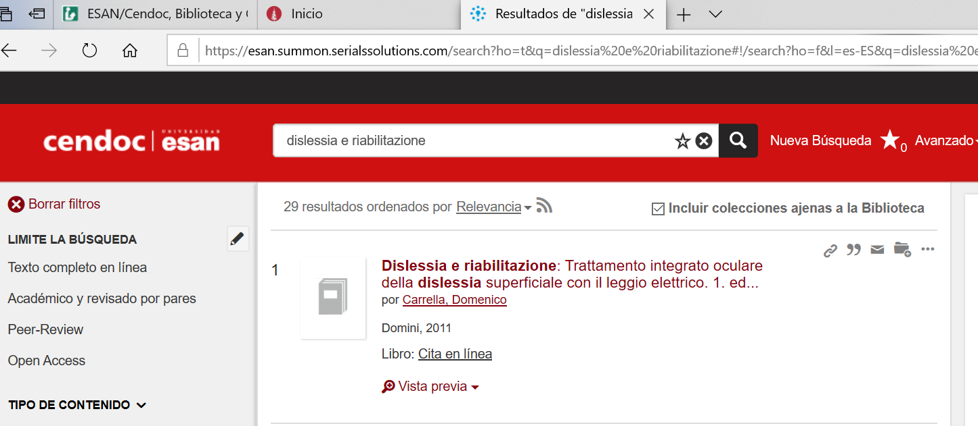https://esan.summon.serialssolutions.com/search?ho=t&q=dislessia%20e%20riabilitazione#!/search?ho=f&l=es-ES&q=dislessia%20e%20riabilitazione