**1 HECPK.SUMMON.SERIALSSOLUTIONS.COM -**  (Higher Education Commission, Pakistan)

[http://hecpk.summon.serialssolutions.com/#!/search?ho=f&l=en&q=DISLESSIA%20E%20RIABILITAZIONE](http://hecpk.summon.serialssolutions.com/%23!/search?ho=f&l=en&q=DISLESSIA%20E%20RIABILITAZIONE)

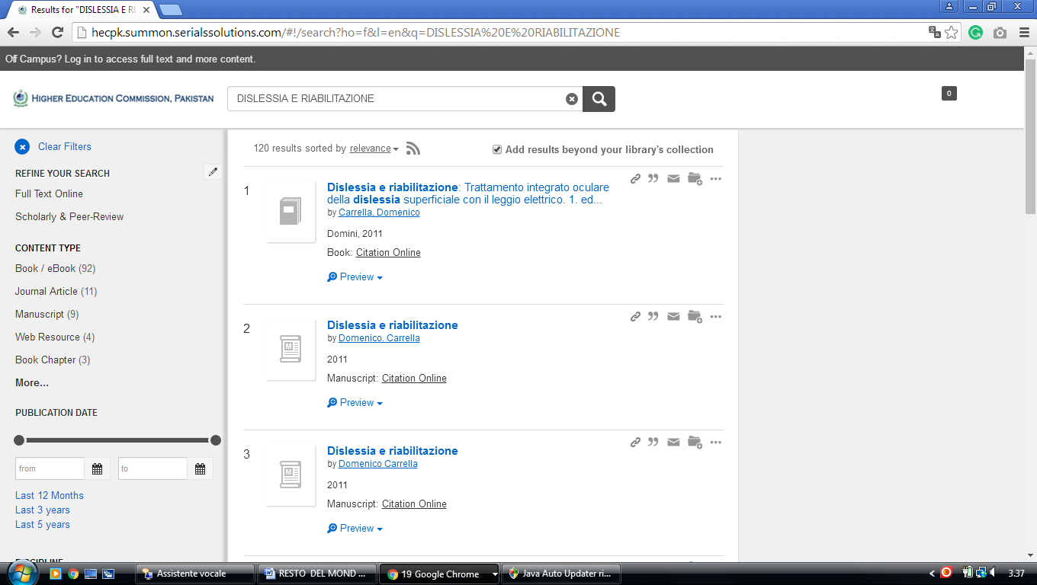

[**Dr Razi-ud-din Siddiqui Memorial Library, Quaid-i-Azam...**](http://www.libdex.com/country/pakistan/islamabad/library_42873.html)**-**[**Islamabad**](http://www.libdex.com/country/pakistan/islamabad/)**,** [**Pakistan**](http://www.libdex.com/country/pakistan/)

http://hecpk.summon.serialssolutions.com/?#!/search?ho=f&l=en&q=dislessia%20e%20riabilitazione

