### 1 [GLOSSARY - SAXION BIBLIOTHEEK](https://saxionbibliotheek.nl/glossary/?setLang=en_US) – (Olanda)

<https://saxion.on.worldcat.org/search?sortKey=DATE_D&databaseList=1842%2C1697%2C2236%2C3313%2C239%2C2375%2C1708%2C638%2C3384&queryString=DISLESSIA+E+RIABILITAZIONE&changedFacet=scope&stickyFacetsChecked=on&scope=&scope=sz%3A36854&format=all&database=all&author=all&year=all&yearFrom=&yearTo>=

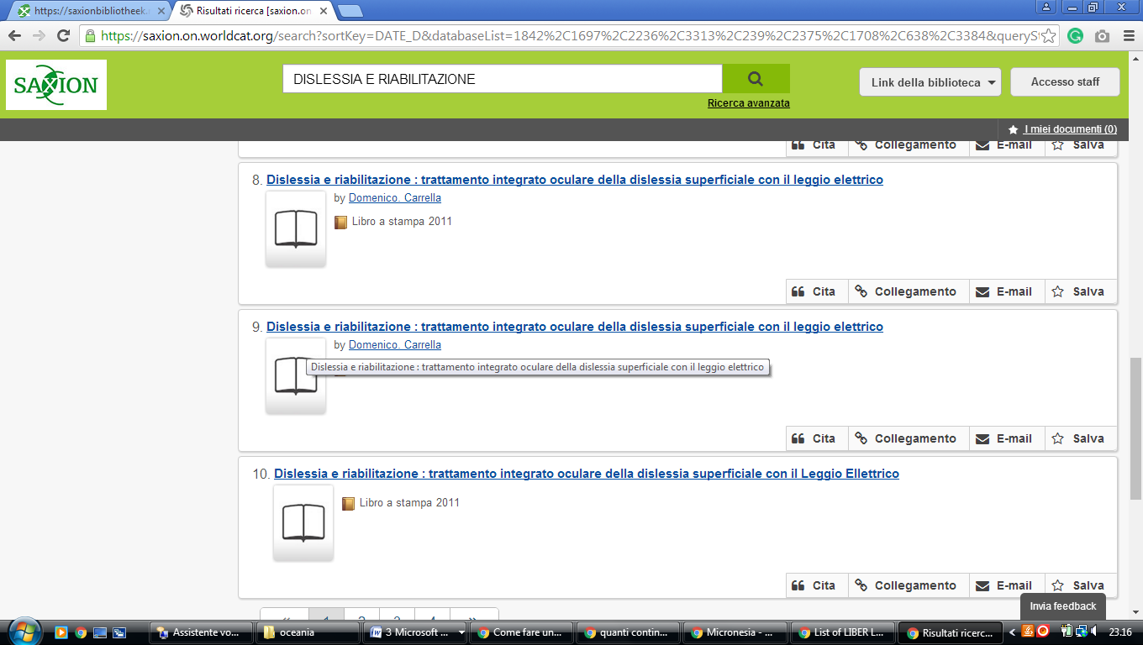

### 2 [LIBRARY UVA - UNIVERSITY OF AMSTERDAM](http://uba.uva.nl/en/) – ([Olanda Settentrionale](https://www.google.it/search?rlz=1C1CHIK_itIT460IT464&biw=1360&bih=677&q=Olanda+Settentrionale&stick=H4sIAAAAAAAAAOPgE-LUz9U3MMorNDRQ4gAx0work7XkspOt9HPykxNLMvPz4AyrgqL8ssy85FQAsGaNfTcAAAA&sa=X&ved=0ahUKEwjY6uqoheHUAhULtBQKHcKdB3cQmxMImQEoATAV))

<http://lib.uva.nl/primo_library/libweb/action/search.do?ct=facet&pcAvailabiltyMode=true&pcAvailClicked=true&frbg=&&fn=search&indx=1&dscnt=0&scp.scps=primo_central_multiple_fe&tb=t&mode=Basic&vid=UVA&ct=search&srt=rank&tab=remote&dum=true&vl(freeText0)=DISLESSIA%20E%20RIABILITAZIONE&dstmp=1518387888231>

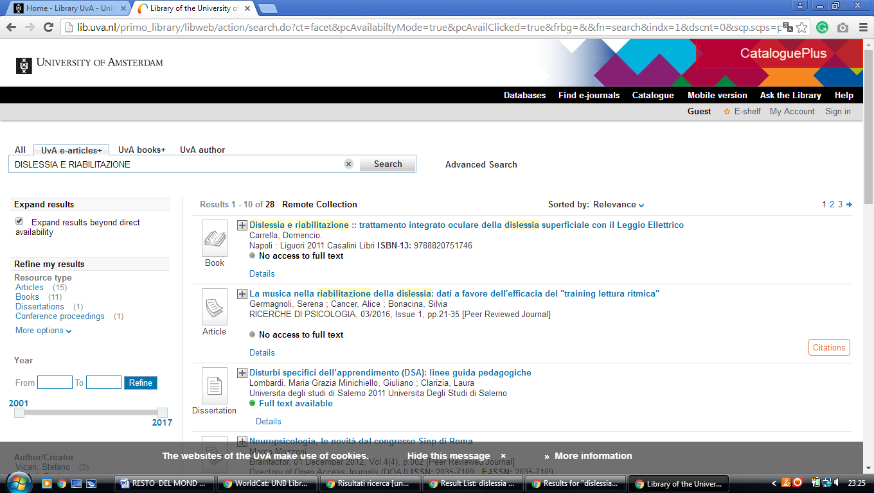

### 3 [VU LIBRARY - VRIJE UNIVERSITEIT AMSTERDAM](https://www.ub.vu.nl/en/) - (Amsterdam, Paesi Bassi)

<https://vu.on.worldcat.org/external-search?queryString=dislessia+e+riabilitazione#/oclc/878784487>

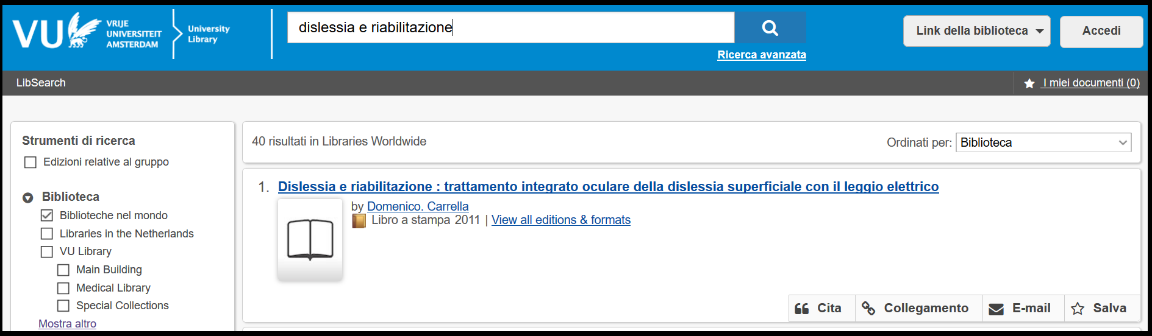

### 4 [HOME - LIBRARY UVA - UNIVERSITY OF AMSTERDAM](http://uba.uva.nl/en/) - (Olanda)

<http://lib.uva.nl/primo_library/libweb/action/search.do;jsessionid=2B01135F1CEA6C61F101F58B52786477?ct=facet&pcAvailabiltyMode=true&pcAvailClicked=true&frbg=&&fn=search&indx=1&dscnt=0&scp.scps=scope%3A(UVA)%2Cprimo_central_multiple_fe&tb=t&mode=Basic&vid=UVA&ct=search&srt=rank&tab=all&dum=true&vl(freeText0)=dislessia%20e%20riabilitazione&dstmp=1520709443590>

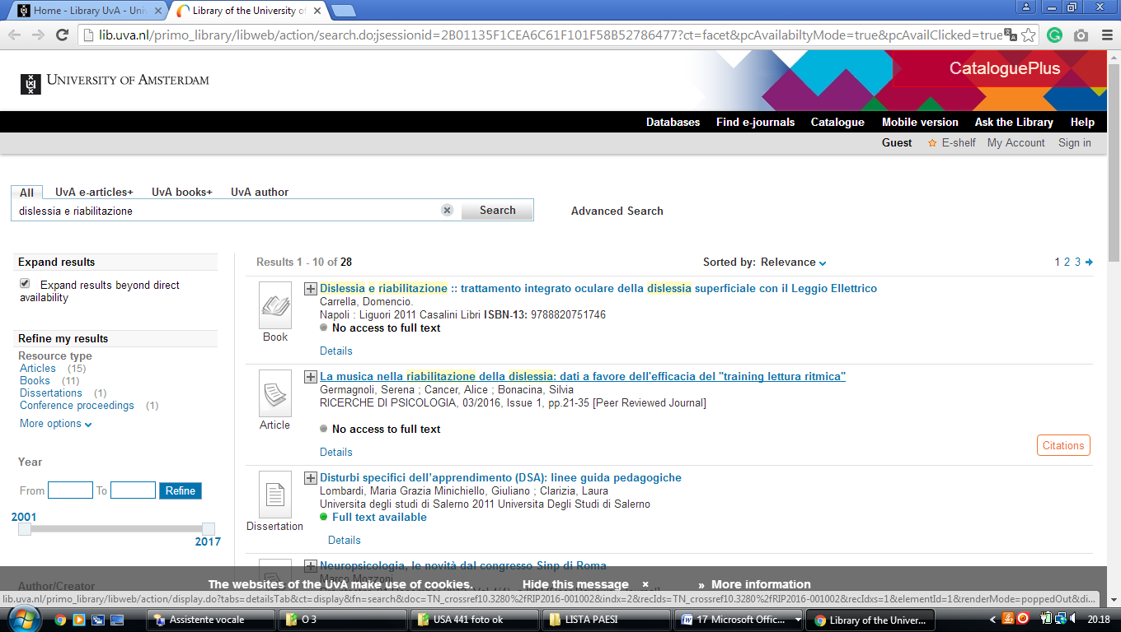

### 5 [KONINKLIJKE BIBLIOTHEEK | NATIONALE BIBLIOTHEEK VAN NEDERLAND](https://www.kb.nl/) – (Olanda)

[https://kb.on.worldcat.org/external-search?&queryString=dislessia%20e%20riabilitazione&SRT=YOP&IKT=1016&ACT=SRCHA&LNG=NE&lang=nl&op=Search#/oclc/878784487](https://kb.on.worldcat.org/external-search?&queryString=dislessia%20e%20riabilitazione&SRT=YOP&IKT=1016&ACT=SRCHA&LNG=NE&lang=nl&op=Search%23/oclc/878784487)

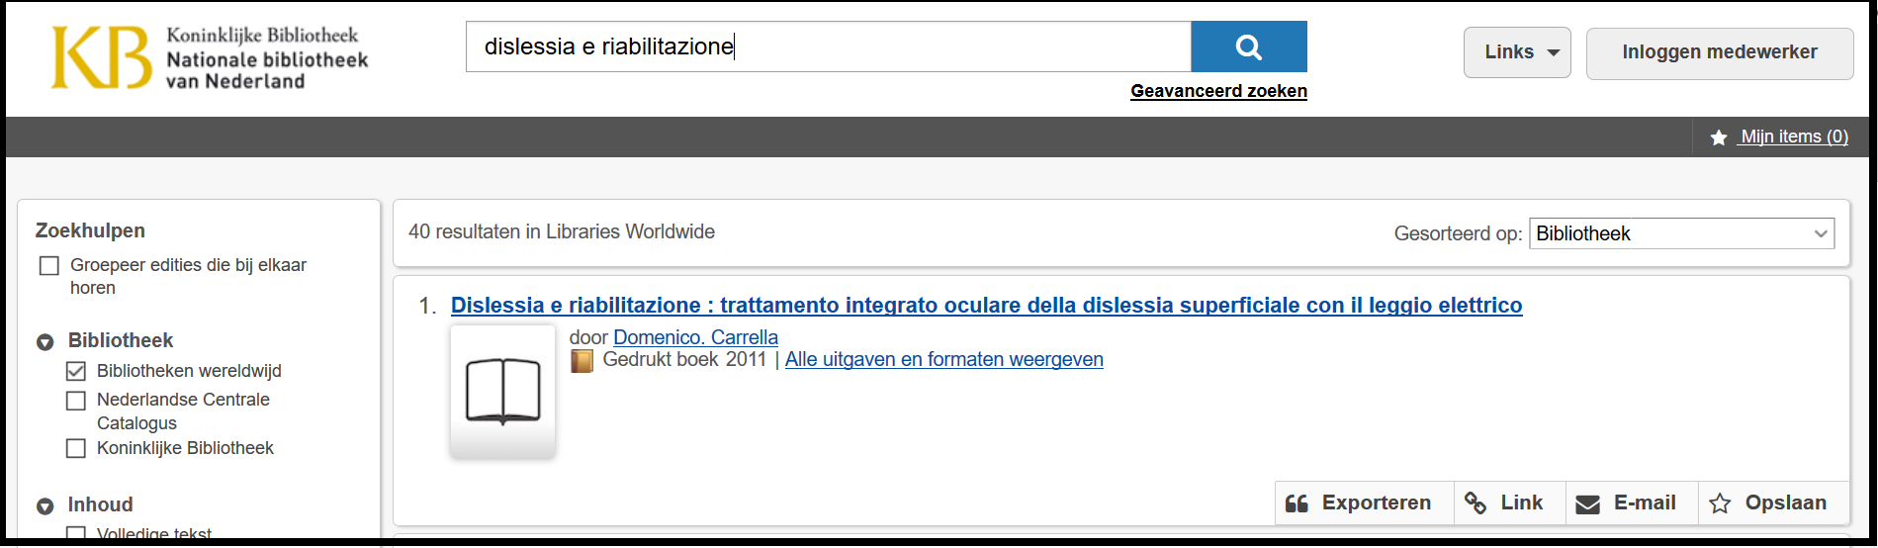

### 6 [WELCOME TO THE HANZE LIBRARY](https://www.hanze.nl/eng/services/facilities/hanze-library) -  (Northern [Netherlands](https://en.wikipedia.org/wiki/Netherlands))

<https://hanze.on.worldcat.org/search?sortKey=BEST_MATCH&databaseList=2375%2C1164%2C1271%2C2007%2C2006%2C3018%2C2897%2C1697%2C2038%2C3313%2C1708%2C638%2C3967&queryString=dislessia+e+riabilitazione&changedFacet=scope&clusterResults=on&scope=&scope=sz%3A34259>

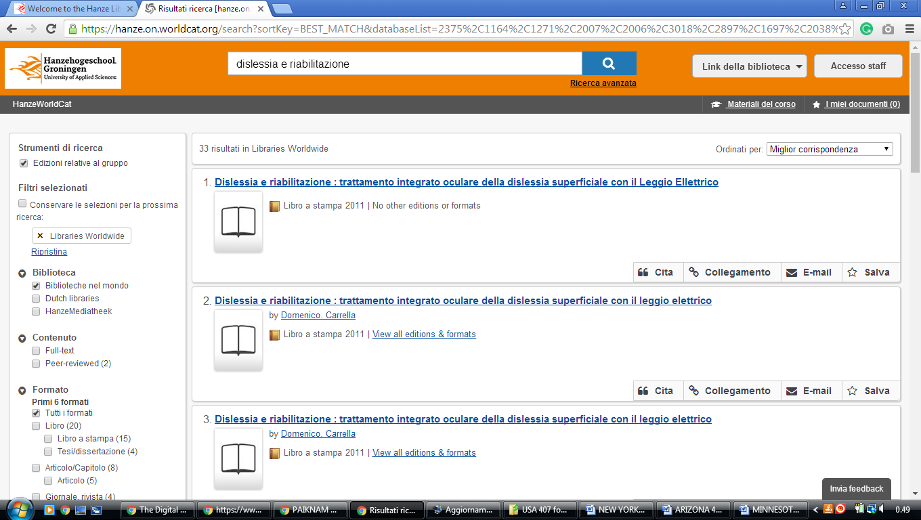

**7 NATIONALE BIBLIOTHEK VAN NEDERLAND –** (BE Den Haag, Paesi Bassi)

<https://kb.on.worldcat.org/external-search?&queryString=dislessia%20e%20riabilitazione&SRT=YOP&IKT=1016&ACT=SRCHA&LNG=NE&lang=nl&op=Search>

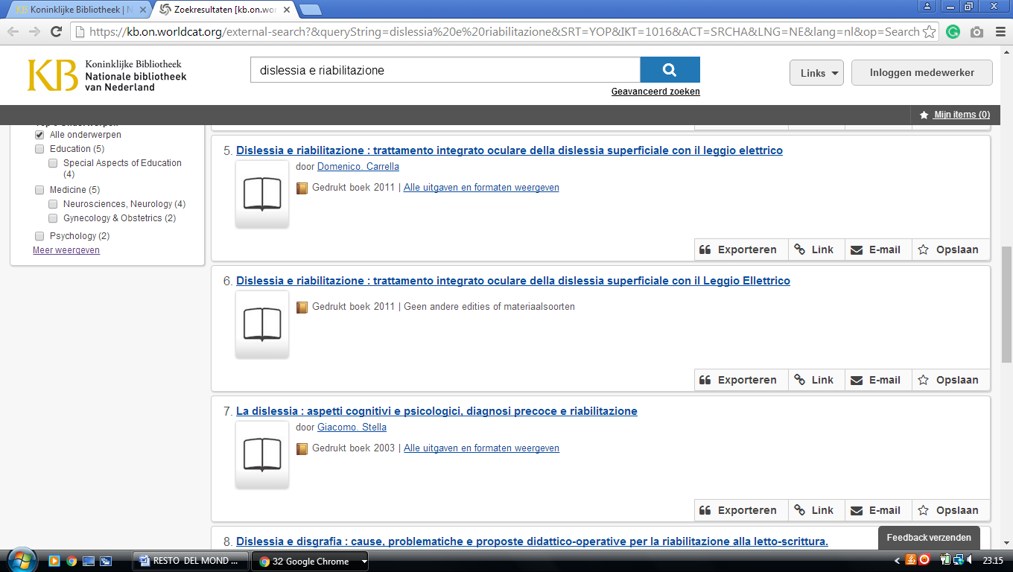

**8 LEIDEN UNIVERSITY LIBRARY** - (BG Leiden, Paesi Bassi)

<http://catalogue.leidenuniv.nl/primo_library/libweb/action/search.do?ct=facet&pcAvailabiltyMode=true&pcAvailClicked=true&vl(3237121UI0)=any&query=any%2Ccontains%2Cdislessia%20e%20riabilitazione&fn=search&indx=1&search_scope=All_Content&dscnt=0&scp.scps=scope%3A(UBL_DSPACE)%2Cscope%3A(%22UBL%22)%2Cscope%3A(UBL_DTL)%2Cscope%3A(UBL_ALMA)%2Cprimo_central_multiple_fe&vid=UBL_V1&ct=search&institution=UBL&tab=all_content&vl(freeText0)=dislessia%20e%20riabilitazione&dstmp=1518387577169&fromDL>

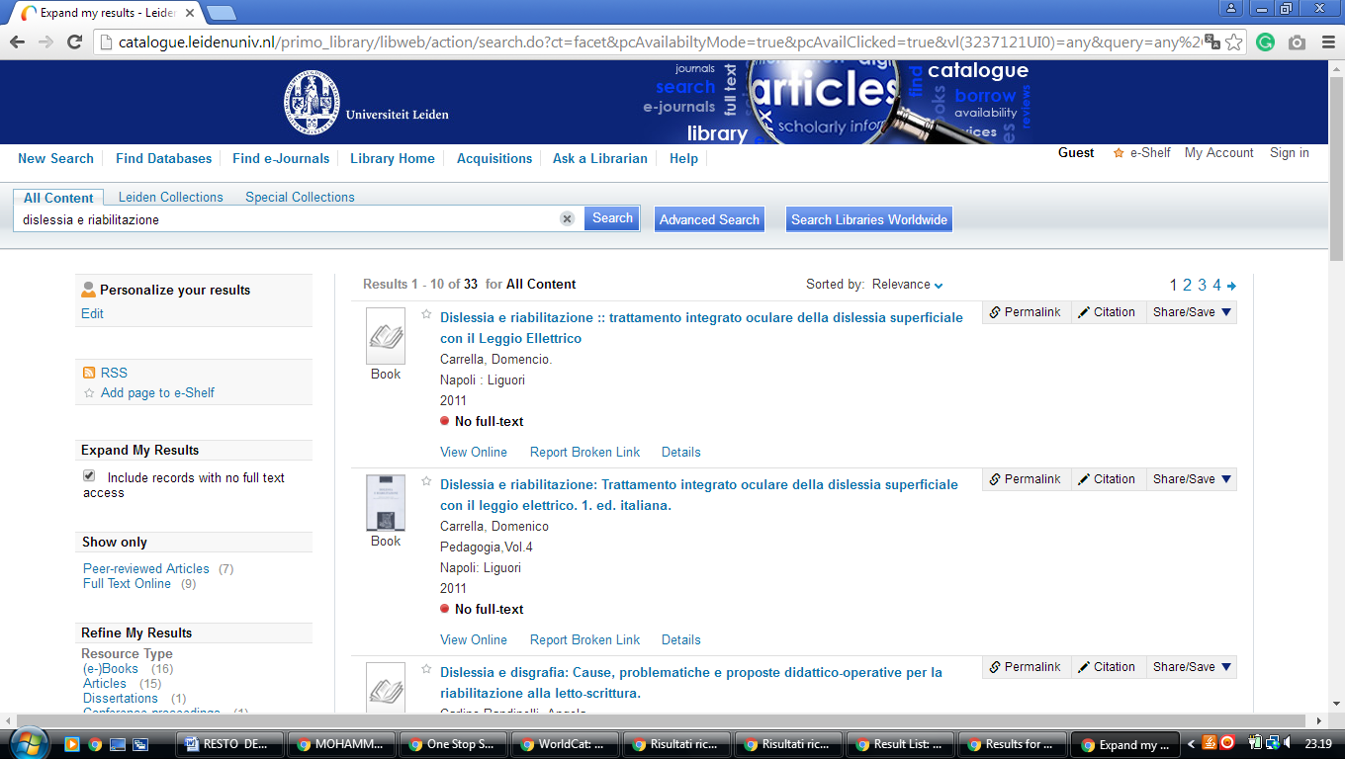----------------------------------------------------------------------------------------------------------------------------

### 9 [LIBRARY - TU DELFT](https://www.tudelft.nl/en/library/) [- (University Of Technology](http://www.library.tudelft.nl/) Delft, Paesi Bassi)

[https://tudelft.on.worldcat.org/search?sortKey=BEST_MATCH&databaseList=&queryString=DISLESSIA+E+RIABILITAZIONE&changedFacet=scope&scope=&scope=wz%3A45280&format=all&database=all&author=all&year=all&yearFrom=&yearTo=#](https://tudelft.on.worldcat.org/search?sortKey=BEST_MATCH&databaseList=&queryString=DISLESSIA+E+RIABILITAZIONE&changedFacet=scope&scope=&scope=wz%3A45280&format=all&database=all&author=all&year=all&yearFrom=&yearTo=)

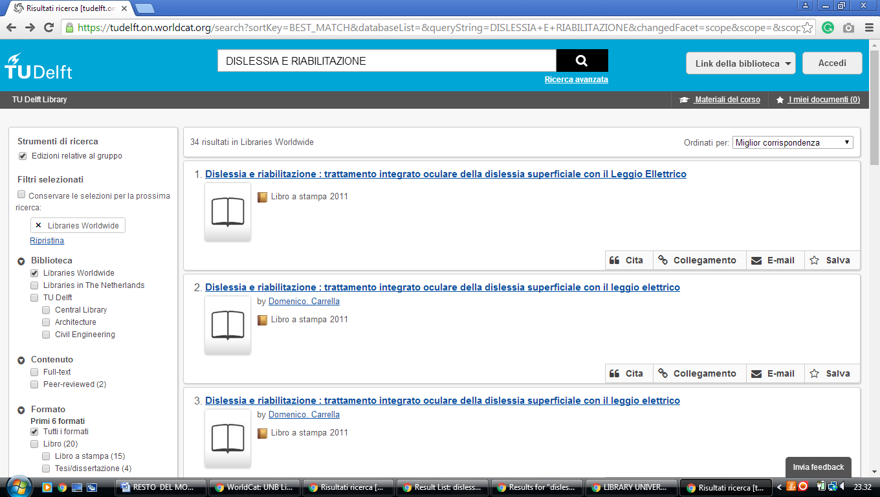

**10 RADBOUD UNIVERSITY LIBRARY –** (Nimega, Paesi Bassi)

<https://ru.on.worldcat.org/search?sortKey=BEST_MATCH&databaseList=2474%2C3441%2C2273%2C2194%2C1931%2C1697%2C2268%2C3313%2C2267%2C3036%2C638%2C2507%2C1978%2C3374%2C3450%2C3250%2C2437%2C3448%2C1941%2C2237%2C2236%2C1982%2C2795%2C2233%2C2375%2C1164%2C2175%2C3384%2C3382%2C3218%2C1953%2C1875%2C3018%2C3336%2C2005%2C1674%2C3378%2C2443%2C1672%2C1834%2C2221%2C3155%2C2264%2C3551%2C2462%2C2262%2C3197%2C2261%2C2260%2C3195%2C3548%2C1524%2C1842%2C2259%2C2897%2C1847%2C3988%2C3429&queryString=DISLESSIA+E+RIABILITAZIONE&changedFacet=scope&scope=&scope=sz%3A36735&format=all&database=all&author=all&year=all&yearFrom=&yearTo>=

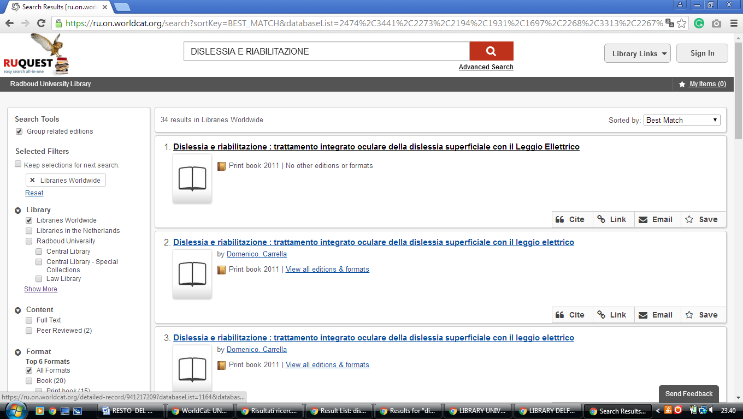

**11 LIBRARY TIBURG UNIVERSITY** – (Tilburg, Paesi Bassi)

<https://tilburguniversity.on.worldcat.org/external-search?queryString=dislessia%20e%20riabilitazione&databaseList=638&page=1&queryType=search&stickyFacetsChecked=false>

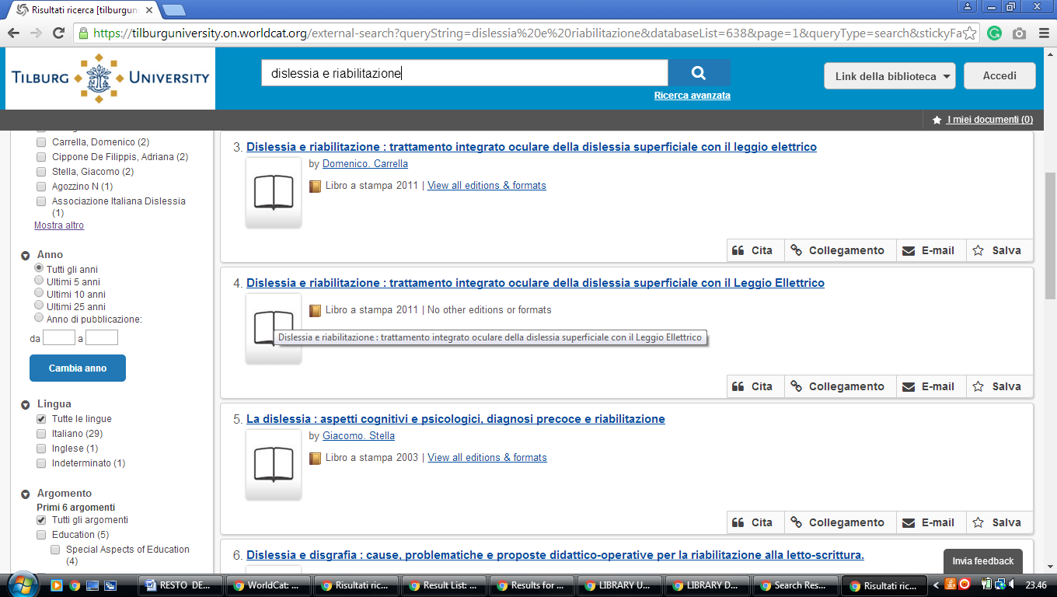

**12 LIBRARY TWENTE UNIVERSITY OVERIJSSEL –** (Netherlands Enschede, Paesi Bassi)

<https://ut.on.worldcat.org/search?sortKey=BEST_MATCH&databaseList=&queryString=DISLESSIA+E+RIABILITAZIONE&changedFacet=scope&scope=&scope=wz%3A9424&format=all&database=all&author=all&year=all&yearFrom=&yearTo>=

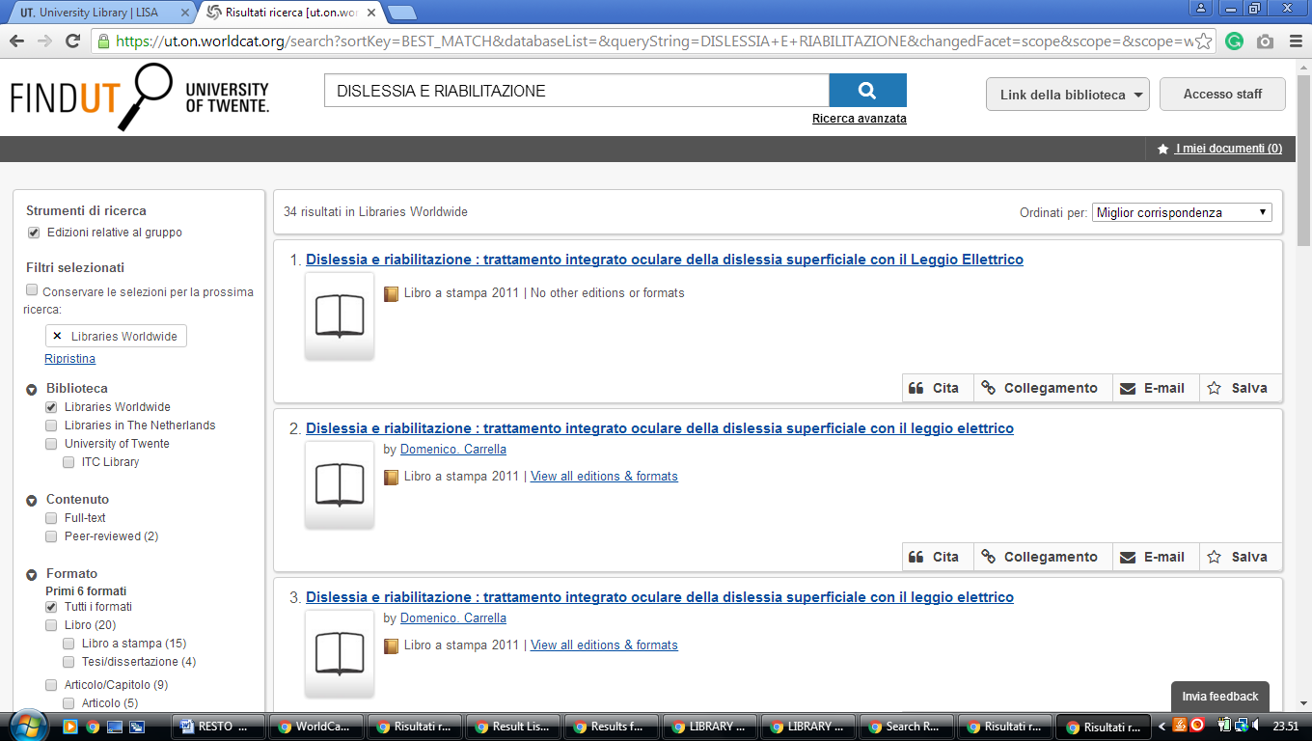

### 13 [UNIVERSITY LIBRARY | ERASMUS UNIVERSITY ROTTERDAM](https://www.eur.nl/en/campus/university-library) – (Paesi Bassi)

<https://eur.on.worldcat.org/search?queryString=dislessia%20e%20riabilitazione&databaseList=2198,3561,2274,2229,1931,233,1697,2269,2268,3313,2662,3036,239,3950,638,2507,1978,4069,3374,1271,283,2237,2038,2236,203,1982,3967,2375,2572,2175,3384,3382,3538,2369,2006,3018,3577,2443,3652,3976,2264,2462,2263,2261,3195,143,1842,2259,2897,2215,3589,3986,1847,3988&page=1&queryType=search&stickyFacetsChecked=false#/oclc/878784487>

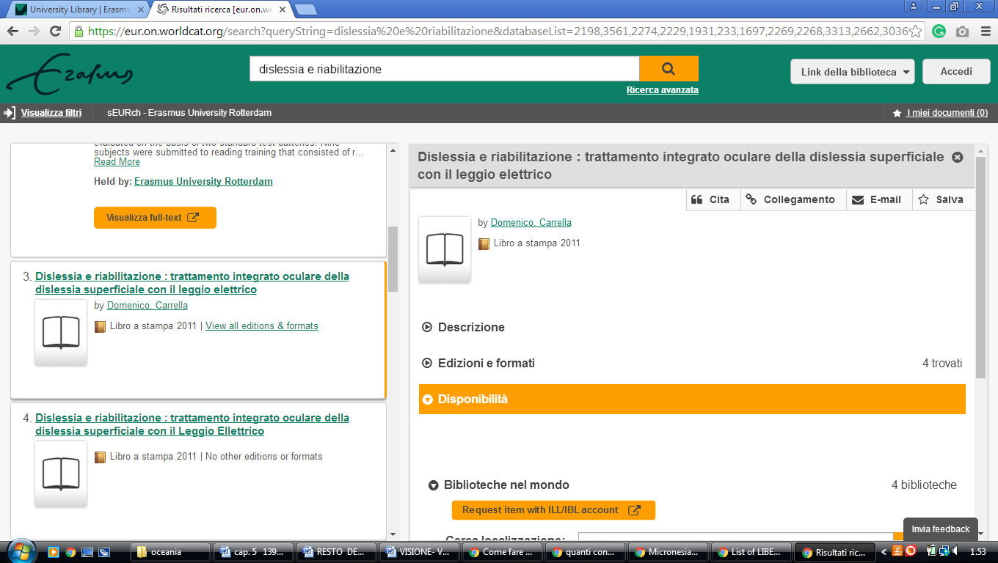

### 14 [MAASTRICHT UNIVERSITY LIBRARY: ONLINE LIBRARY - UNIVERSITEITSBIBLIOTHEEK ..](https://library.maastrichtuniversity.nl/) – (Paesi Bassi)

<https://maastrichtuniversity.on.worldcat.org/external-search?queryString=dislessia%20e%20riabilitazione&databaseList=2375,3441,1164,3384,233,3018,2269,2005,1674,3313,239,3652,4026,638,2507,1834,3879,2264,3551,3374,2263,2262,3197,3450>

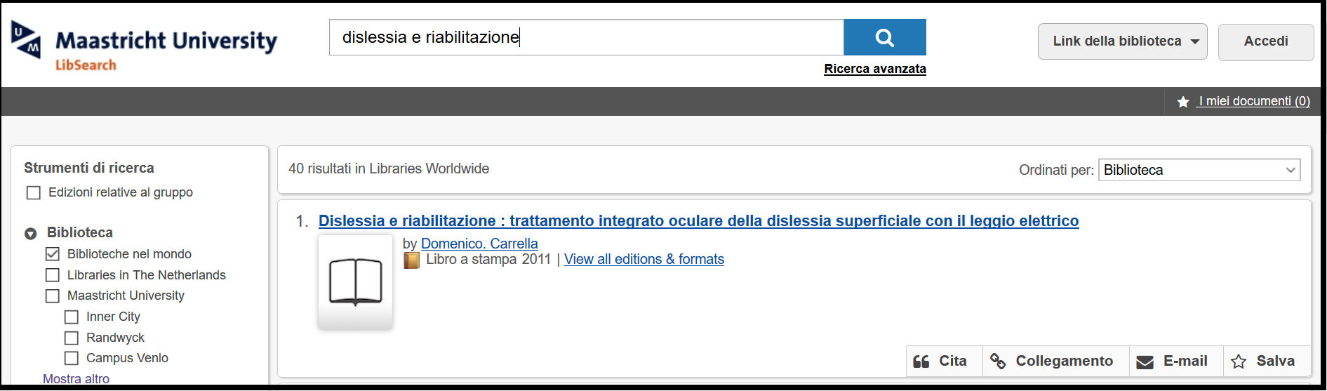

### 15 [UNIVERSITY LIBRARY | LISA](https://www.utwente.nl/en/lisa/library/) - ([University Of Twente](https://www.google.it/search?rlz=1C1CHIK_itIT460IT464&q=library+university+of+twente&spell=1&sa=X&ved=0ahUKEwjZtKbghuTZAhVPqaQKHSnCBusQkeECCCQoAA), Paesi Bassi)

<https://ut.on.worldcat.org/search?sortKey=BEST_MATCH&databaseList=&queryString=dislessia+e+riabilitazione&changedFacet=scope&scope=&scope=wz%3A9424&format=all&database=all&author=all&year=all&yearFrom=&yearTo>=

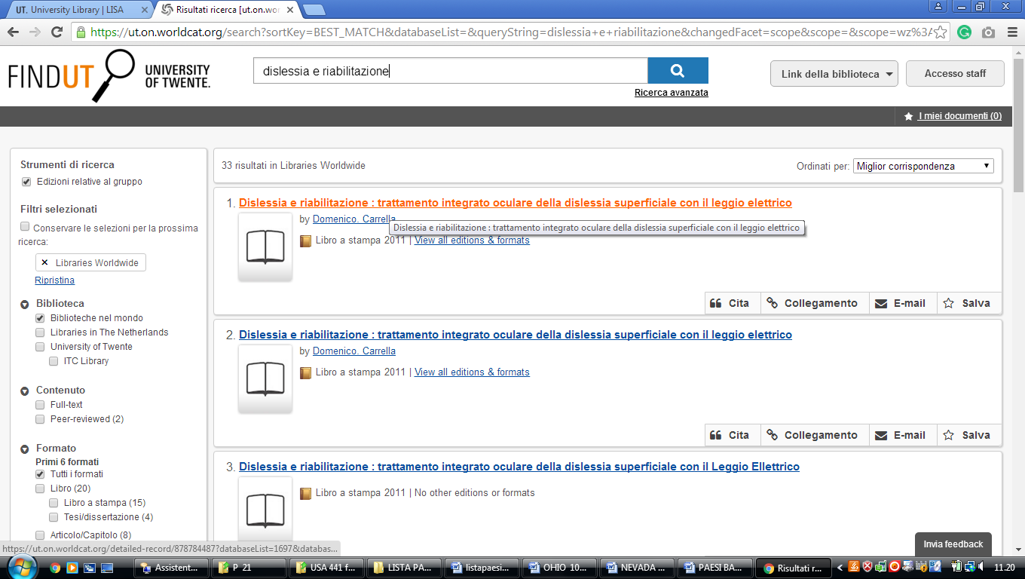

**16 ADAMNET NL** – ( Amsterdam, Paesi Bassi)

<http://adamnet.worldcat.org/title/dislessia-e-riabilitazione-trattamento-integrato-oculare-della-dislessia-superficiale-con-il-leggio-elettrico/oclc/878784487&referer=brief_results>

