### 1 HCT LIBRARIES - HOME

[http://hct.summon.serialssolutions.com/?#!/search?ho=f&l=en&q=dislessia%20e%20riabilitazione](http://hct.summon.serialssolutions.com/?%23!/search?ho=f&l=en&q=dislessia%20e%20riabilitazione)

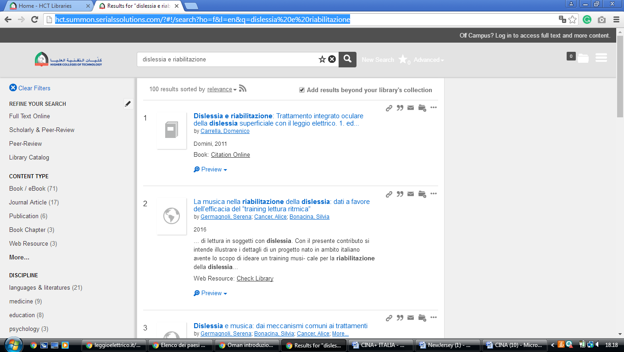

**HIGHER COLLEGE OF TECHNOLOGY (HCT) LIBRARIES, Muscat, OMAN**

[HCT Libraries: Home](https://www.google.com/url?sa=t&rct=j&q=&esrc=s&source=web&cd=1&cad=rja&uact=8&ved=2ahUKEwjpv82Evc7oAhUN7KYKHQN8Az4QFjAAegQIAhAB&url=http%3A%2F%2Flibraries.hct.ac.ae%2F&usg=AOvVaw3k6i2NyrXGfey5MPF8Feru)

