**LIBRARY | PNG UNIVERSITY OF TECHNOLOGY, PAPUA, NEW GUINEA**

[The Matheson Library | Png University Of Technology](https://www.google.com/url?sa=t&rct=j&q=&esrc=s&source=web&cd=3&cad=rja&uact=8&ved=2ahUKEwiw_cHrl_3oAhXph4sKHdShBEcQFjACegQIARAB&url=https%3A%2F%2Fwww.unitech.ac.pg%2Fresources%2Flibrary&usg=AOvVaw1dsXFDUqESG109LQfOIwCj)

[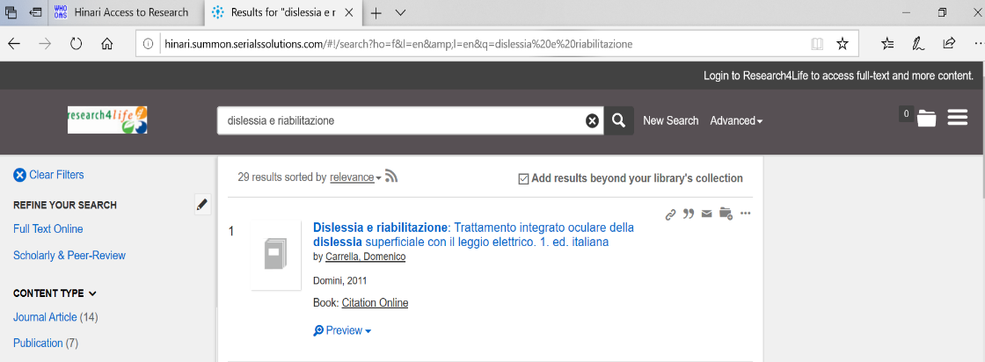](https://www.google.com/url?sa=t&rct=j&q=&esrc=s&source=web&cd=3&cad=rja&uact=8&ved=2ahUKEwiw_cHrl_3oAhXph4sKHdShBEcQFjACegQIARAB&url=https%3A%2F%2Fwww.unitech.ac.pg%2Fresources%2Flibrary&usg=AOvVaw1dsXFDUqESG109LQfOIwCj)