**NORVERGIA = 114**

# PER LA RICERCA MANUALE TRAMITE IL SITO UFFICIALE DELLE UNIVERSITA’ NORVERGESI

# Come entrare nel portale norvegese (Oria.no)

# 1 - Osserva l'immagine

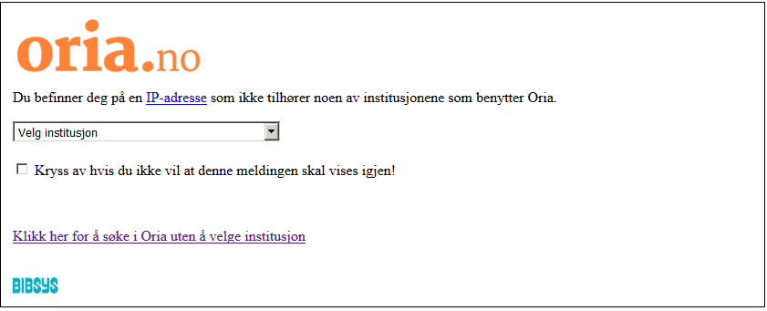

# 2 - Clicca qui

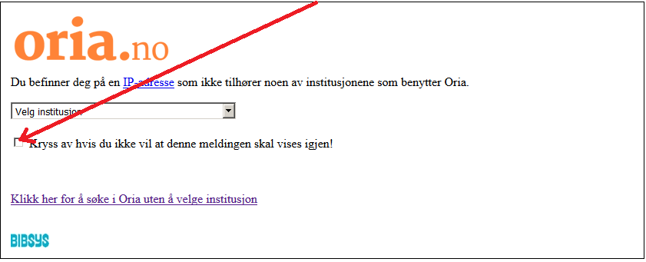

# 3 – Clicca sul menù

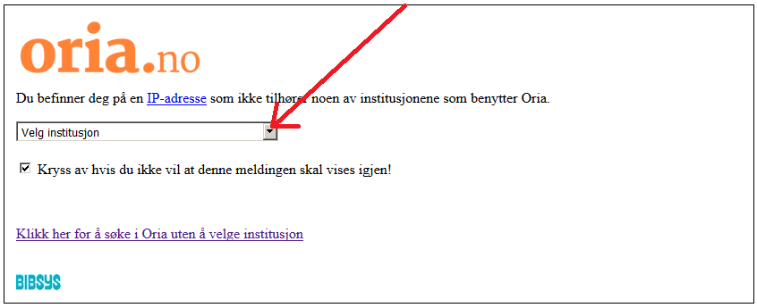

# 4 – Scegli l’Università

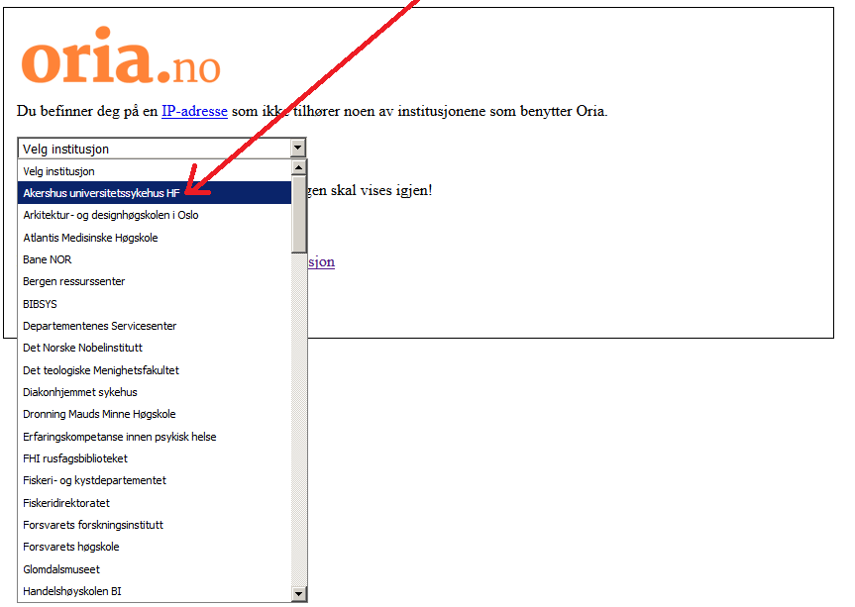

# 5 - Ecco l'Università scelta.

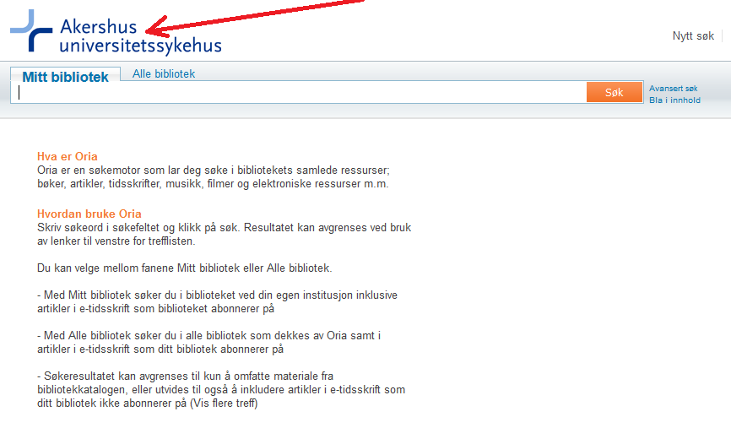

# 6 – Digita qui “Dislessia e Riabilitazione”

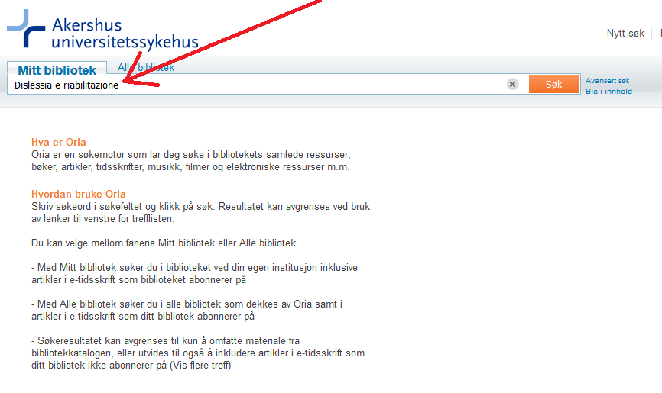

# 7 – Clicca qui

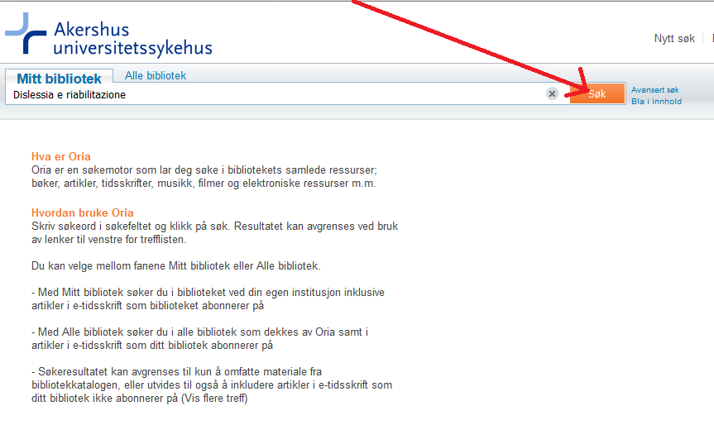

# 8 – Clicca qui per espandere la ricerca

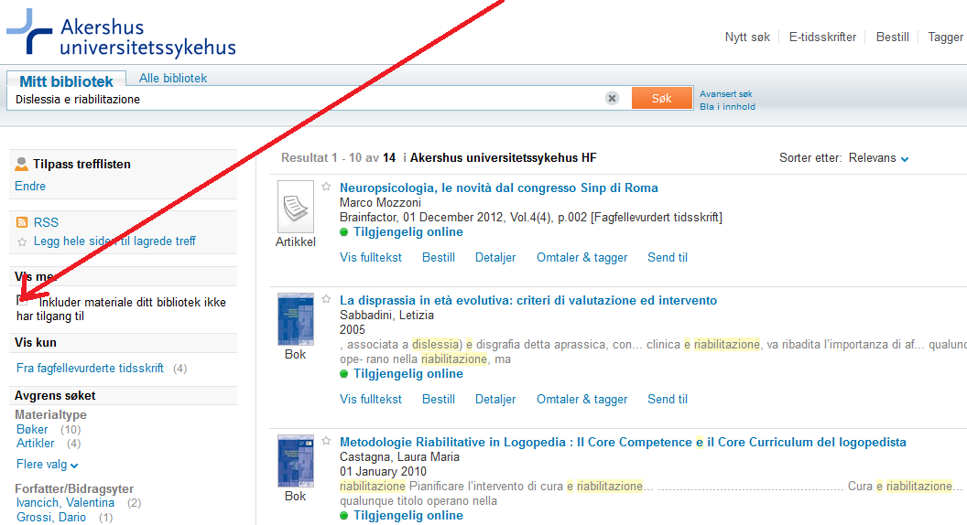

# 9 – Ecco il libro

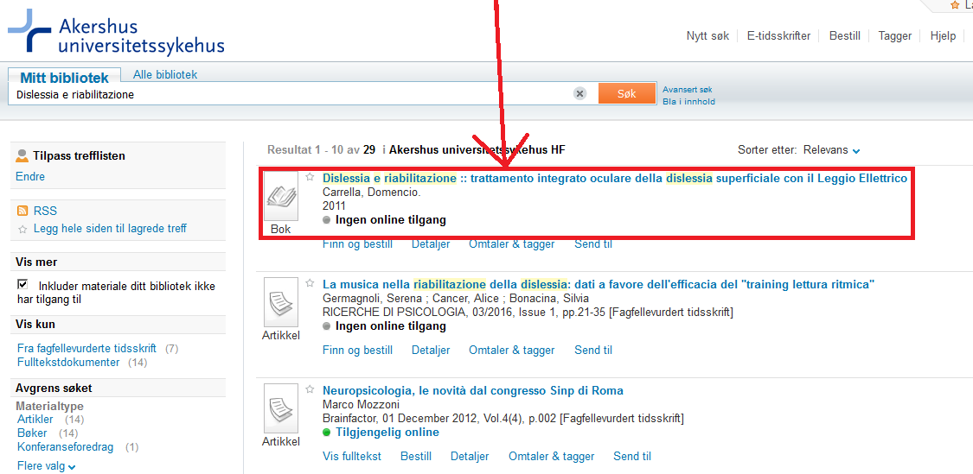

# 9 – Clicca sul link in basso per entrare su [Oria.no](http://www.oria.no/)



**1) Oria.no**

<www.oria.no>

**-------------------------------------------------------------------------------------------------------------------------------**

**IN ALTERNATIVA, PER LA RICERCA VELOCE O AUTOMATICA, CLICCARE I SEGUENTI LINK DIRETTI**

C:\Users\Domenico Carrella\Downloads\AHUS_no_NO.png

**2) Akershus universitetssykehus HF**

<https://bibsys-almaprimo.hosted.exlibrisgroup.com/primo_library/libweb/action/display.do?tabs=viewOnlineTab&ct=display&fn=search&doc=TN_casalini_libriit02503952&indx=1&recIds=TN_casalini_libriit02503952&recIdxs=0&elementId=0&renderMode=poppedOut&displayMode=full&frbrVersion=&frbg=&pcAvailabiltyMode=true&dscnt=0&scp.scps=scope%3A%28SC_OPEN_ACCESS%29%2Cscope%3A%28%22AHUS%22%29%2Cprimo_central_multiple_fe&tb=t&vid=AHUS&mode=Basic&tab=default_tab&srt=rank&dum=true&vl(freeText0)=dislessia%20e%20riabilitazione&dstmp=1496254837634$$>

--------------------------------------------------------------------------------------------------------------------------

**3)** [**architectur org.designhagskolen oslo**](https://www.google.it/search?rlz=1C1CHIK_itIT460IT464&biw=1360&bih=677&q=architectur+org.designhagskolen+oslo&nfpr=1&sa=X&ved=0ahUKEwjOup_x7KLUAhUGwBQKHcsNDa0QvgUIICgB)

<https://bibsys-almaprimo.hosted.exlibrisgroup.com/primo_library/libweb/action/search.do?ct=facet&pcAvailabiltyMode=true&pcAvailClicked=true&frbg=&&fn=search&indx=1&dscnt=0&scp.scps=scope%3A(%22AHO%22)%2Cscope%3A(SC_OPEN_ACCESS)%2CAHO_EbscoLocal%2Cprimo_central_multiple_fe&tb=t&mode=Basic&vid=AHO&ct=search&srt=rank&tab=default_tab&dum=true&vl(freeText0)=dislessia%20e%20riabilitazione&dstmp=1496532451424$$>

**----------------------------------------------------------------------------------------------------------------------**

**\*OSLO\***

**4) Atlantis medisinske høgskole**

[Atlantis medisinske høgskole https://bibsys-almaprimo.hosted.exlibrisgroup.com/primo\_library/libweb/action/display.do?tabs=viewOnlineTab&ct=display&fn=search&doc=TN\_casalini\_libriit02503952&indx=1&recIds=TN\_casalini\_libriit02503952&recIdxs=0&elementId=0&renderMode=poppedOut&displayMode=full&frbrVersion=&frbg=&pcAvailabiltyMode=true&dscnt=1&scp.scps=scope%3A%28SC\_OPEN\_ACCESS%29%2Cscope%3A%28AMH%29%2Cprimo\_central\_multiple\_fe&tb=t&vid=AMH&mode=Basic&tab=default\_tab&srt=rank&dum=true&vl(freeText0)=dislessia%20e%20riabilitazione&dstmp=1496254580233&gathStatIcon=true$$](file://C:\Users\Th3B14z3\Desktop\tutto%20desktop%20gennaio%202018\Tutto%20desktop%20Dicembre17\21_12_2017_SITOMIMMO\Atlantis%20medisinske%20høgskole%20https:\bibsys-almaprimo.hosted.exlibrisgroup.com\primo_library\libweb\action\display.do?tabs=viewOnlineTab&ct=display&fn=search&doc=TN_casalini_libriit02503952&indx=1&recIds=TN_casalini_libriit02503952&recIdxs=0&elementId=0&renderMode=poppedOut&displayMode=full&frbrVersion=&frbg=&pcAvailabiltyMode=true&dscnt=1&scp.scps=scope:(SC_OPEN_ACCESS),scope:(AMH),primo_central_multiple_fe&tb=t&vid=AMH&mode=Basic&tab=default_tab&srt=rank&dum=true&vl(freeText0)=dislessia%20e%20riabilitazione&dstmp=1496254580233&gathStatIcon=true$$)

**-------------------------------------------------------------------------------------------------------------------------------**

**BERGEN**

### C:\Users\Domenico Carrella\Downloads\BRC_no_NO (2).png

### 5) Bergen Ressourssenter

### <https://bibsys-almaprimo.hosted.exlibrisgroup.com/primo_library/libweb/action/display.do?tabs=viewOnlineTab&ct=display&fn=search&doc=TN_casalini_libriit02503952&indx=1&recIds=TN_casalini_libriit02503952&recIdxs=0&elementId=0&renderMode=poppedOut&displayMode=full&frbrVersion=&frbg=&pcAvailabiltyMode=true&dscnt=0&scp.scps=scope%3A%28SC_OPEN_ACCESS%29%2Cscope%3A%28%22BRC%22%29%2Cprimo_central_multiple_fe&tb=t&vid=BRC&mode=Basic&tab=default_tab&srt=rank&dum=true&vl(freeText0)=dislessia%20e%20riabilitazione&dstmp=1496254320299$$>

**------------------------------------------------------------------------------------------------------------------------------**

**C:\Users\Domenico Carrella\Downloads\PFP_no_NO (3).pngFredrik A. Dahls**

**6) Bioforsk plantehelse\*\***

<https://bibsys-almaprimo.hosted.exlibrisgroup.com/primo_library/libweb/action/display.do?tabs=viewOnlineTab&ct=display&fn=search&doc=TN_casalini_libriit02503952&indx=1&recIds=TN_casalini_libriit02503952&recIdxs=0&elementId=0&renderMode=poppedOut&displayMode=full&frbrVersion=&frbg=&pcAvailabiltyMode=true&dscnt=0&scp.scps=scope%3A%28%22PFP%22%29%2Cscope%3A%28SC_OPEN_ACCESS%29%2Cprimo_central_multiple_fe&tb=t&vid=PFP&mode=Basic&tab=default_tab&srt=rank&dum=true&vl(freeText0)=dislessia%20e%20riabilitazione&dstmp=1497114629614&gathStatIcon=true>

-------------------------------------------------------------------------------------------------------------------------------

### 7) [Departementenes servicecenter](https://www.google.it/url?sa=t&rct=j&q=&esrc=s&source=web&cd=2&cad=rja&uact=8&ved=0ahUKEwjWj7mXi6_UAhXIzRQKHcW1CFoQFggsMAE&url=http%3A%2F%2Fqueri.ovba.ru%2F163%2F&usg=AFQjCNEsU8T-K5ZUYM_RP5X6wcm-wEySOw) OSLO

<https://bibsys-almaprimo.hosted.exlibrisgroup.com/primo_library/libweb/action/display.do?tabs=viewOnlineTab&ct=display&fn=search&doc=TN_casalini_libriit02503952&indx=1&recIds=TN_casalini_libriit02503952&recIdxs=0&elementId=0&renderMode=poppedOut&displayMode=full&frbrVersion=&frbg=&pcAvailabiltyMode=true&dscnt=0&scp.scps=scope%3A%28SC_OPEN_ACCESS%29%2Cscope%3A%28%22DEPSS%22%29%2Cprimo_central_multiple_fe&tb=t&vid=DEPSS&mode=Basic&tab=default_tab&srt=rank&dum=true&vl(freeText0)=dislessia%20e%20riabilitazione&dstmp=1497114320659&gathStatIcon=true>

****

**8) Det Norske Nobelinstitutt**

<https://bibsys-almaprimo.hosted.exlibrisgroup.com/primo_library/libweb/action/display.do?tabs=viewOnlineTab&ct=display&fn=search&doc=TN_casalini_libriit02503952&indx=1&recIds=TN_casalini_libriit02503952&recIdxs=0&elementId=0&renderMode=poppedOut&displayMode=full&frbrVersion=&frbg=&pcAvailabiltyMode=true&dscnt=0&scp.scps=scope%3A%28%22NOBEL%22%29%2Cscope%3A%28SC_OPEN_ACCESS%29%2Cprimo_central_multiple_fe&tb=t&vid=NOBEL&mode=Basic&tab=default_tab&srt=rank&dum=true&vl(freeText0)=dislessia%20e%20riabilitazione&dstmp=1496256315574>

-------------------------------------------------------------------------------------------------------------------------------

C:\Users\Domenico Carrella\Downloads\MF_no_NO.png

**9) Det teologiscke menighetsfakultet OSLO**

<https://bibsys-almaprimo.hosted.exlibrisgroup.com/primo_library/libweb/action/display.do?tabs=viewOnlineTab&ct=display&fn=search&doc=TN_casalini_libriit02503952&indx=1&recIds=TN_casalini_libriit02503952&recIdxs=0&elementId=0&renderMode=poppedOut&displayMode=full&frbrVersion=&frbg=&pcAvailabiltyMode=true&dscnt=0&scp.scps=scope%3A%28SC_OPEN_ACCESS%29%2Cscope%3A%28%22MF%22%29%2Cprimo_central_multiple_fe&tb=t&vid=MF&mode=Basic&tab=default_tab&srt=rank&dum=true&vl(freeText0)=dislessia%20e%20riabilitazione&dstmp=1496256475073>

------------------------------------------------------------------------------------------------------------------------------

### OSLO

### C:\Users\Domenico Carrella\Downloads\DIAKON_no_NO (1).png

### 10) [Diakonhjemmet Høgskole](https://www.google.it/url?sa=t&rct=j&q=&esrc=s&source=web&cd=2&cad=rja&uact=8&ved=0ahUKEwjr_rC9wbHUAhUHthoKHTdkBj4QFggpMAE&url=https%3A%2F%2Fno.wikipedia.org%2Fwiki%2FDiakonhjemmet_H%25C3%25B8gskole&usg=AFQjCNEngexZgF1DxXuGqUCQMbRXhLTNpQ)

<https://bibsys-almaprimo.hosted.exlibrisgroup.com/primo_library/libweb/action/display.do?tabs=viewOnlineTab&ct=display&fn=search&doc=TN_casalini_libriit02503952&indx=1&recIds=TN_casalini_libriit02503952&recIdxs=0&elementId=0&renderMode=poppedOut&displayMode=full&frbrVersion=&frbg=&pcAvailabiltyMode=true&dscnt=0&scp.scps=scope%3A%28%22DIAKON%22%29%2Cscope%3A%28SC_OPEN_ACCESS%29%2Cprimo_central_multiple_fe&tb=t&vid=DIAKON&mode=Basic&tab=default_tab&srt=rank&dum=true&vl(freeText0)=dislessia%20e%20riabilitazione&dstmp=1497037426436&gathStatIcon=true>

-------------------------------------------------------------------------------------------------------------------------------

**OSLO**

**11) Diakonhjemmet Sykehus**

<https://bibsys-almaprimo.hosted.exlibrisgroup.com/primo_library/libweb/action/display.do?tabs=viewOnlineTab&ct=display&fn=search&doc=TN_casalini_libriit02503952&indx=1&recIds=TN_casalini_libriit02503952&recIdxs=0&elementId=0&renderMode=poppedOut&displayMode=full&frbrVersion=&frbg=&pcAvailabiltyMode=true&dscnt=0&scp.scps=scope%3A%28SC_OPEN_ACCESS%29%2Cscope%3A%28%22DIASYK%22%29%2Cprimo_central_multiple_fe&tb=t&vid=DIASYK&mode=Basic&tab=default_tab&srt=rank&dum=true&vl(freeText0)=dislessia%20e%20riabilitazione&dstmp=1496256883052>

-------------------------------------------------------------------------------------------------------------------------------

C:\Users\Domenico Carrella\Downloads\DMMH_no_NO.png

**12) Dronning Maud Minne Høgskole**

<https://bibsys-almaprimo.hosted.exlibrisgroup.com/primo_library/libweb/action/display.do?tabs=viewOnlineTab&ct=display&fn=search&doc=TN_casalini_libriit02503952&indx=1&recIds=TN_casalini_libriit02503952&recIdxs=0&elementId=0&renderMode=poppedOut&displayMode=full&frbrVersion=&frbg=&pcAvailabiltyMode=true&dscnt=0&scp.scps=scope%3A%28SC_OPEN_ACCESS%29%2Cscope%3A%28%22DMMH%22%29%2Cprimo_central_multiple_fe&tb=t&vid=DMMH&mode=Basic&tab=default_tab&srt=rank&dum=true&vl(freeText0)=dislessia%20e%20riabilitazione&dstmp=1496257035549>

-----------------------------------------------------------------------------------------------------------------------------



**13) Erfaringskompetanse Innen**

**Psykisk Helse**

<https://bibsys-almaprimo.hosted.exlibrisgroup.com/primo_library/libweb/action/display.do?tabs=viewOnlineTab&ct=display&fn=search&doc=TN_casalini_libriit02503952&indx=1&recIds=TN_casalini_libriit02503952&recIdxs=0&elementId=0&renderMode=poppedOut&displayMode=full&frbrVersion=&frbg=&pcAvailabiltyMode=true&dscnt=1&scp.scps=scope%3A%28SC_OPEN_ACCESS%29%2Cscope%3A%28%22ERFKOMP%22%29%2Cprimo_central_multiple_fe&tb=t&vid=ERFKOMP&mode=Basic&tab=default_tab&srt=rank&dum=true&vl(freeText0)=dislessia%20e%20riabilitazione&dstmp=1496257207286>

-------------------------------------------------------------------------------------------------------------------------------



**14) fiskeri-og Kystdepartmentet**

<https://bibsys-almaprimo.hosted.exlibrisgroup.com/primo_library/libweb/action/display.do?tabs=viewOnlineTab&ct=display&fn=search&doc=TN_casalini_libriit02503952&indx=1&recIds=TN_casalini_libriit02503952&recIdxs=0&elementId=0&renderMode=poppedOut&displayMode=full&frbrVersion=&frbg=&pcAvailabiltyMode=true&dscnt=0&scp.scps=scope%3A%28%22FIDEP%22%29%2Cscope%3A%28SC_OPEN_ACCESS%29%2Cprimo_central_multiple_fe&tb=t&vid=FIDEP&mode=Basic&tab=default_tab&srt=rank&dum=true&vl(freeText0)=dislessia%20e%20riabilitazione&dstmp=1496257387784>

------------------------------------------------------------------------------------------------------------------------------

****

**15) Fiskeridirektoratet**

<https://bibsys-almaprimo.hosted.exlibrisgroup.com/primo_library/libweb/action/display.do?tabs=viewOnlineTab&ct=display&fn=search&doc=TN_casalini_libriit02503952&indx=1&recIds=TN_casalini_libriit02503952&recIdxs=0&elementId=0&renderMode=poppedOut&displayMode=full&frbrVersion=&frbg=&pcAvailabiltyMode=true&dscnt=0&scp.scps=scope%3A%28%22FISKDIR%22%29%2Cscope%3A%28SC_OPEN_ACCESS%29%2Cprimo_central_multiple_fe&tb=t&vid=FISKDIR&mode=Basic&tab=default_tab&srt=rank&dum=true&vl(freeText0)=dislessia%20e%20riabilitazione&dstmp=1496257522084>

-------------------------------------------------------------------------------------------------------------------------------

****

**16) Forstvarets Forskningsinstitutt**

<https://bibsys-almaprimo.hosted.exlibrisgroup.com/primo_library/libweb/action/display.do?tabs=viewOnlineTab&ct=display&fn=search&doc=TN_casalini_libriit02503952&indx=1&recIds=TN_casalini_libriit02503952&recIdxs=0&elementId=0&renderMode=poppedOut&displayMode=full&frbrVersion=&frbg=&pcAvailabiltyMode=true&dscnt=0&scp.scps=scope%3A%28%22FFI_BIBL%22%29%2Cscope%3A%28SC_OPEN_ACCESS%29%2Cprimo_central_multiple_fe&tb=t&vid=FFI_BIBL&mode=Basic&tab=default_tab&srt=rank&dum=true&vl(freeText0)=dislessia%20e%20riabilitazione&dstmp=1496257725025&gathStatIcon=true>

-------------------------------------------------------------------------------------------------------------------------------

**17) Forstvaret Forstvarets Høgskole**

<https://bibsys-almaprimo.hosted.exlibrisgroup.com/primo_library/libweb/action/display.do?tabs=viewOnlineTab&ct=display&fn=search&doc=TN_casalini_libriit02503952&indx=1&recIds=TN_casalini_libriit02503952&recIdxs=0&elementId=0&renderMode=poppedOut&displayMode=full&frbrVersion=&frbg=&pcAvailabiltyMode=true&dscnt=0&scp.scps=scope%3A%28SC_OPEN_ACCESS%29%2Cscope%3A%28%22FHS%22%29%2Cprimo_central_multiple_fe&tb=t&vid=FHS&mode=Basic&tab=default_tab&srt=rank&dum=true&vl(freeText0)=dislessia%20e%20riabilitazione&dstmp=1496258080824>

-------------------------------------------------------------------------------------------------------------------------------

C:\Users\Domenico Carrella\Downloads\GLOMDAL_no_NO.png

**18) Glomdalsmuseet**

<https://bibsys-almaprimo.hosted.exlibrisgroup.com/primo_library/libweb/action/display.do?tabs=viewOnlineTab&ct=display&fn=search&doc=TN_casalini_libriit02503952&indx=1&recIds=TN_casalini_libriit02503952&recIdxs=0&elementId=0&renderMode=poppedOut&displayMode=full&frbrVersion=&vid=GLOMDAL&mode=Basic&tab=alle_bibliotek&dscnt=0&vl(freeText0)=dislessia%20e%20riabilitazione&dstmp=1496258265392>

-------------------------------------------------------------------------------------------------------------------------------

****

**19) Handelshoyskolen BI**

<https://bibsys-almaprimo.hosted.exlibrisgroup.com/primo_library/libweb/action/display.do?tabs=viewOnlineTab&ct=display&fn=search&doc=TN_casalini_libriit02503952&indx=1&recIds=TN_casalini_libriit02503952&recIdxs=0&elementId=0&renderMode=poppedOut&displayMode=full&frbrVersion=&frbg=&pcAvailabiltyMode=true&dscnt=0&scp.scps=scope%3A%28BI%29%2Cprimo_central_multiple_fe&tb=t&vid=BI&mode=Basic&tab=default_tab&srt=rank&dum=true&vl(freeText0)=dislessia%20e%20riabilitazione&dstmp=1496258470256>

-------------------------------------------------------------------------------------------------------------------------------

**C:\Users\Domenico Carrella\Downloads\HDH_240x60 (1).png20) Haraldsplass diakonale Høgskole**

<https://bibsys-almaprimo.hosted.exlibrisgroup.com/primo_library/libweb/action/display.do?tabs=detailsTab&ct=display&fn=search&doc=TN_casalini_libriit02503952&indx=1&recIds=TN_casalini_libriit02503952&recIdxs=0&elementId=0&renderMode=poppedOut&displayMode=full&frbrVersion=&frbg=&pcAvailabiltyMode=true&dscnt=1&scp.scps=scope%3A%28BIBSYS_ILS%29%2Cscope%3A%28SC_OPEN_ACCESS%29%2Cscope%3A%28%22BIBSYS%22%29%2Cprimo_central_multiple_fe&vid=BIBSYS&mode=Basic&srt=rank&tab=default_tab&dum=true&vl(freeText0)=dislessia%20e%20riabilitazione&dstmp=1496258812675&gathStatIcon=true>

-----------------------------------------------------------------------------------------------------------------------------



**21) Helse Fonna HF**

<https://bibsys-almaprimo.hosted.exlibrisgroup.com/primo_library/libweb/action/display.do?tabs=viewOnlineTab&ct=display&fn=search&doc=TN_casalini_libriit02503952&indx=1&recIds=TN_casalini_libriit02503952&recIdxs=0&elementId=0&renderMode=poppedOut&displayMode=full&frbrVersion=&frbg=&pcAvailabiltyMode=true&dscnt=0&scp.scps=scope%3A%28SC_OPEN_ACCESS%29%2Cscope%3A%28%22FONNA%22%29%2Cprimo_central_multiple_fe&tb=t&vid=FONNA&mode=Basic&tab=default_tab&srt=rank&dum=true&vl(freeText0)=dislessia%20e%20riabilitazione&dstmp=1496259223583>

-----------------------------------------------------------------------------------------------------------------------------

**22) Helse More OG Romsdal HF Fagbiblioteket**

<https://bibsys-almaprimo.hosted.exlibrisgroup.com/primo_library/libweb/action/display.do?tabs=viewOnlineTab&ct=display&fn=search&doc=TN_casalini_libriit02503952&indx=1&recIds=TN_casalini_libriit02503952&recIdxs=0&elementId=0&renderMode=poppedOut&displayMode=full&frbrVersion=&frbg=&pcAvailabiltyMode=true&dscnt=0&scp.scps=scope%3A%28%22MOLDESYK%22%29%2Cscope%3A%28SC_OPEN_ACCESS%29%2Cprimo_central_multiple_fe&tb=t&vid=MOLDESYK&mode=Basic&tab=default_tab&srt=rank&dum=true&vl(freeText0)=dislessia%20e%20riabilitazione&dstmp=1496259372695>

-------------------------------------------------------------------------------------------------------------------------------

C:\Users\Domenico Carrella\Downloads\SHDIR_no_NO.png

**23) Helsedirektoratet OSLO**

<https://bibsys-almaprimo.hosted.exlibrisgroup.com/primo_library/libweb/action/display.do?tabs=detailsTab&ct=display&fn=search&doc=TN_casalini_libriit02503952&indx=1&recIds=TN_casalini_libriit02503952&recIdxs=0&elementId=0&renderMode=poppedOut&displayMode=full&frbrVersion=&frbg=&pcAvailabiltyMode=true&dscnt=0&scp.scps=scope%3A%28BIBSYS_ILS%29%2Cscope%3A%28SC_OPEN_ACCESS%29%2Cscope%3A%28%22BIBSYS%22%29%2Cprimo_central_multiple_fe&vid=BIBSYS&mode=Basic&srt=rank&tab=default_tab&dum=true&vl(freeText0)=dislessia%20e%20riabilitazione&dstmp=1497040469063&gathStatIcon=true>

----------------------------------------------------------------------------------------------------------------------------

**24) HL-Senteret OSLO**

<https://bibsys-almaprimo.hosted.exlibrisgroup.com/primo_library/libweb/action/display.do?tabs=viewOnlineTab&ct=display&fn=search&doc=TN_casalini_libriit02503952&indx=1&recIds=TN_casalini_libriit02503952&recIdxs=0&elementId=0&renderMode=poppedOut&displayMode=full&frbrVersion=&frbg=&pcAvailabiltyMode=true&dscnt=1&scp.scps=scope%3A%28%22GRANDE%22%29%2Cscope%3A%28SC_OPEN_ACCESS%29%2Cprimo_central_multiple_fe&tb=t&vid=GRANDE&mode=Basic&tab=default_tab&srt=rank&dum=true&vl(freeText0)=dislessia%20e%20riabilitazione&dstmp=1496259547705>

-------------------------------------------------------------------------------------------------------------------------------

**25) Husbanken** Drammen

<https://bibsys-almaprimo.hosted.exlibrisgroup.com/primo_library/libweb/action/display.do?tabs=detailsTab&ct=display&fn=search&doc=TN_casalini_libriit02503952&indx=1&recIds=TN_casalini_libriit02503952&recIdxs=0&elementId=0&renderMode=poppedOut&displayMode=full&frbrVersion=&frbg=&pcAvailabiltyMode=true&dscnt=0&scp.scps=scope%3A%28BIBSYS_ILS%29%2Cscope%3A%28SC_OPEN_ACCESS%29%2Cscope%3A%28%22BIBSYS%22%29%2Cprimo_central_multiple_fe&vid=BIBSYS&mode=Basic&srt=rank&tab=default_tab&dum=true&vl(freeText0)=dislessia%20e%20riabilitazione&dstmp=1497040882794&gathStatIcon=true>

**----------------------------------------------------------------------------------------------------------------------------**

**C:\Users\Domenico Carrella\Downloads\BDH_no_NO.png**

**26) Høgskolen Betanien** [Fyllingsdalen](https://no.wikipedia.org/wiki/Fyllingsdalen)

<https://bibsys-almaprimo.hosted.exlibrisgroup.com/primo_library/libweb/action/display.do?tabs=viewOnlineTab&ct=display&fn=search&doc=TN_casalini_libriit02503952&indx=1&recIds=TN_casalini_libriit02503952&recIdxs=0&elementId=0&renderMode=poppedOut&displayMode=full&frbrVersion=&frbg=&pcAvailabiltyMode=true&dscnt=0&scp.scps=scope%3A%28SC_OPEN_ACCESS%29%2Cscope%3A%28%22BDH%22%29%2Cprimo_central_multiple_fe&tb=t&vid=BDH&mode=Basic&tab=default_tab&srt=rank&dum=true&vl(freeText0)=dislessia%20e%20riabilitazione&dstmp=1496259742005>

-----------------------------------------------------------------------------------------------------------------------------



**27) Høgskolen I Bergen** Bergen,

<https://bibsys-almaprimo.hosted.exlibrisgroup.com/primo_library/libweb/action/display.do?tabs=viewOnlineTab&ct=display&fn=search&doc=TN_casalini_libriit02503952&indx=1&recIds=TN_casalini_libriit02503952&recIdxs=0&elementId=0&renderMode=poppedOut&displayMode=full&frbrVersion=&frbg=&pcAvailabiltyMode=true&dscnt=0&scp.scps=scope%3A%28%22HIB%22%29%2Cscope%3A%28SC_OPEN_ACCESS%29%2Cprimo_central_multiple_fe&tb=t&vid=HIB&mode=Basic&tab=default_tab&srt=rank&dum=true&vl(freeText0)=dislessia%20e%20riabilitazione&dstmp=1496259911981>

-------------------------------------------------------------------------------------------------------------------------------

**28) Høgskolen I Buskerud** [Kongsberg, Norvegia](https://www.google.it/search?sa=X&rlz=1C1CHIK_itIT460IT464&biw=1360&bih=677&q=Kongsberg+Norvegia&stick=H4sIAAAAAAAAAOPgE-LSz9U3ME4vMbesUuIEsQ0tzE0LtbSyk63084vSE_MyqxJLMvPzUDhWGamJKYWliUUlqUXFAGntxVZFAAAA&ved=0ahUKEwj9qrfLgO3WAhVOa1AKHd0qCTAQmxMIjAEoATAN)

[https://bibsys-almaprimo.hosted.exlibrisgroup.com/primo\_library/libweb/action/display.do?tabs=viewOnlineTab&ct=display&fn=search&doc=TN\_casalini\_libriit02503952&indx=1&recIds=TN\_casalini\_libriit02503952&recIdxs=0&elementId=0&renderMode=poppedOut&displayMode=full&frbrVersion=&frbg=&pcAvailabiltyMode=true&dscnt=0&scp.scps=scope%3A%28SC\_OPEN\_ACCESS%29%2Cscope%3A%28"HIBU"%29%2Cprimo\_central\_multiple\_fe&tb=t&vid=HIBU&mode=Basic&tab=default\_tab&srt=rank&dum=true&vl(freeText0)=dislessia%20e%20riabilitazione&dstmp=1496260052494](https://bibsys-almaprimo.hosted.exlibrisgroup.com/primo_library/libweb/action/display.do?tabs=viewOnlineTab&ct=display&fn=search&doc=TN_casalini_libriit02503952&indx=1&recIds=TN_casalini_libriit02503952&recIdxs=0&elementId=0&renderMode=poppedOut&displayMode=full&frbrVersion=&frbg=&pcAvailabiltyMode=true&dscnt=0&scp.scps=scope%3A%28SC_OPEN_ACCESS%29%2Cscope%3A%28%22HIBU%22%29%2Cprimo_central_multiple_fe&tb=t&vid=HIBU&mode=Basic&tab=default_tab&srt=rank&dum=true&vl(freeText0)=dislessia%20e%20riabilitazione&dstmp=1496260052494)

-------------------------------------------------------------------------------------------------------------------------------

C:\Users\Domenico Carrella\Downloads\HIF_no_NO.png

**29) Høgskolen I Finmmark** Hammerfest,

<https://bibsys-almaprimo.hosted.exlibrisgroup.com/primo_library/libweb/action/display.do?tabs=detailsTab&ct=display&fn=search&doc=TN_casalini_libriit02503952&indx=1&recIds=TN_casalini_libriit02503952&recIdxs=0&elementId=0&renderMode=poppedOut&displayMode=full&frbrVersion=&frbg=&pcAvailabiltyMode=true&dscnt=0&scp.scps=scope%3A%28BIBSYS_ILS%29%2Cscope%3A%28SC_OPEN_ACCESS%29%2Cscope%3A%28%22BIBSYS%22%29%2Cprimo_central_multiple_fe&vid=BIBSYS&mode=Basic&srt=rank&tab=default_tab&dum=true&vl(freeText0)=dislessia%20e%20riabilitazione&dstmp=1497041469746&gathStatIcon=true>

------------------------------------------------------------------------------------------------------------------------------



**30) Høgskolen Gjøvik** **Gjøvik**

<https://bibsys-almaprimo.hosted.exlibrisgroup.com/primo_library/libweb/action/display.do?tabs=viewOnlineTab&ct=display&fn=search&doc=TN_casalini_libriit02503952&indx=1&recIds=TN_casalini_libriit02503952&recIdxs=0&elementId=0&renderMode=poppedOut&displayMode=full&frbrVersion=&frbg=&pcAvailabiltyMode=true&dscnt=0&scp.scps=scope%3A%28%22HIG%22%29%2Cscope%3A%28SC_OPEN_ACCESS%29%2Cprimo_central_multiple_fe&tb=t&vid=HIG&mode=Basic&tab=default_tab&srt=rank&dum=true&vl(freeText0)=dislessia%20e%20riabilitazione&dstmp=1496260324416>

------------------------------------------------------------------------------------------------------------------------------



**31) Høgskolen I Harstad**  **Harstad**

<https://bibsys-almaprimo.hosted.exlibrisgroup.com/primo_library/libweb/action/display.do?tabs=viewOnlineTab&ct=display&fn=search&doc=TN_casalini_libriit02503952&indx=1&recIds=TN_casalini_libriit02503952&recIdxs=0&elementId=0&renderMode=poppedOut&displayMode=full&frbrVersion=&frbg=&pcAvailabiltyMode=true&dscnt=0&scp.scps=scope%3A%28%22HIH%22%29%2Cscope%3A%28SC_OPEN_ACCESS%29%2Cprimo_central_multiple_fe&tb=t&vid=HIH&mode=Basic&tab=default_tab&srt=rank&dum=true&vl(freeText0)=dislessia%20e%20riabilitazione&dstmp=1496260451711>

----------------------------------------------------------------------------------------------------------------------------

C:\Users\Domenico Carrella\Downloads\HH_no_NO.png

**32) Høgskolen Hedmark** Rena, Norvegia

<https://bibsys-almaprimo.hosted.exlibrisgroup.com/primo_library/libweb/action/display.do?tabs=viewOnlineTab&ct=display&fn=search&doc=TN_casalini_libriit02503952&indx=1&recIds=TN_casalini_libriit02503952&recIdxs=0&elementId=0&renderMode=poppedOut&displayMode=full&frbrVersion=&frbg=&pcAvailabiltyMode=true&dscnt=0&scp.scps=scope%3A%28%22HH%22%29%2Cscope%3A%28SC_OPEN_ACCESS%29%2Cprimo_central_multiple_fe&tb=t&vid=HH&mode=Basic&tab=default_tab&srt=rank&dum=true&vl(freeText0)=dislessia%20e%20riabilitazione&dstmp=1496260569624>

------------------------------------------------------------------------------------------------------------------------------

**33) Høgskolen I Lillehammer**  Lillehammer,

<https://bibsys-almaprimo.hosted.exlibrisgroup.com/primo_library/libweb/action/display.do?tabs=viewOnlineTab&ct=display&fn=search&doc=TN_casalini_libriit02503952&indx=1&recIds=TN_casalini_libriit02503952&recIdxs=0&elementId=0&renderMode=poppedOut&displayMode=full&frbrVersion=&frbg=&pcAvailabiltyMode=true&dscnt=0&scp.scps=scope%3A%28SC_OPEN_ACCESS%29%2Cscope%3A%28%22HIL%22%29%2Cprimo_central_multiple_fe&tb=t&vid=HIL&mode=Basic&tab=default_tab&srt=rank&dum=true&vl(freeText0)=dislessia%20e%20riabilitazione&dstmp=1496260704120>

-------------------------------------------------------------------------------------------------------------------------

**34) Høgskolen I Molde**

<https://bibsys-almaprimo.hosted.exlibrisgroup.com/primo_library/libweb/action/display.do?tabs=viewOnlineTab&ct=display&fn=search&doc=TN_casalini_libriit02503952&indx=1&recIds=TN_casalini_libriit02503952&recIdxs=0&elementId=0&renderMode=poppedOut&displayMode=full&frbrVersion=&frbg=&pcAvailabiltyMode=true&dscnt=0&scp.scps=scope%3A%28SC_OPEN_ACCESS%29%2Cscope%3A%28%22HIM%22%29%2Cprimo_central_multiple_fe&tb=t&vid=HIM&mode=Basic&tab=default_tab&srt=rank&dum=true&vl(freeText0)=dislessia%20e%20riabilitazione&dstmp=1496260854545>

----------------------------------------------------------------------------------------------------------------------------



**35) Høgskolen I Narvik**

<https://bibsys-almaprimo.hosted.exlibrisgroup.com/primo_library/libweb/action/display.do?tabs=viewOnlineTab&ct=display&fn=search&doc=TN_casalini_libriit02503952&indx=1&recIds=TN_casalini_libriit02503952&recIdxs=0&elementId=0&renderMode=poppedOut&displayMode=full&frbrVersion=&frbg=&pcAvailabiltyMode=true&dscnt=0&scp.scps=scope%3A%28%22HIN%22%29%2Cscope%3A%28SC_OPEN_ACCESS%29%2Cprimo_central_multiple_fe&tb=t&vid=HIN&mode=Basic&tab=default_tab&srt=rank&dum=true&vl(freeText0)=dislessia%20e%20riabilitazione&dstmp=1496260985705>

------------------------------------------------------------------------------------------------------------------------------

**36) Høgskolen I Nesna**

<https://bibsys-almaprimo.hosted.exlibrisgroup.com/primo_library/libweb/action/display.do?tabs=viewOnlineTab&ct=display&fn=search&doc=TN_casalini_libriit02503952&indx=1&recIds=TN_casalini_libriit02503952&recIdxs=0&elementId=0&renderMode=poppedOut&displayMode=full&frbrVersion=&frbg=&pcAvailabiltyMode=true&dscnt=0&scp.scps=scope%3A%28SC_OPEN_ACCESS%29%2Cscope%3A%28%22HINESNA%22%29%2Cprimo_central_multiple_fe&tb=t&vid=HINESNA&mode=Basic&tab=default_tab&srt=rank&dum=true&vl(freeText0)=dislessia%20e%20riabilitazione&dstmp=1496261108714>

-----------------------------------------------------------------------------------------------------------------------------

**37) Høgskolen** **I Nord Trøndelag**

<https://bibsys-almaprimo.hosted.exlibrisgroup.com/primo_library/libweb/action/display.do?tabs=viewOnlineTab&ct=display&fn=search&doc=TN_casalini_libriit02503952&indx=1&recIds=TN_casalini_libriit02503952&recIdxs=0&elementId=0&renderMode=poppedOut&displayMode=full&frbrVersion=&frbg=&pcAvailabiltyMode=true&dscnt=0&scp.scps=scope%3A%28%22HINT%22%29%2Cscope%3A%28SC_OPEN_ACCESS%29%2Cprimo_central_multiple_fe&tb=t&vid=HINT&mode=Basic&tab=default_tab&srt=rank&dum=true&vl(freeText0)=dislessia%20e%20riabilitazione&dstmp=1496261237613&gathStatIcon=true>

------------------------------------------------------------------------------------------------------------------------------

**38) Høgskolen I Olso OG Akershus OLSO**

<https://bibsys-almaprimo.hosted.exlibrisgroup.com/primo_library/libweb/action/display.do?tabs=viewOnlineTab&ct=display&fn=search&doc=TN_casalini_libriit02503952&indx=1&recIds=TN_casalini_libriit02503952&recIdxs=0&elementId=0&renderMode=poppedOut&displayMode=full&frbrVersion=&frbg=&pcAvailabiltyMode=true&dscnt=0&scp.scps=scope%3A%28%22HIOA%22%29%2Cscope%3A%28SC_OPEN_ACCESS%29%2Cprimo_central_multiple_fe&tb=t&vid=HIOA&mode=Basic&tab=default_tab&srt=rank&dum=true&vl(freeText0)=dislessia%20e%20riabilitazione&dstmp=1496261362426>

-------------------------------------------------------------------------------------------------------------------------------



**39) Høgskolen I sør Trøndelag**

<https://bibsys-almaprimo.hosted.exlibrisgroup.com/primo_library/libweb/action/display.do?tabs=viewOnlineTab&ct=display&fn=search&doc=TN_casalini_libriit02503952&indx=1&recIds=TN_casalini_libriit02503952&recIdxs=0&elementId=0&renderMode=poppedOut&displayMode=full&frbrVersion=&frbg=&pcAvailabiltyMode=true&dscnt=0&scp.scps=scope%3A%28%22HIST%22%29%2Cscope%3A%28SC_OPEN_ACCESS%29%2Cprimo_central_multiple_fe&tb=t&vid=HIST&mode=Basic&tab=default_tab&srt=rank&dum=true&vl(freeText0)=dislessia%20e%20riabilitazione&dstmp=1496261688513>

-------------------------------------------------------------------------------------------------------------------------------

**40) Høgskolen I Telemark**

<https://bibsys-almaprimo.hosted.exlibrisgroup.com/primo_library/libweb/action/display.do?tabs=viewOnlineTab&ct=display&fn=search&doc=TN_casalini_libriit02503952&indx=1&recIds=TN_casalini_libriit02503952&recIdxs=0&elementId=0&renderMode=poppedOut&displayMode=full&frbrVersion=&frbg=&pcAvailabiltyMode=true&dscnt=0&scp.scps=scope%3A%28%22HIT%22%29%2Cscope%3A%28SC_OPEN_ACCESS%29%2Cscope%3A%28DUO%29%2CHIT_EbscoLocal%2Cprimo_central_multiple_fe&tb=t&vid=HIT&mode=Basic&tab=default_tab&srt=rank&dum=true&vl(freeText0)=dislessia%20e%20riabilitazione&dstmp=1496261821951>

-------------------------------------------------------------------------------------------------------------------------------

[**Gå til HSN-Oria >>**](https://bibsys-almaprimo.hosted.exlibrisgroup.com/primo_library/libweb/action/search.do?vid=HIT)

**41) Høgskolen I Vestfold**

<https://bibsys-almaprimo.hosted.exlibrisgroup.com/primo_library/libweb/action/display.do?tabs=viewOnlineTab&ct=display&fn=search&doc=TN_casalini_libriit02503952&indx=1&recIds=TN_casalini_libriit02503952&recIdxs=0&elementId=0&renderMode=poppedOut&displayMode=full&frbrVersion=&frbg=&pcAvailabiltyMode=true&dscnt=0&scp.scps=scope%3A%28%22HIVE%22%29%2Cscope%3A%28SC_OPEN_ACCESS%29%2Cprimo_central_multiple_fe&tb=t&vid=HIVE&mode=Basic&tab=default_tab&srt=rank&dum=true&vl(freeText0)=dislessia%20e%20riabilitazione&dstmp=1496262054932>

-------------------------------------------------------------------------------------------------------------------------------

C:\Users\Domenico Carrella\Downloads\oria.png

**42) Høgskolen I Stord Hugesund**

<https://bibsys-almaprimo.hosted.exlibrisgroup.com/primo_library/libweb/action/display.do?tabs=viewOnlineTab&ct=display&fn=search&doc=TN_casalini_libriit02503952&indx=1&recIds=TN_casalini_libriit02503952&recIdxs=0&elementId=0&renderMode=poppedOut&displayMode=full&frbrVersion=&frbg=&pcAvailabiltyMode=true&dscnt=0&scp.scps=scope%3A%28%22HSH%22%29%2Cscope%3A%28SC_OPEN_ACCESS%29%2Cprimo_central_multiple_fe&tb=t&vid=HSH&mode=Basic&tab=default_tab&srt=rank&dum=true&vl(freeText0)=dislessia%20e%20riabilitazione&dstmp=1496262199555>

-------------------------------------------------------------------------------------------------------------------------------

**C:\Users\Domenico Carrella\Downloads\HSF_nn_NO.png**

**43) Høgskolen I Sogn og Fjordane**

<https://bibsys-almaprimo.hosted.exlibrisgroup.com/primo_library/libweb/action/display.do?tabs=viewOnlineTab&ct=display&fn=search&doc=TN_casalini_libriit02503952&indx=1&recIds=TN_casalini_libriit02503952&recIdxs=0&elementId=0&renderMode=poppedOut&displayMode=full&frbrVersion=&frbg=&pcAvailabiltyMode=true&dscnt=0&scp.scps=scope%3A%28%22HSF%22%29%2Cscope%3A%28SC_OPEN_ACCESS%29%2Cprimo_central_multiple_fe&tb=t&vid=HSF&mode=Basic&tab=default_tab&srt=rank&dum=true&vl(freeText0)=dislessia%20e%20riabilitazione&dstmp=1496262309314>

-------------------------------------------------------------------------------------------------------------------------------



**44) Høgskolen i Østfold**

<https://bibsys-almaprimo.hosted.exlibrisgroup.com/primo_library/libweb/action/display.do?tabs=viewOnlineTab&ct=display&fn=search&doc=TN_casalini_libriit02503952&indx=1&recIds=TN_casalini_libriit02503952&recIdxs=0&elementId=0&renderMode=poppedOut&displayMode=full&frbrVersion=&frbg=&pcAvailabiltyMode=true&dscnt=0&scp.scps=scope%3A%28SC_OPEN_ACCESS%29%2Cscope%3A%28%22HIO%22%29%2Cprimo_central_multiple_fe&tb=t&vid=HIO&mode=Basic&tab=default_tab&srt=rank&dum=true&vl(freeText0)=dislessia%20e%20riabilitazione&dstmp=1496262425581>

-------------------------------------------------------------------------------------------------------------------------

C:\Users\Domenico Carrella\Downloads\HAL_no_NO.png

**45) Høgskolen i Alesund**

<https://bibsys-almaprimo.hosted.exlibrisgroup.com/primo_library/libweb/action/display.do?tabs=viewOnlineTab&ct=display&fn=search&doc=TN_casalini_libriit02503952&indx=1&recIds=TN_casalini_libriit02503952&recIdxs=0&elementId=0&renderMode=poppedOut&displayMode=full&frbrVersion=&frbg=&pcAvailabiltyMode=true&dscnt=0&scp.scps=scope%3A%28SC_OPEN_ACCESS%29%2Cscope%3A%28%22HAL%22%29%2CHAL_EbscoLocal%2Cprimo_central_multiple_fe&tb=t&vid=HAL&mode=Basic&tab=default_tab&srt=rank&dum=true&vl(freeText0)=dislessia%20e%20riabilitazione&dstmp=1496262562029>

-------------------------------------------------------------------------------------------------------------------------------

C:\Users\Domenico Carrella\Downloads\HVO_nn_NO.png

**46) Høgskolen i Volda**

<https://bibsys-almaprimo.hosted.exlibrisgroup.com/primo_library/libweb/action/display.do?tabs=viewOnlineTab&ct=display&fn=search&doc=TN_casalini_libriit02503952&indx=1&recIds=TN_casalini_libriit02503952&recIdxs=0&elementId=0&renderMode=poppedOut&displayMode=full&frbrVersion=&frbg=&pcAvailabiltyMode=true&dscnt=0&scp.scps=scope%3A%28%22HVO%22%29%2Cscope%3A%28SC_OPEN_ACCESS%29%2Cprimo_central_multiple_fe&tb=t&vid=HVO&mode=Basic&tab=default_tab&srt=rank&dum=true&vl(freeText0)=dislessia%20e%20riabilitazione&dstmp=1496262699234>

**-------------------------------------------------------------------------------------------------------------------------------**



**47) Høyskolebiblioteket**

**ved Campus Knistiania**

<https://bibsys-almaprimo.hosted.exlibrisgroup.com/primo_library/libweb/action/display.do?tabs=detailsTab&ct=display&fn=search&doc=TN_casalini_libriit02503952&indx=1&recIds=TN_casalini_libriit02503952&recIdxs=0&elementId=0&renderMode=poppedOut&displayMode=full&frbrVersion=&frbg=&pcAvailabiltyMode=true&dscnt=0&scp.scps=scope%3A%28BIBSYS_ILS%29%2Cscope%3A%28SC_OPEN_ACCESS%29%2Cscope%3A%28%22BIBSYS%22%29%2Cprimo_central_multiple_fe&vid=BIBSYS&mode=Basic&srt=rank&tab=default_tab&dum=true&vl(freeText0)=dislessia%20e%20riabilitazione&dstmp=1497045799689&gathStatIcon=true>

------------------------------------------------------------------------------------------------------------------------------



**48) Høyskolen Diakonova**

<https://bibsys-almaprimo.hosted.exlibrisgroup.com/primo_library/libweb/action/display.do?tabs=detailsTab&ct=display&fn=search&doc=TN_casalini_libriit02503952&indx=1&recIds=TN_casalini_libriit02503952&recIdxs=0&elementId=0&renderMode=poppedOut&displayMode=full&frbrVersion=&frbg=&pcAvailabiltyMode=true&dscnt=0&scp.scps=scope%3A%28BIBSYS_ILS%29%2Cscope%3A%28SC_OPEN_ACCESS%29%2Cscope%3A%28%22BIBSYS%22%29%2Cprimo_central_multiple_fe&vid=BIBSYS&mode=Basic&srt=rank&tab=default_tab&dum=true&vl(freeText0)=dislessia%20e%20riabilitazione&dstmp=1497046092211&gathStatIcon=true>

------------------------------------------------------------------------------------------------------------------------------

**C:\Users\Domenico Carrella\Downloads\IFE_no_NO.png49) Institute for Energytekinikk**

<https://bibsys-almaprimo.hosted.exlibrisgroup.com/primo_library/libweb/action/display.do?tabs=viewOnlineTab&ct=display&fn=search&doc=TN_casalini_libriit02503952&indx=1&recIds=TN_casalini_libriit02503952&recIdxs=0&elementId=0&renderMode=poppedOut&displayMode=full&frbrVersion=&frbg=&pcAvailabiltyMode=true&dscnt=0&scp.scps=scope%3A%28SC_OPEN_ACCESS%29%2Cscope%3A%28%22IFE%22%29%2Cprimo_central_multiple_fe&tb=t&vid=IFE&mode=Basic&tab=default_tab&srt=rank&dum=true&vl(freeText0)=dislessia%20e%20riabilitazione&dstmp=1496263047189>

-------------------------------------------------------------------------------------------------------------------------------

**C:\Users\Domenico Carrella\Downloads\JBV_no_NO.png**

**50) Jemanevereket**

[https://bibsys-almaprimo.hosted.exlibrisgroup.com/primo\_library/libweb/action/display.do?tabs=viewOnlineTab&ct=display&fn=search&doc=TN\_casalini\_libriit02503952&indx=1&recIds=TN\_casalini\_libriit02503952&recIdxs=0&elementId=0&renderMode=poppedOut&displayMode=full&frbrVersion=&frbg=&pcAvailabiltyMode=true&dscnt=0&scp.scps=scope%3A%28SC\_OPEN\_ACCESS%29%2Cscope%3A%28"JBV"%29%2Cprimo\_central\_multiple\_fe&tb=t&vid=JBV&mode=Basic&tab=default\_tab&srt=rank&dum=true&vl(freeText0)=dislessia%20e%20riabilitazione&dstmp=1496272243074](https://bibsys-almaprimo.hosted.exlibrisgroup.com/primo_library/libweb/action/display.do?tabs=viewOnlineTab&ct=display&fn=search&doc=TN_casalini_libriit02503952&indx=1&recIds=TN_casalini_libriit02503952&recIdxs=0&elementId=0&renderMode=poppedOut&displayMode=full&frbrVersion=&frbg=&pcAvailabiltyMode=true&dscnt=0&scp.scps=scope%3A%28SC_OPEN_ACCESS%29%2Cscope%3A%28%22JBV%22%29%2Cprimo_central_multiple_fe&tb=t&vid=JBV&mode=Basic&tab=default_tab&srt=rank&dum=true&vl(freeText0)=dislessia%20e%20riabilitazione&dstmp=1496272243074)

**-------------------------------------------------------------------------------------------------------------------------------**

**C:\Users\Domenico Carrella\Downloads\JUSDEP_no_NO.png**

**51) Justis Beredskapsdepartementet**

<https://bibsys-almaprimo.hosted.exlibrisgroup.com/primo_library/libweb/action/display.do?tabs=viewOnlineTab&ct=display&fn=search&doc=TN_casalini_libriit02503952&indx=1&recIds=TN_casalini_libriit02503952&recIdxs=0&elementId=0&renderMode=poppedOut&displayMode=full&frbrVersion=&frbg=&pcAvailabiltyMode=true&dscnt=0&scp.scps=scope%3A%28%22JUSDEP%22%29%2Cscope%3A%28SC_OPEN_ACCESS%29%2Cprimo_central_multiple_fe&tb=t&vid=JUSDEP&mode=Basic&tab=default_tab&srt=rank&dum=true&vl(freeText0)=dislessia%20e%20riabilitazione&dstmp=1496272456177>

------------------------------------------------------------------------------------------------------------------------------

**C:\Users\Domenico Carrella\Downloads\KT_no_NO.png52) Konkurransetilsynet**

<https://bibsys-almaprimo.hosted.exlibrisgroup.com/primo_library/libweb/action/display.do?tabs=viewOnlineTab&ct=display&fn=search&doc=TN_casalini_libriit02503952&indx=1&recIds=TN_casalini_libriit02503952&recIdxs=0&elementId=0&renderMode=poppedOut&displayMode=full&frbrVersion=&frbg=&pcAvailabiltyMode=true&dscnt=0&scp.scps=scope%3A%28SC_OPEN_ACCESS%29%2Cscope%3A%28%22KT%22%29%2Cprimo_central_multiple_fe&tb=t&vid=KT&mode=Basic&tab=default_tab&srt=rank&dum=true&vl(freeText0)=dislessia%20e%20riabilitazione&dstmp=1497047333366&gathStatIcon=true>

----------------------------------------------------------------------------------------------------------------------------

C:\Users\Domenico Carrella\Downloads\KRUS_no_NO.png

**53) Kriminalomsorgens**

**Utdanningssenter Krus**

<https://bibsys-almaprimo.hosted.exlibrisgroup.com/primo_library/libweb/action/display.do?tabs=viewOnlineTab&ct=display&fn=search&doc=TN_casalini_libriit02503952&indx=1&recIds=TN_casalini_libriit02503952&recIdxs=0&elementId=0&renderMode=poppedOut&displayMode=full&frbrVersion=&frbg=&pcAvailabiltyMode=true&dscnt=1&scp.scps=scope%3A%28SC_OPEN_ACCESS%29%2Cscope%3A%28%22KRUS%22%29%2Cprimo_central_multiple_fe&tb=t&vid=KRUS&mode=Basic&tab=default_tab&srt=rank&dum=true&vl(freeText0)=dislessia%20e%20riabilitazione&dstmp=1496272672862>

**-------------------------------------------------------------------------------------------------------------------------------**

****

**54) Kunst-or desiognhøgskolen I Bergen**

---------------------------------------------------------------------------------------------------------------------------



**55) Kunsthøgskolen I Oslo**

<https://bibsys-almaprimo.hosted.exlibrisgroup.com/primo_library/libweb/action/display.do?tabs=viewOnlineTab&ct=display&fn=search&doc=TN_casalini_libriit02503952&indx=1&recIds=TN_casalini_libriit02503952&recIdxs=0&elementId=0&renderMode=poppedOut&displayMode=full&frbrVersion=&frbg=&pcAvailabiltyMode=true&dscnt=0&scp.scps=scope%3A%28SC_OPEN_ACCESS%29%2Cscope%3A%28KHIO%29%2CKHIO_EbscoLocal%2Cprimo_central_multiple_fe&tb=t&vid=KHIO&mode=Basic&tab=default_tab&srt=rank&dum=true&vl(freeText0)=dislessia%20e%20riabilitazione&dstmp=1496273006168&gathStatIcon=true>

-------------------------------------------------------------------------------------------------------------------------------

****

**56)**

<https://bibsys-almaprimo.hosted.exlibrisgroup.com/primo_library/libweb/action/display.do?tabs=viewOnlineTab&ct=display&fn=search&doc=TN_casalini_libriit02503952&indx=1&recIds=TN_casalini_libriit02503952&recIdxs=0&elementId=0&renderMode=poppedOut&displayMode=full&frbrVersion=&frbg=&pcAvailabiltyMode=true&dscnt=0&scp.scps=scope%3A%28%22LOVISHS%22%29%2Cscope%3A%28SC_OPEN_ACCESS%29%2Cprimo_central_multiple_fe&tb=t&vid=LOVISHS&mode=Basic&tab=default_tab&srt=rank&dum=true&vl(freeText0)=dislessia%20e%20riabilitazione&dstmp=1496273256318>

**----------------------------------------------------------------------------------------------------------------------------**

**57) Maihaugen**

<https://bibsys-almaprimo.hosted.exlibrisgroup.com/primo_library/libweb/action/display.do?tabs=viewOnlineTab&ct=display&fn=search&doc=TN_casalini_libriit02503952&indx=1&recIds=TN_casalini_libriit02503952&recIdxs=0&elementId=0&renderMode=poppedOut&displayMode=full&frbrVersion=&frbg=&pcAvailabiltyMode=true&dscnt=0&scp.scps=scope%3A%28%22MAIHAUG%22%29%2Cscope%3A%28SC_OPEN_ACCESS%29%2Cprimo_central_multiple_fe&tb=t&vid=MAIHAUG&mode=Basic&tab=default_tab&srt=rank&dum=true&vl(freeText0)=dislessia%20e%20riabilitazione&dstmp=1496273406100>

**-----------------------------------------------------------------------------------------------------------------------------**

**58) Misjonshøgskolen**

<https://bibsys-almaprimo.hosted.exlibrisgroup.com/primo_library/libweb/action/display.do?tabs=viewOnlineTab&ct=display&fn=search&doc=TN_casalini_libriit02503952&indx=1&recIds=TN_casalini_libriit02503952&recIdxs=0&elementId=0&renderMode=poppedOut&displayMode=full&frbrVersion=&frbg=&pcAvailabiltyMode=true&dscnt=0&scp.scps=scope%3A%28%22MISJON%22%29%2Cscope%3A%28SC_OPEN_ACCESS%29%2Cscope%3A%28MHS%29%2Cprimo_central_multiple_fe&tb=t&vid=MISJON&mode=Basic&tab=default_tab&srt=rank&dum=true&vl(freeText0)=dislessia%20e%20riabilitazione&dstmp=1496273545183>

**------------------------------------------------------------------------------------------------------------------------------**

****

**59) Museum Stavanger**

<https://bibsys-almaprimo.hosted.exlibrisgroup.com/primo_library/libweb/action/display.do?tabs=viewOnlineTab&ct=display&fn=search&doc=TN_casalini_libriit02503952&indx=1&recIds=TN_casalini_libriit02503952&recIdxs=0&elementId=0&renderMode=poppedOut&displayMode=full&frbrVersion=&frbg=&pcAvailabiltyMode=true&dscnt=0&scp.scps=scope%3A%28%22STAVMUS%22%29%2Cscope%3A%28SC_OPEN_ACCESS%29%2Cprimo_central_multiple_fe&tb=t&vid=STAVMUS&mode=Basic&tab=default_tab&srt=rank&dum=true&vl(freeText0)=dislessia%20e%20riabilitazione&dstmp=1496273666085&gathStatIcon=true>

---------------------------------------------------------------------------------------------------------------------------



**60) Nasjonalbiblioteket**

<https://bibsys-almaprimo.hosted.exlibrisgroup.com/primo_library/libweb/action/display.do?tabs=viewOnlineTab&ct=display&fn=search&doc=TN_casalini_libriit02503952&indx=1&recIds=TN_casalini_libriit02503952&recIdxs=0&elementId=0&renderMode=poppedOut&displayMode=full&frbrVersion=&frbg=&pcAvailabiltyMode=true&dscnt=0&scp.scps=scope%3A%28%22NB%22%29%2Cscope%3A%28SC_OPEN_ACCESS%29%2Cprimo_central_multiple_fe&tb=t&vid=NB&mode=Basic&tab=default_tab&srt=rank&dum=true&vl(freeText0)=dislessia%20e%20riabilitazione&dstmp=1496273840370&gathStatIcon=true>

---------------------------------------------------------------------------------------------------------------------------

**C:\Users\Domenico Carrella\Downloads\FOLKHELS_no_NO.png**

**61) Nasjonal folkehelseinstittutet**

<https://bibsys-almaprimo.hosted.exlibrisgroup.com/primo_library/libweb/action/display.do?tabs=viewOnlineTab&ct=display&fn=search&doc=TN_casalini_libriit02503952&indx=1&recIds=TN_casalini_libriit02503952&recIdxs=0&elementId=0&renderMode=poppedOut&displayMode=full&frbrVersion=&frbg=&pcAvailabiltyMode=true&dscnt=0&scp.scps=scope%3A%28%22FOLKHELS%22%29%2Cscope%3A%28SC_OPEN_ACCESS%29%2Cprimo_central_multiple_fe&tb=t&vid=FOLKHELS&mode=Basic&tab=default_tab&srt=rank&dum=true&vl(freeText0)=dislessia%20e%20riabilitazione&dstmp=1496274319937&gathStatIcon=true>

**C:\Users\Domenico Carrella\Downloads\NIFU_no_NO.png62) NIFU Biblioteket**

<https://bibsys-almaprimo.hosted.exlibrisgroup.com/primo_library/libweb/action/display.do?tabs=viewOnlineTab&ct=display&fn=search&doc=TN_casalini_libriit02503952&indx=1&recIds=TN_casalini_libriit02503952&recIdxs=0&elementId=0&renderMode=poppedOut&displayMode=full&frbrVersion=&frbg=&pcAvailabiltyMode=true&dscnt=1&scp.scps=scope%3A%28SC_OPEN_ACCESS%29%2Cscope%3A%28%22NIFU%22%29%2Cprimo_central_multiple_fe&tb=t&vid=NIFU&mode=Basic&tab=default_tab&srt=rank&dum=true&vl(freeText0)=dislessia%20e%20riabilitazione&dstmp=1496274459034&gathStatIcon=true>

-------------------------------------------------------------------------------------------------------------------------------

**63) NILU Norsk Institutt for lufforskining**

****

<https://bibsys-almaprimo.hosted.exlibrisgroup.com/primo_library/libweb/action/display.do?tabs=viewOnlineTab&ct=display&fn=search&doc=TN_casalini_libriit02503952&indx=1&recIds=TN_casalini_libriit02503952&recIdxs=0&elementId=0&renderMode=poppedOut&displayMode=full&frbrVersion=&frbg=&pcAvailabiltyMode=true&dscnt=0&scp.scps=scope%3A%28SC_OPEN_ACCESS%29%2Cscope%3A%28%22NILU%22%29%2Cprimo_central_multiple_fe&tb=t&vid=NILU&mode=Basic&tab=default_tab&srt=rank&dum=true&vl(freeText0)=dislessia%20e%20riabilitazione&dstmp=1496274597528>

-------------------------------------------------------------------------------------------------------------------------------

****

**64) NINA**

<https://bibsys-almaprimo.hosted.exlibrisgroup.com/primo_library/libweb/action/display.do?tabs=viewOnlineTab&ct=display&fn=search&doc=TN_casalini_libriit02503952&indx=1&recIds=TN_casalini_libriit02503952&recIdxs=0&elementId=0&renderMode=poppedOut&displayMode=full&frbrVersion=&frbg=&pcAvailabiltyMode=true&dscnt=0&scp.scps=scope%3A%28SC_OPEN_ACCESS%29%2Cscope%3A%28%22NINA_DN%22%29%2Cprimo_central_multiple_fe&tb=t&vid=NINA_DN&mode=Basic&tab=default_tab&srt=rank&dum=true&vl(freeText0)=dislessia%20e%20riabilitazione&dstmp=1496274775382>

**------------------------------------------------------------------------------------------------------------------------------**

**C:\Users\Domenico Carrella\Downloads\NLA_no_NO.png**

**65) NLA høgskolen**

<https://bibsys-almaprimo.hosted.exlibrisgroup.com/primo_library/libweb/action/display.do?tabs=viewOnlineTab&ct=display&fn=search&doc=TN_casalini_libriit02503952&indx=1&recIds=TN_casalini_libriit02503952&recIdxs=0&elementId=0&renderMode=poppedOut&displayMode=full&frbrVersion=&frbg=&pcAvailabiltyMode=true&dscnt=0&scp.scps=scope%3A%28%22NLA%22%29%2Cscope%3A%28SC_OPEN_ACCESS%29%2Cprimo_central_multiple_fe&tb=t&vid=NLA&mode=Basic&tab=default_tab&srt=rank&dum=true&vl(freeText0)=dislessia%20e%20riabilitazione&dstmp=1496274931481&gathStatIcon=true>

-------------------------------------------------------------------------------------------------------------------------------

**C:\Users\Domenico Carrella\Downloads\MATFORSK_no_NO.png**

**66) Nofima A\S**

<https://bibsys-almaprimo.hosted.exlibrisgroup.com/primo_library/libweb/action/display.do?tabs=viewOnlineTab&ct=display&fn=search&doc=TN_casalini_libriit02503952&indx=1&recIds=TN_casalini_libriit02503952&recIdxs=0&elementId=0&renderMode=poppedOut&displayMode=full&frbrVersion=&frbg=&pcAvailabiltyMode=true&dscnt=0&scp.scps=scope%3A%28SC_OPEN_ACCESS%29%2Cscope%3A%28%22MATFORSK%22%29%2Cprimo_central_multiple_fe&tb=t&vid=MATFORSK&mode=Basic&tab=default_tab&srt=rank&dum=true&vl(freeText0)=dislessia%20e%20riabilitazione&dstmp=1496275151046>

C:\Users\Domenico Carrella\Downloads\NBANK_no_NO.png-------------------------------------------------------------------------------------------------------------------------------

**67) Norges bank**

<https://bibsys-almaprimo.hosted.exlibrisgroup.com/primo_library/libweb/action/display.do?tabs=viewOnlineTab&ct=display&fn=search&doc=TN_casalini_libriit02503952&indx=1&recIds=TN_casalini_libriit02503952&recIdxs=0&elementId=0&renderMode=poppedOut&displayMode=full&frbrVersion=&frbg=&pcAvailabiltyMode=true&dscnt=0&scp.scps=scope%3A%28SC_OPEN_ACCESS%29%2Cscope%3A%28%22NBANK%22%29%2Cprimo_central_multiple_fe&tb=t&vid=NBANK&mode=Basic&tab=default_tab&srt=rank&dum=true&vl(freeText0)=dislessia%20e%20riabilitazione&dstmp=1496275267116&gathStatIcon=true>

-------------------------------------------------------------------------------------------------------------------------------



68) Norges Forskningsradet

<https://bibsys-almaprimo.hosted.exlibrisgroup.com/primo_library/libweb/action/display.do?tabs=viewOnlineTab&ct=display&fn=search&doc=TN_casalini_libriit02503952&indx=1&recIds=TN_casalini_libriit02503952&recIdxs=0&elementId=0&renderMode=poppedOut&displayMode=full&frbrVersion=&frbg=&pcAvailabiltyMode=true&dscnt=0&scp.scps=scope%3A%28SC_OPEN_ACCESS%29%2Cscope%3A%28%22NFR%22%29%2Cprimo_central_multiple_fe&tb=t&vid=NFR&mode=Basic&tab=default_tab&srt=rank&dum=true&vl(freeText0)=dislessia%20e%20riabilitazione&dstmp=1496275416669&gathStatIcon=true>

---------------------------------------------------------------------------------------------------------------------------

**69)C:\Users\Domenico Carrella\Downloads\NHHB_no_NO.png Norges Handelshøyskole**

<https://bibsys-almaprimo.hosted.exlibrisgroup.com/primo_library/libweb/action/display.do?tabs=viewOnlineTab&ct=display&fn=search&doc=TN_casalini_libriit02503952&indx=1&recIds=TN_casalini_libriit02503952&recIdxs=0&elementId=0&renderMode=poppedOut&displayMode=full&frbrVersion=&frbg=&pcAvailabiltyMode=true&dscnt=0&scp.scps=scope%3A%28SC_OPEN_ACCESS%29%2Cscope%3A%28%22NHHB%22%29%2Cprimo_central_multiple_fe&tb=t&vid=NHHB&mode=Basic&tab=default_tab&srt=rank&dum=true&vl(freeText0)=dislessia%20e%20riabilitazione&dstmp=1496275559233&gathStatIcon=true>

-----------------------------------------------------------------------------------------------------------------------------

**70) Norges Idrettshøgskole**

<https://bibsys-almaprimo.hosted.exlibrisgroup.com/primo_library/libweb/action/display.do?tabs=viewOnlineTab&ct=display&fn=search&doc=TN_casalini_libriit02503952&indx=1&recIds=TN_casalini_libriit02503952&recIdxs=0&elementId=0&renderMode=poppedOut&displayMode=full&frbrVersion=&frbg=&pcAvailabiltyMode=true&dscnt=0&scp.scps=scope%3A%28SC_OPEN_ACCESS%29%2Cscope%3A%28%22NIH%22%29%2Cprimo_central_multiple_fe&tb=t&vid=NIH&mode=Basic&tab=default_tab&srt=rank&dum=true&vl(freeText0)=dislessia%20e%20riabilitazione&dstmp=1496275720590&gathStatIcon=true>

<https://bibsys-almaprimo.hosted.exlibrisgroup.com/primo_library/libweb/action/display.do?tabs=viewOnlineTab&ct=display&fn=search&doc=TN_casalini_libriit02503952&indx=1&recIds=TN_casalini_libriit02503952&recIdxs=0&elementId=0&renderMode=poppedOut&displayMode=full&frbrVersion=&frbg=&pcAvailabiltyMode=true&dscnt=0&scp.scps=scope%3A%28SC_OPEN_ACCESS%29%2Cscope%3A%28%22NIH%22%29%2Cprimo_central_multiple_fe&tb=t&vid=NIH&mode=Basic&tab=default_tab&srt=rank&dum=true&vl(freeText0)=dislessia%20e%20riabilitazione&dstmp=1496357188862>

----------------------------------------------------------------------------------------------------------------------------

**C:\Users\Domenico Carrella\Downloads\NITH_no_NO.png71) Norges Informajonsteknologiske Høgskole**

<https://bibsys-almaprimo.hosted.exlibrisgroup.com/primo_library/libweb/action/display.do?tabs=viewOnlineTab&ct=display&fn=search&doc=TN_casalini_libriit02503952&indx=1&recIds=TN_casalini_libriit02503952&recIdxs=0&elementId=0&renderMode=poppedOut&displayMode=full&frbrVersion=&frbg=&pcAvailabiltyMode=true&dscnt=0&scp.scps=scope%3A%28SC_OPEN_ACCESS%29%2Cscope%3A%28%22NITH%22%29%2Cprimo_central_multiple_fe&tb=t&vid=NITH&mode=Basic&tab=default_tab&srt=rank&dum=true&vl(freeText0)=dislessia%20e%20riabilitazione&dstmp=1497080396142&gathStatIcon=true>

C:\Users\Domenico Carrella\Downloads\NMBU_no_NO.png----------------------------------------------------------------------------------------------------------------------------

**72) Norges miglio– og Biovitenskapelige universitet**

<https://bibsys-almaprimo.hosted.exlibrisgroup.com/primo_library/libweb/action/display.do?tabs=viewOnlineTab&ct=display&fn=search&doc=TN_casalini_libriit02503952&indx=1&recIds=TN_casalini_libriit02503952&recIdxs=0&elementId=0&renderMode=poppedOut&displayMode=full&frbrVersion=&frbg=&pcAvailabiltyMode=true&dscnt=0&scp.scps=scope%3A%28%22NMBU%22%29%2Cscope%3A%28SC_OPEN_ACCESS%29%2Cprimo_central_multiple_fe&tb=t&vid=NMBU&mode=Basic&tab=default_tab&srt=rank&dum=true&vl(freeText0)=dislessia%20e%20riabilitazione&dstmp=1497080674054&gathStatIcon=true>

----------------------------------------------------------------------------------------------------------------------------

****

**73) Norsk Folkemuseum**

<https://bibsys-almaprimo.hosted.exlibrisgroup.com/primo_library/libweb/action/display.do?tabs=viewOnlineTab&ct=display&fn=search&doc=TN_casalini_libriit02503952&indx=1&recIds=TN_casalini_libriit02503952&recIdxs=0&elementId=0&renderMode=poppedOut&displayMode=full&frbrVersion=&frbg=&pcAvailabiltyMode=true&dscnt=0&scp.scps=scope%3A%28SC_OPEN_ACCESS%29%2Cscope%3A%28%22FOLKEMUS%22%29%2Cprimo_central_multiple_fe&tb=t&vid=FOLKEMUS&mode=Basic&tab=default_tab&srt=rank&dum=true&vl(freeText0)=dislessia%20e%20riabilitazione&dstmp=1496357721555&gathStatIcon=true>

**74) Norsk Institutt for vannforskining**

C:\Users\Domenico Carrella\Downloads\NIVA_no_NO.png

<https://bibsys-almaprimo.hosted.exlibrisgroup.com/primo_library/libweb/action/display.do?tabs=viewOnlineTab&ct=display&fn=search&doc=TN_casalini_libriit02503952&indx=1&recIds=TN_casalini_libriit02503952&recIdxs=0&elementId=0&renderMode=poppedOut&displayMode=full&frbrVersion=&frbg=&pcAvailabiltyMode=true&dscnt=0&scp.scps=scope%3A%28SC_OPEN_ACCESS%29%2Cscope%3A%28%22NIVA%22%29%2Cprimo_central_multiple_fe&tb=t&vid=NIVA&mode=Basic&tab=default_tab&srt=rank&dum=true&vl(freeText0)=dislessia%20e%20riabilitazione&dstmp=1496358000297&gathStatIcon=true>

-------------------------------------------------------------------------------------------------------------------------------



**75) Norsk Oljmuseum**

<https://bibsys-almaprimo.hosted.exlibrisgroup.com/primo_library/libweb/action/display.do?tabs=viewOnlineTab&ct=display&fn=search&doc=TN_casalini_libriit02503952&indx=1&recIds=TN_casalini_libriit02503952&recIdxs=0&elementId=0&renderMode=poppedOut&displayMode=full&frbrVersion=&frbg=&pcAvailabiltyMode=true&dscnt=0&scp.scps=scope%3A%28%22NOM%22%29%2Cscope%3A%28SC_OPEN_ACCESS%29%2Cprimo_central_multiple_fe&tb=t&vid=NOM&mode=Basic&tab=default_tab&srt=rank&dum=true&vl(freeText0)=dislessia%20e%20riabilitazione&dstmp=1496358134701&gathStatIcon=true>

-------------------------------------------------------------------------------------------------------------------------------

C:\Users\Domenico Carrella\Downloads\NPOLAR_no_NO.png

**76) Norsk Polarinstitutt**

<https://bibsys-almaprimo.hosted.exlibrisgroup.com/primo_library/libweb/action/display.do?tabs=viewOnlineTab&ct=display&fn=search&doc=TN_casalini_libriit02503952&indx=1&recIds=TN_casalini_libriit02503952&recIdxs=0&elementId=0&renderMode=poppedOut&displayMode=full&frbrVersion=&frbg=&pcAvailabiltyMode=true&dscnt=0&scp.scps=scope%3A%28%22NPOLAR%22%29%2Cscope%3A%28SC_OPEN_ACCESS%29%2Cprimo_central_multiple_fe&tb=t&vid=NPOLAR&mode=Basic&tab=default_tab&srt=rank&dum=true&vl(freeText0)=dislessia%20e%20riabilitazione&dstmp=1497082739857&gathStatIcon=true>

-------------------------------------------------------------------------------------------------------------------------------

**77) Norsk Skogfinsk Museum**



<https://bibsys-almaprimo.hosted.exlibrisgroup.com/primo_library/libweb/action/display.do?tabs=viewOnlineTab&ct=display&fn=search&doc=TN_casalini_libriit02503952&indx=1&recIds=TN_casalini_libriit02503952&recIdxs=0&elementId=0&renderMode=poppedOut&displayMode=full&frbrVersion=&frbg=&pcAvailabiltyMode=true&dscnt=0&scp.scps=scope%3A%28%22SKOFIMUS%22%29%2Cscope%3A%28SC_OPEN_ACCESS%29%2Cprimo_central_multiple_fe&tb=t&vid=SKOFIMUS&mode=Basic&tab=default_tab&srt=rank&dum=true&vl(freeText0)=dislessia%20e%20riabilitazione&dstmp=1496358328548&gathStatIcon=true>

---------------------------------------------------------------------------------------------------------------------------



**78) Norsk Teknisk Museum**

<https://bibsys-almaprimo.hosted.exlibrisgroup.com/primo_library/libweb/action/display.do?tabs=viewOnlineTab&ct=display&fn=search&doc=TN_casalini_libriit02503952&indx=1&recIds=TN_casalini_libriit02503952&recIdxs=0&elementId=0&renderMode=poppedOut&displayMode=full&frbrVersion=&frbg=&pcAvailabiltyMode=true&dscnt=0&scp.scps=scope%3A%28%22TEKNMUS%22%29%2Cscope%3A%28SC_OPEN_ACCESS%29%2Cprimo_central_multiple_fe&tb=t&vid=TEKNMUS&mode=Basic&tab=default_tab&srt=rank&dum=true&vl(freeText0)=dislessia%20e%20riabilitazione&dstmp=1496358493690>

------------------------------------------------------------------------------------------------------------------------------

C:\Users\Domenico Carrella\Downloads\NPOLAR_no_NO.png

**79) Norsk Treteknisk institutt**

<https://bibsys-almaprimo.hosted.exlibrisgroup.com/primo_library/libweb/action/display.do?tabs=viewOnlineTab&ct=display&fn=search&doc=TN_casalini_libriit02503952&indx=1&recIds=TN_casalini_libriit02503952&recIdxs=0&elementId=0&renderMode=poppedOut&displayMode=full&frbrVersion=&frbg=&pcAvailabiltyMode=true&dscnt=0&scp.scps=scope%3A%28SC_OPEN_ACCESS%29%2Cscope%3A%28%22TRETEKN%22%29%2Cprimo_central_multiple_fe&tb=t&vid=TRETEKN&mode=Basic&tab=default_tab&srt=rank&dum=true&vl(freeText0)=dislessia%20e%20riabilitazione&dstmp=1497083516051&gathStatIcon=true>

-------------------------------------------------------------------------------------------------------------------------------

**80) NTNU Universitetsbiblioteket**

<https://bibsys-almaprimo.hosted.exlibrisgroup.com/primo_library/libweb/action/display.do?tabs=viewOnlineTab&ct=display&fn=search&doc=TN_casalini_libriit02503952&indx=1&recIds=TN_casalini_libriit02503952&recIdxs=0&elementId=0&renderMode=poppedOut&displayMode=full&frbrVersion=&frbg=&pcAvailabiltyMode=true&dscnt=0&scp.scps=scope%3A%28NTNU_DELRES%29%2Cscope%3A%28%22NTNU_UB%22%29%2Cscope%3A%28SC_OPEN_ACCESS%29%2Cprimo_central_multiple_fe&tb=t&vid=NTNU_UB&mode=Basic&tab=default_tab&srt=rank&dum=true&vl(freeText0)=dislessia%20e%20riabilitazione&dstmp=1496358717424&gathStatIcon=true>

-----------------------------------------------------------------------------------------------------------------------



**81) Nynorsk Kultursentrum**

<https://bibsys-almaprimo.hosted.exlibrisgroup.com/primo_library/libweb/action/display.do?tabs=viewOnlineTab&ct=display&fn=search&doc=TN_casalini_libriit02503952&indx=1&recIds=TN_casalini_libriit02503952&recIdxs=0&elementId=0&renderMode=poppedOut&displayMode=full&frbrVersion=&frbg=&pcAvailabiltyMode=true&dscnt=0&scp.scps=scope%3A%28%22AASENTUN%22%29%2Cscope%3A%28SC_OPEN_ACCESS%29%2Cprimo_central_multiple_fe&tb=t&vid=AASENTUN&mode=Basic&tab=default_tab&srt=rank&dum=true&vl(freeText0)=dislessia%20e%20riabilitazione&dstmp=1496358913985&gathStatIcon=true>

-----------------------------------------------------------------------------------------------------------------------------

C:\Users\Domenico Carrella\Downloads\OUS_no_NO.png

**82) Olso Universitessykehus**

<https://bibsys-almaprimo.hosted.exlibrisgroup.com/primo_library/libweb/action/search.do?ct=facet&pcAvailabiltyMode=true&pcAvailClicked=true&frbg=&&indx=1&fn=search&dscnt=0&scp.scps=scope%3A(BIBSYS_ILS)%2Cscope%3A(SC_OPEN_ACCESS)%2Cscope%3A(%22BIBSYS%22)%2Cprimo_central_multiple_fe&mode=Basic&vid=BIBSYS&ct=search&srt=rank&tab=default_tab&vl(freeText0)=dislessia%20e%20riabilitazione&dum=true&dstmp=1497083958825>

------------------------------------------------------------------------------------------------------------------------------

**C:\Users\Domenico Carrella\Downloads\politihs_hvit (1).png83) Politihøgsokolen**

<https://bibsys-almaprimo.hosted.exlibrisgroup.com/primo_library/libweb/action/display.do?tabs=detailsTab&ct=display&fn=search&doc=TN_casalini_libriit02503952&indx=1&recIds=TN_casalini_libriit02503952&recIdxs=0&elementId=0&renderMode=poppedOut&displayMode=full&frbrVersion=&frbg=&pcAvailabiltyMode=true&dscnt=0&scp.scps=scope%3A%28BIBSYS_ILS%29%2Cscope%3A%28SC_OPEN_ACCESS%29%2Cscope%3A%28%22BIBSYS%22%29%2Cprimo_central_multiple_fe&vid=BIBSYS&mode=Basic&srt=rank&tab=default_tab&dum=true&vl(freeText0)=dislessia%20e%20riabilitazione&dstmp=1497084606987&gathStatIcon=true>



**84) Regionsenter for barn a gunges**

**psykiske helse**

<https://bibsys-almaprimo.hosted.exlibrisgroup.com/primo_library/libweb/action/display.do?tabs=viewOnlineTab&ct=display&fn=search&doc=TN_casalini_libriit02503952&indx=1&recIds=TN_casalini_libriit02503952&recIdxs=0&elementId=0&renderMode=poppedOut&displayMode=full&frbrVersion=&frbg=&&dscnt=0&scp.scps=scope%3A%28SC_OPEN_ACCESS%29%2Cscope%3A%28%22RBUP_OS%22%29%2Cprimo_central_multiple_fe&tb=t&mode=Basic&vid=RBUP_OS&srt=rank&tab=default_tab&dum=true&vl(freeText0)=dislessia%20e%20riabilitazione&dstmp=1496359374714>

------------------------------------------------------------------------------------------------------------------------------



**85) Riksantikvaren**

<https://bibsys-almaprimo.hosted.exlibrisgroup.com/primo_library/libweb/action/display.do?tabs=viewOnlineTab&ct=display&fn=search&doc=TN_casalini_libriit02503952&indx=1&recIds=TN_casalini_libriit02503952&recIdxs=0&elementId=0&renderMode=poppedOut&displayMode=full&frbrVersion=&frbg=&pcAvailabiltyMode=true&dscnt=0&scp.scps=scope%3A%28%22RIKSANT%22%29%2Cscope%3A%28SC_OPEN_ACCESS%29%2Cprimo_central_multiple_fe&tb=t&vid=RIKSANT&mode=Basic&tab=default_tab&srt=rank&dum=true&vl(freeText0)=dislessia%20e%20riabilitazione&dstmp=1496359539930>

-------------------------------------------------------------------------------------------------------------------------------



**86) Samedikki girjeradju\Sametingets biblitek**

<https://bibsys-almaprimo.hosted.exlibrisgroup.com/primo_library/libweb/action/display.do?tabs=viewOnlineTab&ct=display&fn=search&doc=TN_casalini_libriit02503952&indx=1&recIds=TN_casalini_libriit02503952&recIdxs=0&elementId=0&renderMode=poppedOut&displayMode=full&frbrVersion=&frbg=&pcAvailabiltyMode=true&dscnt=0&scp.scps=scope%3A%28SC_OPEN_ACCESS%29%2Cscope%3A%28%22SAMBIB%22%29%2Cprimo_central_multiple_fe&tb=t&vid=SAMBIB&mode=Basic&tab=default_tab&srt=rank&dum=true&vl(freeText0)=dislessia%20e%20riabilitazione&dstmp=1496359695621>

-------------------------------------------------------------------------------------------------------------------------------

**87) Sami Allakuvla\Sami University College**

<https://bibsys-almaprimo.hosted.exlibrisgroup.com/primo_library/libweb/action/display.do?tabs=viewOnlineTab&ct=display&fn=search&doc=TN_casalini_libriit02503952&indx=1&recIds=TN_casalini_libriit02503952&recIdxs=0&elementId=0&renderMode=poppedOut&displayMode=full&frbrVersion=&frbg=&pcAvailabiltyMode=true&dscnt=0&scp.scps=scope%3A%28SC_OPEN_ACCESS%29%2Cscope%3A%28%22SAMALL%22%29%2Cprimo_central_multiple_fe&tb=t&vid=SAMALL&mode=Basic&tab=default_tab&srt=rank&dum=true&vl(freeText0)=dislessia%20e%20riabilitazione&dstmp=1496445338002&gathStatIcon=true>

-------------------------------------------------------------------------------------------------------------------------------

C:\Users\Domenico Carrella\Downloads\SSHF.png

**88) Sørlandet Sykehus**

<https://bibsys-almaprimo.hosted.exlibrisgroup.com/primo_library/libweb/action/display.do?tabs=viewOnlineTab&ct=display&fn=search&doc=TN_casalini_libriit02503952&indx=1&recIds=TN_casalini_libriit02503952&recIdxs=0&elementId=0&renderMode=poppedOut&displayMode=full&frbrVersion=&frbg=&pcAvailabiltyMode=true&dscnt=0&scp.scps=scope%3A%28SC_OPEN_ACCESS%29%2Cscope%3A%28%22SSHF%22%29%2Cprimo_central_multiple_fe&tb=t&vid=SSHF&mode=Basic&tab=default_tab&srt=rank&dum=true&vl(freeText0)=dislessia%20e%20riabilitazione&dstmp=1496445701409&gathStatIcon=true>

-------------------------------------------------------------------------------------------------------------------------------

**89) Sintef Biblioteket Fvn 1**



<https://bibsys-almaprimo.hosted.exlibrisgroup.com/primo_library/libweb/action/display.do?tabs=viewOnlineTab&ct=display&fn=search&doc=TN_casalini_libriit02503952&indx=1&recIds=TN_casalini_libriit02503952&recIdxs=0&elementId=0&renderMode=poppedOut&displayMode=full&frbrVersion=&frbg=&pcAvailabiltyMode=true&dscnt=0&scp.scps=scope%3A%28%22SINTEF%22%29%2Cscope%3A%28SC_OPEN_ACCESS%29%2Cprimo_central_multiple_fe&tb=t&vid=SINTEF&mode=Basic&tab=default_tab&srt=rank&dum=true&vl(freeText0)=dislessia%20e%20riabilitazione&dstmp=1496445819744&gathStatIcon=true>

------------------------------------------------------------------------------------------------------------------------------

C:\Users\Domenico Carrella\Downloads\NBI_no_NO.png

**90) Sintef Byggforsk**

<https://bibsys-almaprimo.hosted.exlibrisgroup.com/primo_library/libweb/action/display.do?tabs=viewOnlineTab&ct=display&fn=search&doc=TN_casalini_libriit02503952&indx=1&recIds=TN_casalini_libriit02503952&recIdxs=0&elementId=0&renderMode=poppedOut&displayMode=full&frbrVersion=&frbg=&pcAvailabiltyMode=true&dscnt=0&scp.scps=scope%3A%28SC_OPEN_ACCESS%29%2Cscope%3A%28%22NBI%22%29%2Cprimo_central_multiple_fe&tb=t&vid=NBI&mode=Basic&tab=default_tab&srt=rank&dum=true&vl(freeText0)=dislessia%20e%20riabilitazione&dstmp=1497085799008&gathStatIcon=true>

-------------------------------------------------------------------------------------------------------------------------------



**91) Sintef Energi AS**

<https://bibsys-almaprimo.hosted.exlibrisgroup.com/primo_library/libweb/action/display.do?tabs=viewOnlineTab&ct=display&fn=search&doc=TN_casalini_libriit02503952&indx=1&recIds=TN_casalini_libriit02503952&recIdxs=0&elementId=0&renderMode=poppedOut&displayMode=full&frbrVersion=&frbg=&pcAvailabiltyMode=true&dscnt=0&scp.scps=scope%3A%28%22NBI%22%29%2Cscope%3A%28SC_OPEN_ACCESS%29%2Cscope%3A%28%22SINTEF%22%29%2Cscope%3A%28%22SINTEF_E%22%29%2Cprimo_central_multiple_fe&tb=t&vid=SINTEF_E&mode=Basic&tab=default_tab&srt=rank&dum=true&vl(freeText0)=dislessia%20e%20riabilitazione&dstmp=1497086069765&gathStatIcon=true>

-------------------------------------------------------------------------------------------------------------------------------



**92) Skog og landskap**

<https://bibsys-almaprimo.hosted.exlibrisgroup.com/primo_library/libweb/action/display.do?tabs=viewOnlineTab&ct=display&fn=search&doc=TN_casalini_libriit02503952&indx=1&recIds=TN_casalini_libriit02503952&recIdxs=0&elementId=0&renderMode=poppedOut&displayMode=full&frbrVersion=&frbg=&pcAvailabiltyMode=true&dscnt=0&scp.scps=scope%3A%28%22NISK%22%29%2Cscope%3A%28SC_OPEN_ACCESS%29%2Cprimo_central_multiple_fe&tb=t&vid=NISK&mode=Basic&tab=default_tab&srt=rank&dum=true&vl(freeText0)=dislessia%20e%20riabilitazione&dstmp=1496446166868&gathStatIcon=true>

-----------------------------------------------------------------------------------------------------------------------

**C:\Users\Domenico Carrella\Downloads\FORBRUK_no_NO.png93) Statens institutt for forbruksforskning SIFO**

<https://bibsys-almaprimo.hosted.exlibrisgroup.com/primo_library/libweb/action/display.do?tabs=viewOnlineTab&ct=display&fn=search&doc=TN_casalini_libriit02503952&indx=1&recIds=TN_casalini_libriit02503952&recIdxs=0&elementId=0&renderMode=poppedOut&displayMode=full&frbrVersion=&frbg=&pcAvailabiltyMode=true&dscnt=0&scp.scps=scope%3A%28%22FORBRUK%22%29%2Cscope%3A%28SC_OPEN_ACCESS%29%2Cprimo_central_multiple_fe&tb=t&vid=FORBRUK&mode=Basic&tab=default_tab&srt=rank&dum=true&vl(freeText0)=dislessia%20e%20riabilitazione&dstmp=1497096466151&gathStatIcon=true>

------------------------------------------------------------------------------------------------------------------------------



94) **) Statens institutt for rusmiddelforskning**

<https://bibsys-almaprimo.hosted.exlibrisgroup.com/primo_library/libweb/action/display.do?tabs=viewOnlineTab&ct=display&fn=search&doc=TN_casalini_libriit02503952&indx=1&recIds=TN_casalini_libriit02503952&recIdxs=0&elementId=0&renderMode=poppedOut&displayMode=full&frbrVersion=&frbg=&pcAvailabiltyMode=true&dscnt=0&scp.scps=scope%3A%28SC_OPEN_ACCESS%29%2Cscope%3A%28%22SIRUS%22%29%2Cprimo_central_multiple_fe&tb=t&vid=SIRUS&mode=Basic&tab=default_tab&srt=rank&dum=true&vl(freeText0)=dislessia%20e%20riabilitazione&dstmp=1496446342826&gathStatIcon=true>

------------------------------------------------------------------------------------------------------------------------------

**C:\Users\Domenico Carrella\Downloads\SSB_no_NO.png95) Statistisk setralbyrà**

<https://bibsys-almaprimo.hosted.exlibrisgroup.com/primo_library/libweb/action/display.do?tabs=viewOnlineTab&ct=display&fn=search&doc=TN_casalini_libriit02503952&indx=1&recIds=TN_casalini_libriit02503952&recIdxs=0&elementId=0&renderMode=poppedOut&displayMode=full&frbrVersion=&frbg=&pcAvailabiltyMode=true&dscnt=0&scp.scps=scope%3A%28SC_OPEN_ACCESS%29%2Cscope%3A%28%22SSB%22%29%2Cprimo_central_multiple_fe&tb=t&vid=SSB&mode=Basic&tab=default_tab&srt=rank&dum=true&vl(freeText0)=dislessia%20e%20riabilitazione&dstmp=1496446457225&gathStatIcon=true>

------------------------------------------------------------------------------------------------------------------------------

C:\Users\Domenico Carrella\Downloads\BREDK_no_NO.png

**96) Stadped bibliotek**

<https://bibsys-almaprimo.hosted.exlibrisgroup.com/primo_library/libweb/action/search.do?ct=facet&pcAvailabiltyMode=true&pcAvailClicked=true&frbg=&&fn=search&indx=1&dscnt=0&scp.scps=scope%3A(SC_OPEN_ACCESS)%2Cscope%3A(%22BREDK%22)%2Cprimo_central_multiple_fe&tb=t&mode=Basic&vid=BREDK&ct=search&srt=rank&tab=default_tab&dum=true&vl(freeText0)=dislessia%20e%20riabilitazione&dstmp=1496446591011>

-----------------------------------------------------------------------------------------------------------------------

C:\Users\Domenico Carrella\Downloads\oria_uislogo.jpg

**97) Stavanger Universitetssjukehus**

<https://bibsys-almaprimo.hosted.exlibrisgroup.com/primo_library/libweb/action/search.do?ct=facet&pcAvailabiltyMode=true&pcAvailClicked=true&frbg=&&fn=search&indx=1&dscnt=0&scp.scps=scope%3A(%22UBIS%22)%2Cscope%3A(SC_OPEN_ACCESS)%2Cprimo_central_multiple_fe&tb=t&mode=Basic&vid=UBIS&ct=search&srt=rank&tab=default_tab&dum=true&vl(freeText0)=dislessia%20e%20riabilitazione&dstmp=1496446714354>

------------------------------------------------------------------------------------------------------------------------------



**98) Sykehuset Østfold HF**

<https://bibsys-almaprimo.hosted.exlibrisgroup.com/primo_library/libweb/action/display.do?tabs=viewOnlineTab&ct=display&fn=search&doc=TN_casalini_libriit02503952&indx=1&recIds=TN_casalini_libriit02503952&recIdxs=0&elementId=0&renderMode=poppedOut&displayMode=full&frbrVersion=&frbg=&pcAvailabiltyMode=true&dscnt=0&scp.scps=scope%3A%28SC_OPEN_ACCESS%29%2Cscope%3A%28%22OSTFSYK%22%29%2Cprimo_central_multiple_fe&tb=t&vid=OSTFSYK&mode=Basic&tab=default_tab&srt=rank&dum=true&vl(freeText0)=dislessia%20e%20riabilitazione&dstmp=1496446855142&gathStatIcon=true>

-----------------------------------------------------------------------------------------------------------------

C:\Users\Domenico Carrella\Downloads\TELSYK_no_NO.png

**99) Sykehuset Telemark HF**

<https://bibsys-almaprimo.hosted.exlibrisgroup.com/primo_library/libweb/action/display.do?tabs=viewOnlineTab&ct=display&fn=search&doc=TN_casalini_libriit02503952&indx=1&recIds=TN_casalini_libriit02503952&recIdxs=0&elementId=0&renderMode=poppedOut&displayMode=full&frbrVersion=&frbg=&pcAvailabiltyMode=true&dscnt=0&scp.scps=scope%3A%28%22TELSYK%22%29%2Cscope%3A%28SC_OPEN_ACCESS%29%2Cprimo_central_multiple_fe&tb=t&vid=TELSYK&mode=Basic&tab=default_tab&srt=rank&dum=true&vl(freeText0)=dislessia%20e%20riabilitazione&dstmp=1497097628965&gathStatIcon=true>

-------------------------------------------------------------------------------------------------------------------------------



**100) Universitetetsbibllioteket I Agder**

<https://bibsys-almaprimo.hosted.exlibrisgroup.com/primo_library/libweb/action/display.do?tabs=viewOnlineTab&ct=display&fn=search&doc=TN_casalini_libriit02503952&indx=1&recIds=TN_casalini_libriit02503952&recIdxs=0&elementId=0&renderMode=poppedOut&displayMode=full&frbrVersion=&frbg=&pcAvailabiltyMode=true&dscnt=0&scp.scps=scope%3A%28BIBSYS_ILS%29%2Cprimo_central_multiple_fe&tb=t&vid=UBA&mode=Basic&tab=alle_bibliotek&srt=rank&dum=true&vl(freeText0)=dislessia%20e%20riabilitazione&dstmp=1496447129650&gathStatIcon=true>



**101) Universitetsbiblioteket I Bergen**

<https://bibsys-almaprimo.hosted.exlibrisgroup.com/primo_library/libweb/action/display.do?tabs=viewOnlineTab&ct=display&fn=search&doc=TN_casalini_libriit02503952&indx=1&recIds=TN_casalini_libriit02503952&recIdxs=0&elementId=0&renderMode=poppedOut&displayMode=full&frbrVersion=&frbg=&pcAvailabiltyMode=true&dscnt=0&scp.scps=scope%3A%28SC_OPEN_ACCESS%29%2Cscope%3A%28UBB_MARCUS%29%2Cscope%3A%28%22UBB%22%29%2Cprimo_central_multiple_fe&tb=t&vid=UBB&mode=Basic&tab=default_tab&srt=rank&dum=true&vl(freeText0)=dislessia%20e%20riabilitazione&dstmp=1496447304486&gathStatIcon=true>

------------------------------------------------------------------------------------------------------------------------------

C:\Users\Domenico Carrella\Downloads\UBIN_no_NO.png

**102) Universitetsbiblioteket i Nordland**

<https://bibsys-almaprimo.hosted.exlibrisgroup.com/primo_library/libweb/action/display.do?tabs=viewOnlineTab&ct=display&fn=search&doc=TN_casalini_libriit02503952&indx=1&recIds=TN_casalini_libriit02503952&recIdxs=0&elementId=0&renderMode=poppedOut&displayMode=full&frbrVersion=&frbg=&pcAvailabiltyMode=true&dscnt=0&scp.scps=scope%3A%28%22UBIN%22%29%2Cscope%3A%28SC_OPEN_ACCESS%29%2Cprimo_central_multiple_fe&tb=t&vid=UBIN&mode=Basic&tab=default_tab&srt=rank&dum=true&vl(freeText0)=dislessia%20e%20riabilitazione&dstmp=1496447437099&gathStatIcon=true>



**103) Universitetsbiblioteket i Oslo**

<https://bibsys-almaprimo.hosted.exlibrisgroup.com/primo_library/libweb/action/display.do?tabs=detailsTab&ct=display&fn=search&doc=TN_casalini_libriit02503952&indx=1&recIds=TN_casalini_libriit02503952&recIdxs=0&elementId=0&renderMode=poppedOut&displayMode=full&frbrVersion=&frbg=&pcAvailabiltyMode=true&dscnt=0&scp.scps=scope%3A%28SC_OPEN_ACCESS%29%2Cscope%3A%28DUO%29%2Cscope%3A%28%22UBO%22%29%2Cprimo_central_multiple_fe&tb=t&vid=UBO&mode=Basic&tab=default_tab&srt=rank&dum=true&vl(freeText0)=dislessia%20e%20riabilitazione&dstmp=1496447559560&gathStatIcon=true>

-----------------------------------------------------------------------------------------------------------------------------

**C:\Users\Domenico Carrella\Downloads\oria_uislogo (1).jpg104) Universitetsbiblioteket i Stavanger**

<https://bibsys-almaprimo.hosted.exlibrisgroup.com/primo_library/libweb/action/display.do?tabs=viewOnlineTab&ct=display&fn=search&doc=TN_casalini_libriit02503952&indx=1&recIds=TN_casalini_libriit02503952&recIdxs=0&elementId=0&renderMode=poppedOut&displayMode=full&frbrVersion=&frbg=&pcAvailabiltyMode=true&dscnt=0&scp.scps=scope%3A%28%22UBIS%22%29%2Cscope%3A%28SC_OPEN_ACCESS%29%2Cprimo_central_multiple_fe&tb=t&vid=UBIS&mode=Basic&tab=default_tab&srt=rank&dum=true&vl(freeText0)=dislessia%20e%20riabilitazione&dstmp=1496447752593&gathStatIcon=true>

------------------------------------------------------------------------------------------------------------------------------



**105) UiT Norges Arktiske Universitet**

<https://bibsys-almaprimo.hosted.exlibrisgroup.com/primo_library/libweb/action/display.do?tabs=viewOnlineTab&ct=display&fn=search&doc=TN_casalini_libriit02503952&indx=1&recIds=TN_casalini_libriit02503952&recIdxs=0&elementId=0&renderMode=poppedOut&displayMode=full&frbrVersion=&frbg=&pcAvailabiltyMode=true&dscnt=0&scp.scps=scope%3A%28%22UBTO%22%29%2Cscope%3A%28SC_OPEN_ACCESS%29%2Cprimo_central_multiple_fe&tb=t&vid=UBTO&mode=Basic&tab=default_tab&srt=rank&dum=true&vl(freeText0)=dislessia%20e%20riabilitazione&dstmp=1496447869935&gathStatIcon=true>

-----------------------------------------------------------------------------------------------------------------------------

**107) Vea – Statens Fagskole**

<https://bibsys-almaprimo.hosted.exlibrisgroup.com/primo_library/libweb/action/display.do?tabs=viewOnlineTab&ct=display&fn=search&doc=TN_casalini_libriit02503952&indx=1&recIds=TN_casalini_libriit02503952&recIdxs=0&elementId=0&renderMode=poppedOut&displayMode=full&frbrVersion=&frbg=&pcAvailabiltyMode=true&dscnt=0&scp.scps=scope%3A%28%22VEA%22%29%2Cscope%3A%28SC_OPEN_ACCESS%29%2Cprimo_central_multiple_fe&tb=t&vid=VEA&mode=Basic&tab=default_tab&srt=rank&dum=true&vl(freeText0)=dislessia%20e%20riabilitazione&dstmp=1496448288378&gathStatIcon=true>

-------------------------------------------------------------------------------------------------------------------------



**108) Vegdirektoratet**

<https://bibsys-almaprimo.hosted.exlibrisgroup.com/primo_library/libweb/action/display.do?tabs=detailsTab&ct=display&fn=search&doc=TN_casalini_libriit02503952&indx=1&recIds=TN_casalini_libriit02503952&recIdxs=0&elementId=0&renderMode=poppedOut&displayMode=full&frbrVersion=&frbg=&pcAvailabiltyMode=true&dscnt=0&scp.scps=scope%3A%28BIBSYS_ILS%29%2Cscope%3A%28SC_OPEN_ACCESS%29%2Cscope%3A%28%22BIBSYS%22%29%2Cprimo_central_multiple_fe&vid=BIBSYS&mode=Basic&srt=rank&tab=default_tab&dum=true&vl(freeText0)=dislessia%20e%20riabilitazione&dstmp=1497113245205&gathStatIcon=true>

----------------------------------------------------------------------------------------------------------------------------

C:\Users\Domenico Carrella\Downloads\SABHF_no_NO.png

**109) Vestre Viken HF – Baerum Sykehus**

<https://bibsys-almaprimo.hosted.exlibrisgroup.com/primo_library/libweb/action/display.do?tabs=viewOnlineTab&ct=display&fn=search&doc=TN_casalini_libriit02503952&indx=1&recIds=TN_casalini_libriit02503952&recIdxs=0&elementId=0&renderMode=poppedOut&displayMode=full&frbrVersion=&frbg=&pcAvailabiltyMode=true&dscnt=0&scp.scps=scope%3A%28SC_OPEN_ACCESS%29%2Cscope%3A%28%22SABHF%22%29%2Cprimo_central_multiple_fe&tb=t&vid=SABHF&mode=Basic&tab=default_tab&srt=rank&dum=true&vl(freeText0)=dislessia%20e%20riabilitazione&dstmp=1496448576981&gathStatIcon=true>

-------------------------------------------------------------------------------------------------------------------------------

C:\Users\Domenico Carrella\Downloads\SABHF_no_NO.png

**110) Vestre Viken HF – Drammen Sykehus**

<https://bibsys-almaprimo.hosted.exlibrisgroup.com/primo_library/libweb/action/display.do?tabs=viewOnlineTab&ct=display&fn=search&doc=TN_casalini_libriit02503952&indx=1&recIds=TN_casalini_libriit02503952&recIdxs=0&elementId=0&renderMode=poppedOut&displayMode=full&frbrVersion=&frbg=&pcAvailabiltyMode=true&dscnt=1&scp.scps=scope%3A%28SC_OPEN_ACCESS%29%2Cscope%3A%28%22SABHF%22%29%2Cscope%3A%28%22BUSKSYK%22%29%2Cprimo_central_multiple_fe&tb=t&vid=BUSKSYK&mode=Basic&tab=default_tab&srt=rank&dum=true&vl(freeText0)=dislessia%20e%20riabilitazione&dstmp=1497113723369&gathStatIcon=true>

--------------------------------------------------------------------------------------------------------------------------



**111) Westerdals Hayskole**

<https://bibsys-almaprimo.hosted.exlibrisgroup.com/primo_library/libweb/action/display.do?tabs=viewOnlineTab&ct=display&fn=search&doc=TN_casalini_libriit02503952&indx=1&recIds=TN_casalini_libriit02503952&recIdxs=0&elementId=0&renderMode=poppedOut&displayMode=full&frbrVersion=&frbg=&pcAvailabiltyMode=true&dscnt=1&scp.scps=scope%3A%28%22WSOC%22%29%2Cscope%3A%28SC_OPEN_ACCESS%29%2Cprimo_central_multiple_fe&tb=t&vid=WSOC&mode=Basic&tab=default_tab&srt=rank&dum=true&vl(freeText0)=dislessia%20e%20riabilitazione&dstmp=1496448802742&gathStatIcon=true>

-------------------------------------------------------------------------------------------------------------------------------

****

**112) NORWAY UNION CAT**

<https://bibsys-almaprimo.hosted.exlibrisgroup.com/primo_library/libweb/action/display.do?tabs=detailsTab&ct=display&fn=search&doc=TN_casalini_libriit02503952&indx=1&recIds=TN_casalini_libriit02503952&recIdxs=0&elementId=0&renderMode=poppedOut&displayMode=full&frbrVersion=&frbg=&pcAvailabiltyMode=true&dscnt=0&scp.scps=scope%3A%28BIBSYS_ILS%29%2Cscope%3A%28SC_OPEN_ACCESS%29%2Cscope%3A%28%22BIBSYS%22%29%2Cprimo_central_multiple_fe&vid=BIBSYS&mode=Basic&srt=rank&tab=default_tab&dum=true&vl(freeText0)=dislessia%20e%20riabilitazione&dstmp=1489920788289&gathStatIcon=true>

### -------------------------------------------------------------------------------------------------------------------------------

**C:\Users\Domenico Carrella\Downloads\PFP_no_NO (2).png**

**113) Bioforsk**

<https://bibsys-almaprimo.hosted.exlibrisgroup.com/primo_library/libweb/action/display.do?tabs=viewOnlineTab&ct=display&fn=search&doc=TN_casalini_libriit02503952&indx=1&recIds=TN_casalini_libriit02503952&recIdxs=0&elementId=0&renderMode=poppedOut&displayMode=full&frbrVersion=&frbg=&pcAvailabiltyMode=true&dscnt=0&scp.scps=scope%3A%28%22PFP%22%29%2Cscope%3A%28SC_OPEN_ACCESS%29%2Cprimo_central_multiple_fe&tb=t&vid=PFP&mode=Basic&tab=default_tab&srt=rank&dum=true&vl(freeText0)=dislessia%20e%20riabilitazione&dstmp=1496255138672>

------------------------------------------------------------------------------------------------------------------------------



**114)** **\*\*Olso\*\* Departementenes servicesenter\*\***

[https://bibsys-almaprimo.hosted.exlibrisgroup.com/primo\_library/libweb/action/display.do?tabs=detailsTab&ct=display&fn=search&doc=TN\_casalini\_libriit02503952&indx=1&recIds=TN\_casalini\_libriit02503952&recIdxs=0&elementId=0&renderMode=poppedOut&displayMode=full&frbrVersion=&frbg=&pcAvailabiltyMode=true&dscnt=0&scp.scps=scope%3A%28BIBSYS\_ILS%29%2Cscope%3A%28SC\_OPEN\_ACCESS%29%2Cscope%3A%28%22BIBSYS%22%29%2Cprimo\_central\_multiple\_fe&vid=BIBSYS&mode=Basic&srt=rank&tab=default\_tab&dum=true&vl(freeText0)=dislessia%20e%20riabilitazione&dstmp=1496537360474&gathStatIcon=true$$](https://bibsys-almaprimo.hosted.exlibrisgroup.com/primo_library/libweb/action/display.do?tabs=detailsTab&ct=display&fn=search&doc=TN_casalini_libriit02503952&indx=1&recIds=TN_casalini_libriit02503952&recIdxs=0&elementId=0&renderMode=poppedOut&displayMode=full&frbrVersion=&frbg=&pcAvailabiltyMode=true&dscnt=0&scp.scps=scope:(BIBSYS_ILS),scope:(SC_OPEN_ACCESS),scope:(%22BIBSYS%22),primo_central_multiple_fe&vid=BIBSYS&mode=Basic&srt=rank&tab=default_tab&dum=true&vl(freeText0)=dislessia%20e%20riabilitazione&dstmp=1496537360474&gathStatIcon=true$$)