**PRÉSIDENCE DE L’UNIVERSITÉ DE TOAMASINA BARIKADIMY, Toamasina,** **MADAGASCAR**

[TISC Directory: Madagascar - Toamasina (Université de ...](https://www.google.com/url?sa=t&rct=j&q=&esrc=s&source=web&cd=2&cad=rja&uact=8&ved=2ahUKEwjJ2sG359HoAhXyQEEAHcreApIQFjABegQIAxAB&url=https%3A%2F%2Fwww.wipo.int%2Ftisc%2Fen%2Fsearch%2Fdetails.jsp%3Fid%3D5757&usg=AOvVaw09Rb_5oY-xrNL8JIKvvgtV&cshid=1586107919737618)

[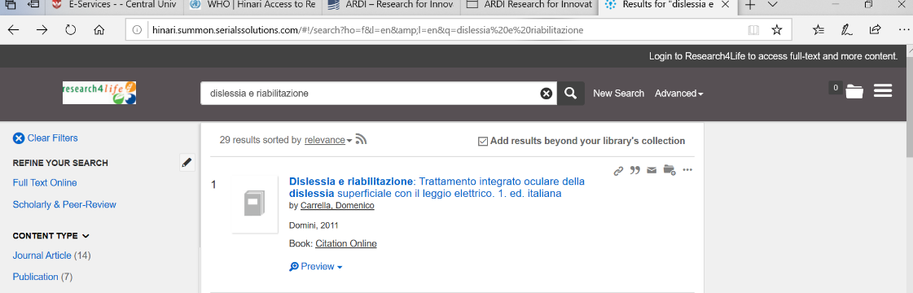](https://www.google.com/url?sa=t&rct=j&q=&esrc=s&source=web&cd=2&cad=rja&uact=8&ved=2ahUKEwjJ2sG359HoAhXyQEEAHcreApIQFjABegQIAxAB&url=https%3A%2F%2Fwww.wipo.int%2Ftisc%2Fen%2Fsearch%2Fdetails.jsp%3Fid%3D5757&usg=AOvVaw09Rb_5oY-xrNL8JIKvvgtV&cshid=1586107919737618)