**MACAU UNIVERSITY OF SCIENCE AND TECHNOLOGY,** [**Taipa, MACAU**](https://en.wikipedia.org/w/index.php?title=Taipa,_Macau&action=edit&redlink=1)

[Macau University of Science and Technology Library 澳門科技 ...](https://www.google.com/url?sa=t&rct=j&q=&esrc=s&source=web&cd=26&cad=rja&uact=8&ved=2ahUKEwijj-jWx_roAhWisKQKHV84De04ChAWMA96BAgIEAE&url=https%3A%2F%2Flibrarytechnology.org%2Flibrary%2F58219&usg=AOvVaw3lF21S6Oo7ilFRcdivRWDb)

[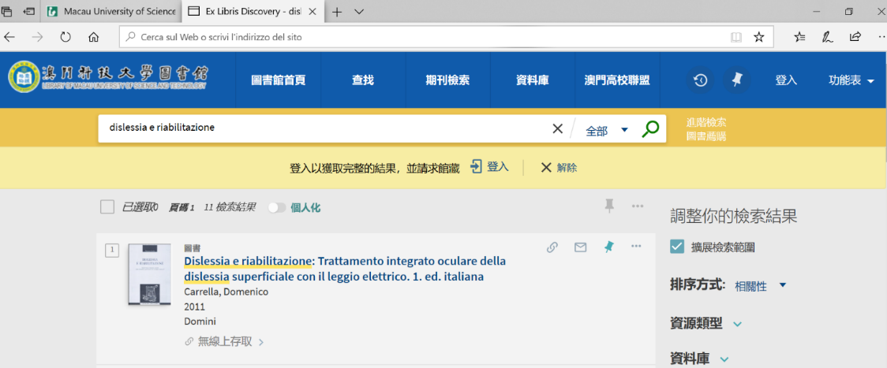](https://www.google.com/url?sa=t&rct=j&q=&esrc=s&source=web&cd=26&cad=rja&uact=8&ved=2ahUKEwijj-jWx_roAhWisKQKHV84De04ChAWMA96BAgIEAE&url=https%3A%2F%2Flibrarytechnology.org%2Flibrary%2F58219&usg=AOvVaw3lF21S6Oo7ilFRcdivRWDb)