### 1 [NATIONAL LIBRARY OF LATVIA](https://www.lnb.lv/en)

<https://primolatvija.hosted.exlibrisgroup.com/primo-explore/search?query=any,contains,dislessia%20e%20riabilitazione&tab=default_tab&search_scope=default_scope&vid=371>

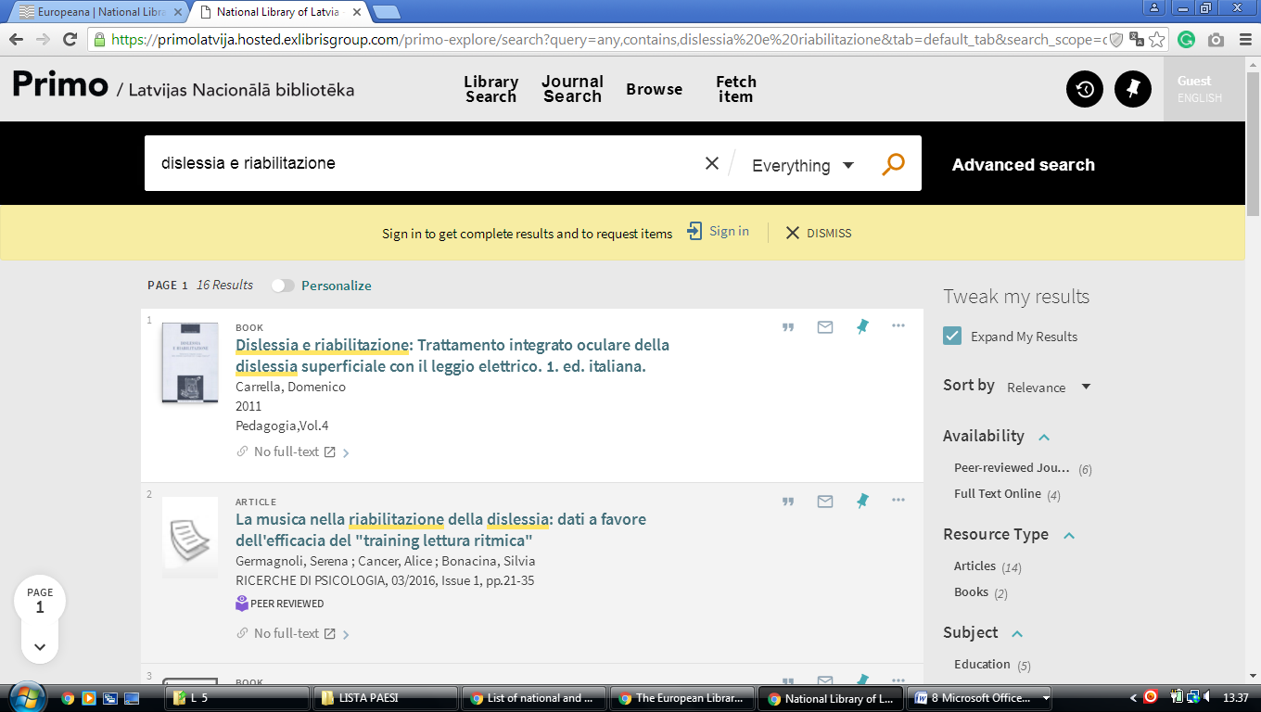

[**Libraries University of Latvia**](https://www.lu.lv/en/studies/libraries/)

<https://primolatvija.hosted.exlibrisgroup.com/primo-explore/search?query=any,contains,dislessia%20e%20riabilitazione&tab=default_tab&search_scope=default_scope&vid=371KISCLU_VU1&lang=en_US&offset=0&pcAvailability=true>

