**[1 LEBANESE AMERICAN UNIVERSITY](http://libraries.lau.edu.lb/index.php" \t "_blank" \o "Lebanese American University)**LIBRARY - (Beirut, Lebanon)

<http://lau.summon.serialssolutions.com/?#!/search?ho=f&l=en&q=DISLESSIA%20E%20RIABILITAZIONE>

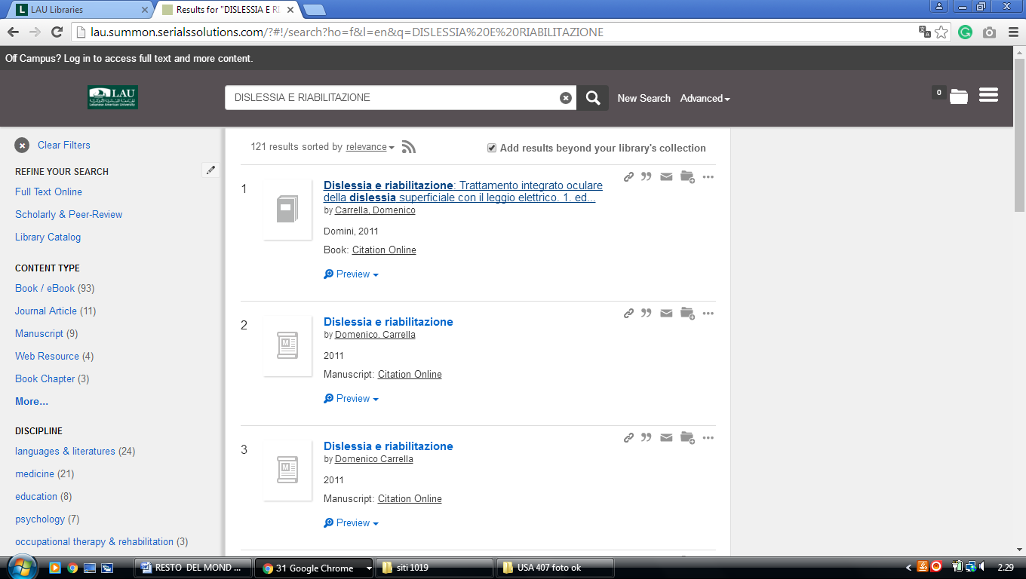-------------------------------------------------------------------------------------------------------------------------------

### 2 [AMERICAN UNIVERSITY OF BEIRUT - UNIVERSITY LIBRARIES - HOME](http://www.aub.edu.lb/ulibraries)

(Beirut, Lebanon)

<http://aub.summon.serialssolutions.com/#!/search?ho=f&fvf=ContentType,Book%20Review,t&l=en&q=(dislessia%20e%20riabilitazione)>

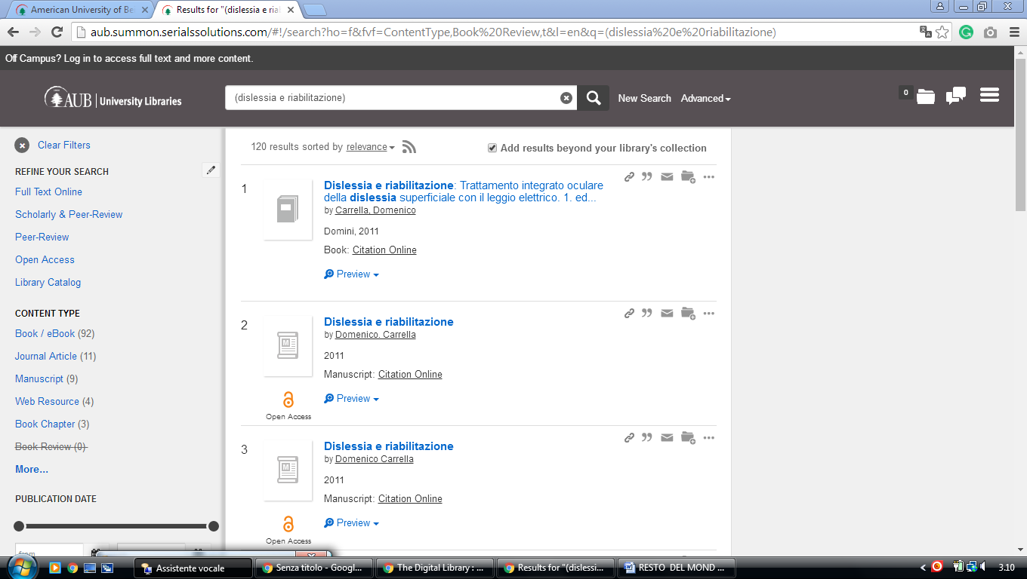

### 3 [LAU LIBRARIES](http://libraries.lau.edu.lb/index.php) - (Beirut and Byblos, Lebanon)

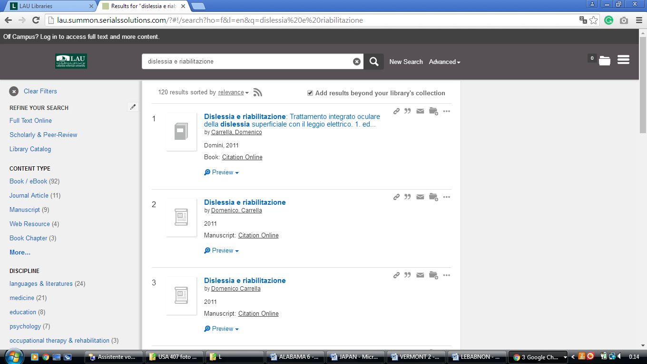<http://lau.summon.serialssolutions.com/?#!/search?ho=f&l=en&q=dislessia%20e%20riabilitazione>

**Lebanese American University, Beirut, Lebanon**

[LAU Libraries - Lebanese American University](https://www.google.com/url?sa=t&rct=j&q=&esrc=s&source=web&cd=1&cad=rja&uact=8&ved=2ahUKEwj03LPbqs3oAhVlmIsKHTmnBSQQFjAAegQIBxAB&url=http%3A%2F%2Flibraries.lau.edu.lb%2Findex.php&usg=AOvVaw0ePFYKYWZ8VWtf0Yn1Vp-A)

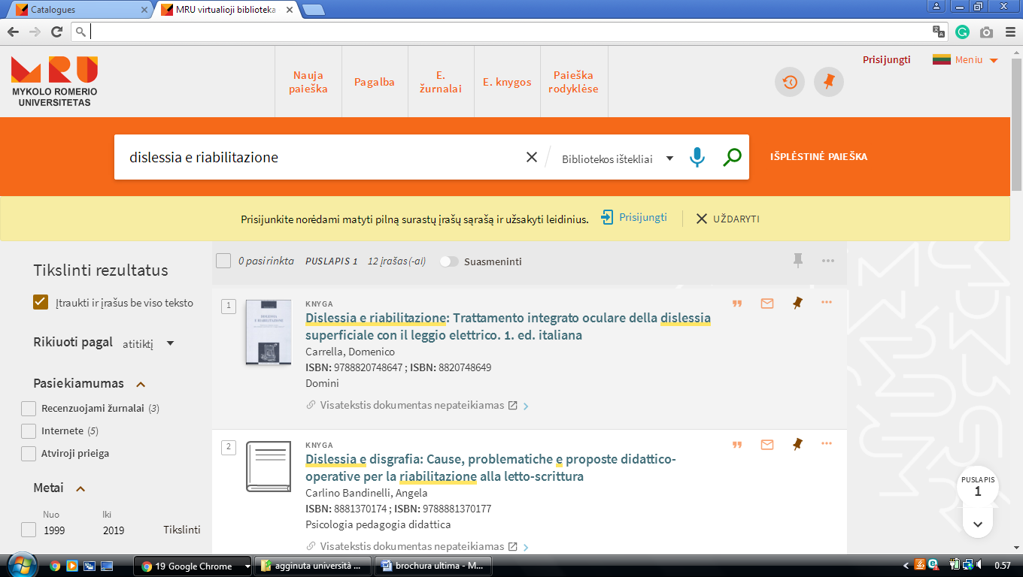

LEBANON

Issam Fares Library and Learning Center  
جامعة البلمند

**University of Balamand,** [**Koura**](https://librarytechnology.org/libraries/search.pl?City=Koura&Country=Lebanon), LEBANON

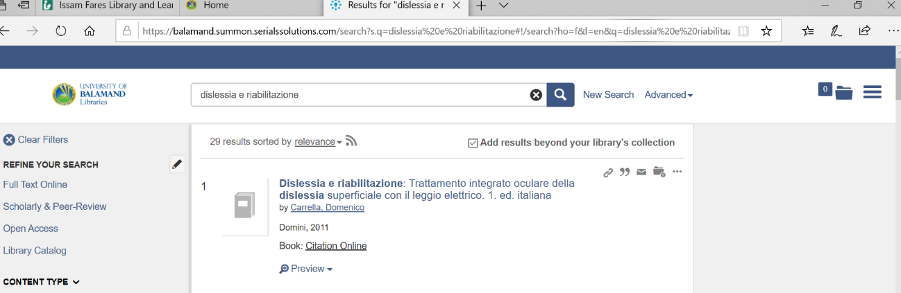https://balamand.summon.serialssolutions.com/search?s.q=dislessia%20e%20riabilitazione#!/search?ho=f&l=en&q=dislessia%20e%20riabilitazione