**[NATIONAL LIBRARY OF LAOS](http://www.nationallibraryoflaos.org/),** [**Vientiane**](https://en.wikipedia.org/wiki/Vientiane)**,** [**LAOS**](https://en.wikipedia.org/wiki/Laos)

[About Us - The National Library of Laos](https://www.google.com/url?sa=t&rct=j&q=&esrc=s&source=web&cd=3&cad=rja&uact=8&ved=2ahUKEwi5lpOcgtzoAhVWXRUIHQJTDr0QFjACegQICBAB&url=http%3A%2F%2Fnationallibraryoflaos.net%2Fen%2Fabout-us%2F&usg=AOvVaw3QRUBQX_hYLaLhxzY2H_dT&cshid=1586458549076682)

[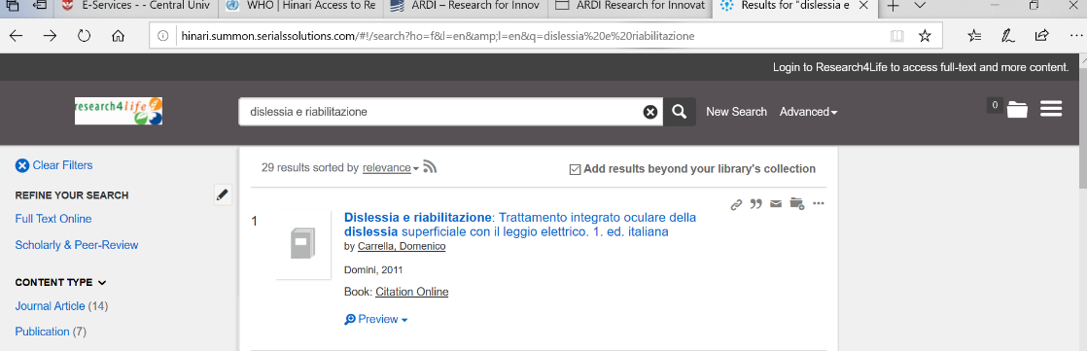](https://www.google.com/url?sa=t&rct=j&q=&esrc=s&source=web&cd=3&cad=rja&uact=8&ved=2ahUKEwi5lpOcgtzoAhVWXRUIHQJTDr0QFjACegQICBAB&url=http%3A%2F%2Fnationallibraryoflaos.net%2Fen%2Fabout-us%2F&usg=AOvVaw3QRUBQX_hYLaLhxzY2H_dT&cshid=1586458549076682)