**AMERICAN UNIVERSITY IN KYRGYZSTAN,** [**Bishkek**](https://en.wikipedia.org/wiki/Bishkek)**,** [**KYRGYZSTAN**](https://en.wikipedia.org/wiki/Kyrgyzstan)

[American University of Central Asia - Bishkek & Kyrgyzstan](https://www.google.com/url?sa=t&rct=j&q=&esrc=s&source=web&cd=2&cad=rja&uact=8&ved=2ahUKEwi2i-6A-9voAhWMG5oKHX4LASQQFjABegQIARAC&url=https%3A%2F%2Fwww.auca.kg%2Fen%2Fbishkek%2F&usg=AOvVaw0diFb2HgfSszooZHvf8J4r)

[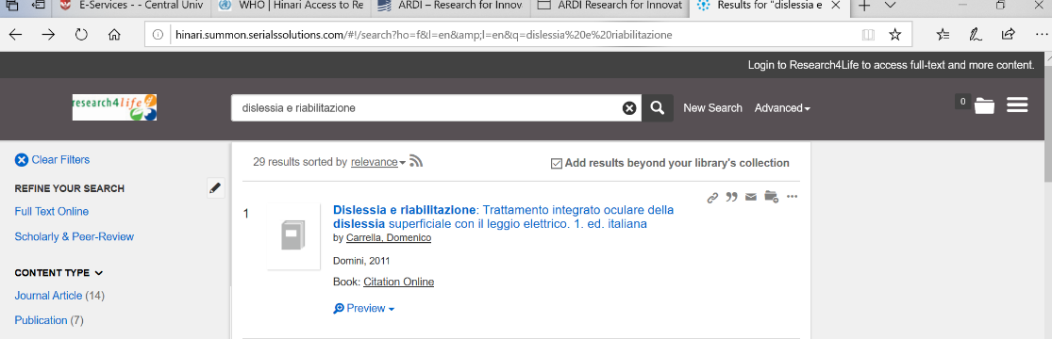](https://www.google.com/url?sa=t&rct=j&q=&esrc=s&source=web&cd=2&cad=rja&uact=8&ved=2ahUKEwi2i-6A-9voAhWMG5oKHX4LASQQFjABegQIARAC&url=https%3A%2F%2Fwww.auca.kg%2Fen%2Fbishkek%2F&usg=AOvVaw0diFb2HgfSszooZHvf8J4r)