**NAZARBAYEV UNIVERSITY, Nur-Sultan, KAZAKHSTAN**

[Nazarbayev University Library](https://www.google.com/url?sa=t&rct=j&q=&esrc=s&source=web&cd=1&cad=rja&uact=8&ved=2ahUKEwjk7dyco8zoAhWylYsKHdT1DooQtwIwAHoECAQQAQ&url=https%3A%2F%2Fnu.kz.libguides.com%2FEbscoDiscoverService&usg=AOvVaw0dulGmMNIyYfRCtT77jdMP)

[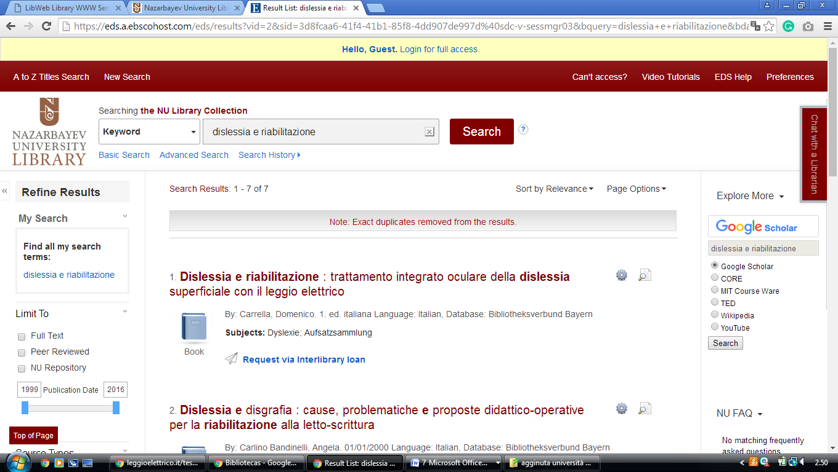](https://www.google.com/url?sa=t&rct=j&q=&esrc=s&source=web&cd=1&cad=rja&uact=8&ved=2ahUKEwjk7dyco8zoAhWylYsKHdT1DooQtwIwAHoECAQQAQ&url=https%3A%2F%2Fnu.kz.libguides.com%2FEbscoDiscoverService&usg=AOvVaw0dulGmMNIyYfRCtT77jdMP)

[**Nazarbayev University Library**](http://library.nu.edu.kz/wps/portal) **Astana, KAZAKHSTAN**

https://eds.a.ebscohost.com/eds/results?vid=2&sid=3d8fcaa6-41f4-41b1-85f8-4dd907de997d%40sdc-v-sessmgr03&bquery=dislessia+e+riabilitazione&bdata=JnR5cGU9MCZzZWFyY2hNb2RlPUFuZCZzaXRlPWVkcy1saXZl