### 1 [HOME - UCC LIBRARY HOME - UCC LIBRARY AT UNIVERSITY COLLEGE CORK](http://libguides.ucc.ie/) – (Irlanda)

<http://ucc.summon.serialssolutions.com/?q=dislessia+e+riabilitazione#!/search?ho=f&l=it-IT&q=dislessia%20e%20riabilitazione>

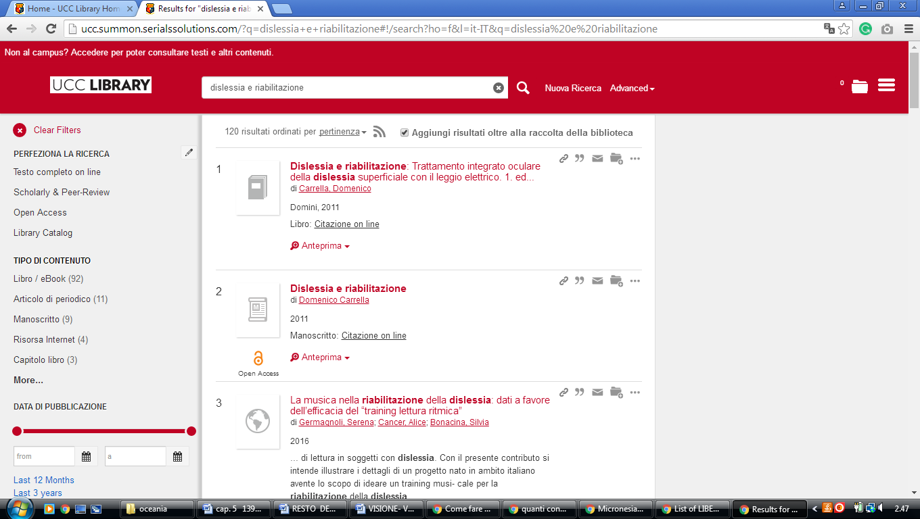

**2** [**CORK INSTITUTE OF TECHNOLOGY LIBRARY**](http://library.cit.ie/) – (Bishopstown, Ireland)

<https://cit.summon.serialssolutions.com/search?SORT=%2BZ&sortdropdown=-&searchlimits=&page=search&searchMethod=2&idx=kw&q=dislessia+e+riabilitazione#!/search?ho=f&l=en&SORT=%2BZ&sortdropdown=-&page=search&searchMethod=2&idx=kw&q=dislessia%20e%20riabilitazione>

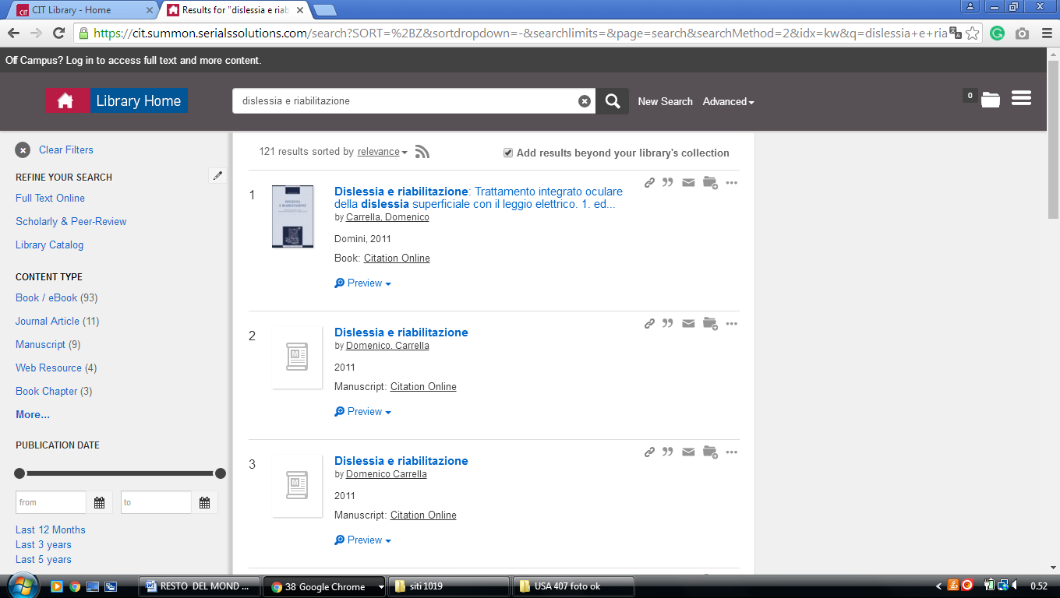

### 3 [LIBRARY | MAYNOOTH UNIVERSITY](https://www.maynoothuniversity.ie/library) – (Ireland)

<http://nuim.summon.serialssolutions.com/search?ho=t&keep_r=true&s.q=dislessia+e+riabilitazione&spellcheck=true#!/search?ho=f&l=en&q=dislessia%20e%20riabilitazione>

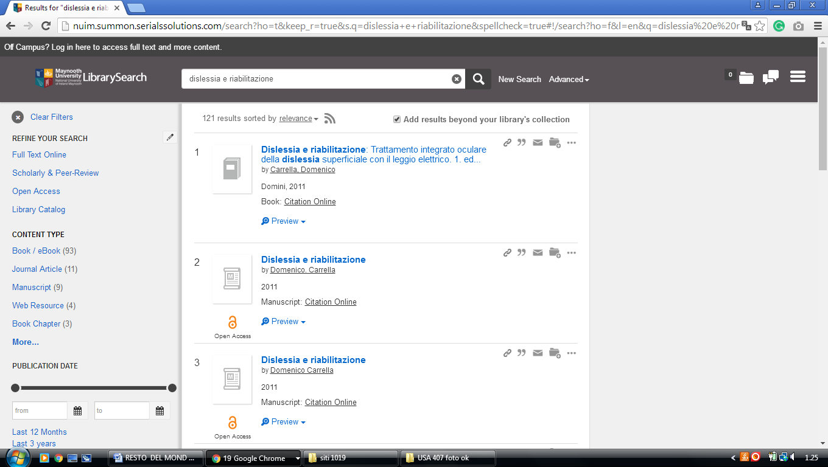

4 [**UCD LIBRARY**](http://www.ucd.ie/library/) – (Dublin, Ireland)

<http://ucd.summon.serialssolutions.com/?formids=target&lang=eng&suite=def&s.fvf%5B%5D=ContentType%2CBook+Review%2Ct&reservedids=lang%2Csuite&submitmode=&submitname=&s.q=dislessia+e+riabilitazione&button=#!/search?ho=f&fvf=ContentType,Book%20Review,t&l=en&q=dislessia%20e%20riabilitazione>

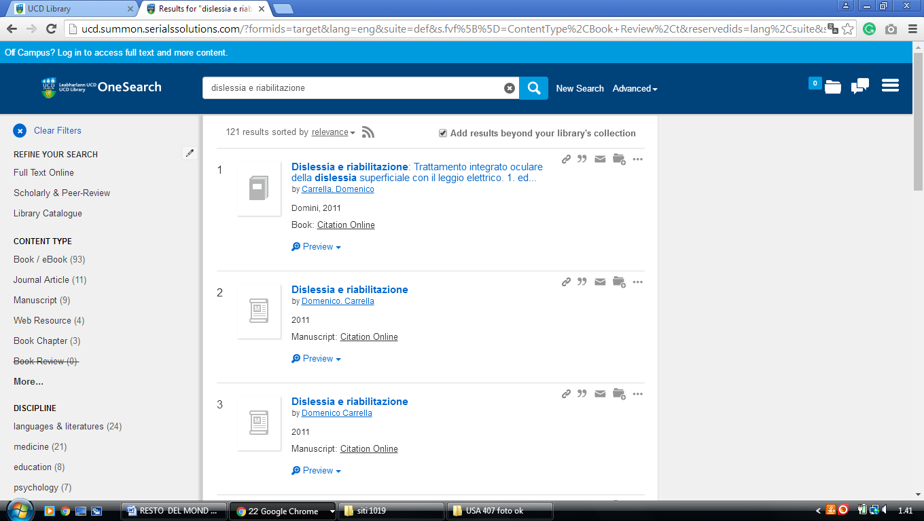

**5 LIBRARY UNIVERSITÀ OF LIMERICK – (**Limerick, Ireland)

<https://ul-ie-primo.hosted.exlibrisgroup.com/primo-explore/search?tab=tab1&search_scope=CSCOP_EVERYTHING&vid=353UOL_VU1&lang=en_US&offset=0&query=any,contains,DISLESSIA%20E%20RIABILITAZIONE&sortby=rank&pcAvailability=true>

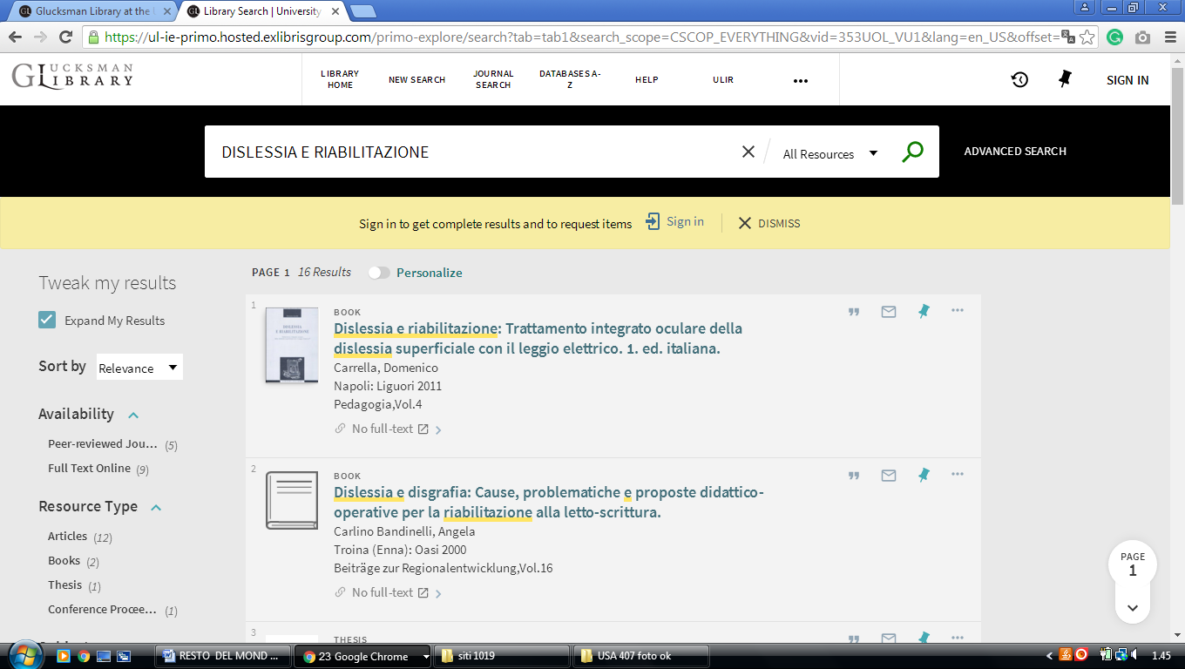

**6 LIBRARY** [**QUEEN’S UNIVERSITY OF BELFAST**](http://www.qub.ac.uk/directorates/InformationServices/TheLibrary/) – (Belfast, Northern Ireland)

<http://eds.a.ebscohost.com/eds/results?vid=0&sid=3ba45317-e1e7-4c67-baf4-22e3d4c8abc9%40sessionmgr4010&bquery=dislessia+e+riabilitazione&bdata=JmNsaTA9RlQmY2x2MD1ZJnR5cGU9MCZzaXRlPWVkcy1saXZlJnNjb3BlPXNpdGU%3d>

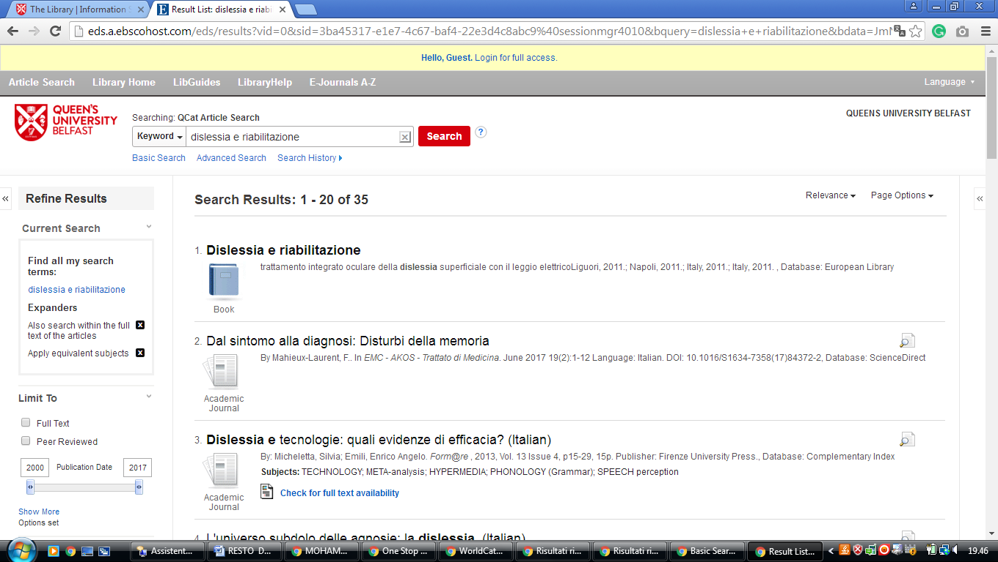

**7** [**TRINITY COLLEGE DUBLIN - THE EUROPEAN LIBRARY**](http://www.theeuropeanlibrary.org/tel4/contributor/P01382)- (Dublino, Ireland)

<http://www.theeuropeanlibrary.org/tel4/contributor/P01382>

<http://www.theeuropeanlibrary.org/tel4/search?query=dislessia%20e%20riabilitazione>

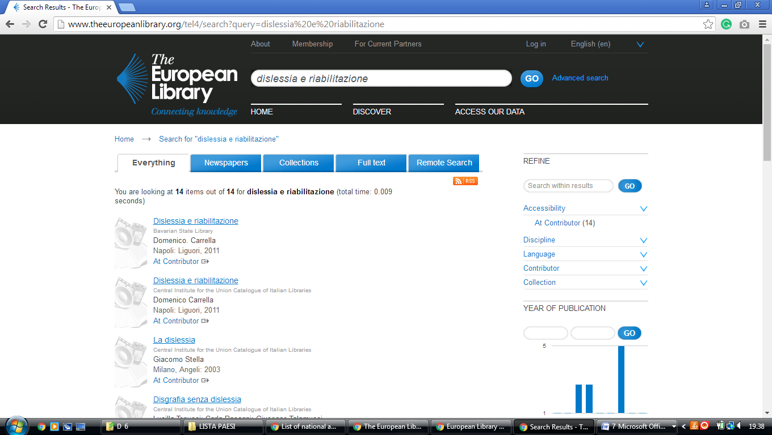

Glucksman Library **University of Limerick**

https://uol.primo.exlibrisgroup.com/discovery/search?query=any,contains,dislessia%20e%20riabilitazione&tab=TAB1&search_scope=MyInst_and_CI&vid=353UOL_INST:353UOL_VU1&lang=en&offset=0&pcAvailability=true

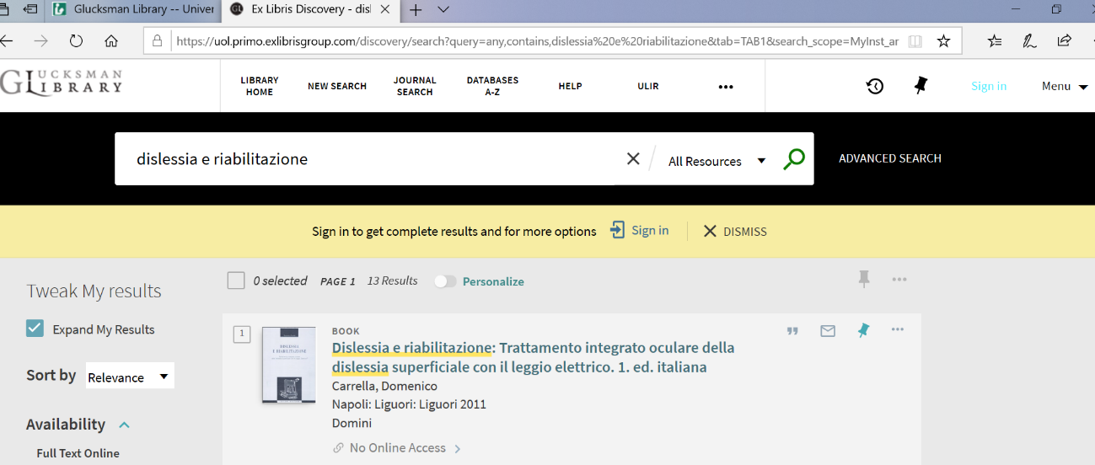

**Maynooth University Library** [**Kildare**](https://librarytechnology.org/libraries/search.pl?City=Kildare&Country=Ireland), **IRELAND**

Russell Library

nuim.summon.serialssolutions.com/search?spellcheck=true&keep_r=true&ho=t&s.q=dislessia+e+riabilitazione#!/search?ho=f&l=en&q=dislessia%20e%20riabilitazione

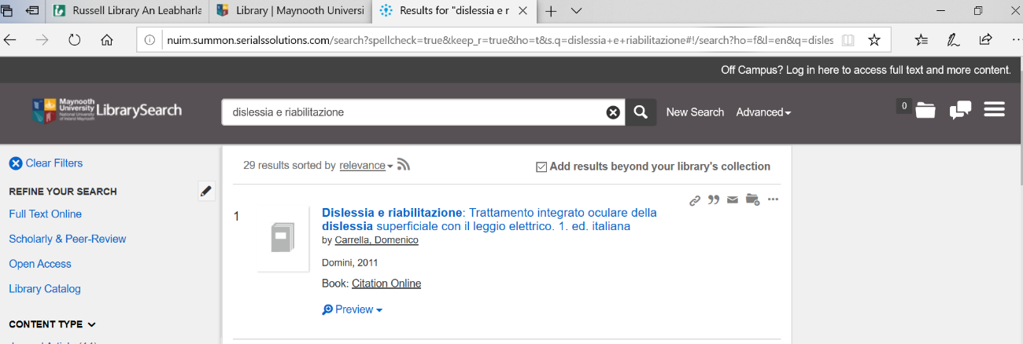

University College, Dublin Library

**University College, Dublin**

ucd.summon.serialssolutions.com/#!/search?ho=f&l=en&q=dislessia%20e%20riabilitazione

