**1 LIBRARY** [**HITOTSUBASHI UNIVERSITY**](http://www.lib.hit-u.ac.jp/) – (Tokyo, Japan)

<http://hit-u.summon.serialssolutions.com/search?q=dislessia%20e%20riabilitazione#!/search?ho=f&l=it-IT&q=dislessia%20e%20riabilitazione>

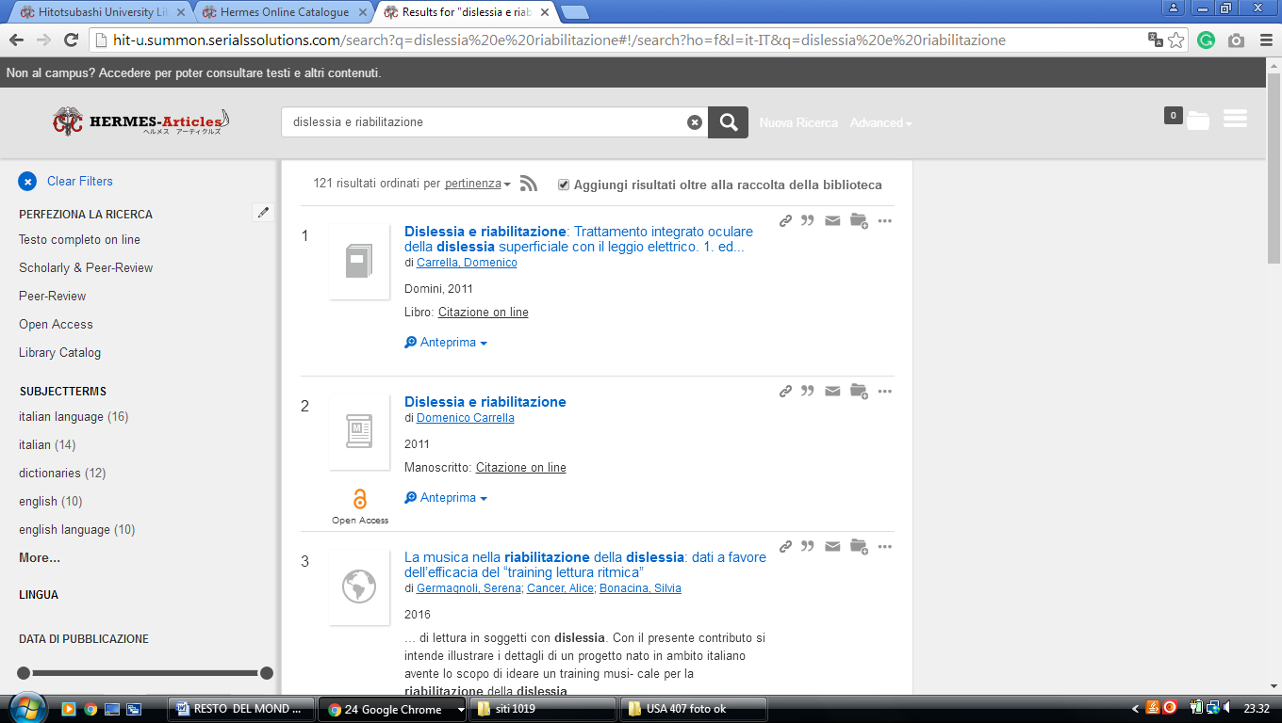

**2**  [**NAGOYA UNIVERSITY LIBRARY**](http://www.nul.nagoya-u.ac.jp/) - (Nagoya, Japan)

<http://nagoya.summon.serialssolutions.com/search?lang=ja&q=dislessia+e+riabilitazione#!/search?ho=f&l=jp&lang=ja&q=dislessia%20e%20riabilitazione>

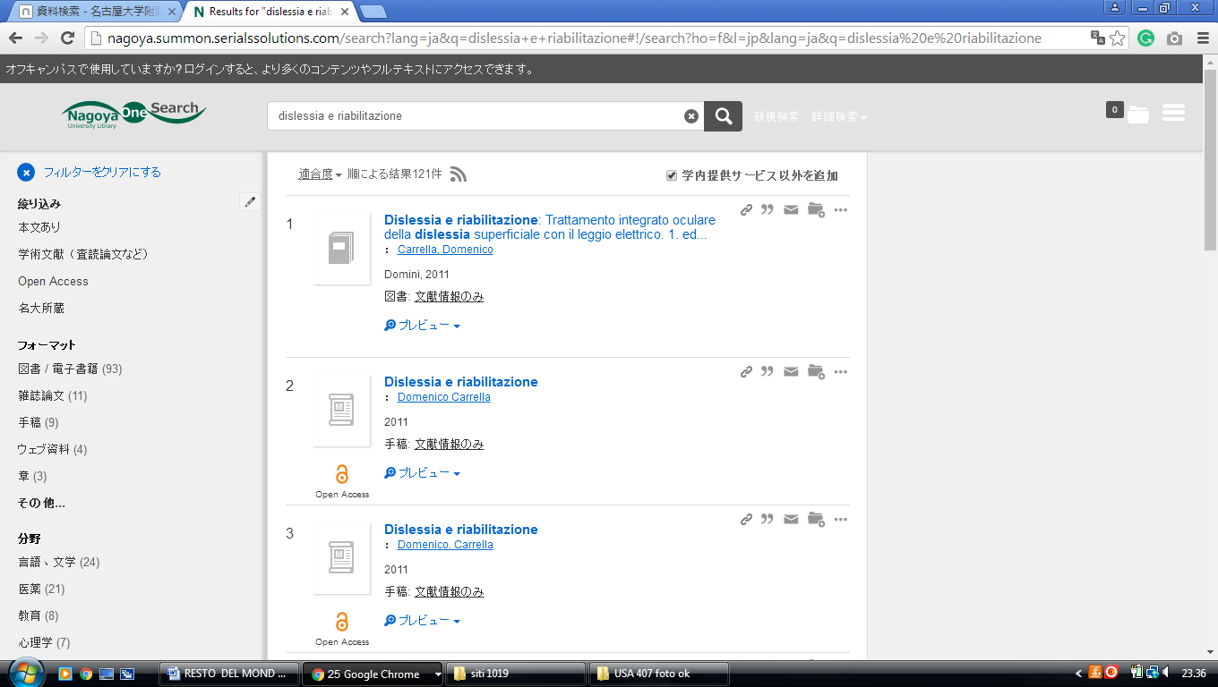

3 [**OSAKA UNIVERSITY LIBRARY**](http://www.library.osaka-u.ac.jp/) **- (**Osaka, Japan)

<https://eds.b.ebscohost.com/eds/detail/detail?vid=1&sid=0155acdb-e10e-4520-8d13-61598b76d542%40sessionmgr101&bdata=JnNpdGU9ZWRzLWxpdmU%3d#AN=edsfis.959441&db=edsfis>

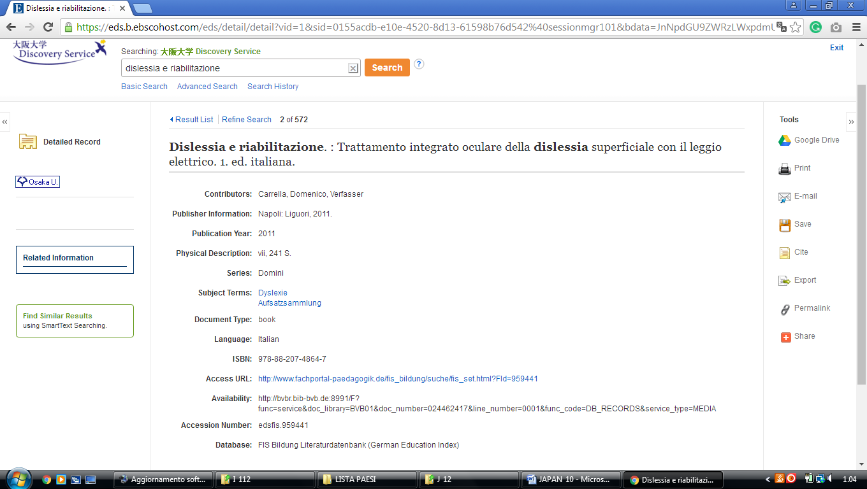

**4 TOKYO.SUMMON.SERIALSSOLUTIONS.COM – (**Library [University Of Tokyo](http://www.lib.u-tokyo.ac.jp/), Japan)

<http://tokyo.summon.serialssolutions.com/#!/search?ho=f&l=jp&q=dislessia%20e%20riabilitazione>

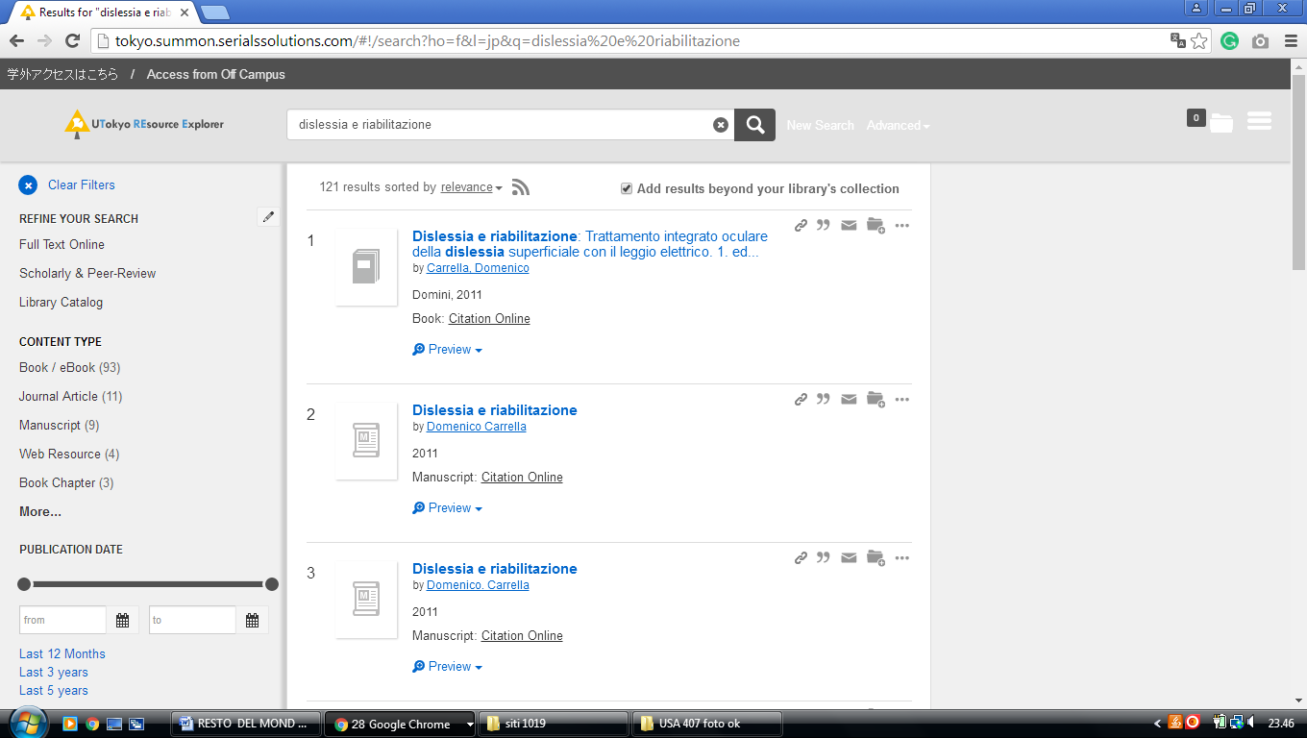

5 [**UNIVERSITY OF TOYAMA LIBRARY**](http://www.lib.u-toyama.ac.jp/) – (Toyama, Japan)

<https://calil.jp/search?q=DISLESSIA%20E%20RIABILITAZIONE>

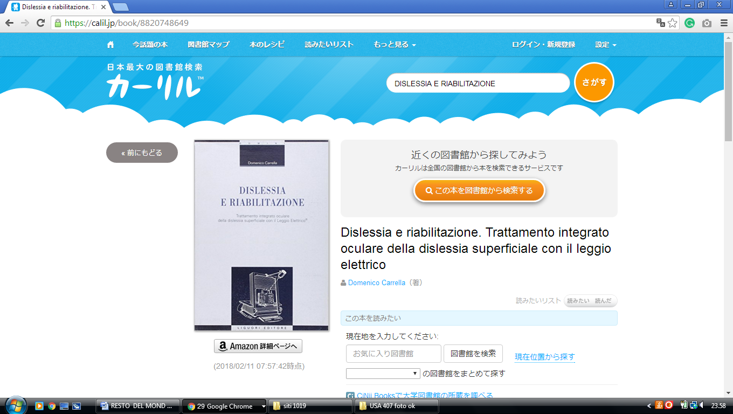

**6**  [**AZABU UNIVERSITY LIBRARY – (**](http://turf.azabu-u.ac.jp/) Japan)

<http://usaco.hosted.exlibrisgroup.com/primo_library/libweb/action/dlSearch.do?query=any%2Ccontains%2C+dislessia+e+riabilitazione&queryTemp=+dislessia+e+riabilitazione&institution=AZABU&vid=azabu&tab=default_tab&search_scope=default_scope&mode=Basic&displayMode=full&bulkSize=50&highlight=false&dum=true&displayField=all&pcAvailabiltyMode=true>

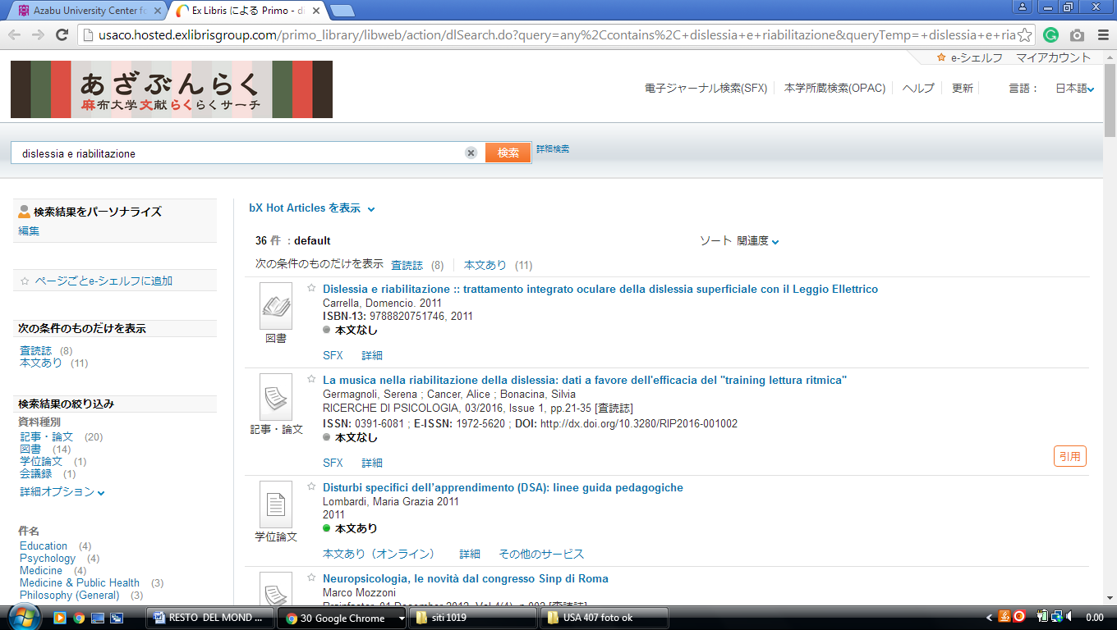

**7 BUKKYO.SUMMON.SERIALSSOLUTIONS.COM – (**Bukkyo University Library, (Japan)

<http://bukkyo.summon.serialssolutions.com/#!/search?ho=f&l=jp&q=dislessia%20e%20riabilitazione>

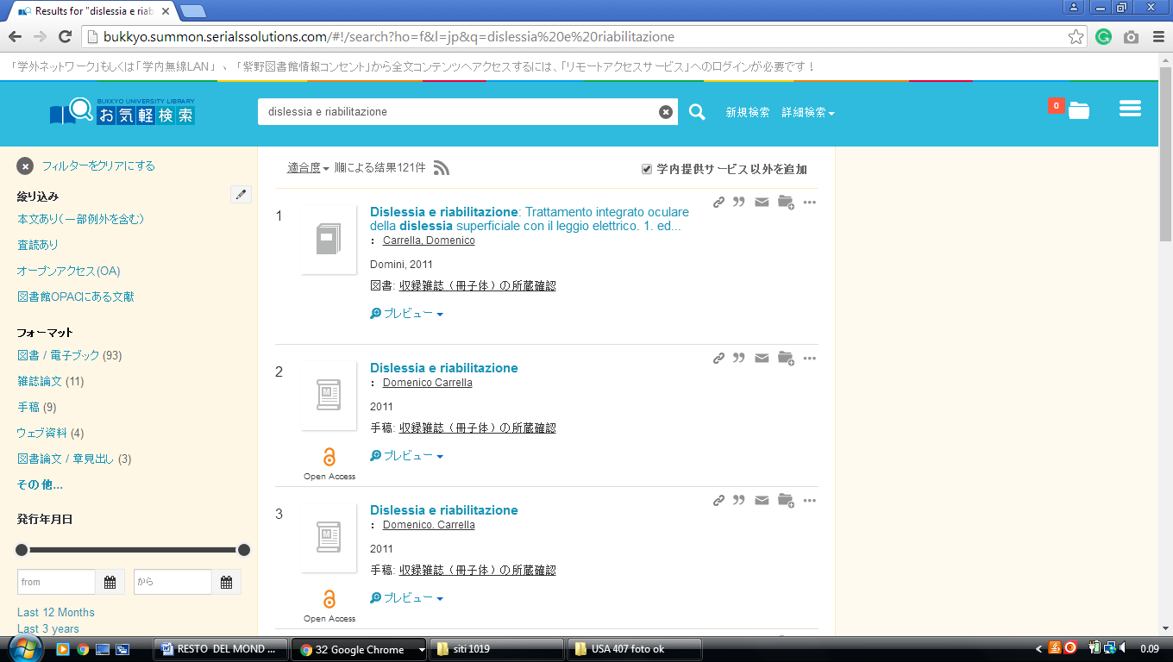

### 8 LIBRARY UNIVERSITY OF FUKUI - (Japan o [福井大学附属図書館: index](http://www.flib.u-fukui.ac.jp/))

<http://eds.a.ebscohost.com/eds/results?vid=0&sid=2e534f9a-2ad1-4215-a253-c4c39b800acc%40sessionmgr4009&bquery=dislessia+e+riabilitazione&bdata=Jmxhbmc9amEmdHlwZT0wJnNpdGU9ZWRzLWxpdmU%3d>

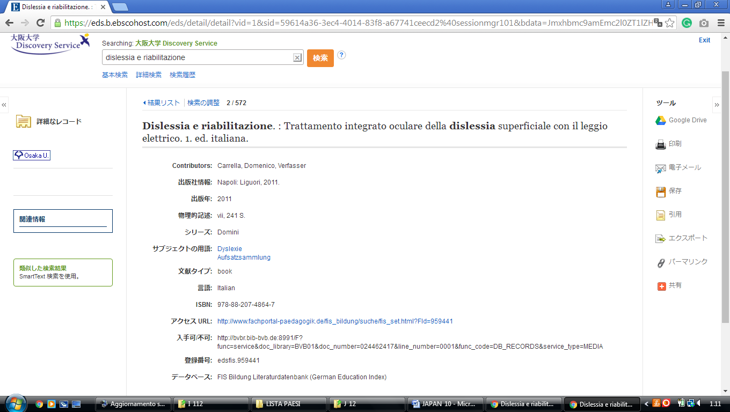

**9 LIBRARY UNIVERSITY KOBE -**  (Japan)

<http://usaco.hosted.exlibrisgroup.com/primo_library/libweb/action/search.do?ct=facet&pcAvailabiltyMode=true&pcAvailClicked=true&frbg=&&fn=search&indx=1&dscnt=0&scp.scps=scope%3A(KOBE_KERNEL)%2Cscope%3A(KOBE_OPAC)%2Cscope%3A(KOBE_SFX_JOURNAL)%2Cscope%3A(KOBE_SFX_BOOK)%2Cscope%3A(KOBE_EDMC)%2Cscope%3A(KOBE_NCC)%2Cscope%3A(KOBE_SUMIDA)%2Cscope%3A(KOBE_KAIKOU)%2Cscope%3A(KOBE_SHIBUYA)%2Cscope%3A(KOBE_KAKEN)%2Cscope%3A(KOBE_MONJO)%2Cprimo_central_multiple_fe&tb=t&mode=Basic&vid=kobe&ct=search&srt=rank&tab=all_tab&dum=true&vl(freeText0)=DISLESSIA%20E%20RIABILITAZIONE&dstmp=1518304971349>

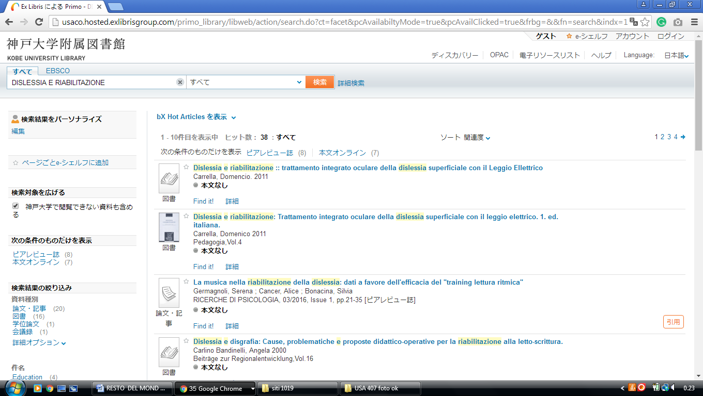

### 10 KOBE UNIVERSITY LIBRARY | 神戸大学附属図書, - Kōbe Daigaku - Università di Kobe

<http://usaco.hosted.exlibrisgroup.com/primo_library/libweb/action/search.do;jsessionid=6954358A200513A28F08182F2121AAAE?ct=facet&pcAvailabiltyMode=true&pcAvailClicked=true&frbg=&&fn=search&indx=1&dscnt=0&scp.scps=scope%3A(KOBE_KERNEL)%2Cscope%3A(KOBE_OPAC)%2Cscope%3A(KOBE_SFX_JOURNAL)%2Cscope%3A(KOBE_SFX_BOOK)%2Cscope%3A(KOBE_EDMC)%2Cscope%3A(KOBE_NCC)%2Cscope%3A(KOBE_SUMIDA)%2Cscope%3A(KOBE_KAIKOU)%2Cscope%3A(KOBE_SHIBUYA)%2Cscope%3A(KOBE_KAKEN)%2Cscope%3A(KOBE_MONJO)%2Cprimo_central_multiple_fe&tb=t&mode=Basic&vid=kobe&ct=search&srt=rank&tab=all_tab&dum=true&vl(freeText0)=dislessia%20e%20riabilitazione&dstmp=1520114635421>

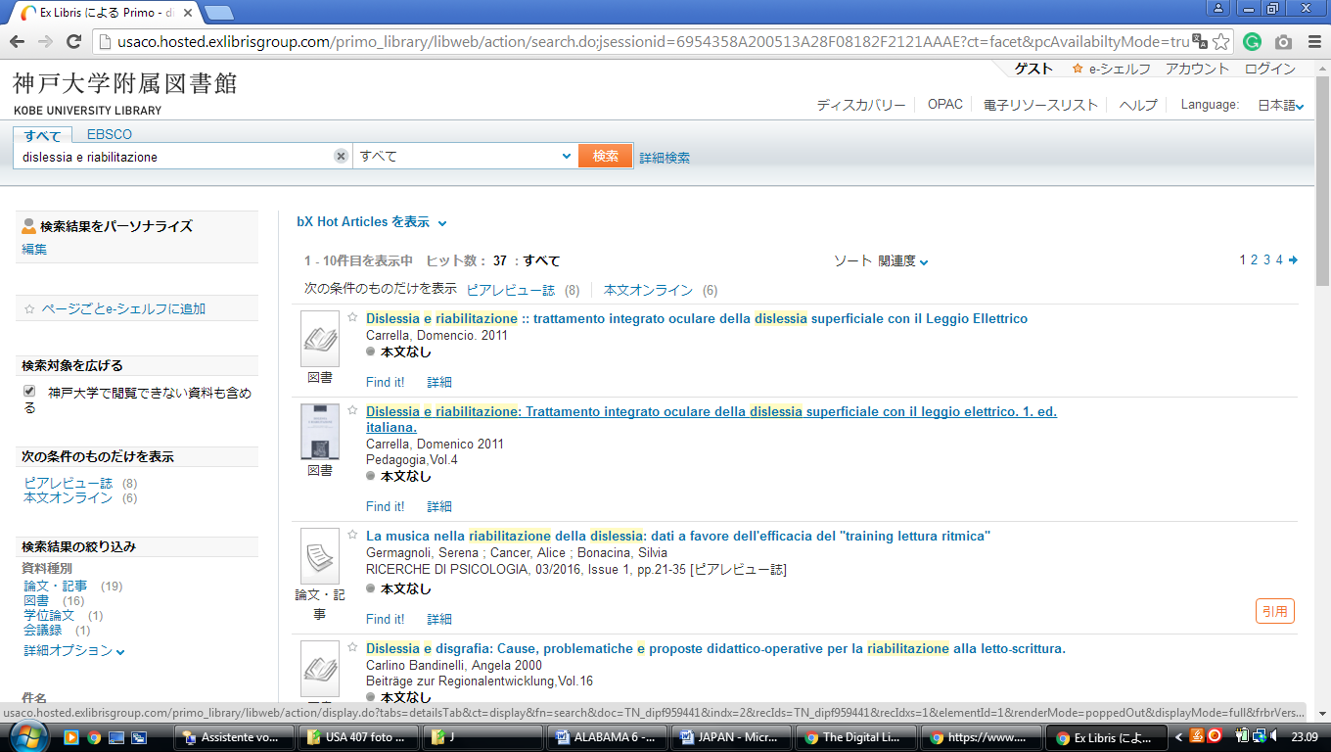

11 [LIBRARY | INTERNATIONAL UNIVERSITY OF JAPAN](http://www.iuj.ac.jp/library/) – ([Minamiuonuma](https://en.wikipedia.org/wiki/Minamiuonuma" \o "Minamiuonuma), [Niigata Prefecture](https://en.wikipedia.org/wiki/Niigata_Prefecture), Japan)

<http://iuj.summon.serialssolutions.com/?q=dislessia+e+riabilitazione#!/search?ho=f&l=en&q=dislessia%20e%20riabilitazione>

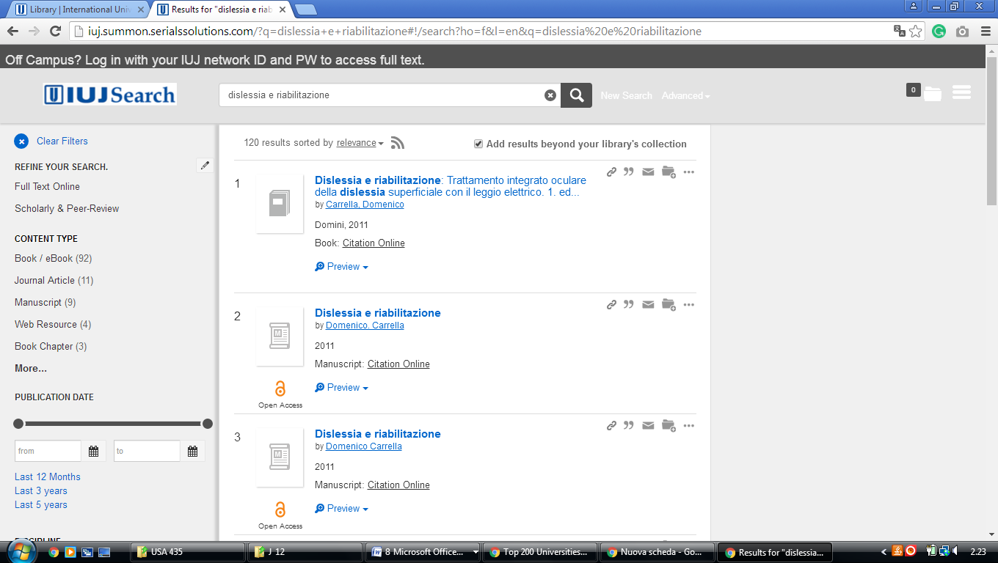

**Waseda University Library**

<https://waseda.primo.exlibrisgroup.com/discovery/search?vid=81SOKEI_WUNI:WINE&tab=Everything&search_scope=MyInst_and_CI&mode=basic&lang=en&displayMode=full&bulkSize=10&highlight=true&dum=true&query=any,contains,dislessia%20e%20riabilitazione&displayField=all&pcAvailabiltyMode=true&q=dislessia%20e%20riabilitazione>

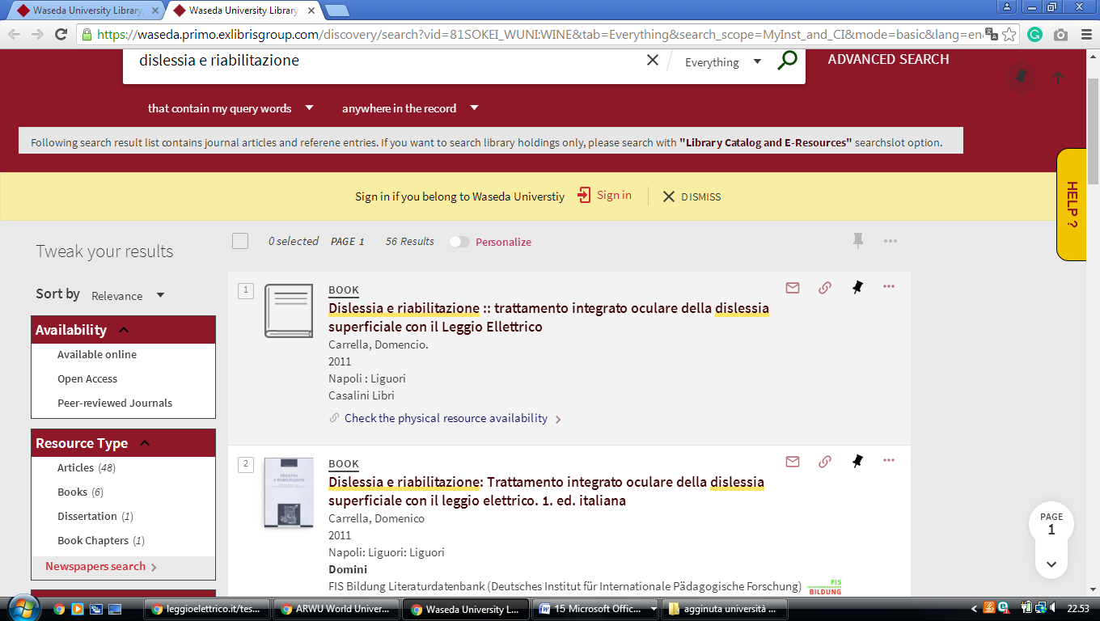

### Keio University Media Center

https://search.lib.keio.ac.jp/discovery/search?query=any,contains,%20dislessia%20e%20riabilitazione&tab=CentralIndex&search_scope=CentralIndex&vid=81SOKEI_KEIO:KEIO&lang=en&offset=0

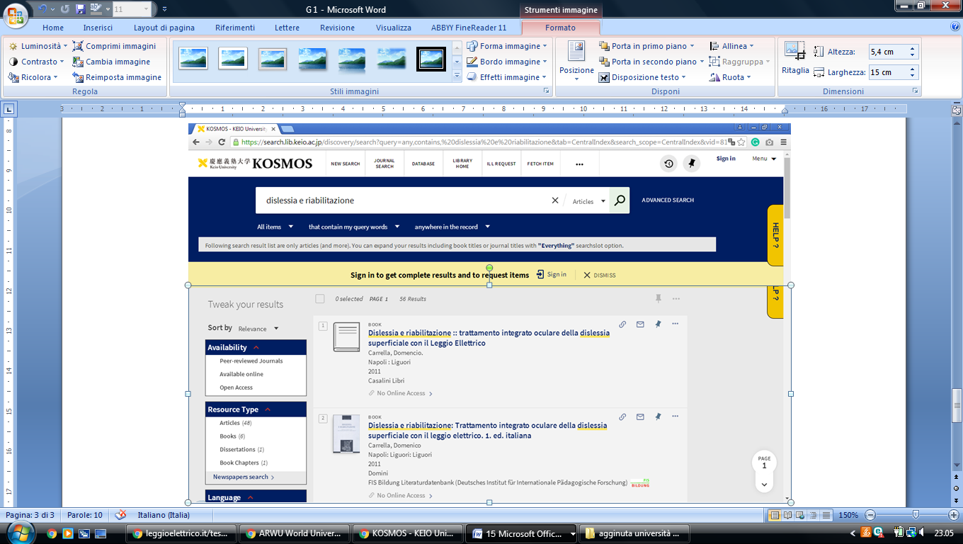

法政大学図書館 HOSEI UNIVERSITY Librar ok

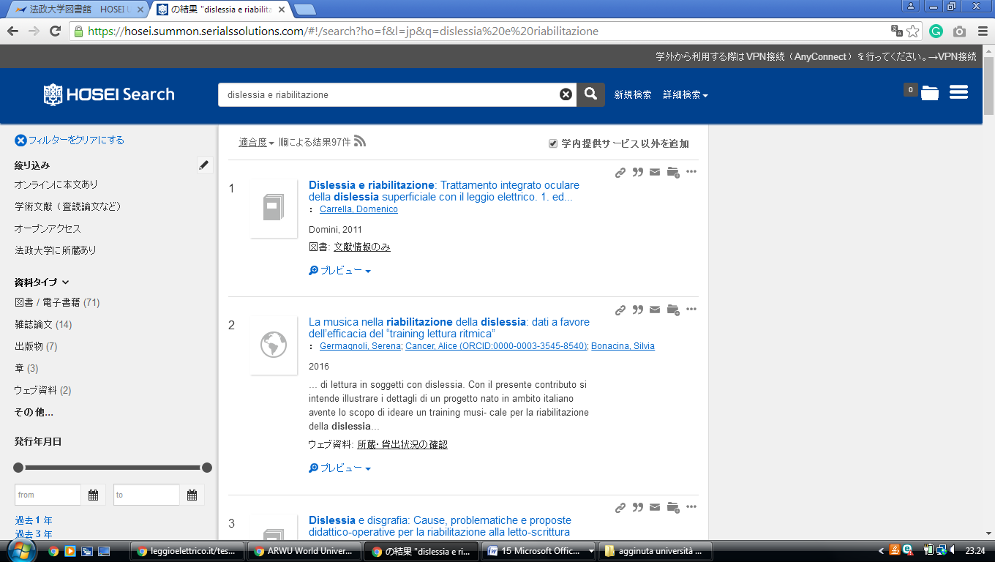https://hosei.summon.serialssolutions.com/#!/search?ho=f&l=jp&q=dislessia%20e%20riabilitazione

[Doshisha University Library ok](https://library.doshisha.ac.jp/en/)

http://doshisha.summon.serialssolutions.com/en/#!/search?ho=f&l=en&q=dislessia%20e%20riabilitazione

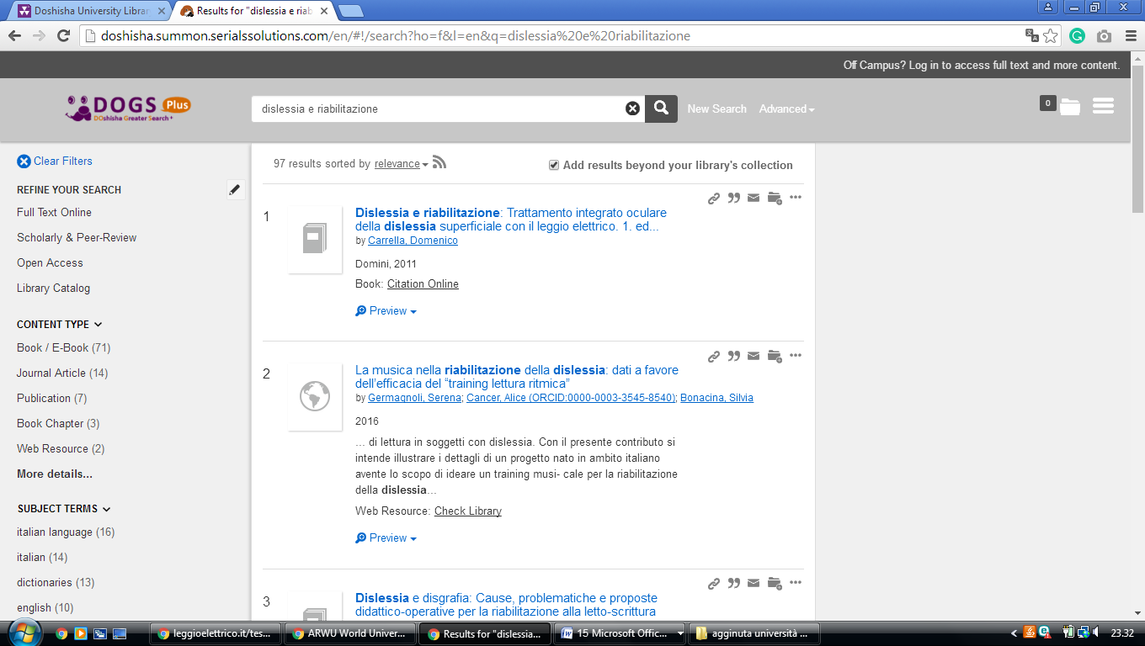

### [RITSUMEIKAN UNIVERSITY LIBRARY ok](http://www.ritsumei.ac.jp/library/eng/)

http://eds.a.ebscohost.com/eds/results?vid=0&sid=703eb122-c6ef-4a82-bd57-ccbe1c0ec1a3%40sessionmgr4007&bquery=dislessia%2Be%2Briabilitazione&bdata=JnR5cGU9MCZzZWFyY2hNb2RlPUFuZCZzaXRlPWVkcy1saXZl

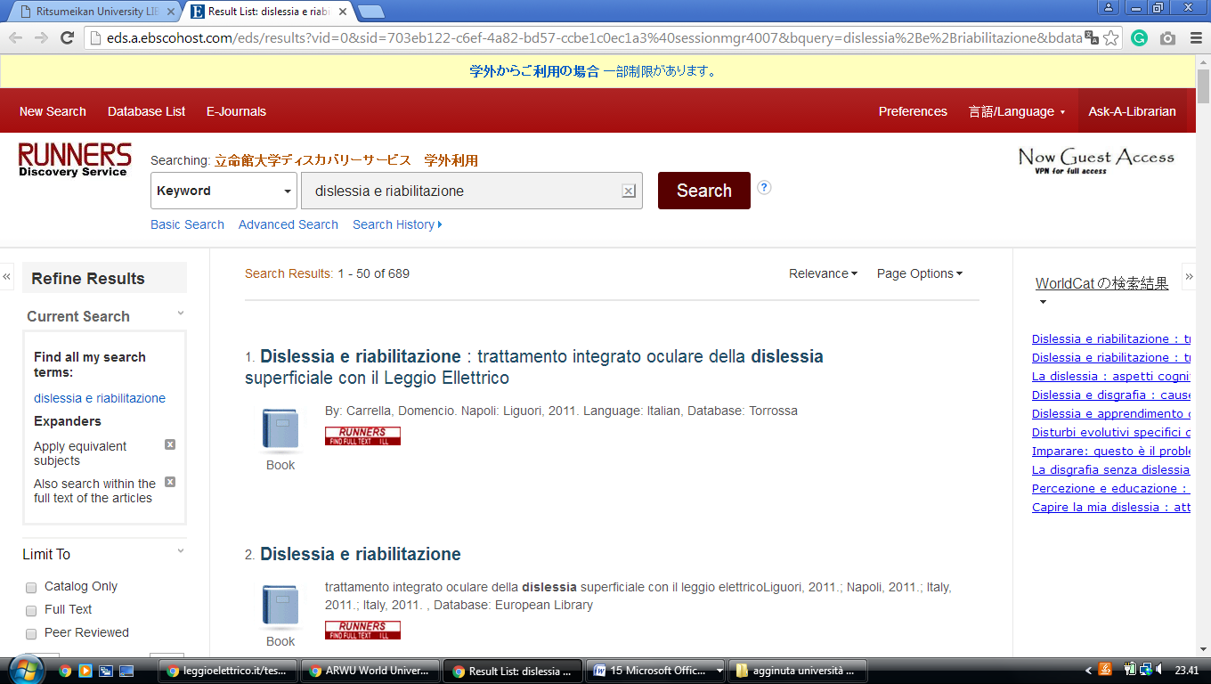

[**Kyoto University Library - 京都大学図書館機構**](https://www.kulib.kyoto-u.ac.jp/mainlib/en/)

http://kyoto.summon.serialssolutions.com/en/search?l=en&q=dislessia%20e%20riabilitazione#!/search?ho=f&l=en&q=dislessia%20e%20riabilitazione

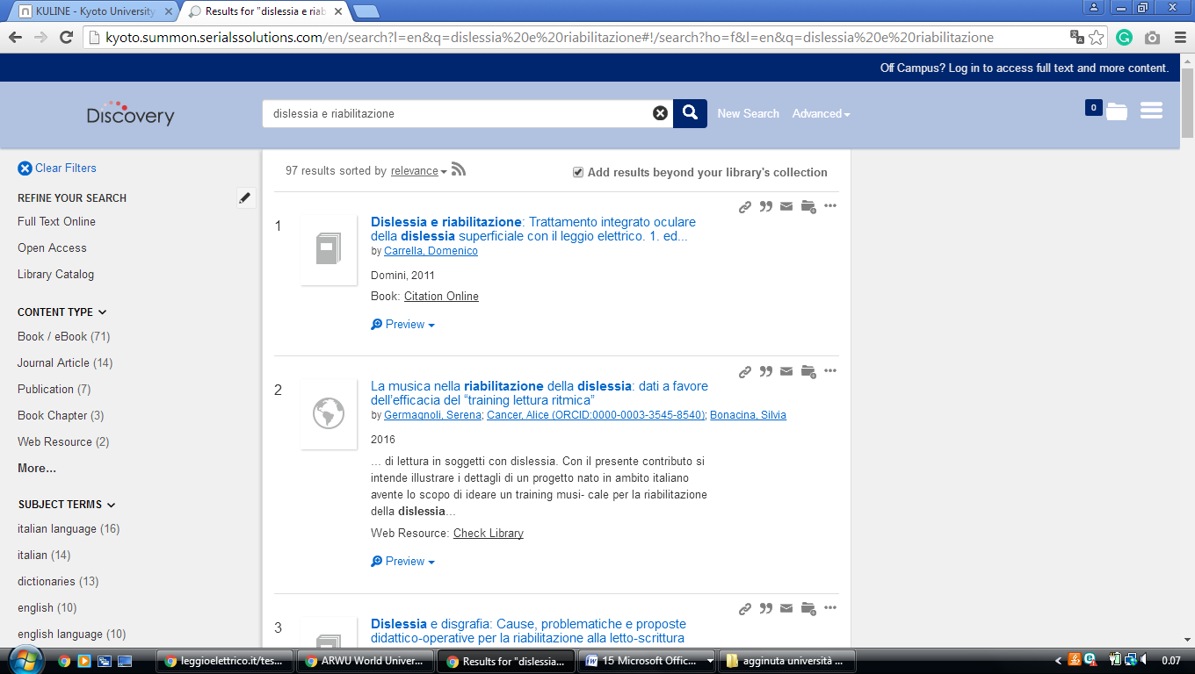

Kanagawa University Library

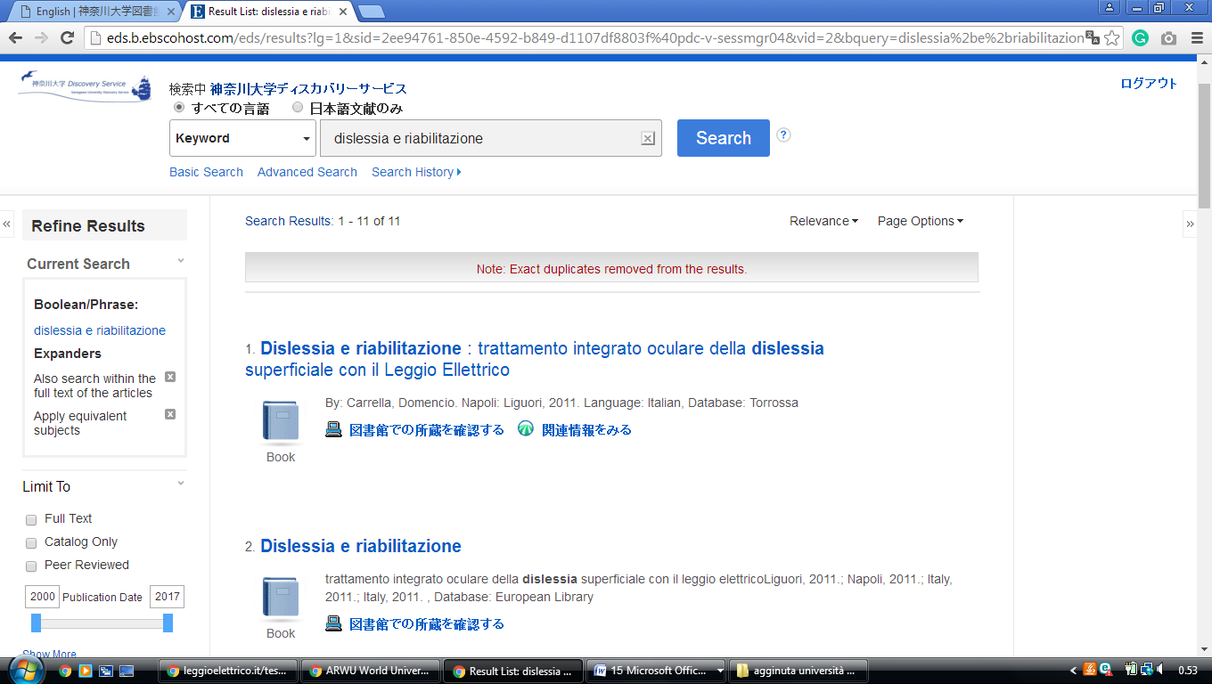<http://eds.b.ebscohost.com/eds/results?lg=1&sid=2ee94761-850e-4592-b849-d1107df8803f%40pdc-v-sessmgr04&vid=2&bquery=dislessia%2be%2briabilitazione&bdata=Jmxhbmc9amEmdHlwZT0wJnNlYXJjaE1vZGU9U3RhbmRhcmQmc2l0ZT1lZHMtbGl2ZQ%253d%253d&bquery=dislessia+e+riabilitazione&bdata=JnR5cGU9MCZzZWFyY2hNb2RlPVN0YW5kYXJkJnNpdGU9ZWRzLWxpdmU%3d>