**[FACULTY OF LAW, UNIVERSITY OF GHANA](https://www.wipo.int/library/en/contact.jsp?dir_id=2588)**

[Contact Information: Faculty of Law, University of Ghana - WIPO](https://www.google.com/url?sa=t&rct=j&q=&esrc=s&source=web&cd=14&cad=rja&uact=8&ved=2ahUKEwiz--2u3NHoAhVmwMQBHcboCec4ChAWMAN6BAgCEAE&url=https%3A%2F%2Fwww.wipo.int%2Flibrary%2Fen%2Fcontact.jsp%3Fdir_id%3D2588&usg=AOvVaw3sA5WtJkx-yVFjrB9Q-Zi8&cshid=1586104781439866)

[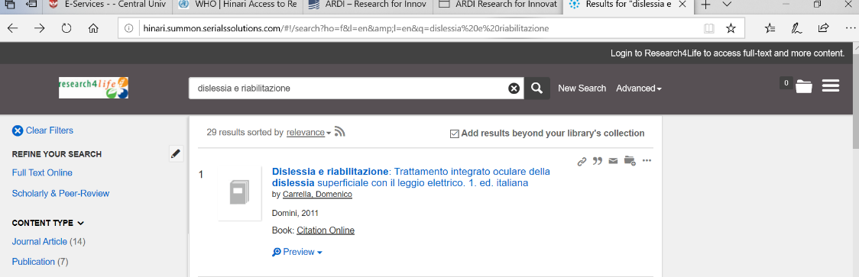](https://www.google.com/url?sa=t&rct=j&q=&esrc=s&source=web&cd=14&cad=rja&uact=8&ved=2ahUKEwiz--2u3NHoAhVmwMQBHcboCec4ChAWMAN6BAgCEAE&url=https%3A%2F%2Fwww.wipo.int%2Flibrary%2Fen%2Fcontact.jsp%3Fdir_id%3D2588&usg=AOvVaw3sA5WtJkx-yVFjrB9Q-Zi8&cshid=1586104781439866)