1 [**SWANSEA UNIVERSITY LIBRARIES**](http://www.swansea.ac.uk/iss/libraries/) - (Swansea, Galles)

<http://whel-primo.hosted.exlibrisgroup.com/primo_library/libweb/action/search.do?ct=facet&pcAvailabiltyMode=true&pcAvailClicked=true&submit=Find&vl(119149442UI0)=any&query=any%2Ccontains%2C%20dislessia%20e%20riabilitazione&indx=1&fn=search&query_store=%20dislessia%20e%20riabilitazione&dscnt=0&search_scope=LSCOP_EVERYTHING&scp.scps=scope%3A(44WHELF_SWA)%2Cprimo_central_multiple_fe%2C44WHELF_SWA_Ebsco&vid=44WHELF_SWA_VU1&ct=search&institution=44WHELF_SWA&bulkSize=10&tab=tab4&prefLang=en_US&sortField=&vl(freeText0)=%20dislessia%20e%20riabilitazione&dstmp=1518283514181&fromDL>

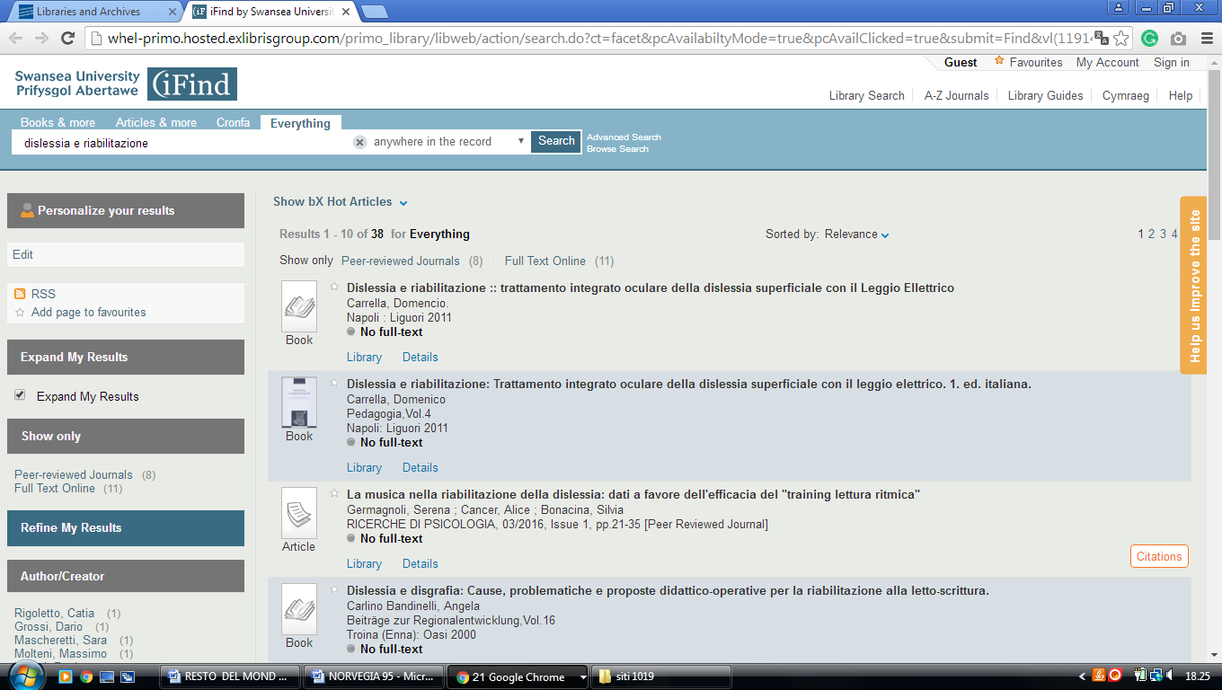

**2**  [**WELCOME TO THE LIBRARY AND ARCHIVES - BANGOR UNIVERSITY**](https://www.bangor.ac.uk/library/) **– (**[County](https://en.wikipedia.org/wiki/County#United_Kingdom) Of [Gwynedd](https://en.wikipedia.org/wiki/Gwynedd), [North](https://en.wikipedia.org/wiki/North_Wales) [Wales](https://en.wikipedia.org/wiki/Wales))

<https://whel-primo.hosted.exlibrisgroup.com/primo_library/libweb/action/search.do?ct=facet&pcAvailabiltyMode=true&pcAvailClicked=true&submit=Search&query=any%2Ccontains%2Cdislessia%20e%20riabilitazione&fn=search&indx=1&search_scope=CSCOP_EVERYTHING&dscnt=0&scp.scps=scope%3A(44WHELF_BANG)%2C44WHELF_BANG_Ebsco%2Cprimo_central_multiple_fe&onCampus=false&vid=44WHELF_BANG_VU2&institution=44WHELF_BANG&bulkSize=10&ct=search&highlig>

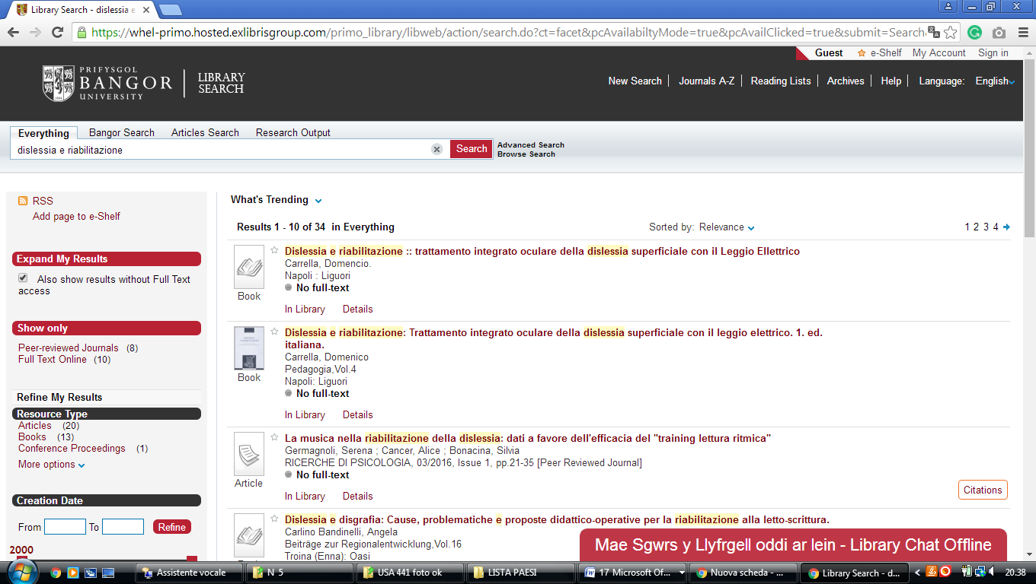

[**Aberystwyth**](https://it.wikipedia.org/wiki/Aberystwyth)**, Galles**

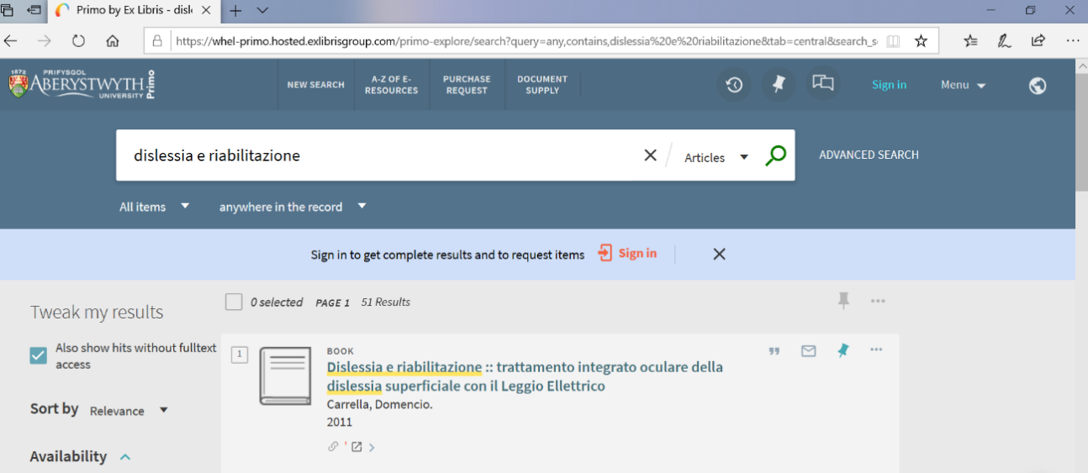<https://whel-primo.hosted.exlibrisgroup.com/primo-explore/search?query=any,contains,dislessia%20e%20riabilitazione&tab=central&search_scope=Primo_Central&vid=44WHELF_ABW_VU1&lang=en_US&offset=0&pcAvailability=true>