**1** [**UNIVERSITY OF EVRY VAL D’ESSONNE**](http://www.biblio.univ-evry.fr/) **LIBRARY –** (Evry, France)

<https://focus.universite-paris-saclay.fr/primo-explore/search?tab=default_tab&search_scope=default_scope&vid=33PUP_VU1&lang=fr_FR&query=any,contains,dislessia%20e%20riabilitazione&sortby=rank&pcAvailability=true>

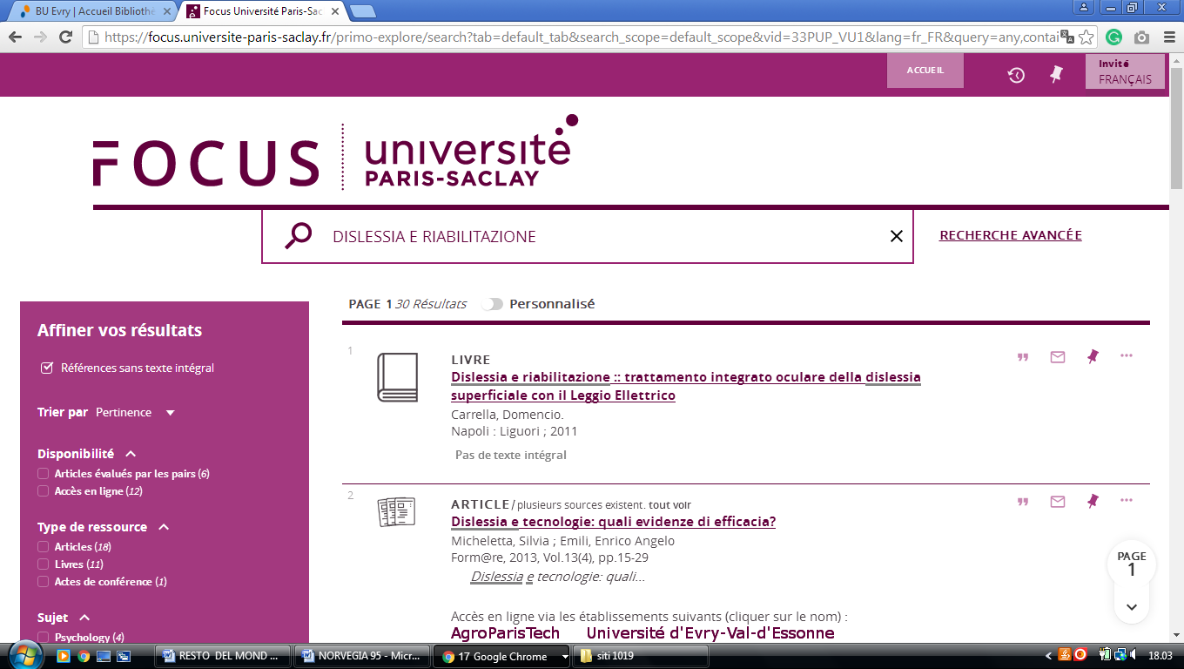

**2 UNILIM.SUMMON.SERIALSSOLUTIONS.COM – (**Universite De Limoges, France)

<http://unilim.summon.serialssolutions.com/?#!/search?ho=f&l=it-IT&q=DISLESSIA%20E%20RIABILITAZIONE>

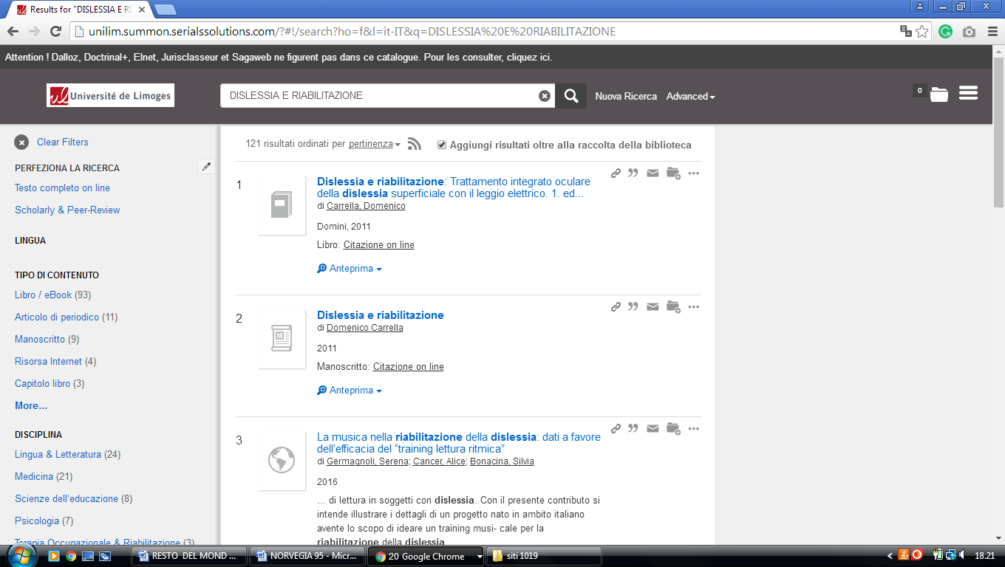

### 3 [CATALOGUES - BU LYON-3](http://bu.univ-lyon3.fr/catalogues-31150.kjsp) - ( Lyon, France)

<http://lyon3.summon.serialssolutions.com/?q=dislessia+e+riabilitazione#!/search?ho=f&l=it-IT&q=dislessia%20e%20riabilitazione>

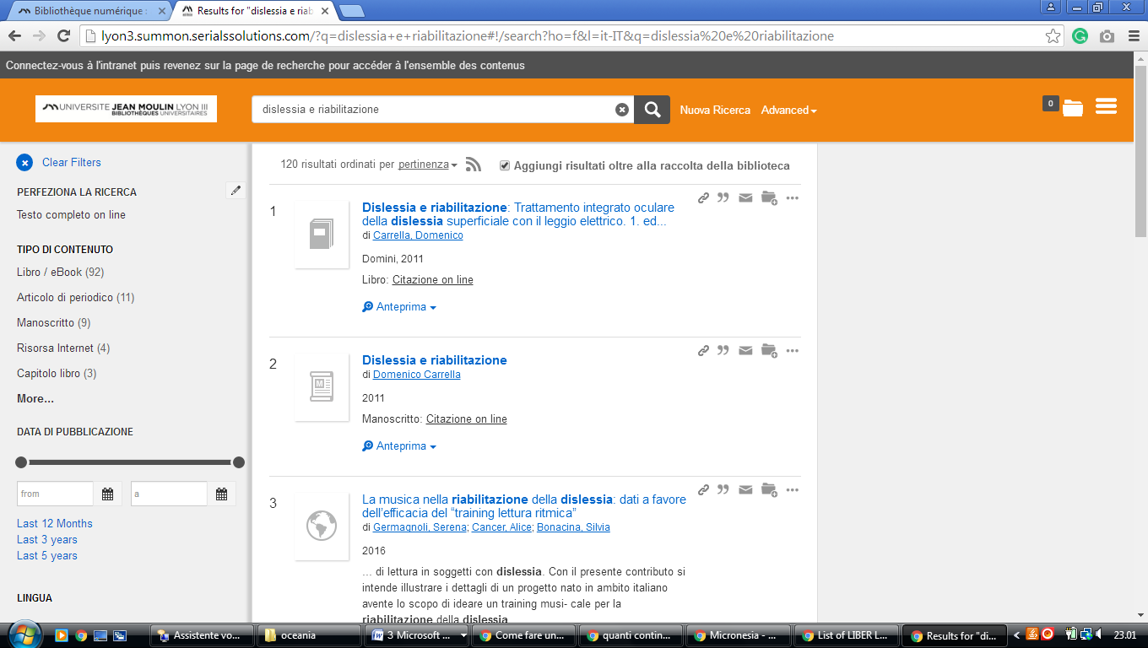

### 4 [UNIVERSITÉ LYON 2 - BIBLIOTHÈQUES](https://www.univ-lyon2.fr/bibliotheques/) – (Francia)

[https://lyon2.summon.serialssolutions.com/search?q=dislessia+e+riabilitazione#!/search?ho=f&l=it-IT&q=dislessia%20e%20riabilitazione](https://lyon2.summon.serialssolutions.com/search?q=dislessia+e+riabilitazione" \l "!/search?ho=f&l=it-IT&q=dislessia%20e%20riabilitazione)

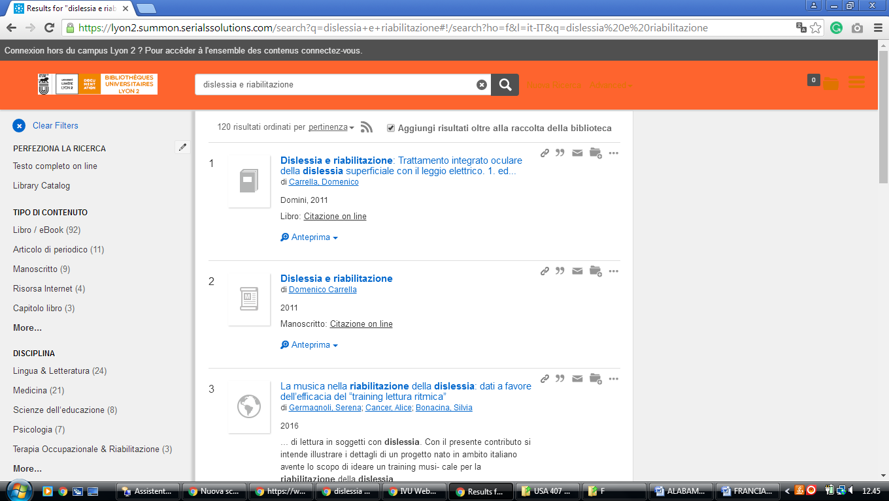

### 5 [HEC PARIS BIBLIOTHÈQUE](http://www.hec.fr/Bibliotheque) - (Parigi, Francia)

<http://eds.a.ebscohost.com/eds/results?vid=1&sid=bbff9dfd-c371-4ec1-945c-5f61c1d6504a%40sessionmgr4006&bquery=(dislessia+AND+e+AND+riabilitazione)&bdata=JnR5cGU9MCZzaXRlPWVkcy1saXZlJnNjb3BlPXNpdGU%3d>

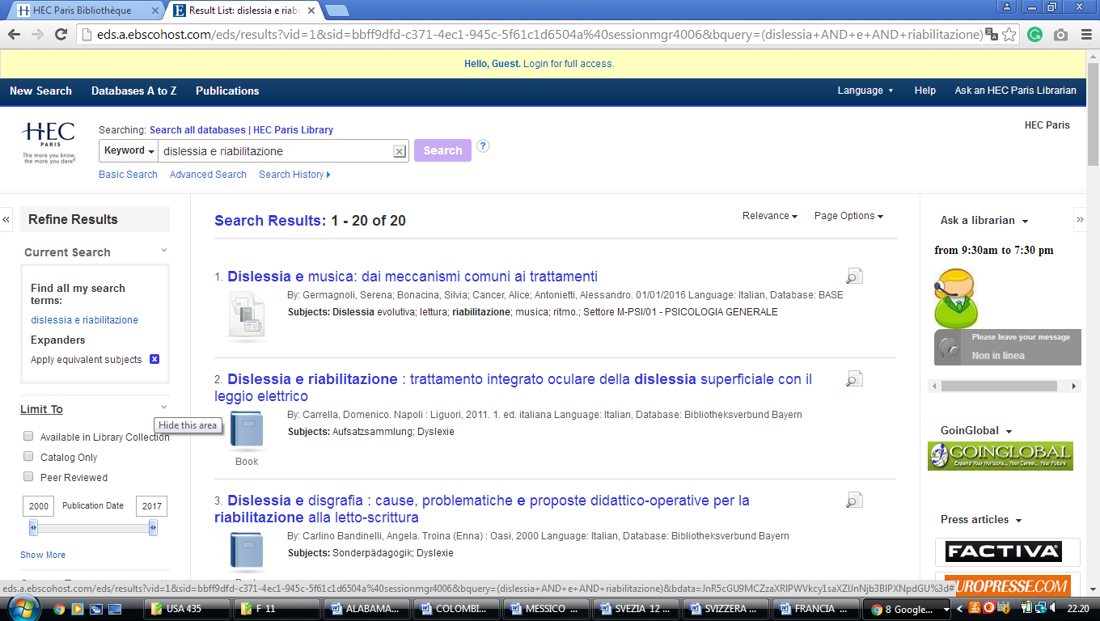

**6** [**BU - UNIVERSITÉ DE LA RÉUNION**](http://bu.univ-reunion.fr/) **–** (Saint-Denis, Francia)

### <http://optimus.univ-reunion.fr:1701/primo_library/libweb/action/display.do?tabs=detailsTab&ct=display&fn=search&doc=TN_dipf959441&indx=1&recIds=TN_dipf959441&recIdxs=0&elementId=0&renderMode=poppedOut&displayMode=full&frbrVersion=&dscnt=0&tab=remote_tab&dstmp=1521073510427&pcAvailabiltyMode=true&vl(freeText0)=dislessia+e+riabilitazione&vid=URN&mode=Basic>

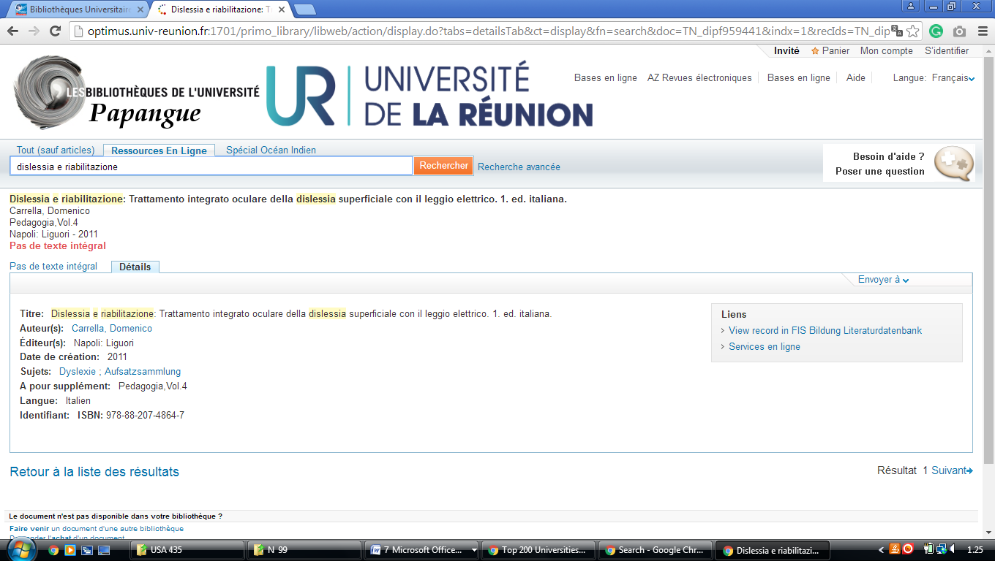

### 7 [SCD - UNIVERSITÉ DE LILLE](http://bu.univ-lille2.fr/) - [(De Lille](http://bu.univ-lille2.fr/cherchertrouver/ressources-en-ligne/), Francia)

<http://eds.a.ebscohost.com/eds/detail/detail?vid=2&sid=84ff1830-3291-4a74-a208-5eb02e43f0b5%40sessionmgr4006&bdata=JkF1dGhUeXBlPWlwLHVpZCZsYW5nPWZyJnNpdGU9ZWRzLWxpdmUmc2NvcGU9c2l0ZQ%3d%3d#AN=edsfis.959441&db=edsfis>

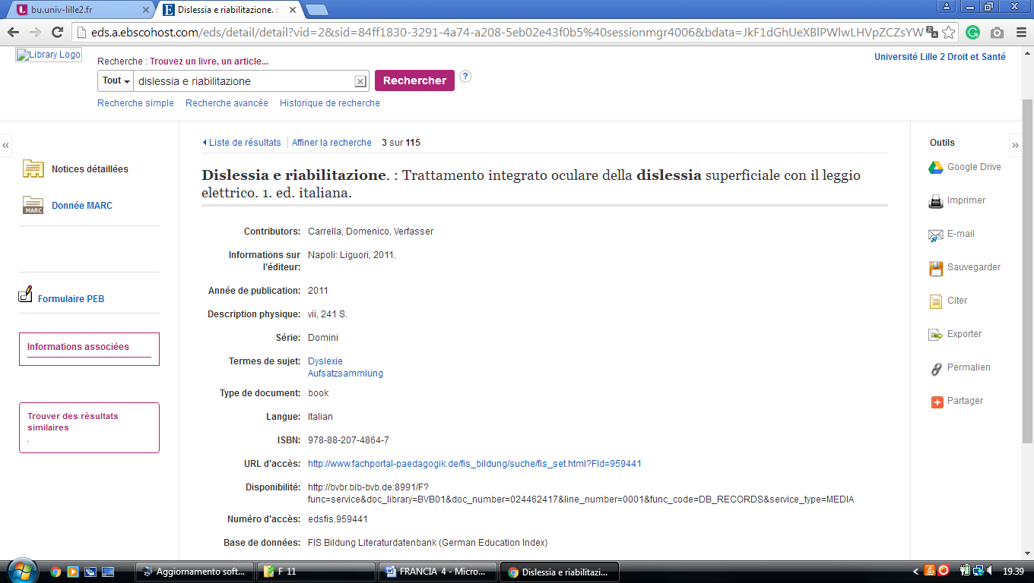

8 Saint Francis University - Francia

https://stfrancisuniversity.on.worldcat.org/search?queryString=dislessia+e+riabilitazione

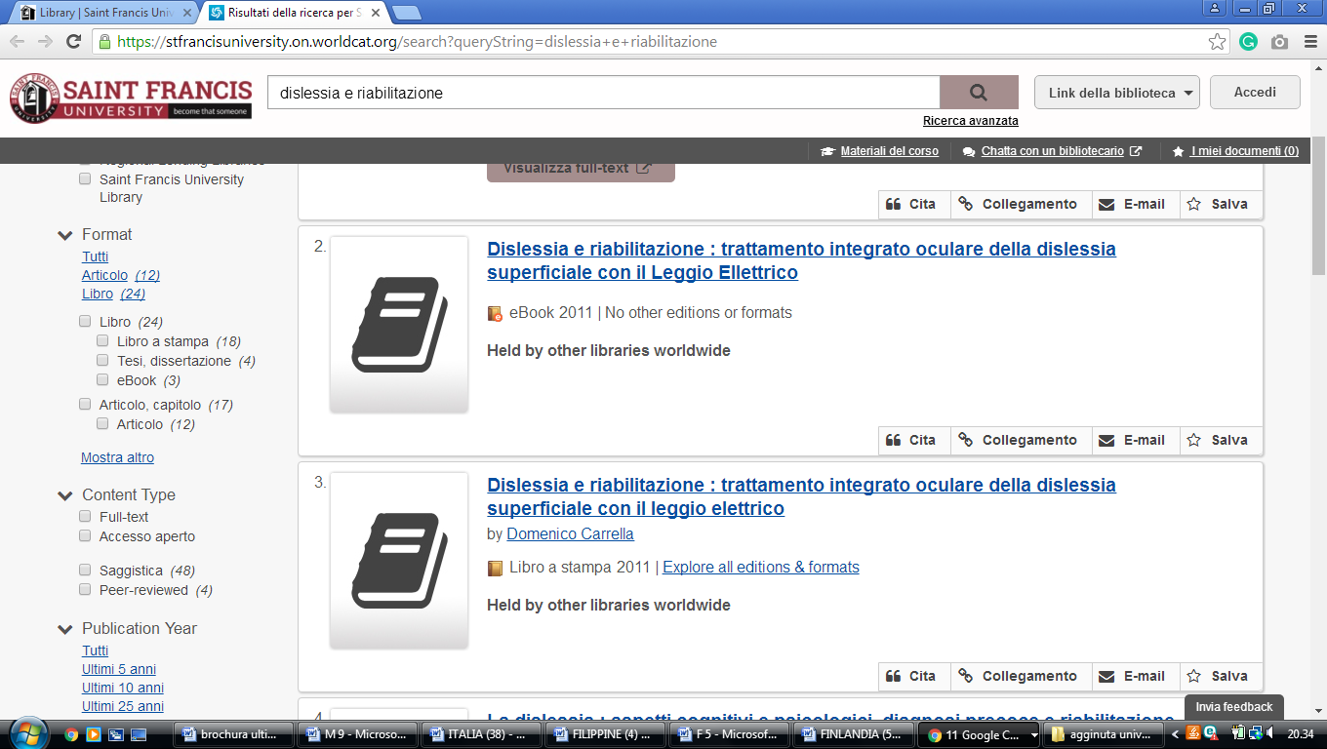

University of Lorraine Libraries

https://udl.primo.exlibrisgroup.com/discovery/search?vid=33UDL_INST:UDL&tab=Everything&search_scope=MyInst_and_CI&mode=basic&displayMode=full&bulkSize=10&highlight=true&dum=true&query=any,contains,dislessia%20e%20riabilitazione&displayField=all&pcAvailabiltyMode=true&lang=fr&pcAvailability=true

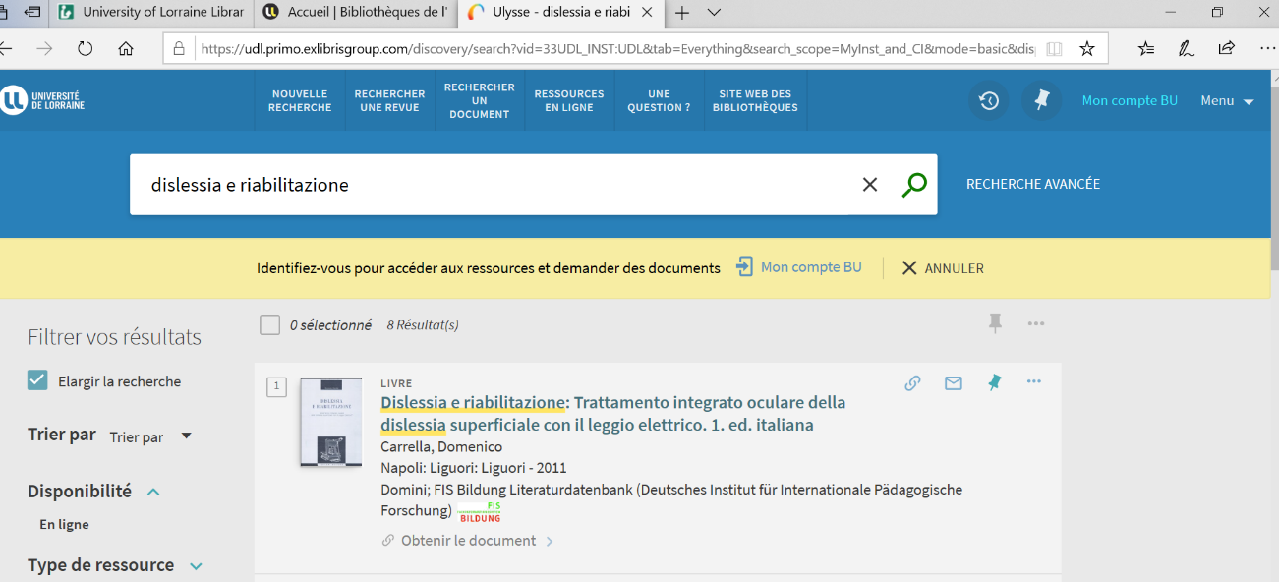

**Bibliothèque La Pérouse**

https://ifremer.on.worldcat.org/

