**1 THE NATIONAL LIBRARY FINLAND –** (Helsinki, Finlandia)

<https://kansalliskirjasto.finna.fi/PrimoRecord/pci.casalini_libriit02503952>

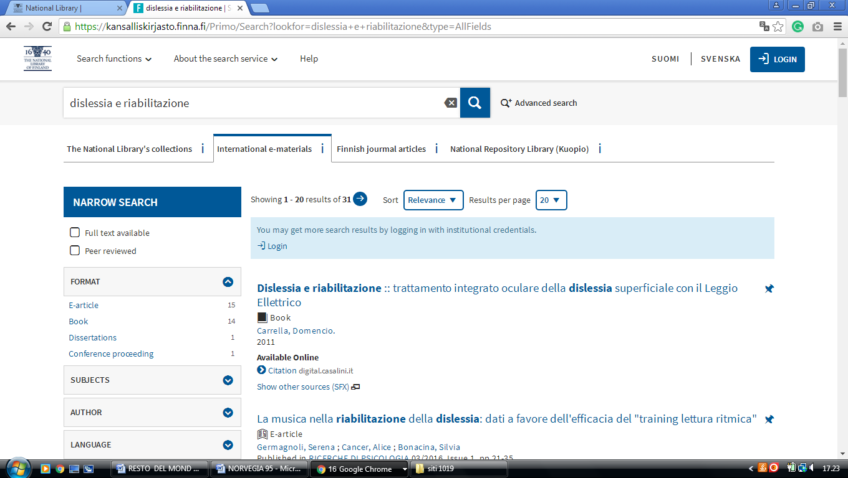

**2**  [**TAMPERE UNIVERSITY LIBRARY**](http://www.uta.fi/kirjasto/) – (Tampere, Finland)

<http://utafi.summon.serialssolutions.com/en-UK/#!/search?ho=f&l=en-UK&q=dislessia%20e%20riabilitazione>

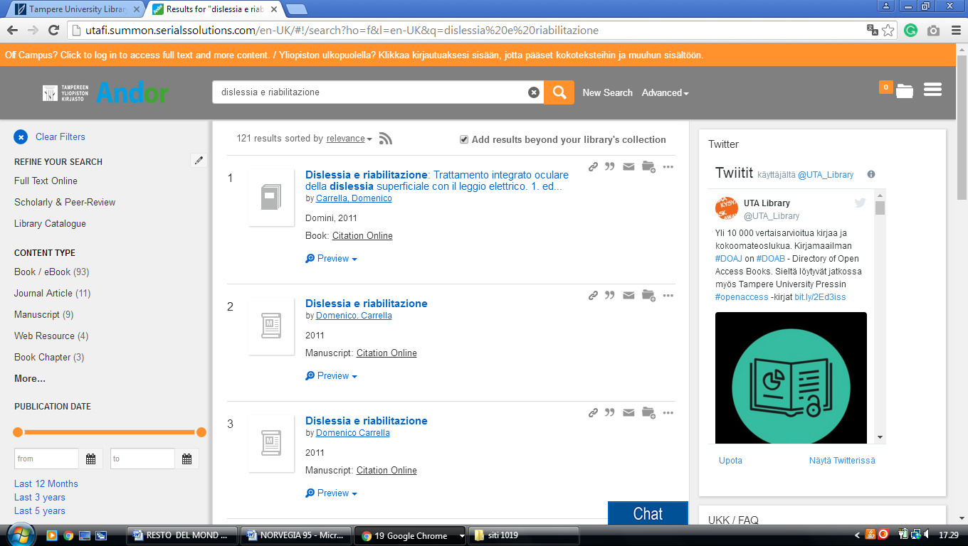

**3**  [**HELSINKI UNIVERSITY OF TECHNOLOGY**](http://lib.hut.fi/) – (Espoo, Finland)

<https://aalto.finna.fi/Primo/Search?lookfor=dislessia+e+riabilitazione&type=AllFields>

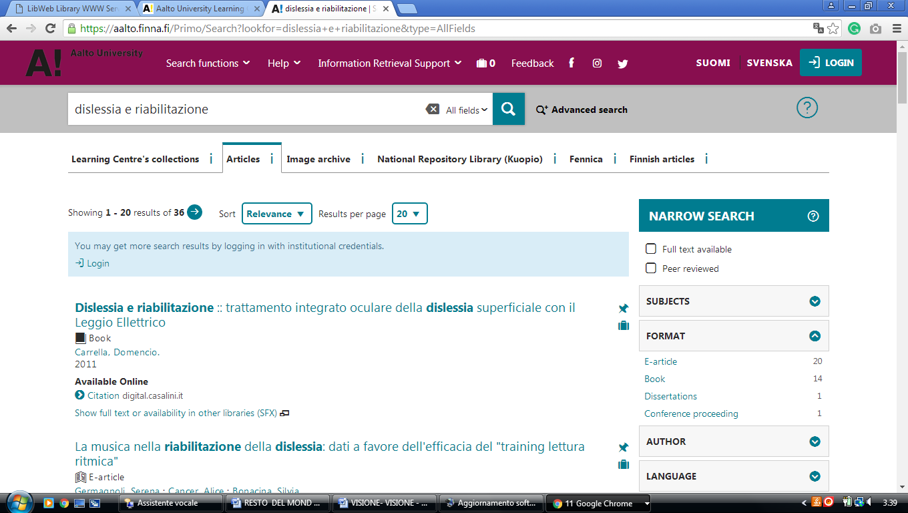

### 4 [OULU UNIVERSITY LIBRARY - OULUN YLIOPISTO](http://www.oulu.fi/library) - (Finlandia)

<https://oula.finna.fi/Primo/Search?lookfor=dislessia+e+riabilitazione&type=AllFields>

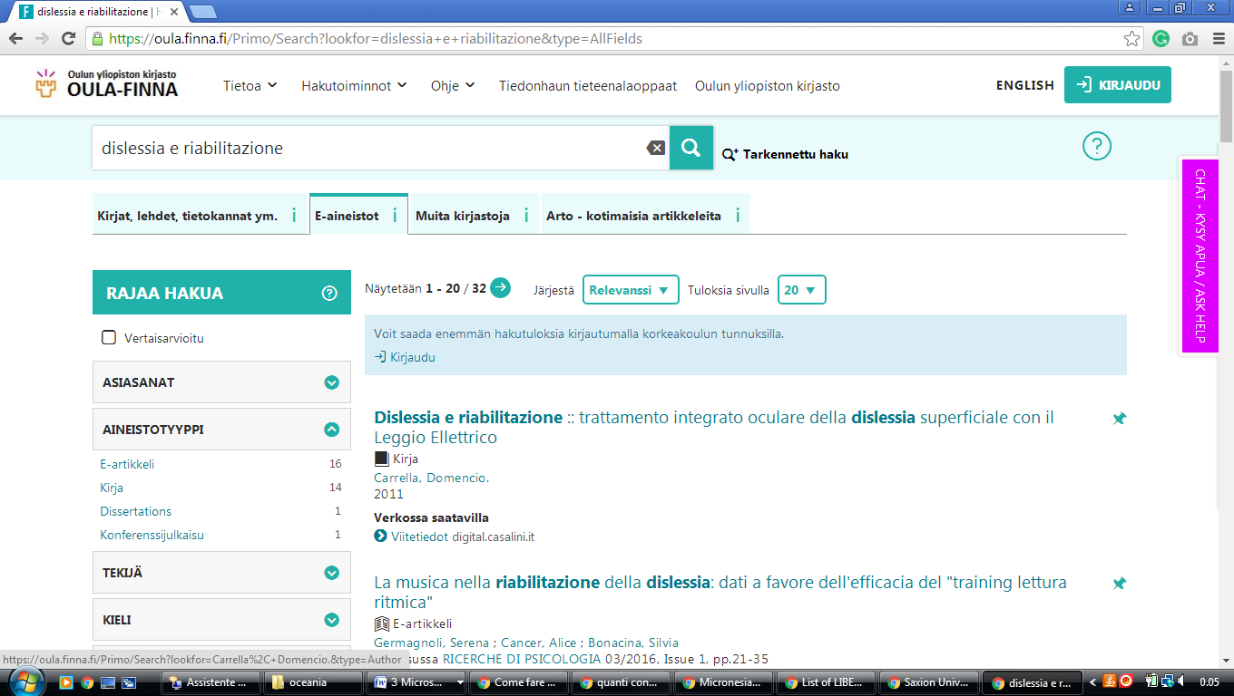

### 5 [LIBRARY - TURUN YLIOPISTO](http://www.utu.fi/library) - (Turku, Finlandia)

<https://utu.finna.fi/Primo/Search?lookfor=dislessia+e+riabilitazione&type=AllFields>

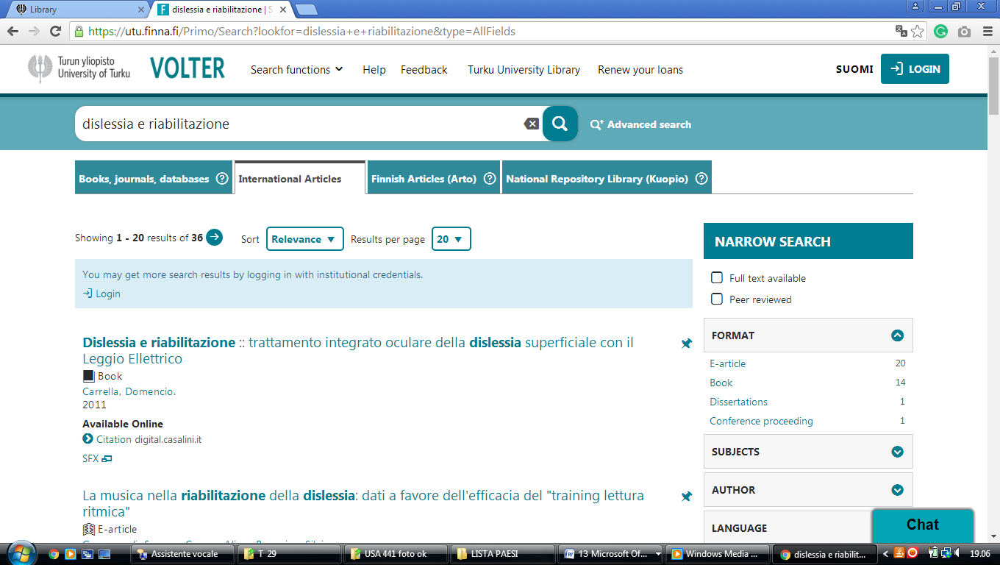

### [Helsinki University Library - Helka - Finna](https://helka.finna.fi/?lng=en-gb)

https://helka.finna.fi/Primo/Search?lookfor=dislessia+e+riabilitazione&type=AllFields

